A Penicillium chrysogenum-based expression system for the production of small, cysteine-rich antifungal proteins for structural and functional analyses

Christoph Sonderegger¹, László Galgóczi¹, Sandra Garrigues², Ádám Fizil³, Attila Borics⁴, Paloma Manzanares², Nikoletta Hegedüs^{1§}, Anna Huber¹, Jose F. Marcos², Gyula Batta³, Florentine Marx^{1*}

¹Division of Molecular Biology, Biocenter, Medical University of Innsbruck, Innrain 80-82, 6020 Innsbruck, Austria
²Biotechnology Department, Instituto de Agroquímica y Tecnología de Alimentos (IATA), Consejo Superior de Investigaciones Científicas (CSIC), Avenida Agustín Escardino 7, 46980 Paterna, Valencia, Spain
³Department of Organic Chemistry, Faculty of Science and Technology, University of Debrecen, Egyetem tér 1, 4032 Debrecen, Hungary
⁴Institute of Biochemistry, Biological Research Centre of Hungarian Academy of Sciences, Temesvári krt. 62, 6726 Szeged, Hungary

§Current address: Sandoz GmbH, Biochemiestrasse 10, 6250 Kundl, Austria
*Corresponding author

Table S1. Composition of media used in this study.
Description | Compositionª
Complete medium (CM) | 2% glucose, 0.2% peptone, 0.1% yeast extract, 0.1% NZ-amine (Sigma), 2% salt solution A, 0,1% trace elements solution (pH 6.5)
Salt solution A | 2.6% KCl, 2.6% MgSO₄ x 7 H₂O, 7.6% KH₂PO₄, 0.2% chloroform
P. chrysogenum minimal medium (PcMM)^{b} | 2% sucrose, 0.3% NaNO₃, 0.05% KCl, 0.05% MgSO₄ x 7 H₂O, 0.005% FeSO₄ x 7 H₂O, 0.1% trace elements solution A, 25 mM NaCl/P_{i} (pH 5.8)
Trace elements solution A | 0.1% FeSO₄ x 7 H₂O, 0.9% ZnSO₄ x 7 H₂O, 0.4% CuSO₄ x 5 H₂O, 0.01% MnSO₄ x H₂O, 0.01% H₃BO₃, 0.01% Na₂MoO₄ x 2 H₂O
P. digitatum minimal medium (PdMM) | 1% glucose, 0.0001% FeSO_{4,} 0.8% NH₄NO₃, 2% salt solution B, 1% trace elements solution B, 40 mM MES buffer (pH 5.3)
Salt solution B | 1.5% NaCl, 2.6% MgSO₄ x 7 H₂O, 7.6% KH₂PO₄
Trace elements solution B | 0.01% H₃BO₃, 0.01% CuSO₄ x 5H₂O, 0.01% MnSO₄ x H₂O, 0.01% Na₂MoO₄ x 2H₂O, 0.01% ZnSO₄ x 7 H₂O
ªPercent values are given as w/v for solids and v/v for solutions.
^{b}For NMR-based analyses, isotope-labelling of PAF[Pc] was performed in PcMM by replacing 0.3% NaNO₃ with 0.3% Na¹⁵NO₃ for single labelling and by replacing 0.3% NaNO₃ with 0.3% Na¹⁵NO₃ and 2% sucrose with 1% ¹³C-glucose (Euriso-Top, Saarbrücken, Germany).

Table S2. Oligonucleotides used in this study. Mutation primers for generation of PAF variants are in bold with underlined mismatches for amino acid conversions.

Name | Sequence 5'-3'
M13 | GTAAAACGACGGCCAGTGAG
T7var | TACGACTCACTATAGGGCG
opaf8 | CAAATCACCACAGTTGCCC
opaf9 | TCTCTTCGCTGCAATGGG
opaf10 | GCTGCCACCCCCAAGATGACTG
opafF31Nfw | GTGCCCCAAGAACGATAACAAG
opafF31Nrev | CTTGTTATCGTTCTTGGGGCAC
opafY48Qfw | GTCGACACCCAGAACAACGC
opafY48Qrev | GCGTTGTTCTGGGTGTCGAC
intron1paf | GTTGTGGTCCCGAACCGTTAGTCG
opaf13 | GGTCAAGCCGATTTCGAGAATGACCGTAGTG
OJM483 | ATCCCGGGGAATTCAGAGAGCTTTTCGTACG
OJM484 | ATTCTAGAGCAGCAGTTTGATAGTTATCCCT
1stF | GGCCCCATGGTGGTAAACAAGTAGTG
1stR | GGTGGCGGCCGCTCTAGAACTAG
2ndF | CACACAGAGCTCATGATCTG
2ndR | GTGTAGGGTAGTAAGCTTCGAG
3rdARsign | CAGGACACCGGCCTC
3rdBF | GACTTCCGCCATTGAATGGTCTCTGCGATCACC
4thFsign | GAGGCCGGTGTCCTGCTTGAGTATAAAGGAG
4thR | CAGAGACCATTCAATGGCGGAAGTC
6thAR | GTAAACCAGATCATGAGCTCTGTGTG
6thBF | CTCGAAGCTTACTACCCTACACCCAC

Figure S1

pSK275paf

GTGGCACTTTTCGGGGAAATGTGCGCGGAACCCCTATTTGTTTATTTTTCTAAATACATTCAAATATGTATCCGCTCATG
AGACAATAACCCTGATAAATGCTTCAATAATATTGAAAAAGGAAGAGTATGAGTATTCAACATTTCCGTGTCGCCCTTAT
TCCCTTTTTTGCGGCATTTTGCCTTCCTGTTTTTGCTCACCCAGAAACGCTGGTGAAAGTAAAAGATGCTGAAGATCAGT
TGGGTGCACGAGTGGGTTACATCGAACTGGATCTCAACAGCGGTAAGATCCTTGAGAGTTTTCGCCCCGAAGAACGTTTT
CCAATGATGAGCACTTTTAAAGTTCTGCTATGTGGCGCGGTATTATCCCGTATTGACGCCGGGCAAGAGCAACTCGGTCG
CCGCATACACTATTCTCAGAATGACTTGGTTGAGTACTCACCAGTCACAGAAAAGCATCTTACGGATGGCATGACAGTAA
GAGAATTATGCAGTGCTGCCATAACCATGAGTGATAACACTGCGGCCAACTTACTTCTGACAACGATCGGAGGACCGAAG
GAGCTAACCGCTTTTTTGCACAACATGGGGGATCATGTAACTCGCCTTGATCGTTGGGAACCGGAGCTGAATGAAGCCAT
ACCAAACGACGAGCGTGACACCACGATGCCTGTAGCAATGGCAACAACGTTGCGCAAACTATTAACTGGCGAACTACTTA
CTCTAGCTTCCCGGCAACAATTAATAGACTGGATGGAGGCGGATAAAGTTGCAGGACCACTTCTGCGCTCGGCCCTTCCG
GCTGGCTGGTTTATTGCTGATAAATCTGGAGCCGGTGAGCGTGGGTCTCGCGGTATCATTGCAGCACTGGGGCCAGATGG
TAAGCCCTCCCGTATCGTAGTTATCTACACGACGGGGAGTCAGGCAACTATGGATGAACGAAATAGACAGATCGCTGAGA
TAGGTGCCTCACTGATTAAGCATTGGTAACTGTCAGACCAAGTTTACTCATATATACTTTAGATTGATTTAAAACTTCAT
TTTTAATTTAAAAGGATCTAGGTGAAGATCCTTTTTGATAATCTCATGACCAAAATCCCTTAACGTGAGTTTTCGTTCCA
CTGAGCGTCAGACCCCGTAGAAAAGATCAAAGGATCTTCTTGAGATCCTTTTTTTCTGCGCGTAATCTGCTGCTTGCAAA
CAAAAAAACCACCGCTACCAGCGGTGGTTTGTTTGCCGGATCAAGAGCTACCAACTCTTTTTCCGAAGGTAACTGGCTTC
AGCAGAGCGCAGATACCAAATACTGTCCTTCTAGTGTAGCCGTAGTTAGGCCACCACTTCAAGAACTCTGTAGCACCGCC
TACATACCTCGCTCTGCTAATCCTGTTACCAGTGGCTGCTGCCAGTGGCGATAAGTCGTGTCTTACCGGGTTGGACTCAA
GACGATAGTTACCGGATAAGGCGCAGCGGTCGGGCTGAACGGGGGGTTCGTGCACACAGCCCAGCTTGGAGCGAACGACC
TACACCGAACTGAGATACCTACAGCGTGAGCTATGAGAAAGCGCCACGCTTCCCGAAGGGAGAAAGGCGGACAGGTATCC
GGTAAGCGGCAGGGTCGGAACAGGAGAGCGCACGAGGGAGCTTCCAGGGGGAAACGCCTGGTATCTTTATAGTCCTGTCG
GGTTTCGCCACCTCTGACTTGAGCGTCGATTTTTGTGATGCTCGTCAGGGGGGCGGAGCCTATGGAAAAACGCCAGCAAC
GCGGCCTTTTTACGGTTCCTGGCCTTTTGCTGGCCTTTTGCTCACATGTTCTTTCCTGCGTTATCCCCTGATTCTGTGGA
TAACCGTATTACCGCCTTTGAGTGAGCTGATACCGCTCGCCGCAGCCGAACGACCGAGCGCAGCGAGTCAGTGAGCGAGG
AAGCGGAAGAGCGCCCAATACGCAAACCGCCTCTCCCCGCGCGTTGGCCGATTCATTAATGCAGCTGGCACGACAGGTTT
CCCGACTGGAAAGCGGGCAGTGAGCGCAACGCAATTAATGTGAGTTAGCTCACTCATTAGGCACCCCAGGCTTTACACTT
TATGCTTCCGGCTCGTATGTTGTGTGGAATTGTGAGCGGATAACAATTTCACACAGGAAACAGCTATGACCATGATTACG
CCAAGCGCGCAATTAACCCTCACTAAAGGGAACAAAAGCTGGGTACCGGGCCCCCCCTCGAGGTCGACGGTATCGATAAG
CTTGATGGCCTAGATGGCCTCTTGCATCTTTGTTTGTATTATACTGTCTTTCTTGTTACACATAATTATTCTAGAATGCC
CCACCGTTACATACGGGACACAGCCATTTACATATGCATGTGGATTACGAGCTAACGAGTTCATTCAAATCTCAGAACTA
TCACATAATCATCATTCCCCTATCGTCAAAGACCGTAAGACAAATCCGGTTCATGCACTGAACCCATTCGGGTAGTGAGT
CATTTACTCAGCACACTCGCGCTGACGCTCGTCGAACACCTTCAATGCCTCCTCGGCAGCCTTGACACCACTGAGAACCA
TGGCACCGAAGGTAGGGCCCATGCGGTTAAAGCCATCAATTTCAGACAGCTCCATACCGCCGATTATCAAGCCCTTAGTA
ACCTCGCGGGTGTTCTTGACGATGGCATCCTCGGCCGAGTTCATGTCGAGACCACGCATGCCACCTAGCTTGTCGACGCT
GCCCATGGACACCAAGCGCTTCGCACAGAAGGCGCCGAATGGCCCATCGTGACCAGTGGTACTGATGATGACAGGAGCGT
TGATAGTGTTGGGGTCCATGCAGGAGTGATCATCGTGGTGAAGGGTGACCAGCGTCCAGTTGACGACAACACCAGCAATC
TGGGGGTTGCCGTTCTCGGTCGGACGGGTGATCAAGTCCTCAACAGCGGTAGCATTGAAGAGCTTGACATTGGGGAAGGA
GAGAACCTTCGACATGAGTGTCGAGGTAAACAGGGAGGCGTGCTTGACGACAACGTAGTTGGGGTTTGCGTCCTCTTCGT
AAGGAACACCCAGCTCGTTCAGGAAGACTTCCGCGGGACGGCGCATGACCATAGCAGAAAAGAGTTGGCCACCCAACCAG
GCACCGCCACCTATTGCACGTTAGTTCCGGAAAGCTGAGTGCAAGGCAATCCATCATGGACTACTGACCAGGAGAGACGC
TGGCCTCGACGATAGCAATCTTCAGGTCCGGACGAGCCTTGGCCAAGACGTACGCAGTGCTCAGACCGCAGGAACCAGCA
CCAACAATGACAACGTCACTTTCAGCGTACTTGTCCAGGTCCTCAAAGTAACGTCTGGTCATGGCACGAGAGACCTGGCT
TTCGCGGATAGGGGCGAACTTGAACTCGTCCCACTTGCCACCGAAATGGTCCAACAGCTTGGTCTGAGAAGCTCCCTCAA
CGGGGACGGTCTCAGAAACCACGACCTTACCCTTGAGGCCGGTAGCGGCCACAGTGGGTTCGTAGATGGCAGCTGGAGGA
GACATGTTTCAAGTTGCAATGACTATCATCTGTTAGCCATTCCATCAACAGGAAGAACGAGAGAAGGCATGACCCTTTTC
GCTGGTATTATCCAGATCAAGTTTTAGCCGTATAATCTCAGAACGAACCCAGTCCATCGATGCCATGTCCTTCTAGACTA
GGATCCTAGAGTCTAGGGCCCAGCTTAGGGAGGGCATGTGAATGCATCGATGACTGGGAACGAACACCGGCCCACGCCAA
AGACGTTACCTAAGATACCTTGATCATTGTGAGAGTCCAGCCAAAAGTATTCCATGACTTCCATCGTATGCCCTCTAGAG
GGCTAATCGAGGAGTGTATTTACATTGTCGGTTGGTTTGGGAACTATAGAAGATGGTCAGTTATTCCAATCACCAAAGGT
TTATCGAAGGGAGGAAGACTTGTTCAGTTTCGTCCGAGGACTTTTGGAATTCAAATCTGAGATAGAGAATTGTGTGGGAT
GAGAGGAAAAGGAAGAAGATGGTGGGGTTCAGAAGGAGGGGTTGAGTTAAATAGCATGGGTTGAGTCAACGTGATAAGGG
CACTATACCGTATAGATCAGCGGCACCCGATTCTATCCGTTCCTTTTGCTCCTCTTTAGCTTTGACCGGTGAGCCGGACA
AGAAACAAGTGAAATCATCCTGACATCGGCGGACGATCTCCTAGCTTTTACATTTCGTTACCAATGGGATCCCGTAATCA
ATTGGCCTGAGTGGCCATCGAATTCCTGCAGGAATTCAGAGAGCTTTTCGTACGAAGTGCGTAATGTACGTAGCATTTTA
TGGTAGCATGCAAAGCACATTTTGCTGCAACCCCAATTTAATGCGGTCCTGCTCAATAATTGATCTGCACTAAGGCCTTG
GCGATGGGGCCAGAAAAGGGTTGTTCAGTGGTGTGTACTCCGTAATGGTCAAGCCGATTTCGAGAATGACCGTAGTGTTC
ATTCATCAGTGCGATATTAAATCAGTTAGCTACTCTATCTGAAAGCTAATAAATTTCTTTACCACTAACAATACTCTTCT
CTGACTGAAAGTACCTTTTCCACTCCCCTCATACTTCATGTTTTAAGCTCAACCGTAGGAAAGCCTGTATATCTTAAAAG
ATTTGGATTTACTCTTCCAGCGCTTACTGTCTGCTCTTTCGGCCGAGCGAACCTTGGCAGTATGATCGGACTATGTACTT
TGTTACACAAAAGGAGAAGCGGGGCTGCCACTGAGGACAACCCCTGTTCAAGGGCTAGCATCCCGCTGTAAGCCCACCCA
TCCCACCTTGAAGTATGCAACTTTTGACCGCCTAGACCATGTGAGCTTATGTTACTGAAATACTACCCGCGAATCATTTC
CTAATTTGCTTTGGCTCGAATCCACCCCAGCCCTACGTAACACAACCGGGAGCTGCCTTACAGCTTGGCTGTATCACAGT
ATCACATAGATACATACATAGTATAGTGCCTTTGCCTTTTCGACCTATAAGCATCCGCCATATGCTAAACCTTCTCATAT
ACCAACATTTTGGATTTGGAGATCATTTCCTAGTGAAACAACTTTATCAAATGCAATGCAGCCATCGTCCTTTGCAGATC
CGAGTGGCCCAGTCACCGTGTCAACGTGTCAGCCGTTTTCTCTGCTTTTTAGGAAATGATTACCACTAGGTAAGCCCAAA
AATATCTTCCTGGTAAACAAGTAGTGCATCTTACCCCGGAGGCTGAAGCAGGTAAGGGATTTTGGAGAGACCCCACCCGT
AAGAATATACCAGCCAAGAGGTCCAGTATCCTGAAGTATGTGAGGCATTAATGTCATTGGAGAAGTCATGCAATCCATAA
GCTGCCACCCCCAAGATGACTGCATTGGACCTGAGCATTGTATGTGTCACCTTTCACACAGAGCTCATGATCTGGTTTAT
AAAGGCGGCTTCATGACCCTCAATTCCATATAGTATCACTCCCATCACAGCATTTCGATATCTTCAACCACTTTAACCTT
CTCCAGAGGATCATCATCTCAAGCCCTTCATAATGCAAATCACCACAGTTGCCCTTTTTCTCTTCGCTGCAATGGGCGGG
GTAGCCACCCCCATTGAGTCTGTATCAAACGACCTCGATGCCAGGGCTGAGGCCGGTGTCCTGGCCAAATACACCGGAGT
GAGTAAACATCAATATCCCATACCTTAAGTACTCACTTGGGAATCGCGACTAACGGTTCGGGACCACAACTCAGAAATGC
ACCAAATCTAAGAACGAATGTAAATACAAGAACGATGCTGGAAAGGACACTTTTATCAAGTGCCCCAAGTTTGATAACAA
GAAGGTAGAATATCAATCATTCGGAAGTAGCCATCTGAATCGATTTCGTGCTAATCTCGCTCTTTTTTCCAGTGCACCAA
GGATAATAACAAATGTACCGTCGACACCTACAACAACGCTGTCGATTGTGACTAGATGGTCTCTGCGATCACCAGGGCAT
TTAATGGTTTTTGGTTCCCTTCTTGTTGGTGATATGCGAGATGCCCTGTGATTCTCGAAGCTTACTACCCTACACCCACA
AGGACTCGAACCAAGGACTGCTCGGTGGGTGATACATATACACCCAGTATCTATCCAGCTTCAATTTTCGGCGAATTTTG
TTTCTTATTTCATAAAGACACTCGTTTGATATCTAGCTAGATATTGTTGCTCATCAACGAAATGGTTGTAGATTATCGAA
TATATCCAGCATCTTTTGATCGTAGTCGGAAGTGAAATGGAGTACTATGATACGACACATGTACATTGTAAGCAGAAATA
GGCTAGAGGGATAACTATCAAACTGCTGCAGCCCGGGGGATCCACTAGTTCTAGAGCGGCCGCCACCGCGGTGGAGCTCC
AATTCGCCCTATAGTGAGTCGTATTACGCGCGCTCACTGGCCGTCGTTTTACAACGTCGTGACTGGGAAAACCCTGGCGT
TACCCAACTTAATCGCCTTGCAGCACATCCCCCTTTCGCCAGCTGGCGTAATAGCGAAGAGGCCCGCACCGATCGCCCTT
CCCAACAGTTGCGCAGCCTGAATGGCGAATGGGACGCGCCCTGTAGCGGCGCATTAAGCGCGGCGGGTGTGGTGGTTACG
CGCAGCGTGACCGCTACACTTGCCAGCGCCCTAGCGCCCGCTCCTTTCGCTTTCTTCCCTTCCTTTCTCGCCACGTTCGC
CGGCTTTCCCCGTCAAGCTCTAAATCGGGGGCTCCCTTTAGGGTTCCGATTTAGTGCTTTACGGCACCTCGACCCCAAAA
AACTTGATTAGGGTGATGGTTCACGTAGTGGGCCATCGCCCTGATAGACGGTTTTTCGCCCTTTGACGTTGGAGTCCACG
TTCTTTAATAGTGGACTCTTGTTCCAAACTGGAACAACACTCAACCCTATCTCGGTCTATTCTTTTGATTTATAAGGGAT
TTTGCCGATTTCGGCCTATTGGTTAAAAAATGAGCTGATTTAACAAAAATTTAACGCGAATTTTAACAAAATATTAACGC
TTACAATTTAG

Figure S1. Nucleotide sequence of the plasmid pSK275paf (7051 bp) containing the paf gene expression cassette with 5'-UTR (blue, nt 4272-5552), paf gene (magenta, nt 5553-5975) and 3'-UTR (orange, nt 5976-6349. The ampR (nt 327-986) and ptrA (nt 2247-4243) resistance genes are marked in brown and green, respectively.

Construction of pSK275nfap^{paf_signal}

The paf gene with partial 5’- and 3’-UTR from pSK275paf was amplified and cloned into NcoI/NotI digested pGEM-T (pGEM-T_1ststep) (Fig. S2A). In the second step the paf gene with partial 5’- and 3’-UTR from pGEM-T_1ststep was amplified and cloned into SacI/HindIII digested pUC19 (pUC19_2ndstep) (Fig. S2B). In the third step partial paf 5’-UTR with the PAF pre-pro sequenece encoding region and partial paf 3’-UTR with the last 15 nucleotides (GACTTCCGCCATTGA) of nfap ORF was amplified from pUC19_2ndstep (Fig. S2C). Then the mature NFAP encoding cDNA with the last 15 nucleotides (GAGGCCGGTGTCCTG) of the PAF pre-pro sequence and partial paf 3’-UTR was amplified from the previously constructed pBSK(-)nfap (Virágh et al. 2014, Protein Expr Purif; 94:79-84.) containing the cDNA of the mature NFAP (Fig. S2D). Joint PCR was used to assemble partial paf 5’-UTR with the PAF pre-pro sequenece encoding region, partial paf 3’-UTR with last 15 nucleotides (GACTTCCGCCATTGA) of nfap ORF, and mature NFAP encoding cDNA with the last 15 nucleotides (GAGGCCGGTGTCCTG) of the PAF pre-pro sequence and partial paf 3’-UTR. Then this construct was cloned into SacI/HindIII digested pUC19 (pUC19_5thstep) (Fig. S2E). In the next steps partial paf 5’- and 3’-UTRs, and mature NFAP encoding cDNA with partial paf 5’-UTR, PAF pre-pro sequence encoding region and partial paf 3’-UTR were amplifed from pGEM-T_1ststep and pUC19_5thstep, respectively. Finally these amplicons were assembled by joint PCR (Fig. S2F) and cloned into BspMI/NotI digested pSK275paf (pSK275nfap^{paf_signal}).

A
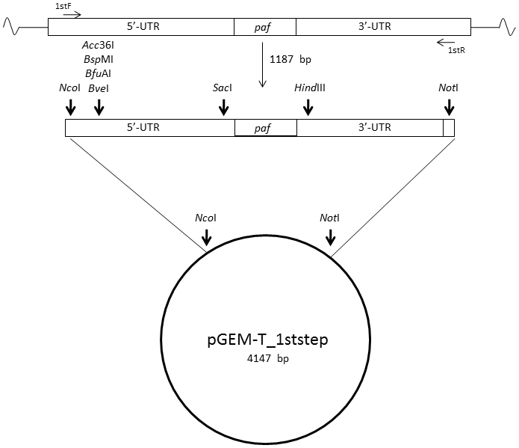

B
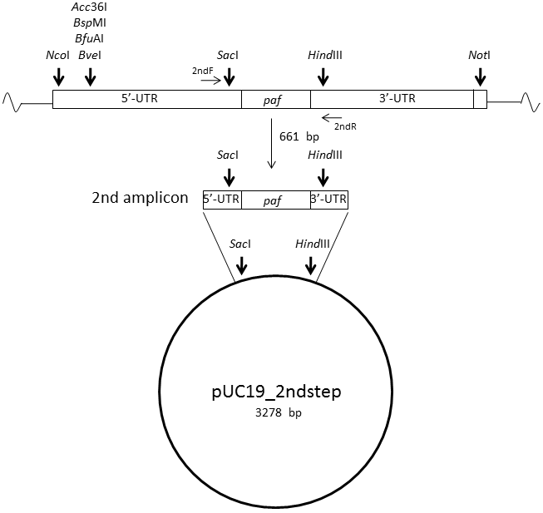

C
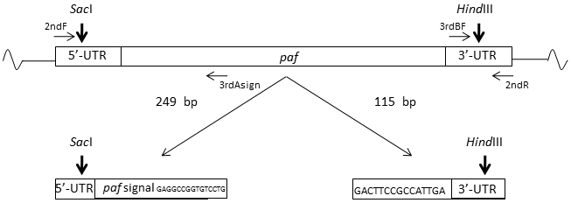

D
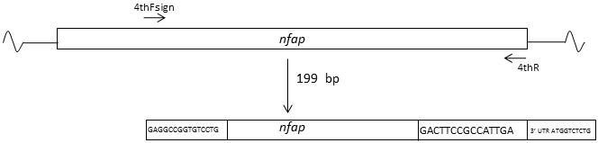
E
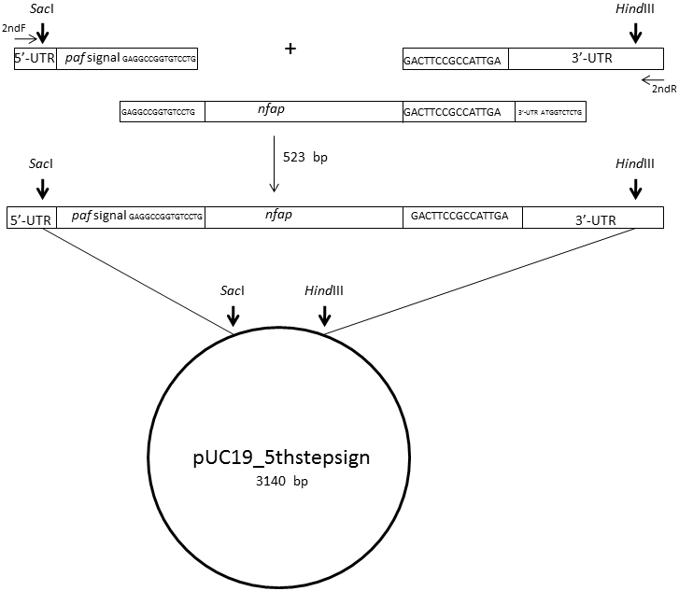
F
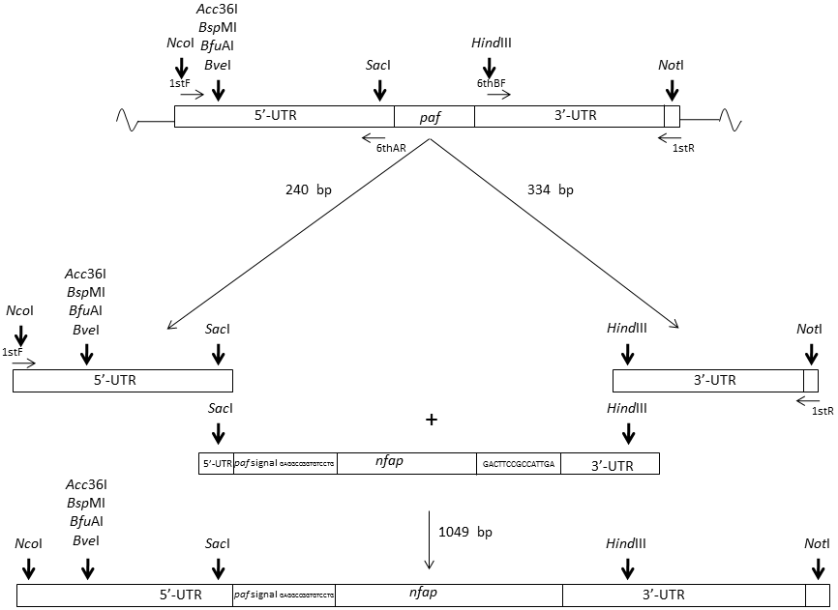

Figure S2. Schematic representation of the cloning strategy of the NFAP expression vector pSK275nfap^{paf_signal}. The restriction sites are shown with vertical bold arrows; the oligonucleotides for PCR amplifications are indicated by horizontal light arrows.

Southern blot analysis

In Southern blotting experiments the random integration of the transforming DNA into the fungal genomes was proved by using a 1.3 kb DIG-labelled PCR probe spanning a part of the paf gene and the paf promoter (Fig. S3). The digestion of genomic DNA of the recipient strain P. chrysogenum ∆paf with NdeI resulted in two hybridizing fragments sized 3.4 kbp and 9 kbp, or 1.3 kbp and 3.1 kbp, when the restriction enzymes NheI/XhoI were used (Supplements, Fig. S3A). The 3.4 kbp and 9 kbp fragments were found in the NdeI-digested genomic DNA of P. chrysogenum strains PAF^{Y48Q}, PAF^{F31N} and PAF (Fig. S3B), whereas the 1.3 kbp and 3.1 kbp fragments were visible in the NheI/XhoI-digested genomic DNA of P. chrysogenum strain NFAP (Fig. S3C). This indicated that the nourseothricin resistant gene (nat1) cassette was still present in the genomes of these transformed strains. The hybridizing fragments of 2.7 kbp in size proved the presence the plasmids with the expression cassettes in the genomes of P. chrysogenum strains PAF^{Y48Q} (Fig. S3B (a)), PAF^{F31N} (Fig. S3B (b)) and PAF (Fig. S3B (c)). In the P. chrysogenum strain NFAP the integration of the expression plasmid into the genome was evident from the 2.5 kbp sized fragment (Fig. S3C). The additional signals of various sizes and intensities further proved that at least single or multiple-copy random plasmid integrations in these P. chrysogenum strains had occurred. The analysis of the NdeI digested genomic DNA of P. digitatum strain PAF revealed the presence of at least three copies of the paf expression cassette (Fig. S3D (b)) in contrast to the lack of signals in the not transformed P. digitatum recipient strain (Fig. S3D (a)).

Figure S3

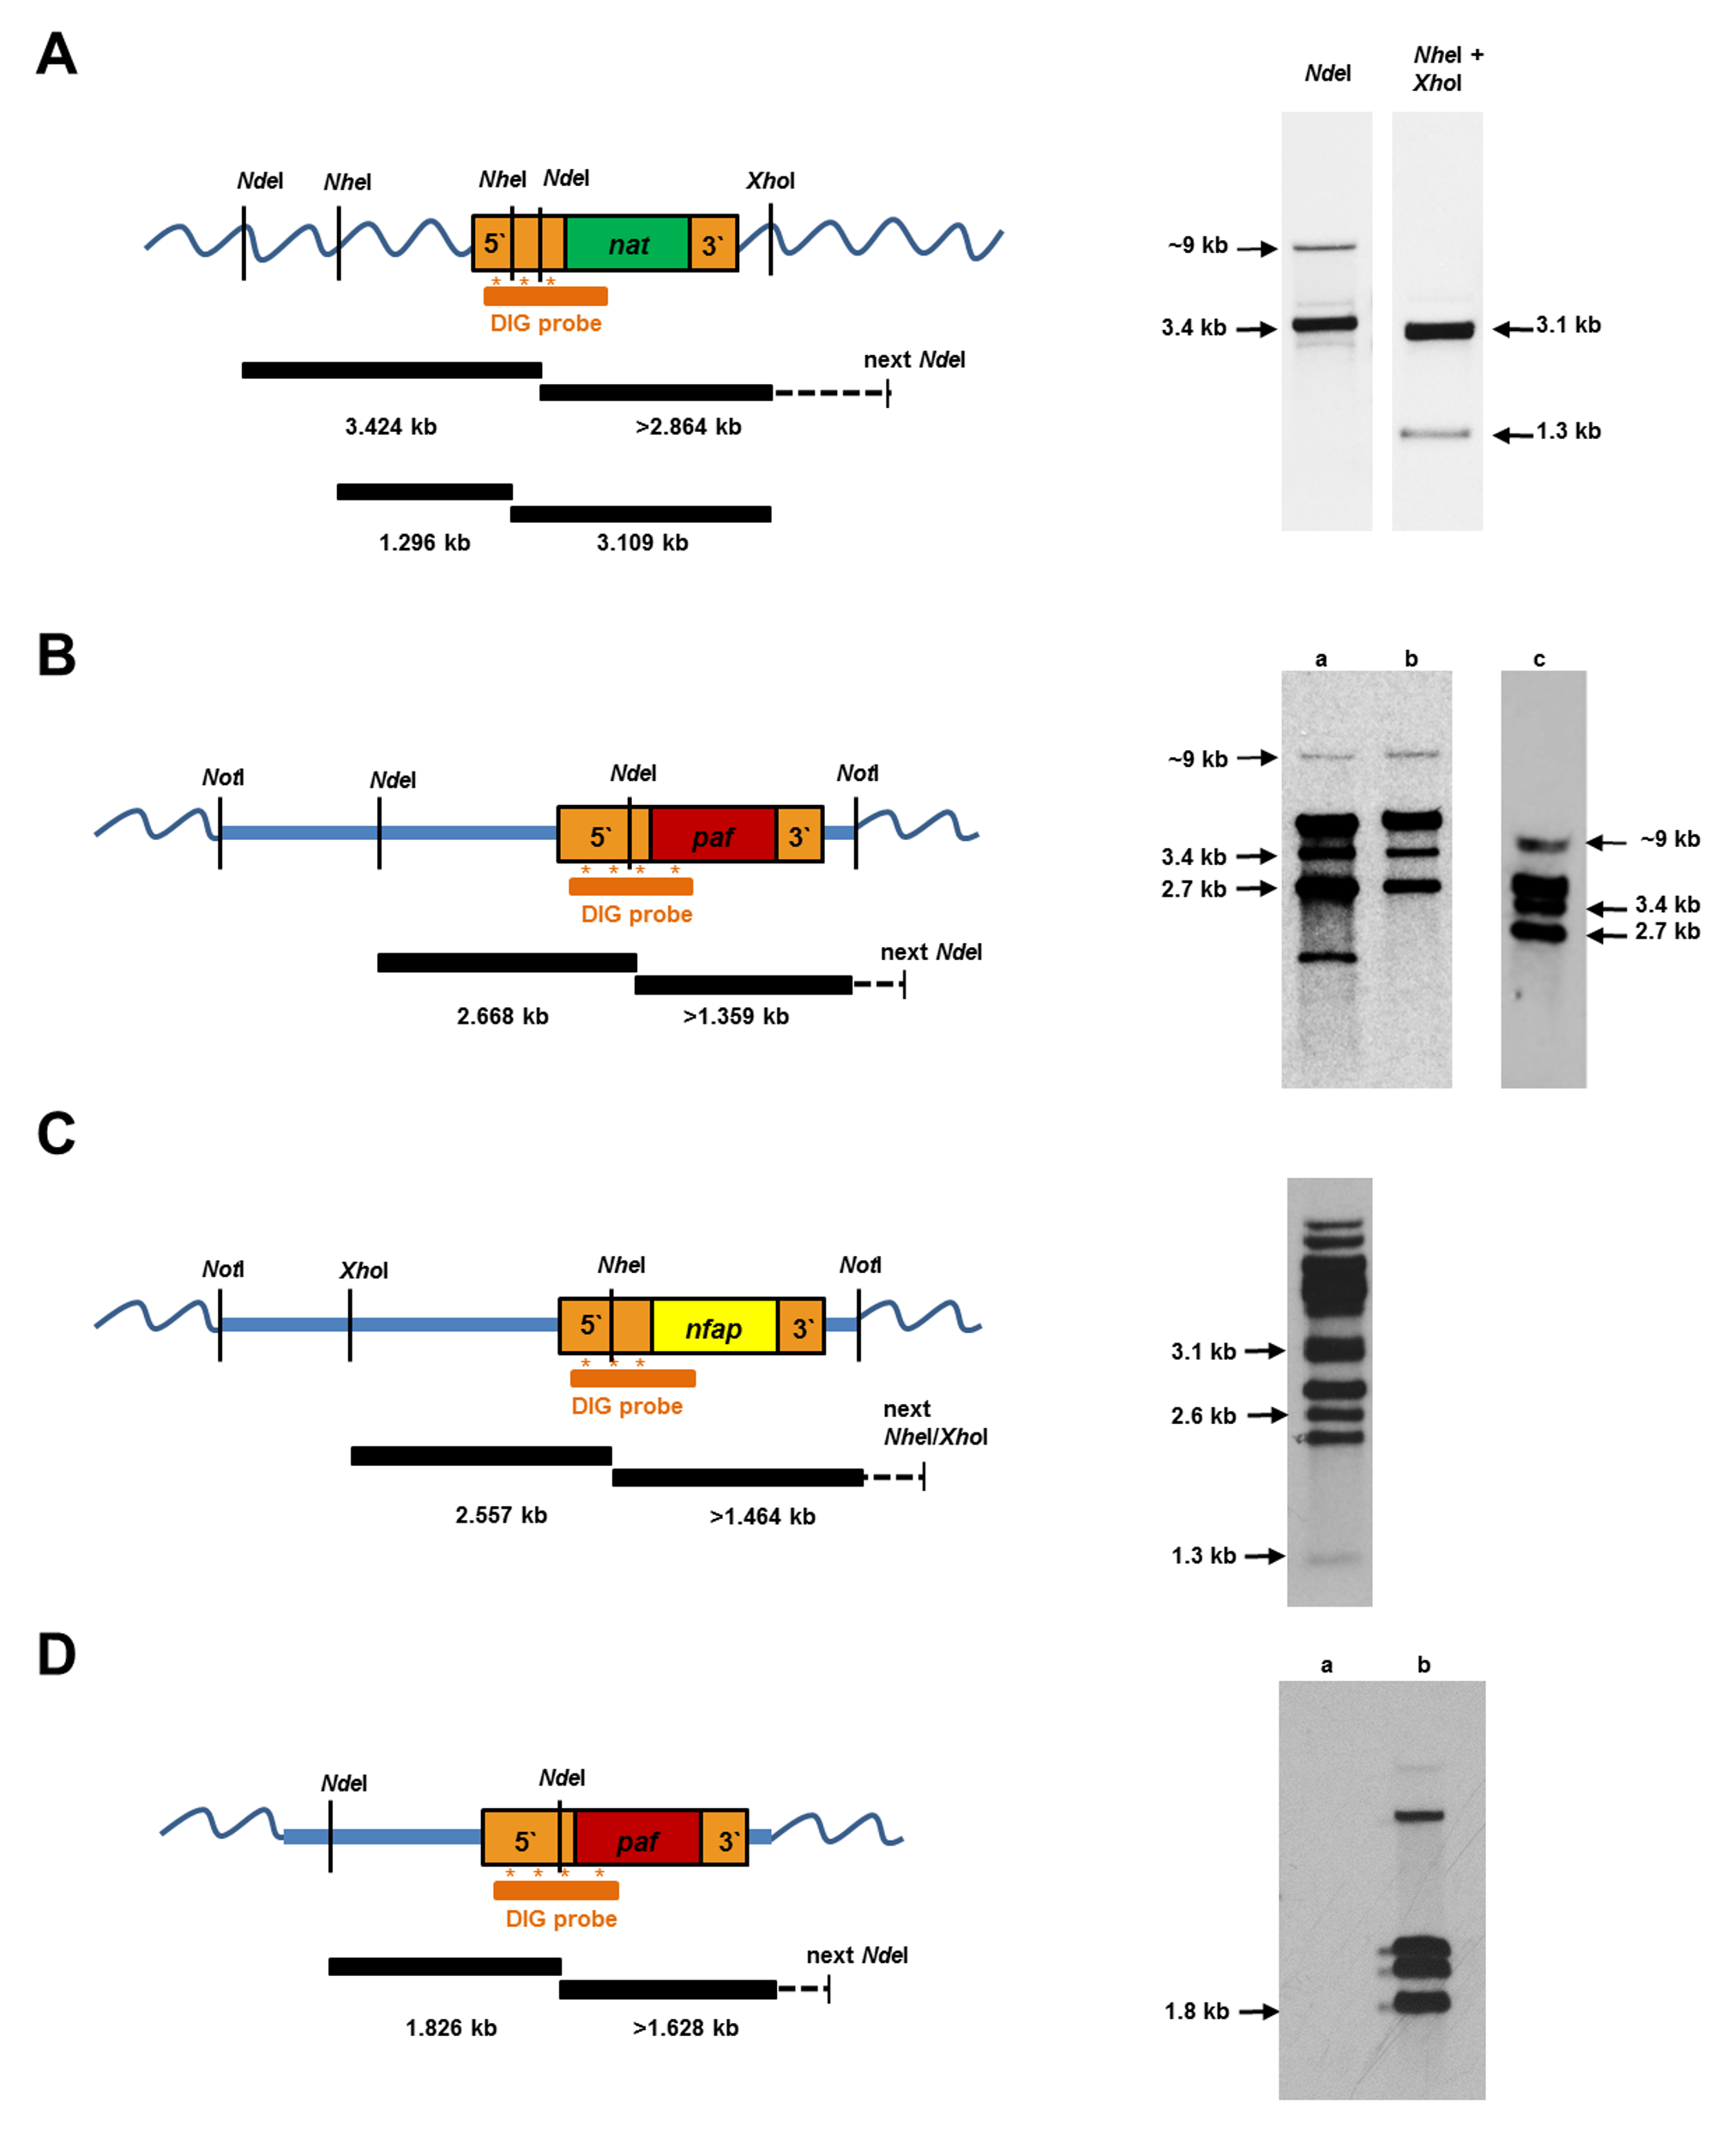

Figure S3. Southern blot analysis for genomic integration of the P. chrysogenum expression cassette in the Penicillium cell factories. Left: schematic representation of the expression cassettes comprising the paf-specific 5'-UTR and 3'-UTR (orange) and the respective gene coding sequences (green: nat1; red: paf; yellow: nfap). The pSK275 plasmid backbones and the Penicillium sp. genomes are represented by blue straight and wavy lines, respectively. The position of the paf 5´-UTR-specific DIG-labelled probe (orange line) is indicated with asterisks representing the region of hybridization, the hybridizing fragments with the expected sizes are delineated below in black. Right: Southern blots of digested genomic DNA showing site-specific and random genomic integrations (RI). (A) Recipient strain P. chrysogenum ∆paf, digested with NdeI or with NheI/XhoI (control). (B) Transformed P. chrysogenum ∆paf strains for the production of (a) PAF^{Y48Q}, (b) PAF^{F31N} and (c) PAF, DNA digested with NdeI. (C) Transformed P. chrysogenum ∆paf strain for NFAP production, DNA digested with NheI/XhoI and (D) P. digitatum (a) not transformed and (b) transformed for PAF production, DNA digested with NdeI.

Figure S4

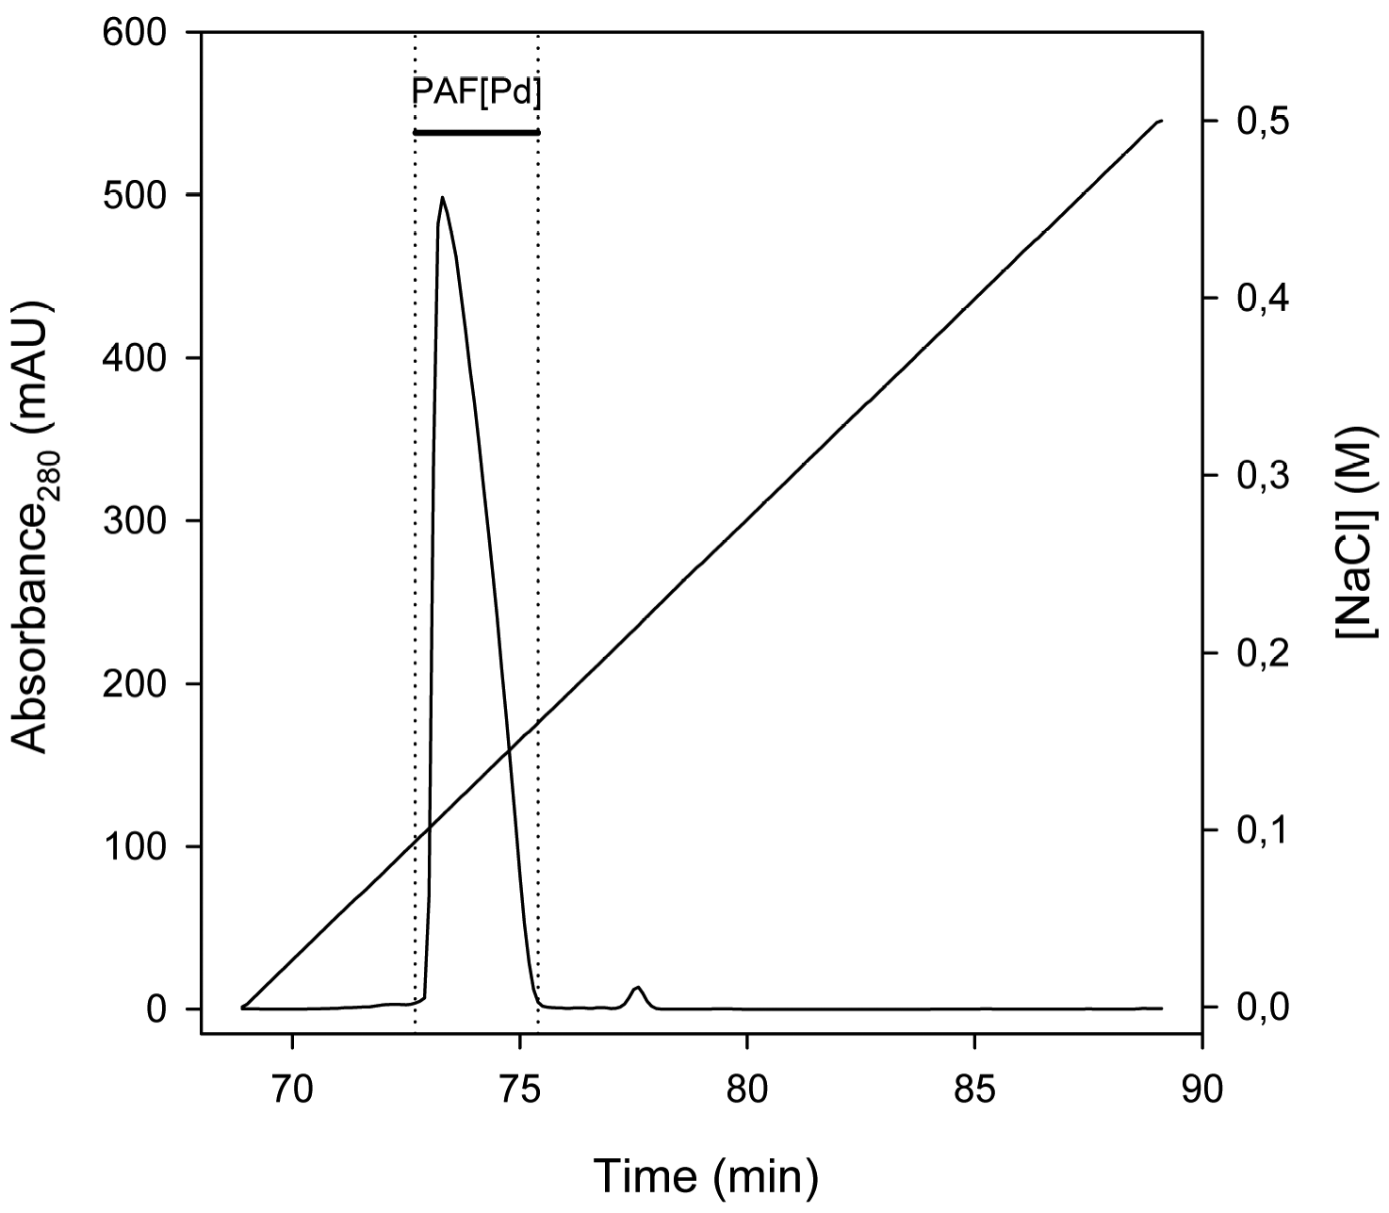
Figure S4. The elution pattern of PAF[Pd] purified by cation-exchange chromatography. Experimental details are described in the text.

Figure S5

Figure S5. Growth inhibition assays with A. niger exposed to 0-1.2 μg/mL of PAF, PAF[Pc], PAF[Pd], NFAP, NFAP[Pc], and 0-800 μg/mL of PAF^{F31N} and PAF^{Y48Q}. Overview images were taken after 48 h of incubation at 30 °C. One representative experiment out of three is presented.

