Supplementary information

Fermentative production and direct extraction of (-)-α-bisabolol in metabolically engineered Escherichia coli

Gui Hwan Han^{1†}, Seong Keun Kim^{1,2†}, Paul Kyung-Seok Yoon^{1,3}, Younghwan Kang¹, Byoung Su Kim⁴, Yaoyao Fu¹, Bong Hyun Sung⁵, Heung Chae Jung¹, Dae-Hee Lee^{1,2}*, Seon-Won Kim⁶* and Seung-Goo Lee^{1,2}*

¹Synthetic Biology and Bioengineering Research Center, Korea Research Institute of Bioscience and Biotechnology (KRIBB), Daejeon 34141, Republic of Korea
²Biosystems and Bioengineering Program, University of Science and Technology (UST), Daejeon 34113, Republic of Korea
³Department of Chemical and Biological Engineering, Korea University, Seoul 02841, Republic of Korea
⁴Department of Biotechnology, Chonnam National University, Yeosu 550749, Republic of Korea
⁵Bioenergy and Biochemical Research Center, Korea Research Institute of Bioscience and Biotechnology (KRIBB), Daejeon 34141, Republic of Korea
⁶Division of Applied Life Science (BK21 Plus), PMBBRC, Gyeongsang National University, Jinju 52828, Republic of Korea

Figure S1. Nucleotide sequence of the E. coli codon-optimized MrBBS gene.
1 ATGAGCACAC TGAGCGTCAG CACCCCGAGC TTTAGCAGCA GCCCTCTGTC GAGCGTGAAT
61 AAGAACAGCA CCAAGCAGCA TGTCACTCGT AACAGCGTGA TCTTTCACGA CTCGATTTGG
121 GGGGACCAGT TCCTGGAATA CAAAGAGAAA TTCAACGTTG CAACCGAGAA ACAGCTTATA
181 GAAGAGCTGA AAGAAGAAGT GCGTAACGAA CTGATGATTC GTGCATGTAA TGAAGCGAGC
241 CGGTATATCA AACTGATCCA GCTGATCGAT GTTGTTGAAC GTCTGGGGCT GGCCTATCAT
301 TTTGAAAAAG AGATTGAGGA AAGCCTCCAG CATATATATG TGACGTATGG TCATAAATGG
361 ACGAATTACA ACAATATTGA GAGCCTGAGT CTGTGGTTCC GCCTGCTTCG TCAAAATGGC
421 TTTAATGTTA GCTCGGATAT ATTTGAAAAT CACATTGATG AGAAAGGAAA TTTTCAGGAG
481 AGCCTGTGCA ATGATCCGCA GGGGATGCTG GCGCTGTATG AAGCGGCATA TATGCGTGTT
541 GAAGGAGAGA TCATTCTGGA CAAAGCACTC GAATTTACCA AGCTGCATCT GGGGATCATT
601 AGCAATGATC CTAGCTGTGA TAGCAGCCTA CGTACGGAAA TCAAGCAGGC ACTGAAACAG
661 CCACTGCGCC GGCGGCTGCC AAGGCTGGAA GCCGTTCGTT ACATTGCCAT TTATCAGCAG
721 AAGGCGAGCC ATAGCGAGGT TCTGCTGAAG CTGGCCAAAC TGGACTTCAA CGTTCTGCAG
781 GAAATGCACA AAGACGAATT GAGCCAAATA TGCAAATGGT GGAAAGATCT GGATATACGT
841 AACAAACTGC CCTATGTTCG TGATCGTCTG ATTGAAGGCT ATTTTTGGAT TCTGGGTATT
901 TATTTCGAAC CGCAACACTC CCGTACCCGT ATGTTCCTGA TGAAAACCTG TATGTGGCTG
961 ATCGTGCTGG ACGATACGTT TGATAATTAC GGCACCTATG AAGAGTTAGA GATCTTTACC
1021 CAAGCAGTCG AACGTTGGAG CATTACCTGT CTGGATGAAC TGCCAGAGTA TATGAAGCTG
1081 ATATATCACG AGCAATTTCG CGTGCATCAG GAAATGGAGG AAAGCCTGGA AAAGGAGGGT
1141 AAGGCCTACC AGATTCATTA TATCAAAGAA ATGGCCAAAG AAGGTACTCG TTCGCTGCTG
1201 CTGGAAGCGA AATGGCTGAA GGAAGGCTAT ATGCCTACCC TGGATGAGTA CCTGAGCAAC
1261 AGCCTGGTCA CCTGCGGCTA TGCACTGATG ACCGCACGCA GCTACGTTGC CCGTGACGAC
1321 GGCATTGTTA CCGAAGATGC ATTCAAATGG GTTGCAACGC ACCCGCCGAT TGTTAAAGCA
1381 GCATGCAAAA TTCTGCGCCT GATGGACGAC ATTGCAACCC ATAAAGAGGA ACAGGAGCGG
1441 GGACACATTG CAAGTAGCAT TGAGTGTTAC AGGAAGGAAA CCGGAGCTAG CGAAGAGGAG
1501 GCTTGCATGG ACTTTCTGAA GCAGGTTGAA GATGGTTGGA AAGTTATTAA TCAAGAAAGC
1561 CTGATGCCGA CCGATGTTCC GTTCCCTCTG CTGATTCCGG CAATTAACCT GGCACGTGTG
1621 AGCGACACCC TGTACAAAGA CAACGATGGT TATAATCATG CCGATAAAGA GGTTATAGGT
1681 TATATTAAAA GCCTGTTTGT ACATCCGATG ATAGTCTAA

Figure S2. Extraction efficiency of (-)-α-bisabolol using n-dodecane.

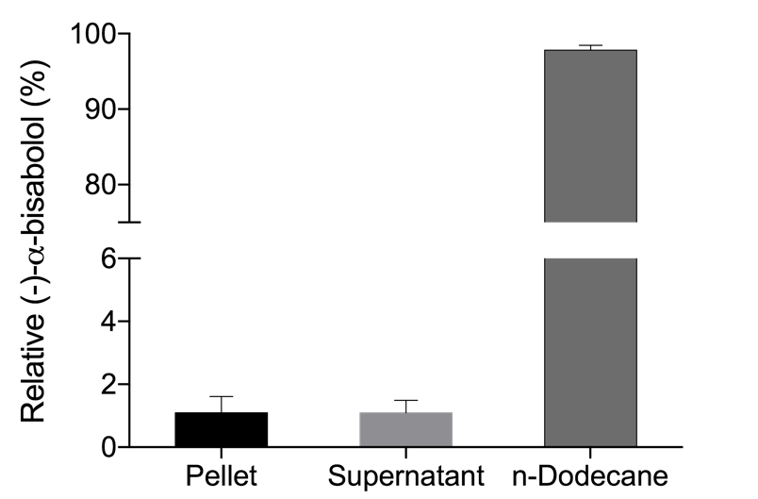

Figure S3. Cell growth during optimization of (-)-α-bisabolol production in E. coli DH5α expressing MrBBS and entire MVA pathway genes.

