Additional file 2
Improving the production of 22-hydroxy-23,24-bisnorchol-4-ene-3-one from sterols in Mycobacterium neoaurum by increasing cell permeability and modifying multiple genes

Liang-Bin Xiong¹, Hao-Hao Liu¹, Li-Qin Xu, Wan-Ju Sun, Feng-Qing Wang* and Dong-Zhi Wei*

State Key Laboratory of Bioreactor Engineering, Newworld Institute of Biotechnology, East China University of Science and Technology, Shanghai 200237, China

Running Head: Increase 4-HBC productivity in M. neoaurum

¹ These authors contributed equally to this work.
* Address correspondence to Feng-Qing Wang, fqwang@ecust.edu.cn; Dong-Zhi Wei, dzhwei@ecust.edu.cn
Email addresses for other authors:
Liang-Bin Xiong: lbxiong2010@163.com
Hao-Hao Liu: hhliu2012@163.com
Li-Qin Xu: liqin_xu@yeah.net
Wan-Ju Sun: sunwj4135@126.com
Additional Methods
Steroid uptake analysis of mycobacterial cells
The uptake of steroids in the mmpL3-deficient M. neoaurum ATCC 25795 was determined by measuring the amount of cholest-4-en-3-one entering the cells per unit of time. Before use, cholest-4-en-3-one was emulsified in Tween 80 (5% w/v) aqueous solution at 121 °C for 60 min. Cultivation conditions were the same as described in the paper. The cultivation system containing 1.0 g/L cholest-4-en-3-one was sampled after 12 h of growth (at least 5 mL). Samples were centrifuged at 12000×g for 10 min, washed with 1.0 mL of ddH₂O for two times, and washed with 1.0 mL of the mixture of petroleum ether and ethyl acetate (60:40, v/v) to remove the cholest-4-en-3-one in culture media. Then, the cells (50 mg, in wet weight) were suspended with 1.0 mL of acetonitrile and ddH₂O (70:30, v/v). After adding 0.8 g of glass beads, the cells were broke with FastPrep-24 Instrument (MP Biomedicals, CA, USA) and centrifuged at 12000×g for 10 min. Cholest-4-en-3-one entering cells could be released and dissolved in the acetonitrile solution. The extracts were analyzed by thin-layer chromatography (TLC) on aluminum-backed silica gel 60-precoated plates F254 (Merck & Co., Inc., Hesse-Darmstadt, Germany) in a solvent system (petroleum ether: ethyl acetate, 80:20, v/v). The spots on the plates were observed under UV light. Besides, the extracts (30 μL) were analyzed with a reversed-phase C18-column (250 mm × 4.6 mm) at 254 nm with an Agilent 1100 series HPLC. The methanol was used as the mobile phase.

Figure S1
Figure S1 Effects of mmpL3 deficiency on the uptake of steroids in M. neoaurum ATCC 25795. The cholest-4-en-3-one entered into the mycobacterial cells after 12 h of growth in MM containing 1.0 g/L cholest-4-en-3-one was assessed. a. TLC analyses of cholest-4-en-3-one in the wild-type strain (WT) and the mmpL3-deficient strain (ΔmmpL3). b. HPLC analyses of cholest-4-en-3-one in the two strains. The uptake of cholest-4-en-3-one was increased about 33.7%.

Figure S2
Figure S2 Effects of the deletion of mmpL3 on the phytosterol utilization in the 4-HBC-producing strain. Quantitative analyses of the residual phytosterols, when the strains were cultured in MYC/02 medium with 2.0 g/L phytosterols addition. Data represent the mean ± standard deviation of three measurements.
Figure S3
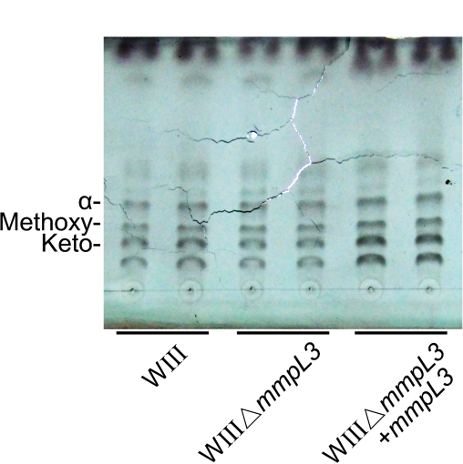
Figure S3 Effect of mmpL3 deficiency on the content of mycolic acids in the cell envelope. The typical 4-HBC-producing strain WIII, the mmpL3 deleted strain WIIIΔmmpL3 and the mmpL3 complemented strain WIIIΔmmpL3+mmpL3 were cultured in MYC/02 medium with 1.0 g/L phytosterols. The MAMEs (α-, methoxy- and keto- are three forms of mycolic acids in M. neoaurum) was isolated from the cells after the extractable lipids were removed. The same amount of the extracts was used similarly and the plates were revealed with cupric sulfate (10% w/v in an 8% v/v phosphoric acid solution).

