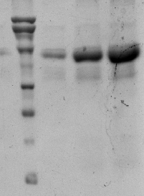
M 1 2 3
Purified rHSA
66
97
kDa
43

A.

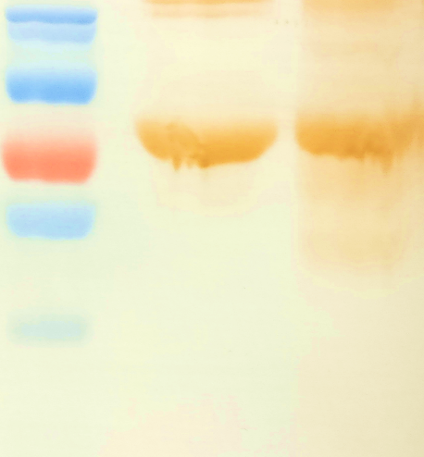

M 1 2
kDa
~68
~93

B.

