Additional file 2
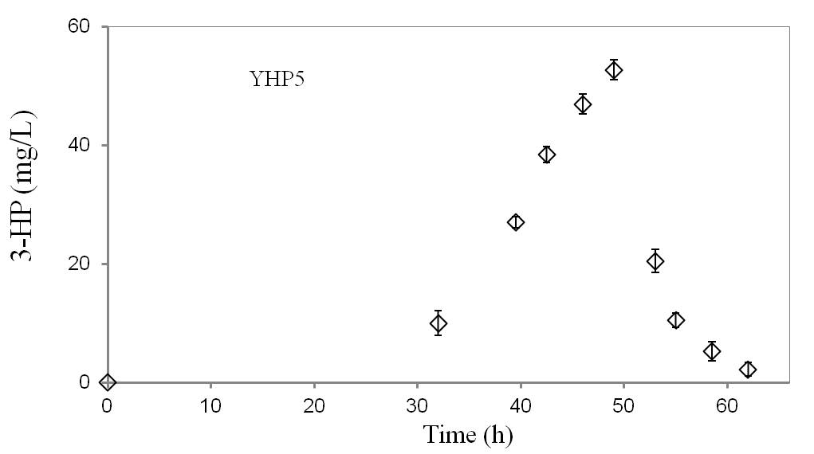

Figure S1 3-HP degradation at the transition from exponential phase to stationary phase of YHP5 (M. extorquens AM1/pJY80 (PmxaF::mcr)). Data was calculated from three independent biological replicates.

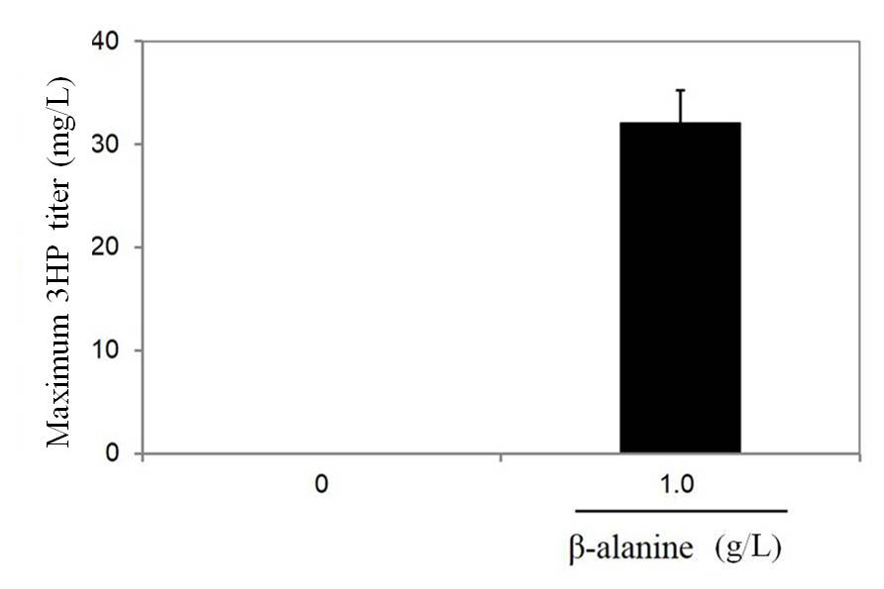

Figure S2 3-HP production in the YHP9 strain grown on methanol with the addition of β-alanine to the medium. X axis is the concentration (g/L) of β-alanine in the medium. YHP9 (BHBT5/pJY80 (P_{mxaF} :: yhxA-ydfG)).

Figure S3 ¹³C-tracing experiment was carried out by switching from ¹²C-β-alanine to ¹³C-β-alanine in the YHP9 strain.

Figure S4 Control assay (i.e. no 3-HP addition) did not detect the accumulation of 3-HP-CoA and acrylyl-CoA by cell extracts of strain YHP8 in a time course. Shown are data for the reaction mixture for 10 min before the addition of NADPH and for 10 min after the addition of NADPH. YHP8 (BHBT5/pJY80).

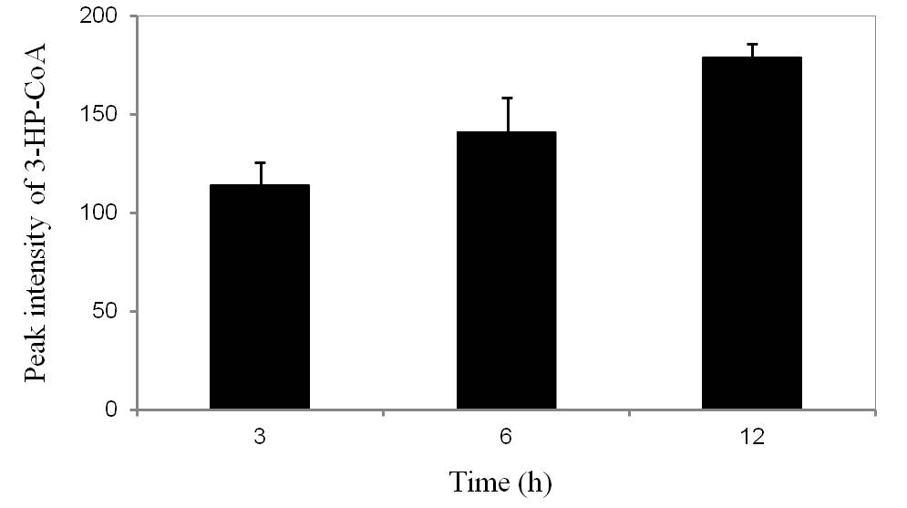

Figure S5 Analysis of 3-HP-CoA formed during the reductive conversion of 3-HP catalyzed by the purified protein (META1_2054). The protein was expressed on pET.32M.3C in the strain E. coli BL21 (DE3).

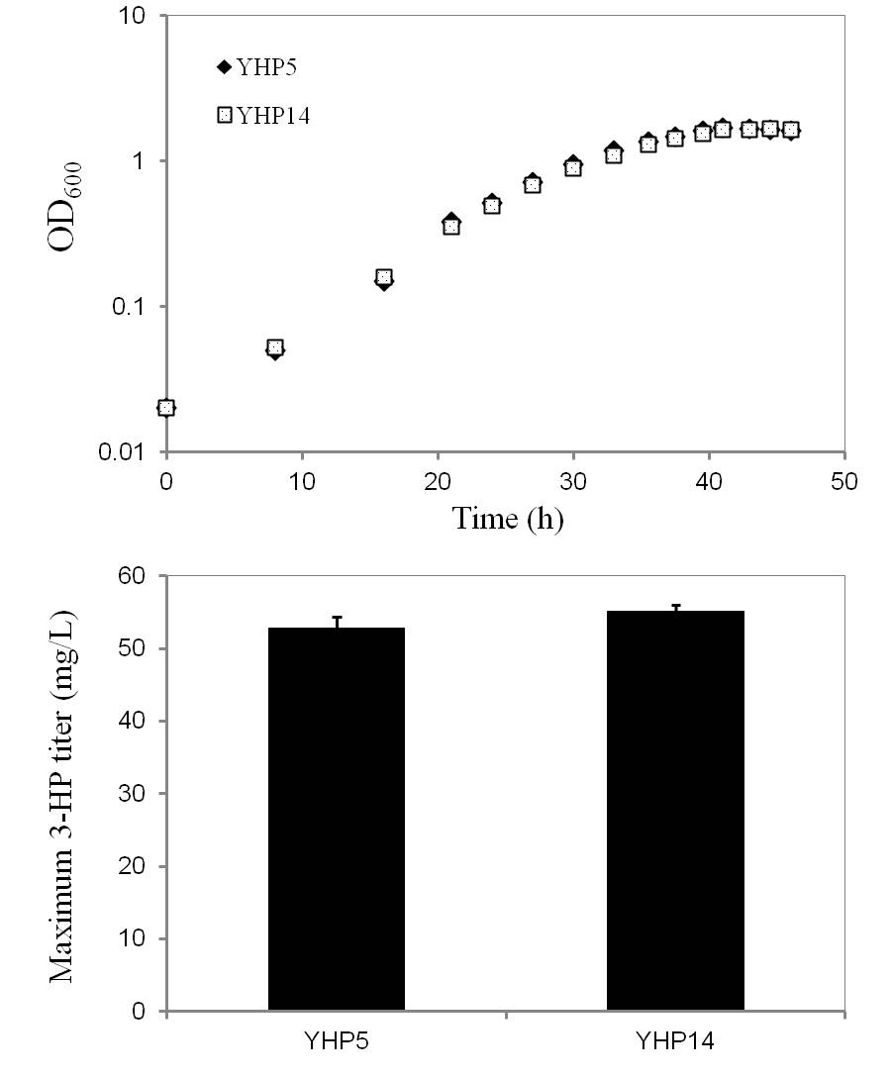

Figure S6 Growth curve and 3-HP production in the strain YHP14.
The gene pyk was amplified from M. extorquens AM1 genome, The amplified fragments were then cloned into pYM05 plasmid to construct pYM12 (PmxaF::mcr-pyk). Plasmid pYM12 was then transformed into M. extorquens AM1 by electroporation to obtain the strain YHP14 (M. extorquens AM1/ PmxaF::mcr-pyk).

