Additional Information for

Biochemical analysis and the preliminary crystallographic characterization of D-tagatose 3-epimerase from Rhodobacter sphaeroides

Zhengliang Qi^{a,b,c}, Zhangliang Zhu^{c}, Jian-Wen Wang^{c}, Songtao Li^{c}, Qianqian Guo^{c}, Panpan Xu^{c}, Fuping Lu^{a,b,c,d*}, Hui-Min Qin^{a,b,c*}

ªKey Laboratory of Industrial Fermentation Microbiology, Ministry of Education, P. R. China;
^{b}Tianjin Key Laboratory of Industrial Microbiology, P. R. China;
^{c}College of Biotechnology, Tianjin University of Science and Technology, P. R. China;
^{d}National Engineering Laboratory for Industrial Enzymes, Tianjin 300457, P. R. China

*Corresponding authors: F. Lu; H.-M. Qin
Tel: +86-22-60601958. Fax: +86-22-60602298
E-mail: lfp@tust.edu.cn; huiminqin@tust.edu.cn

Table S1 Primers used for the construction of recombinant RsDTE.
Primer name | Sequence of primer
R118W_F | GTCTTCGCCGGCTGGCCGCCCTTCCCC
R118W_R | GGGGAAGGGCGGCCAGCCGGCGAAGAC

Table S2 Crystallization conditions are listed as following.
Crystal kits | Position | Crystallization conditions
C. S. | B5 | 30% PEG 4000; 0.1 M Tris-HCl, pH 8.5; 0.2 M Lithium sulfate
C. S. | F10 | 12% PEG 20,000; 0.1M MES, pH 6.5
C. S. | H1 | 10% PEG 8,000; 0.1M HEPES, pH 7.5; 8% Ethylene glycol
JCSG+ | E12 | 10% PEG 8,000; 0.1M Imidizole, pH 8.0
Wizard | A1 | 20% PEG 8,000; CHES, pH 9.5
Wizard | A12 | 20% PEG 1,000; 0.1M Imidazole, pH 8.0; 0.2 M Ca(OAc)₂
Wizard | D9 | 20% PEG 3,000; Acetate, pH 4.5
Index | D3 | 30% v/v Jeffamine ® ED-2001, pH 7.0; 0.1 M HEPES, pH 7.0

C.S. means crystal screen

Figure S1 PCR product of DTE-pET28a and enzyme digestion.
1: plasmid of DTE-pET28a extracted from JM109; 2: enzyme digestion by single restriction endonuclease; 3: enzyme digestion by double restriction endonuclease; 4: PCR product of DTE-pET28a

Figure S2 SDS-PAGE analysis of DTE. Lane 1: supernatant; Lane 2: precipitant; Lane 3: resin trapped with DTE; Lane 4: elution.

Figure S3 Purification of RsDTE by size-exclusion chromatography.

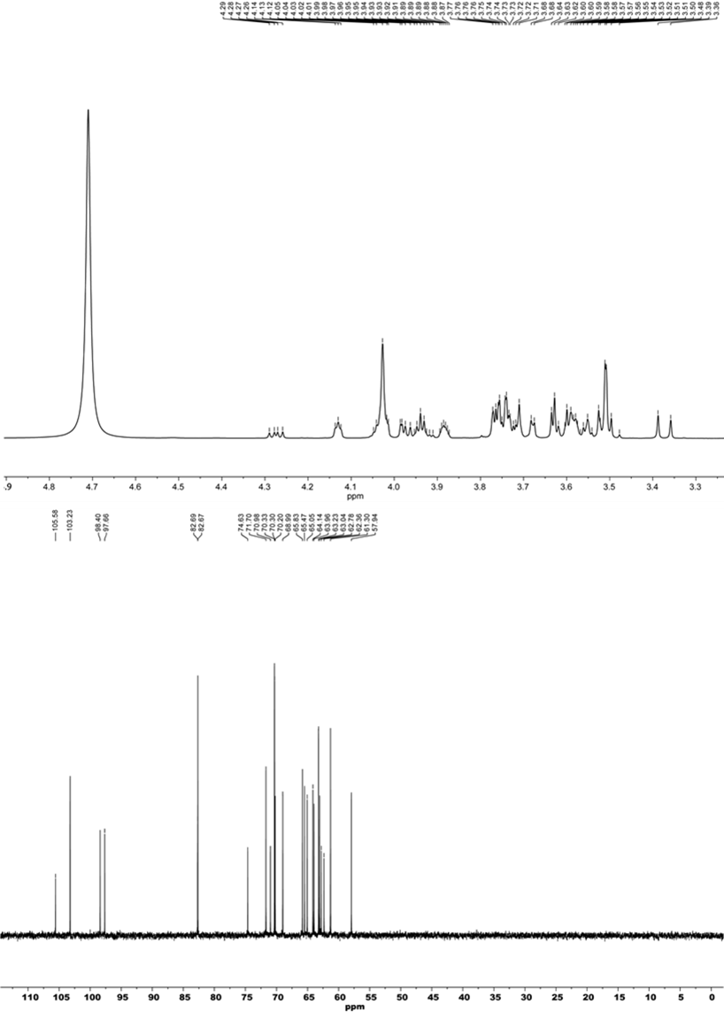
S4 Spectral data for hydrocarbons analyzed.

Figure S5 Crystallization conditions screened with crystal kits.

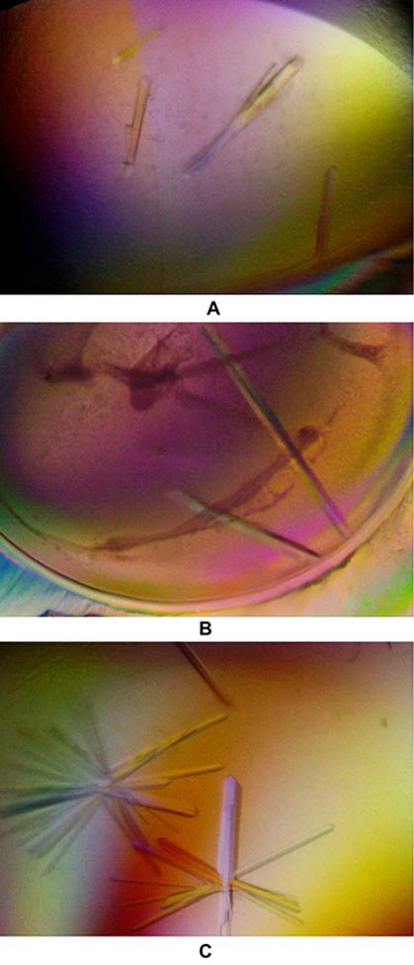

Figure S6 Crystals of RsDTE under refined crystallization conditions.

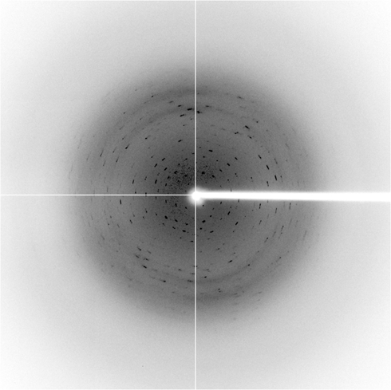

Figure S7 X-ray diffraction image from RsDTE crystal.

Figure S8 Phylogenetic tree of RsDTE and the enzymes with amino acid sequences similar to RsDTE. The determined crystal structures of DTEs were marked as asterisk.

Figure S9 Amino acid sequence alignments of D-tagatose 3-epimerase from different strains.

