Additional data to the manuscript:

Production of the compatible solute α-D-glucosylglycerol by metabolically engineered Corynebacterium glutamicum

By Benjamin Roenneke, Natalie Rosenfeldt, Sami Derya, Jens F. Novak, Kay Marin, Reinhard Krämer, and Gerd M. Seibold

The supplementary data comprise one figure Fig. S1

Correspondence: Gerd M. Seibold, Institute of Microbiology & Biotechnology, University of Ulm, 89081 Ulm, Germany. Tel.: +49 (0)731 502 4853; fax: +49 (0)731 502 2719; e-mail: gerd.seibold@uni-ulm.de

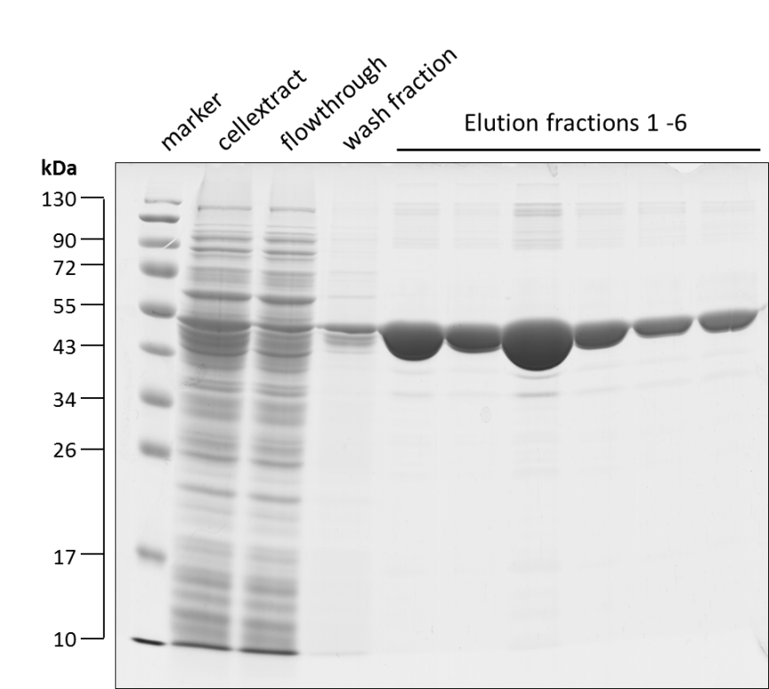

Fig. S1: Purification of recombinant streptavidin-tagged C. glutamicum OtsA from E. coli BL21(DE3)(pASK-IBA3-otsA): SDS-PAGE analysis of crude cell extract and Streptavidin-affinity chromatography flow-through, wash fraction, and elution fractions. PAGE ruler prestained protein ladder (MBI Fermentas) was used as marker.

