Additional Material

Engineering of 3-ketosteroid-Δ¹-dehydrogenase based site-directed saturation mutagenesis for efficient biotransformation of steroidal substrates

Shuhong Mao^{1,2,3,4‡}, Jian-Wen Wang^{4‡}, Fufeng Liu^{1,2,3,4‡}, Zhangliang Zhu⁴, Dengke Gao⁴, Qianqian Guo⁴, Panpan Xu⁴, Zheng Ma⁴, Yali Hou⁴, Xiaotao Cheng⁴, Dengyue Sun⁴, Fuping Lu^{1,2,3,4,5}* and Hui-Min Qin^{1,2,3,4,5}*

¹ State Key Laboratory of Food Nutrition and Safety;
² Key Laboratory of Industrial Fermentation Microbiology, Ministry of Education;
³ Tianjin Key Laboratory of Industrial Microbiology;
⁴ College of Biotechnology, Tianjin University of Science and Technology;
⁵ National Engineering Laboratory for Industrial Enzymes, Tianjin 300457, People’s Republic of China

‡These authors contributed equally to this work.
*Corresponding authors: F. Lu: lfp@tust.edu.cn; H.-M. Qin: huiminqin@tust.edu.cn
Additional file
Table S1 Primers used for the construction of KsdD3 WT and mutants
Table S2 Energy minimization of KsdD3 with and without substrate for the wild-type and mutants
Table S3 Productivity of steroid bioconversion in 48 h (g•L⁻¹•h⁻¹)
Fig. S1 Purification of KsdD3.
Fig. S2 The relative activity of KsdD3 mutants towards steroidal substrates.
Fig. S3 Production analysis by GC-MS
Fig. S4A Spectral data for hydrocarbons analysis of 16α,17α-epoxypregna-11α-hydroxy-1,4-diene-3,20-dione by NMR
Fig. S4B Spectral data for hydrocarbons analysis of 3-hydroxy-9,10-secoandrosta-1,3,5(10)-triene-9,17-dione by NMR
Fig. S4C Spectral data for hydrocarbons analysis of 17α-hydroxypregna-1,4-diene-3,11,20-trione by NMR
Fig. S5 Amino acid sequence alignments of 3-ketosteroid-Δ1-dehydrogenase from different strains
Fig. S6 The relative catalytic activity of KsdD3 mutants toward AD
Fig. S7 The relative catalytic activity of saturation mutagenesis on W299 toward AD
Fig. S8 The relative catalytic activity of KsdD WT and mutants toward various steroidal substrates
Fig. S9 Michaelis–Menten plots of KsdD3 WT and W299A, W299G mutants toward nine steroidal substrates
Fig. S10 Potential of mean force (PMF) profiles of the KsdD3 wild type and mutants over the distance along the substrate channel

Table S1 Primers used for the construction of KsdD3 WT and mutants
WT  Mutants | Primers
WT  Mutants | Forward | Reverse
KsdD | GGAATTCCATATGATGGACTGGGCAGAG | CCGGAATTCTCATCGCGCGTCCTC
Y115A | GCCCCGTGGCCGGATTACTTTGG | ACTCTCGAAGCTGAAGTGGTCGTCTTC
Y115R | CGCCCGTGGCCGGATTACTTTGG | ACTCTCGAAGCTGAAGTGGTCGTCTTC
W117A | GCGCCGGATTACTTTGGCGATGC | CGGGTAACTCTCGAAGCTGAAGTGG
W117F | TCCCGGATTACTTTGGCGATGCACC | ACGGGTAACTCTCGAAGCTGAAGTGGTC
W117I | ATACCGGATTACTTTGGCGATGC | CGGGTAACTCTCGAAGCTGAAGTG
W117Y | ATCCGGATTACTTTGGCGATGCACC | ACGGGTAACTCTCGAAGCTGAAGTGGTC
H134S | AGCATTATTCCGACCCCGCTGCC | GCGCTGGCCGTCACGAC
I136E | GAGCCGACCCCGCTGCCTGTT | AATGTGGCGCTGGCCGTC
I136N | ATCCGACCCCGCTGCCTG | TAATGTGGCGCTGGCCGTCAC
P139A | GCGCTGCCTGTTCCGAGCG | GGTCGGAATAATGTGGCGCTGG
P139D | GATCTGCCTGTTCCGAGCGCAC | GGTCGGAATAATGTGGCGCTGG
P139E | GAGCTGCCTGTTCCGAGCGC | GGTCGGAATA ATGTGGCGCTG
P139S | TCGCTGCCTGTTCCGAGCG | GGTCGGAATAATGTGGCGCTGG
P155E | GAGCTGGATAATGATCGTTTAGGCACC | GCCACGAACCACTTCACGTAATTC
F296A | GCTGCCCTGTGGTTTACCGGCG | GGCGCTGCGACCGTCAG
F296G | GGTGCCCTGTGGTTTACCGGCG | GGCGCTGCGACCGTCAGG
L298V | GTGTGGTTTACCGGCGGTATCTTTG | GGCAAAGGCGCTGCGAC
D321S | AGTCGTCTGGGCCGCGCAG | ATACGGGGCGCTTTCATTCACG
M361N | ATGTGGACGAAGAACAGTATGTGGCCG | TGCTCACGTTGGTGGCACG
W299A | GCGTTTACCGGCGGTATCTTTGTGGACG | CAGGGCAAAGGCGCTGCG
W299C | CTTTACCGGCGGTATCTTTGTGGAC | CACAGGGCAAAGGCGCTGC
W299D | GATTTTACCGGCGGTATCTTTGTGGAC | CAGGGCAAAGGCGCTGC
W299E | GAGTTTACCGGCGGTATCTTTGTGGAC | CAGGGCAAAGGCGCTGC
W299F | TCTTTACCGGCGGTATCTTTGTGGACG | ACAGGGCAAAGGCGCTGCG
W299G | GGGTTTACCGGCGGTATCTTTGTGGAC | CAGGGCAAAGGCGCTGCG
W299H | CATTTTACCGGCGGTATCTTTGTGGACG | CAGGGCAAAGGCGCTGCG
W299I | ATATTTACCGGCGGTATCTTTGTGGAC | CAGGGCAAAGGCGCTGC
W299K | AAGTTTACCGGCGGTATCTTTGTGGAC | CAGGGCAAAGGCGCTGC
W299L | TGTTTACCGGCGGTATCTTTGTGGAC | ACAGGGCAAAGGCGCTGC
W299M | ATGTTTACCGGCGGTATCTTTGTGGAC | CAGGGCAAAGGCGCTGC
W299N | AATTTTACCGGCGGTATCTTTGTGGAC | CAGGGCAAAGGCGCTGC
W299P | CCGTTTACCGGCGGTATCTTTGTGGAC | CAGGGCAAAGGCGCTGCG
W299Q | CAGTTTACCGGCGGTATCTTTGTGGACG | CAGGGCAAAGGCGCTGCG
W299R | AGGTTTACCGGCGGTATCTTTGTGGAC | CAGGGCAAAGGCGCTGCG
W299S | CGTTTACCGGCGGTATCTTTGTGGAC | ACAGGGCAAAGGCGCTGC
W299T | ACGTTTACCGGCGGTATCTTTGTGGACG | CAGGGCAAAGGCGCTGCG
W299V | GTGTTTACCGGCGGTATCTTTGTGGAC | CAGGGCAAAG GCGCTGC
W299Y | ATTTTACCGGCGGTATCTTTGTGGACG | ACAGGGCAAAGGCGCTGC

Table S2 Energy minimization of KsdD3 with and without substrate for the wild-type and mutants
system | E_{min} without AD  (kJ/mol) | E_{min} with AD (kJ/mol)
WT | -730361 | -780365
W299A | -889872 | -900902
W299G | -903028 | -921104

Table S3 Productivity of steroid bioconversion in 48 h (g·L-1·h-1)
 |  | AD | TS | 17-MT | Cortisone | CA
KsdD3 | WT | 0.023±0.002 | 0.026±0.003 | 0.018±0.004 | 0.021±0.004 | 0.013±0.001
KsdD3 | W299A | 0.043±0.001 | 0.047±0.001 | 0.032±0.002 | 0.031±0.003 | 0.020±0.006
KsdD3 | W299G | 0.034±0.005 | 0.033±0.002 | 0.021±0.003 | 0.025±0.002 | 0.017±0.002
E. coli | WT | 0.039±0.001 | 0.044±0.003 | 0.034±0.002 | 0.045±0.004 | 0.023±0.003
E. coli | W299A | 0.050±0.003 | 0.052±0.002 | 0.046±0.004 | 0.047±0.003 | 0.031±0.002
E. coli | W299G | 0.046±0.002 | 0.049±0.001 | 0.037±0.002 | 0.042±0.001 | 0.020±0.001

Fig. S1 Purification of KsdD3. Lane 1: before induction; Lane 2: after induction; Lane 3: supernatant; Lane 4: precipitant; Lane 5: flowthrough; Lanes 6-9: elution.

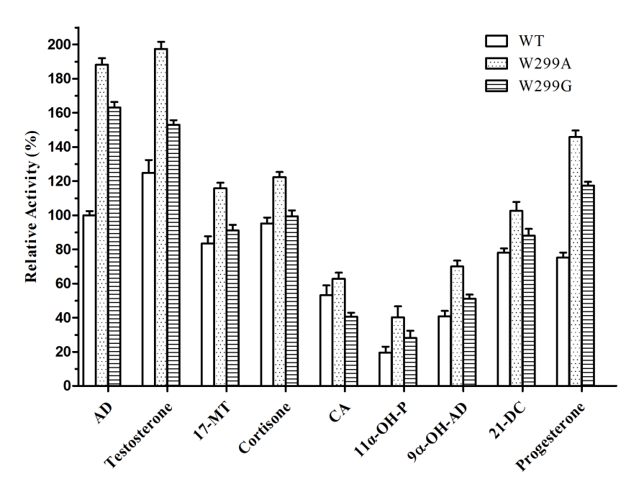
Fig. S2 The relative activity of KsdD3 mutants towards steroidal substrates. The activity of KsdD3 WT toward AD is represented as 100 and the error bars are standard deviations (n = 3).
Fig. S3 Production analysis by GC-MS

Fig. 4A Spectral data for hydrocarbons analysis of 16α,17α-epoxypregna-11α-hydroxy-1,4-diene-3,20-dione by NMR.

¹H NMR (400 MHz, DMSO): δ 7.79 (d, J = 10.0Hz, 1H), 6.12 – 5.93 (m, 2H), 4.76 (s,1H),4.06 – 3.91 (m, 2H), 2.60 – 2.48 (m, 2H), 2.43 – 2.28 (m, 2H), 2.03 (s, 3H), 1.91 (dd, J = 13.6, 6.2 Hz, 2H), 1.83 (dd, J = 11.2, 3.0 Hz, 1H), 1.49 – 1.38 (t, J = 12.6Hz, 1H), 1.34 – 1.23 (m, 4H), 1.09 – 1.00 (m, 5H); ¹³C NMR (100 MHz, DMSO): δ 204.64, 185.36, 168.50, 159.45, 123.61, 69.67, 65.86, 60.47, 60.18, 43.75, 43.70, 41.99, 40.98, 32.87, 32.25, 31.47, 26.75, 25.72, 18.66, 15.82.

Fig. 4B Spectral data for hydrocarbons analysis of 3-hydroxy-9,10-secoandrosta-1,3,5(10)-triene-9,17-dione by NMR.

¹H NMR (400 MHz, CDCl₃): δ 6.97 (d, J = 8.2 Hz, 1H), 6.68 (d, J = 2.5 Hz, 1H), 6.61 (dd, J = 8.1, 2.5 Hz, 1H), 6.36 (s, 1H), 2.75 – 2.63 (m, 1H), 2.62 – 2.38 (m, 5H), 2.31 – 2.16 (m, 4H), 2.11 – 1.95 (m, 2H), 1.93 – 1.80 (m, 2H), 1.77 – 1.57 (m, 3H), 1.15 (s, 3H); ¹³C NMR (100 MHz, CDCl3): δ 219.02, 211.56, 154.17, 141.73, 131.08, 127.42, 115.71, 112.84, 77.42, 77.10, 76.78, 49.61, 49.01, 47.59, 37.37, 36.13, 30.93, 30.27, 26.59, 22.39, 18.34, 13.41, 0.98.

Fig. 4C Spectral data for hydrocarbons analysis of 17α-hydroxypregna-1,4-diene-3,11,20-trione by NMR.

¹H NMR (400 MHz, CDCl₃): δ 7.66 (d, J = 10.2 Hz, 1H), 6.21 (dd, J = 10.2, 1.8 Hz, 1H), 6.09 (s, 1H), 3.12 (s, 1H), 2.85 – 2.75 (m, 2H), 2.52 (td, J = 13.5, 4.2 Hz, 1H), 2.45 – 2.31 (m, 3H), 2.27 (s, 3H), 2.10 (d, J = 12.3 Hz, 2H), 2.05 – 1.92 (m, 3H), 1.76 (m, 2H), 1.50 (dd, J = 12.1, 6.2 Hz, 3H), 1.44 (s, 3H); ¹³C NMR (100 MHz, CDCl3): δ 210.48, 209.40, 186.40, 166.36, 155.09, 127.80, 124.81, 88.62, 60.20, 51.75, 49.76, 49.36, 42.37, 36.16, 34.04, 33.71, 32.30, 27.76, 23.67, 18.94, 16.40.

Fig. S5 Amino acid sequence alignments of 3-ketosteroid-Δ¹-dehydrogenase from different strains. The catalytic residues were marked as red asterisk. FAD binding residues were marked as yellow circle. The substrate-binding residues were marked as blue triangle.
A. simplex: Arthrobacter simplex, AIY19527.1; R. erythropolis SQ1: Rhodococcus erythropolis SQ1, AF096929.1; G. neofelifaecis: Gordonia neofelifaecis, WP_009680993.1; M. smegmatis mc²155: Mycobacterium smegmatis mc²155, YP887187; M. neoaurum: Mycobacterium neoaurum ATCC 25795, GQ411074.1; R. ruber Chol-4: Rhodococcus ruber Chol-4, AFH57399.1.

Fig. S6 The relative catalytic activity of KsdD3 mutants toward AD

Fig. S7 The relative catalytic activity of saturation mutagenesis on W299 toward AD

Fig. S8 The relative catalytic activity of KsdD WT and mutants toward various steroidal substrates. The activities of wild-type KsdD3 are represented as 100, respectively and the error bars are standard deviations (n =3).

Fig. S9 Michaelis–Menten plots of KsdD3 WT and W299A, W299G mutants toward nine steroidal substrates.

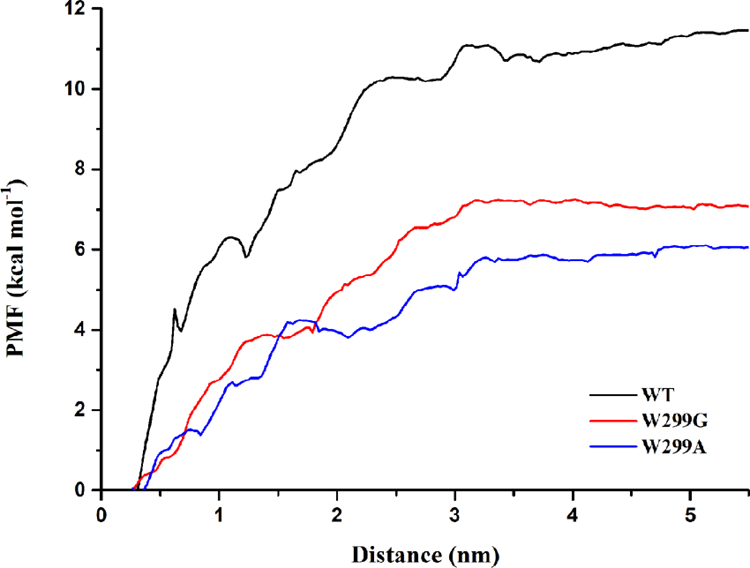
Fig. S10 Potential of mean force (PMF) profiles of the KsdD3 wild type and mutants over the distance along the substrate channel.

