Additional file for
Production of a recombinant peroxidase in different glyco-engineered Pichia pastoris strains – a morphological and physiological comparison

Alexander Pekarsky^{1,+}, Lukas Veiter^{1,2,+}, Vignesh Rajamanickam^{1,2}, Christoph Herwig^{1,2}, Clemens Grünwald-Gruber³, Friedrich Altmann³ and Oliver Spadiut^{1*}

¹ Technische Universität Wien, Institute of Chemical, Environmental and Bioscience Engineering, Research Area Biochemical Engineering, Gumpendorfer Strasse 1a, 1060 Vienna, Austria
² Christian Doppler Laboratory for Mechanistic and Physiological Methods for Improved Bioprocesses, TU Wien, Gumpendorfer Straße 1a, 1060 Vienna, Austria
³ Department of Chemistry, University of Natural Resources and Life Sciences, Muthgasse 18, 1190 Vienna, Austria
+ Equal contribution
* Correspondence: Oliver Spadiut, TU Wien, Institute of Chemical, Environmental and Bioscience Engineering, Research Area Biochemical Engineering, Gumpendorfer Strasse 1a, 1060 Vienna, Austria. Tel: +43 1 58801 166473, Fax: +43 1 58801 166980, Email: oliver.spadiut@tuwien.ac.at

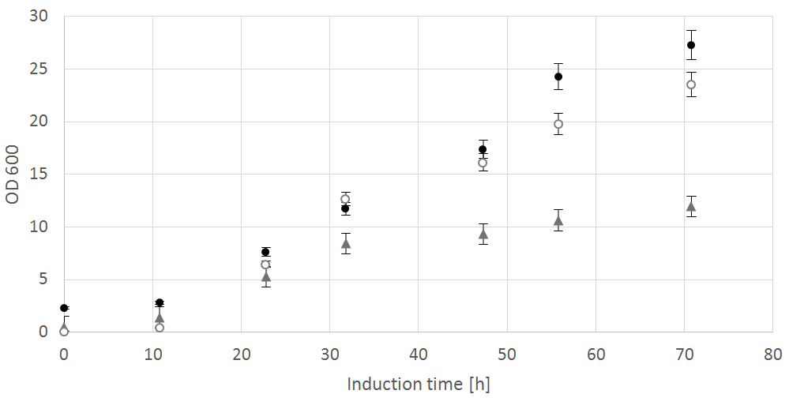
Figure S1: OD₆₀₀ over induction time in shake-flask experiment, black-filled circle = wt, unfilled white circle = SuperMan₅, grey triangle = ∆OCH1.
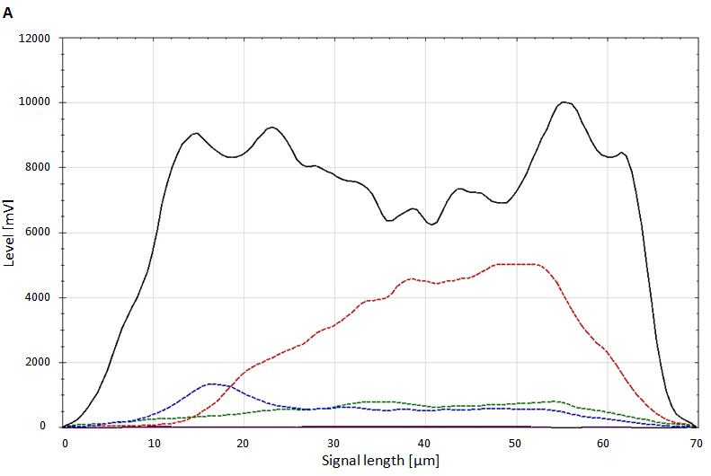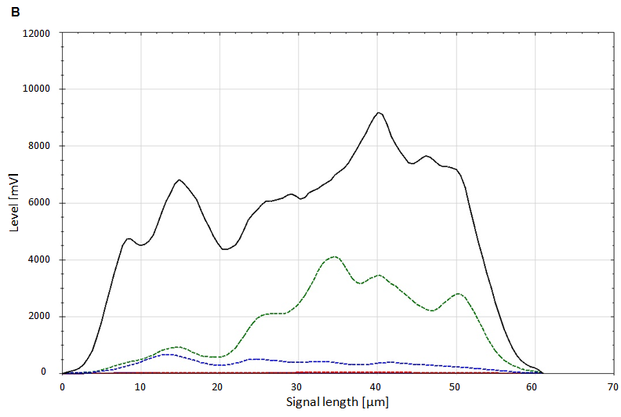
Figure S2: Comparison of signal profiles from flow cytometer. FSC (black line -), SSC (blue line --), green (green line --) and red (red line --) fluorescence signals of SuperMan₅ clusters after 23 h induction time in shake-flasks. In viability-declined cluster (A) a clear increase in red fluorescence is visible from PI staining in contrast to the viable cluster (B).

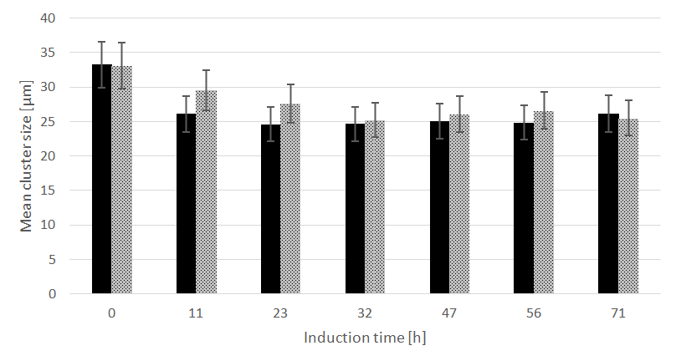
Figure S3: Mean cluster size of ∆OCH1 (black bars) and SuperMan₅ (dotted grey bars) over induction time in shake-flask cultivation. Standard deviations are derived from multiple measurements (at least 3) of single culture shake-flask samples.

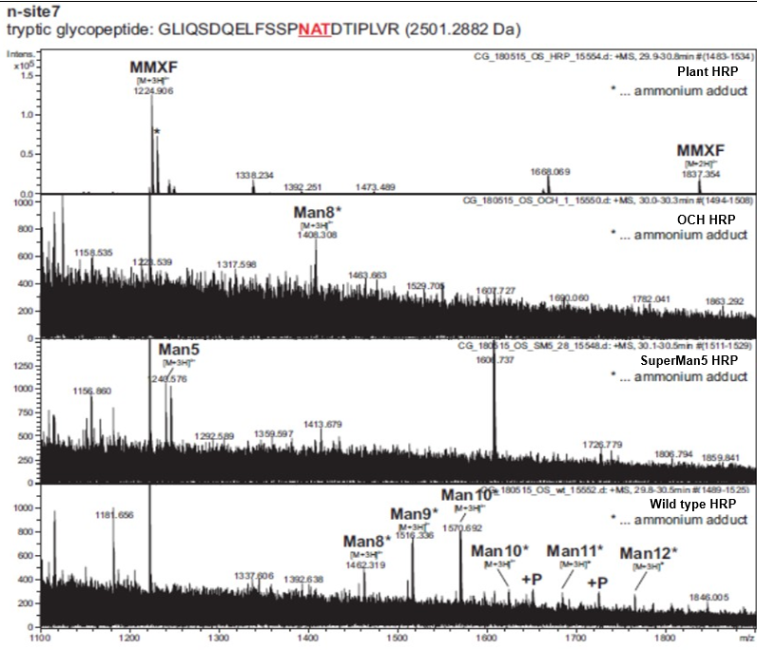
Figure S4: ESI-MS spectra of HRP glycopeptides at n-glycosylation site 7. The triply (or doubly) charged site 7 N-glycopeptide GLIQSDQELFSSPNATDTIPLVR of natural HRP and HRP produced in a ∆OCH1, in SuperMan₅ and in wt P. pastoris are shown. The wt_HRP exhibits also phosphorylated versions (P) of the oligomannosidic glycans.
To avoid interference by glycoproteins other than HRP, the glycosylation status of the HRP variants was deduced from glycopeptides, as shown for glycosite 7 (GLIQSDQELFSSPNATDTIPLVR). While natural HRP carries the plant typical MMXF structure with xylose and fucose and only 3 mannose residues, HRP C1A produced by wt
P. pastoris exhibited a very heterogeneous pattern in which Man₉ and Man₁₀ glycans predominated and some phosphorylated glycans were also found. HRP C1A from the ∆OCH1 strain contained mainly the Man₈ structure and HRP C1A from the SuperMan₅ strain was modified by Man₅ as expected.

