Additional Data
OhsR acts as an organic peroxide-sensing transcriptional activator using an S-mycothiolation mechanism in Corynebacterium glutamicum

Meiru Si^{1#*}, Tao Su^{1#}, Can Chen^{2#*}, Jinfeng Liu¹, Zhijin Gong¹, Chengchuan Che¹, GuiZhi Li¹, Ge Yang¹

¹ College of Life Sciences, Qufu Normal University, Qufu, Shandong 273165, China;

² College of Life Science and Agronomy, Zhoukou Normal University, Zhoukou，Henan 466001, China

Running title: OhsR is organic peroxide-specific redox sensor

# These authors contributed equally to this work.

* Corresponding authors:
Meiru Si, Can Chen

E-mail: smr1016@126.com; chenc02@126.com
Tel: 86-15666758564; 86-18736207816

Table S1. Bacterial strains and plasmids used in this study.
Strains or plasmids | Relevant genotype description | References
Strains
Corynebacterium glutamicum
RES167 | Restriction-deficient mutant of ATCC13032, Δ(cglIM-cglIR-cglIIR) |  | [1]
ΔohsR | ohsR deleted in RES167 |  | This study
WT(pXMJ19) | wild type RES167 containing pXMJ19 vector |  | [2]
ΔohsR(pXMJ19) | ΔohsR containing pXMJ19 vector |  | This study
ΔohsR(pXMJ19-ohsR) | Complementation of ohsR in ΔohsR |  | This study
ΔohsR(pXMJ19-ohsR:C125S) | Complementation of ohsR:C125S in ΔohsR |  | This study
ΔohsR(pXMJ19-ohsR:C261S) | Complementation of ohsR:C261S in ΔohsR |  | This study
ΔohsR (pXMJ19-His₆-ohsR) | ΔohsR containing pXMJ19-His₆-ohsR |  | This study
ΔmshCΔohsR (pXMJ19-His₆-ohsR) | ΔmshCΔohsR containing pXMJ19-His₆-ohsR |  | This study
ΔmshCΔohsR(pXMJ19-ohsR:C261S) | Complementation of ohsR:C261S in ΔmshCΔohsR |  | This study
Δohr | ohr deleted in RES167 |  | [3]
ΔohrΔohsR | ohr and ohsR deleted in RES167 |  | This study
ΔoxyR | oxyR deleted in RES167 |  | [4]
ΔsigH | sigH deleted in RES167 |  | [3]
ΔrosR | rosR deleted in RES167 |  | This study
ΔqorR | qorR deleted in RES167 |  | This study
E. coli
BL21(DE3) | Host for expression vector pET28a |  | Novagen
JM109 | recA1 supE44 endA1 hsdR17 gyrA96 relA1 thi Δ(lac-proAB)F′(traD36 proABlacI^{q} lacΔZM15) |  | Stratagene
Plasmids
pK18mobsacB | Suicide plasmid carrying sacB for selecting double crossover in C. glutamicum, Km^{r} |  | [5]
pK18mobsacB-ΔohsR | Construct used for in-frame deletion of ohsR |  | This study
pK18mobsacB-P_{ohsR}::lacZ | P_{ohsR}::lacZ fusion in pK18mobsacB |  | This study
pK18mobsacB-P_{ohr}::lacZ | P_{ohr}::lacZ fusion in pK18mobsacB |  | [3]
pXMJ19 | Shuttle vector (Ptac lacI^{q} pBL1 oriV_{C. glutamicum} pK18 oriV_{E. coli}) |  | [6]
pXMJ19-ohsR | ohsR cloned into pXMJ19 for complementation |  | This study
pXMJ19-ohsR:C125S | ohsR:C125S cloned into pXMJ19 for complementation |  | This study
pXMJ19-ohsR:C261S | ohsR:C261S cloned into pXMJ19 for complementation |  | This study
pXMJ19-His₆-ohsR | ohsR cloned into pXMJ19-His₆ for complementation |  | This study
pET28a | Expression vector with N-terminal hexahistidine affinity tag |  | Novagen
pET28a-trx | trx in pET28a |  | [7]
pET28a-trxR | trxR in pET28a |  | [7]
pET28a-ohsR | ohsR in pET28a |  | This study
pET28a-ohsR:C125S | ohsR:C125S in pET28a |  | This study
pET28a-ohsR:C261S | ohsR:C261S in pET28a |  | This study

Additional References
1. Tauch A, Kirchner O, Löffler B, Götker S, Pühler A, Kalinowski J. Efficient electrotransformation of corynebacterium diphtheriae with a mini-replicon derived from the Corynebacterium glutamicum plasmid pGA1. Curr Microbiol. 2002; 45: 362-367.
2. Schäfer A, Tauch A, Jäger W, Kalinowski J, Thierbach J, Pühler A. Small mobilizable multi-purpose cloning vectors derived from the Escherichia coli plasmids pK18 and pK19: selection of defined deletions in the chromosome of Corynebacterium glutamicum. Gene. 1994;145: 69-73.
3. Si M, Wang J, Xiao X, Guan J, Zhang Y, Ding W, Chaudhry MT, Wang Y, Shen X. Ohr Protects Corynebacterium glutamicum against organic hydroperoxide induced oxidative Stress. PLoS One. 2015;10(6): e0131634.
4. Si M, Wang T, Pan J, Lin J, Chen C, Wei Y, Lu Z, Wei G, Shen X. Graded response of the multifunctional 2-Cysteine peroxiredoxin, CgPrx, to increasing levels of hydrogen peroxide in Corynebacterium glutamicum. Antioxidants & Redox Signaling. 2017;26(1):1-14.
5. Jakoby M, Ngouoto-Nkili CE, Burkovski A. Construction and application of new Corynebacterium glutamicum vectors. Biotechnol Tech.1999;13: 437-441.
6. Karimova G, Pidoux J, Ullmann A, Ladant D. A bacterial two-hybrid system based on a reconstituted signal transduction pathway. Proc Natl Acad Sci U S A.1998;95;5752-5756.

7. Su T, Si M, Zhao Y, Liu Y, Yao S, Che C, Chen C. A thioredoxin-dependent peroxiredoxin Q from Corynebacterium glutamicum plays an important role in defense against oxidative stress. PLoS One.2018;13(2): e0192674.

Table S2. Primers used in this study.
Primers |  | 5’-3’ sequence
COhsR-F |  | CGCGGATCGTGGAACCATTCGAATTAGAGAAAG(BamHI) | For cloning ohsR and its variants into pXMJ19 and pXMJ19-His₆
COhsR-R |  | CCGGAATTCTCAAGCCTTCAAGTACGCTCGGTTG(EcoRI)
OOhsR-F |  | CGCGGATCGTGGAACCATTCGAATTAGAGAAAG(BamHI) | For cloning ohsR and its variants into pET28a
OOhsR-R |  | ACGCGTCGACTCAAGCCTTCAAGTACGCTCGGTTG(SalI)
DOhsR-F1 |  | CCGGAATTCGCAACGGCGCCGTCGTATTCAACG (EcoRI) | To generate pK18mobsacB-ΔohsR and ohsR mutant DNA fragments
DOhsR-R1 |  | GATTTCACTTCTACGGTTTCATCG | To generate pK18mobsacB-ΔohsR and ohsR mutant DNA fragments
DOhsR-F2 |  | CGATGAAACCGTAGAAGTGAAATCGGTTGCAACTGCTCCACCATCAAG | To generate pK18mobsacB-ΔohsR and ohsR mutant DNA fragments
DOhsR-R2 |  | GGAAGATCTGGGCCGGGATTTTTGTTGTTTAG (BglII) | To generate pK18mobsacB-ΔohsR and ohsR mutant DNA fragments
POhsR-F |  | TCCCCCGGGGAACCCCCAACGAGCTCACCGGAG(SmaI) | To generate pK18mobsacB-P_{OhsR}::lacZ
POhsR-R |  | ACTAGTTTCGAATGGTTCCACGGTGGCGAGTG(SpeI) | To generate pK18mobsacB-P_{OhsR}::lacZ
lacZY-F |  | CACTCGCCACCGTGGAACCATTCGAAACTAGTATGACCATGATTACGGATTC(SpeI) | To generate pK18mobsacB-P_{OhsR}::lacZ
lacZY-R |  | AAAACTGCAGTTAAGCGACTTCATTCACCTG(PstI) | To generate pK18mobsacB-P_{OhsR}::lacZ
OhsR-C125S-F |  | GTGAACGGGCCCAGTTATTATCTTC | To obtain pET28a-ohsR:C125S and pXMJ19-ohsR:C125S
OhsR-C125S-R |  | GAAGATAATAACTGGGCCCGTTCAC | To obtain pET28a-ohsR:C125S and pXMJ19-ohsR:C125S
OhsR-C261S-F |  | GACCGAAAAATCAGCGAGGGAAATC | To generate pET28a-ohsR:C261S and pXMJ19-ohsR:C261S
OhsR-C261S-R |  | GATTTCCCTCGCTGATTTTTCGGTC | To generate pET28a-ohsR:C261S and pXMJ19-ohsR:C261S
QOhsR-F |  | CTTGCTCACCCGCCTTGACG | RT-PCR
QOhsR-R |  | AGTTTAGCGGGGCATGCTTG
QOhr-F |  | CCGCCAAAGGCTTTGGGCGG | RT-PCR
QOhr-R |  | GCTAACTCGGGCACCAACCG
EOhr-F |  | CACCTTGTTGGTGGGCCGGG | To produce the 200 bp EMSA Ohr promoter DNA
EOhr-R |  | GAGAGAACACAAAGAATACG | To produce the 200 bp EMSA Ohr promoter DNA
Control-F |  | GGTGCGCTCGAATTTGAAATG | To produce the 200 bp EMSA control DNA of Ohr
Control-R |  | CCACCAGCGCCGTTTGGCCC | To produce the 200 bp EMSA control DNA of Ohr
Underlined sites indicate restriction enzyme cutting sites added for cloning. Letters in italic denote the mutation sites in overlap PCR for site-directed mutation.

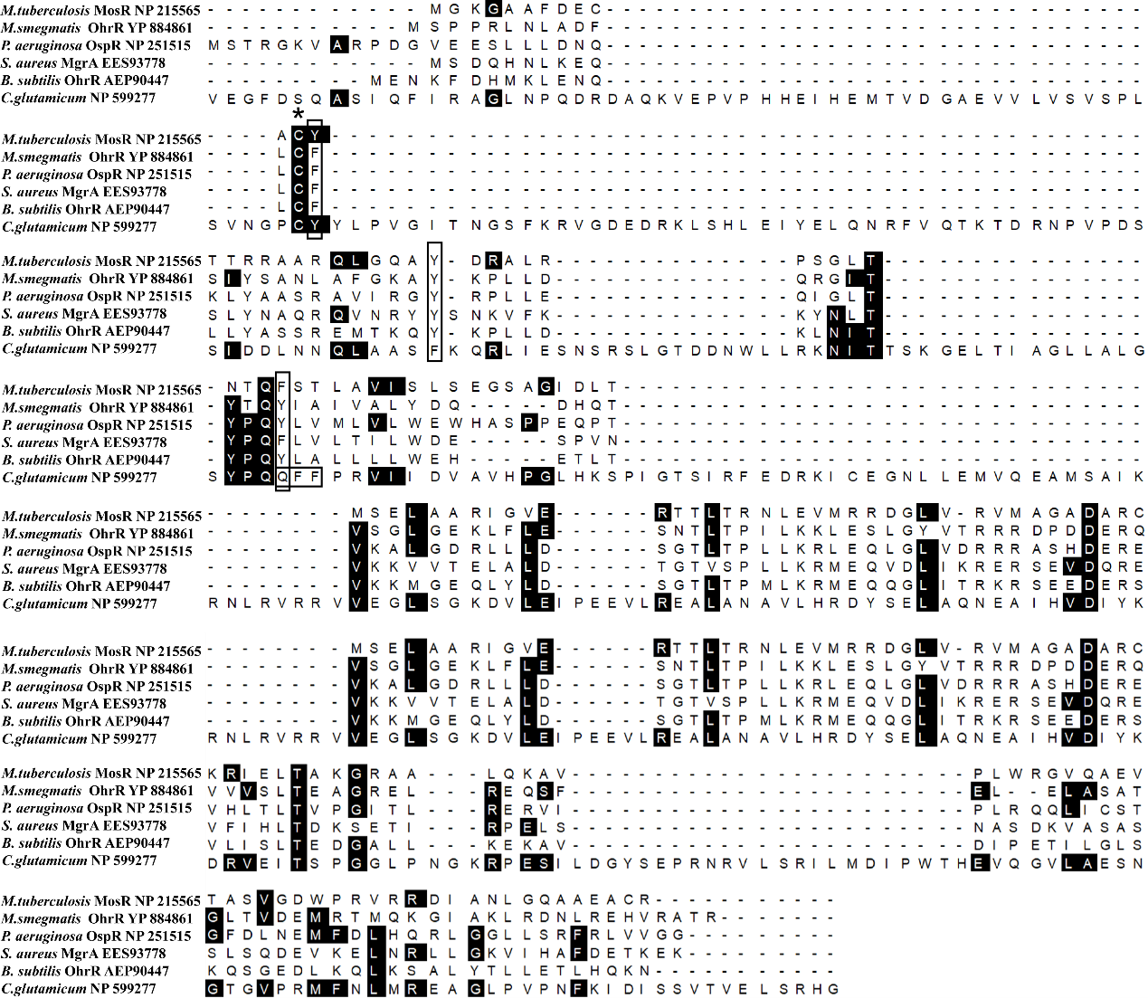
Figure S1 Multiple sequence alignment of OhsR with the OhrR in other organisms. Conserved Cys residue was highlighted in a black star. Aromatic amino acids surrounding conserved Cys residue were pointed out by black box. Residues that were identical in all of the 6 sequences were depicted on the black background. Reference sequences were retrieved from the NCBI Database, including M. tuberculosis MosR (NP 215565); M. smegmatis OhrR (YP 884861); P. aeruginosa OspR (NP 251515); S. aureus MgrA (EES93778); B. subtilis OhrR (AEP90447), C. glutamicum ATCC (NP 599277).

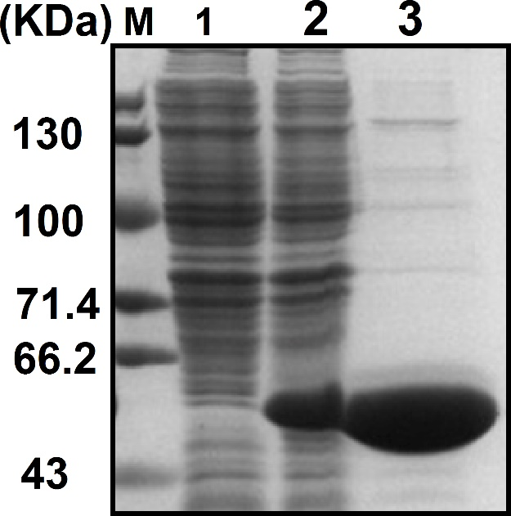
Figure S2 Non-reducing SDS-PAGE analysis of proteins expressed in E. coli containing pET28a-ohsR plasmid. M, broad-range protein marker; lane 1, crude extract (5 μg) without IPTG induction; lane 2, crude extract (5 μg) with induction; lane 3, loading of purified His₆-OhsR protein.

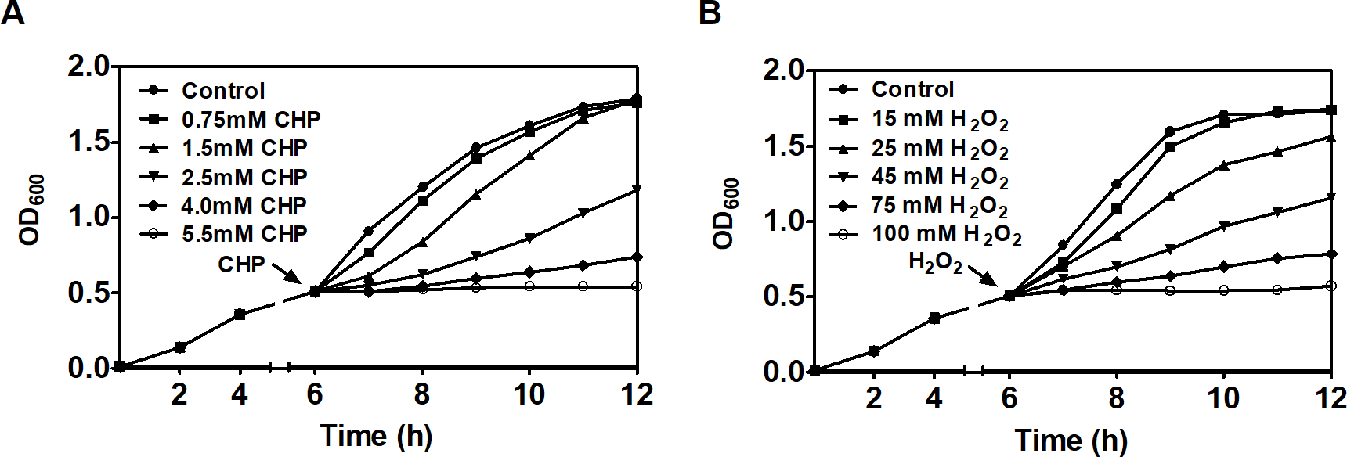
Figure S3 Growth curves of C. glutamicum in response to sub-lethal concentrations of toxins. C. glutamicum wild type was grown in LB medium to OD₆₀₀ of 0.6 and exposed to different toxic agents of various concentrations. The cultures continued to be incubated for 6 h, and the OD₆₀₀ was measured in 2 h intervals.

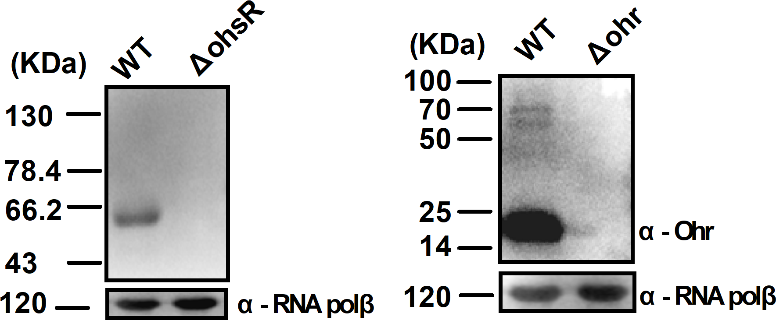

Figure S4 The OhsR and Ohr was examined in C. glutamicum. Anti-OhsR and Anti-Ohr antibodies detected a single protein with a mobility consistent with the predicted size that was absent from ΔohsR and Δohr mutants. Antibodies to RNA polβ were used as a loading control.

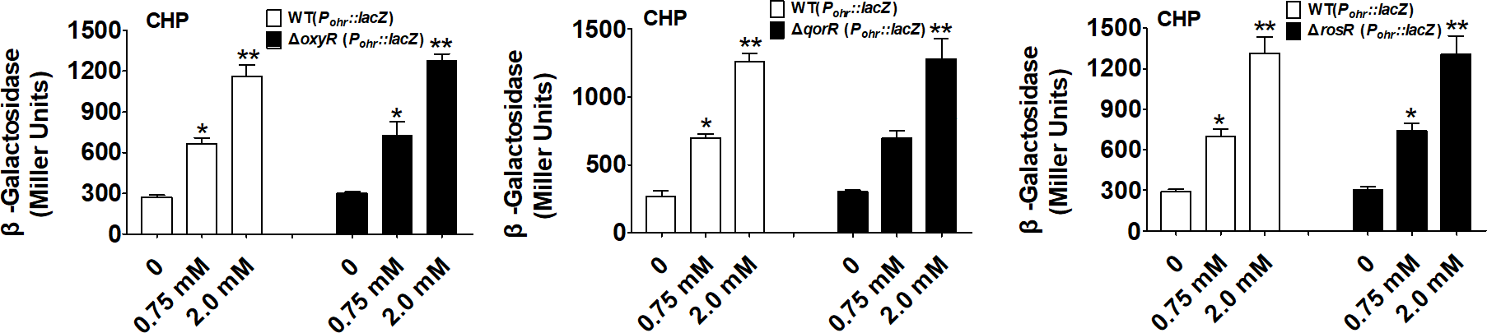

Figure S5 Regulation of ohr by OxyR, QorR, and RosR. Cells were grown in LB medium to an OD₆₀₀ nm of 0.6. Ohr expression was analyzed 30 min after indicated CHP addition. β-Galactosidase analyses of ohr promoter activities by using the transcriptional P_{ohr}::lacZ chromosomal fusion reporter expressed in indicated strains under stress conditions. **, P < 0.01; *: P≤0.05.

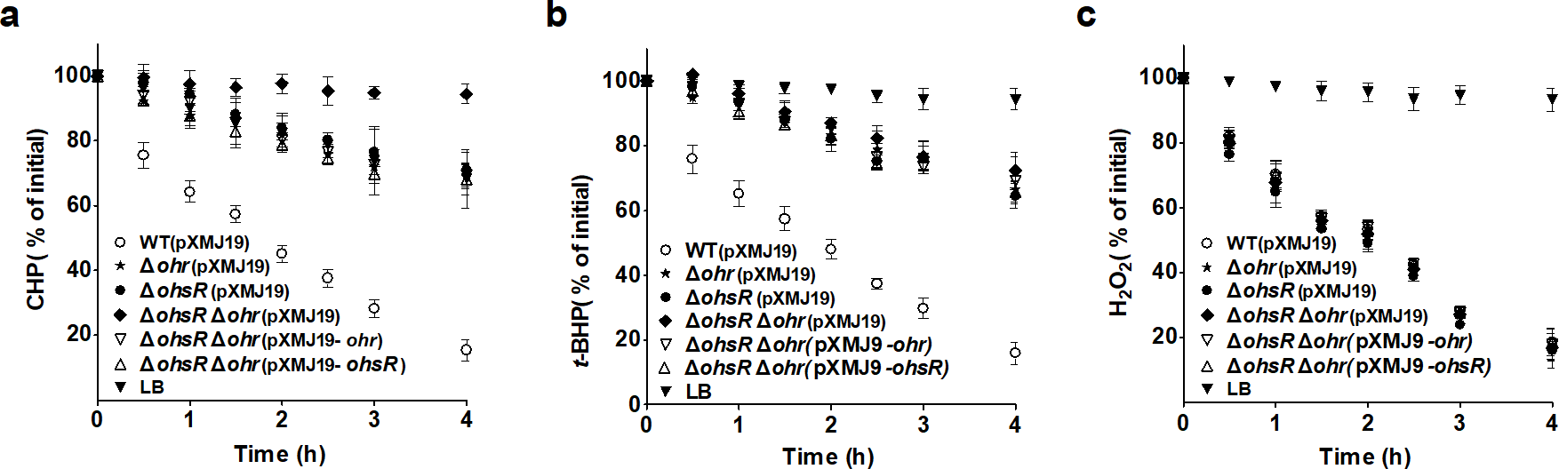

Figure S6 Role of OhsR in scavenging peroxides. Cultures grown in LB medium to an OD at 600 nm of 0.6 were divided and either treated with CHP (A), t-BHP (B), or H₂O₂ (C). At various time points after addition of peroxides, the level of residual peroxides remaining in the culture medium were determined with the ferrous xylenol orange (FOX) assay. Data shown are the averages of three independent experiments, and error bars indicate the SDs from three independent experiments.

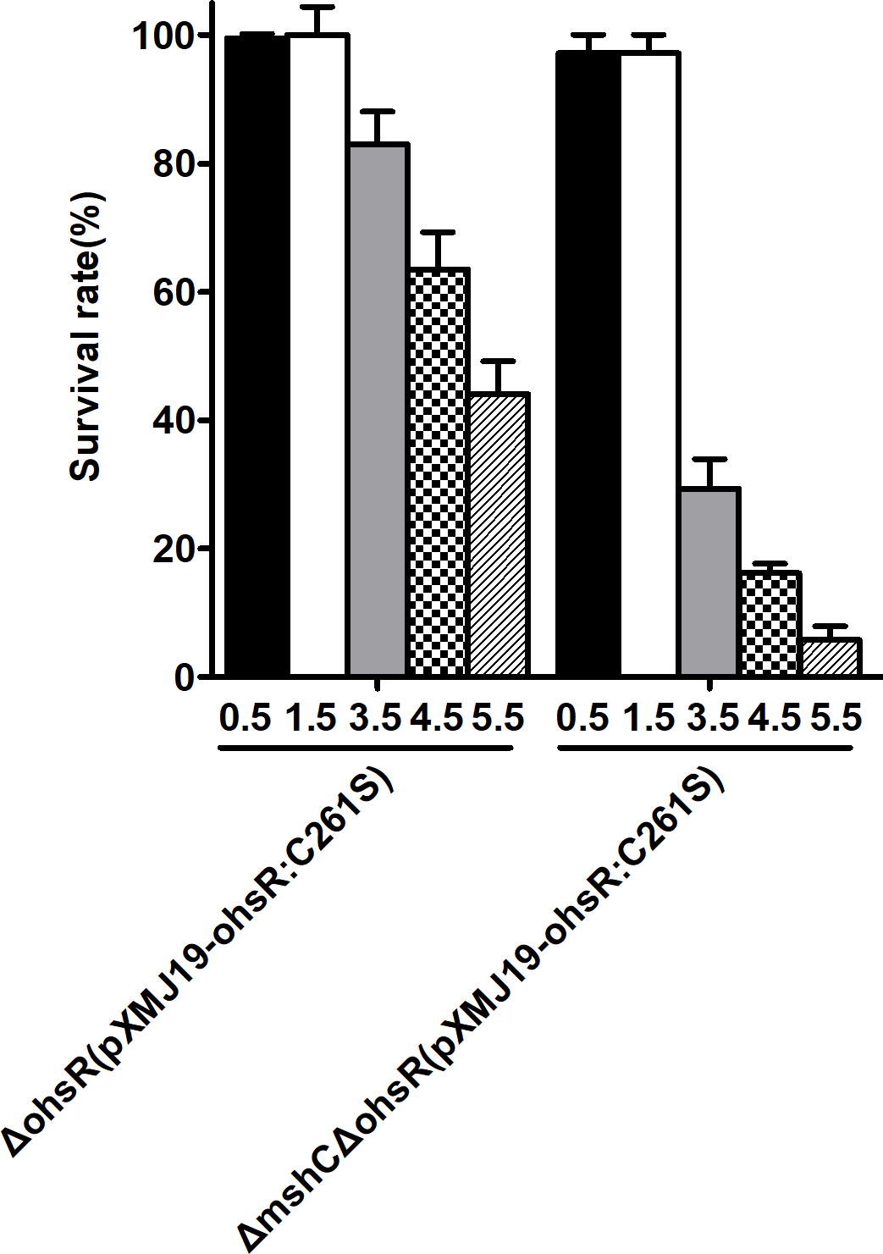
Figure S7 Survival rates of the relevant C. glutamicum in response to the different concentrations of CHP. C. glutamicum wild type was grown in LB medium to an OD₆₀₀ of 0.6 and exposed to different concentrations of various CHP at 30 °C for 30 min. After treatment, the cultures were serially diluted, spreaded on LB plates and incubated at 30 °C for 36 h. Survival percentages were calculated as [(CFU ml⁻¹ with stress)/(CFU ml⁻¹ without stress)]×100. Mean values with standard deviations (error bars) from at least three repeats are shown.

