Additional file

Production of L-alanyl-L-glutamine by immobilized Pichia pastoris GS115 expressing α-amino acid ester acyltransferase

Yimin Li¹, Jiaoqi Gao², Xuze Pei¹, Cong Du¹, Chao Fan³, Wenjie Yuan¹*, Fengwu Bai⁴

¹School of Life Science and Biotechnology, Dalian University of Technology, Dalian 116024, China
²Division of Biotechnology, Dalian Institute of Chemical Physics, Dalian 116023, China
³Research and Development Center, Dalian Innobio Corporation Limited, Dalian 116600, China
⁴School of Life Science and Biotechnology, Shanghai Jiaotong University, Shanghai 200240, China

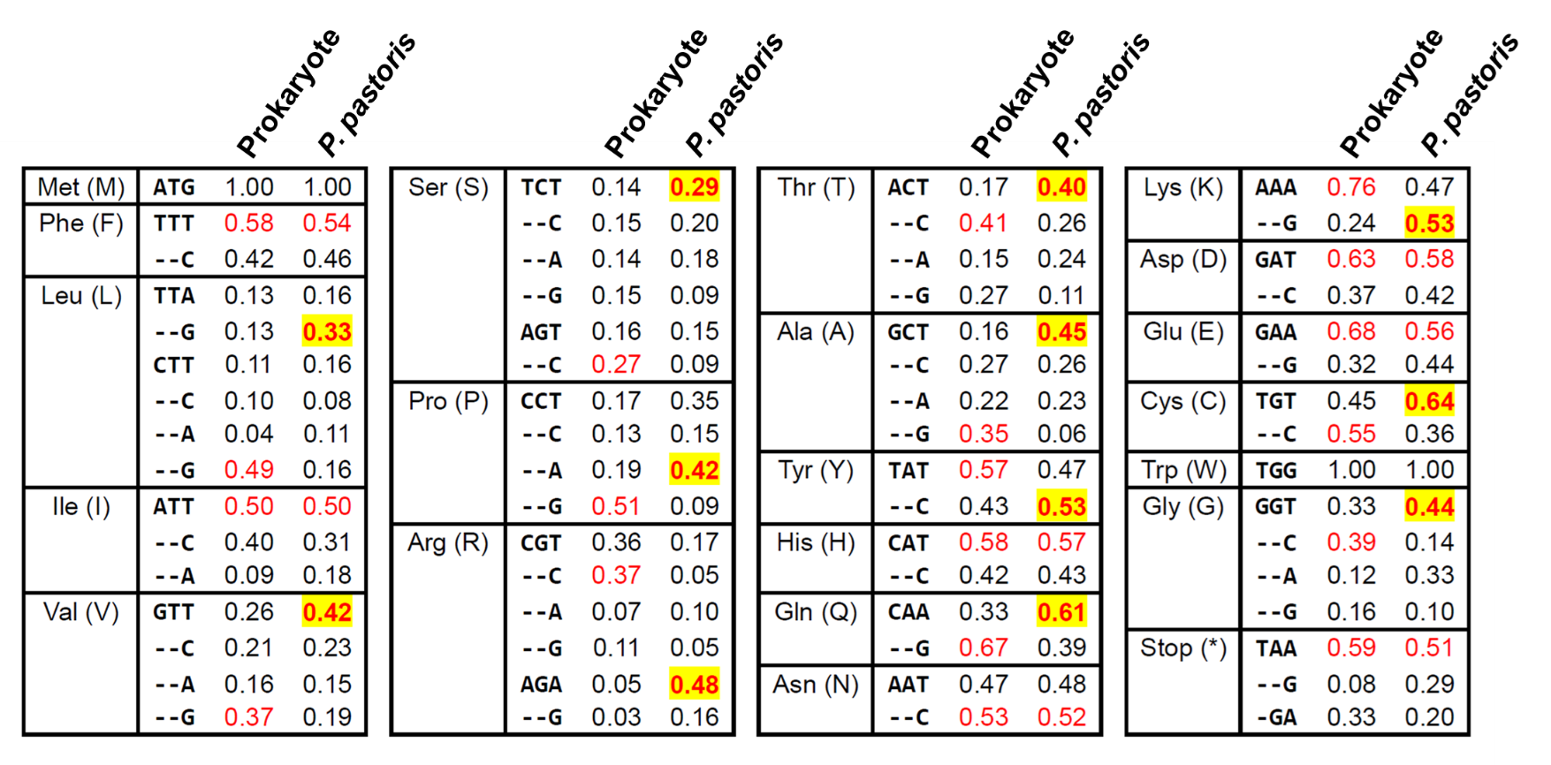
Figure S1. The difference of codon usage bias between prokaryotic and P. pastoris. Frequencies of the synonymous codons were demonstrated for each corresponding amino acid. A preferred codon was all represented in red, while highlight indicated that the codon usage bias had changed in P. pastoris. The hyphen indicated the same as the above base and the asterisk indicated termination codon.
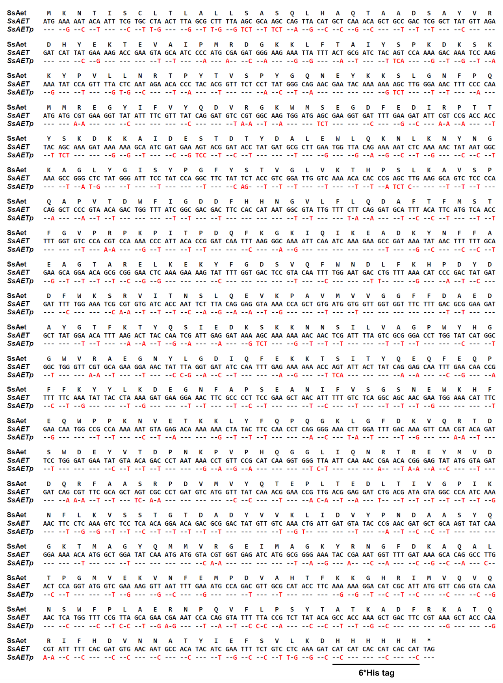
Figure S2. Nucleotide sequences of the original gene SsAET and the optimized gene SsAETp along with the consistent amino acid sequence. The altered base was shown by the corresponding letter while the consistent base was represented by a hyphen, and the asterisk represented transcriptional stop codon.

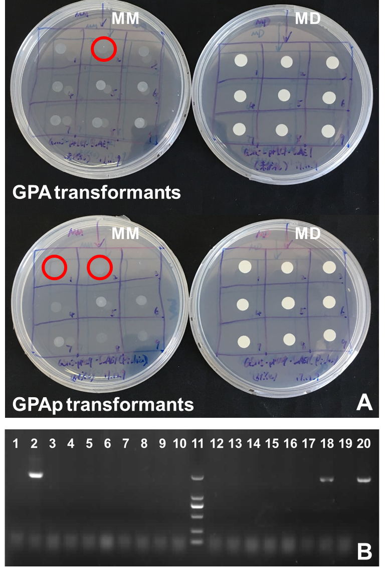
Figure S3. Screening and verification of transformants. (A) His⁺ Mut^{S} transformants were selected according to growth on MD/MM agar plate (partial results). (B) PCR validation of recombinants. Lanes 1-10 were GPA recombinants; Lanes 12-20 were GPAp recombinants; Lane 11 was DL2000 DNA marker.
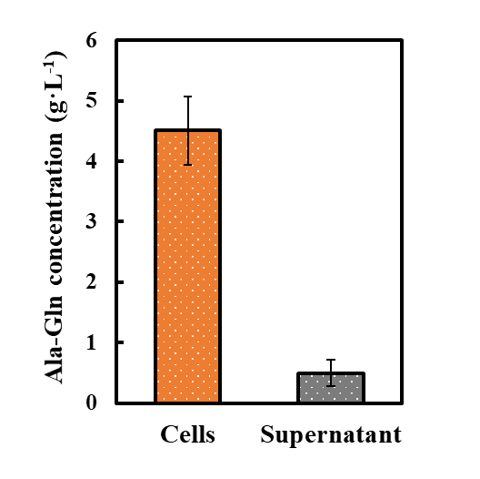
Figure S4. Comparison of catalytic activity between the supernatant and cells. The supernatant and cells were denoted in grey and orange, respectively.

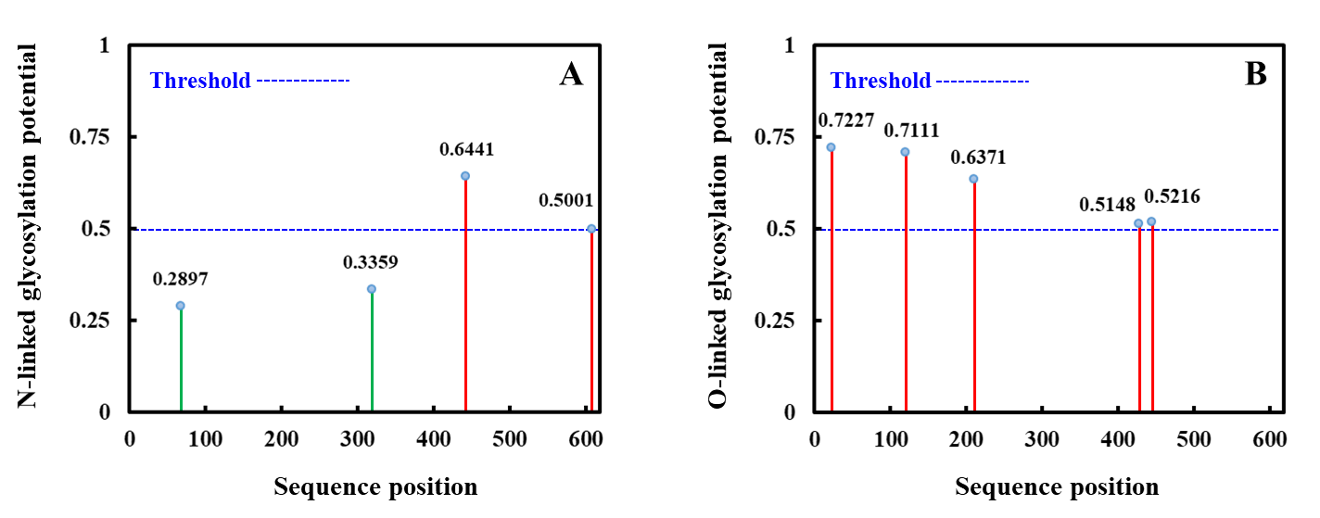
Figure S5. Predicted glycosylation sites across the protein sequence. (A) putative N-linked glycosylation sites. (B) putative O-linked glycosylation sites. A position with a potential (vertical lines) crossing the threshold (horizontal line at 0.5) was predicted as a positive glycosylated site.

* Corresponding author. Tel: +86-41184706308; Fax: +86-41184706308. E-mail address: ywj@dlut.edu.cn (wj yuan);

