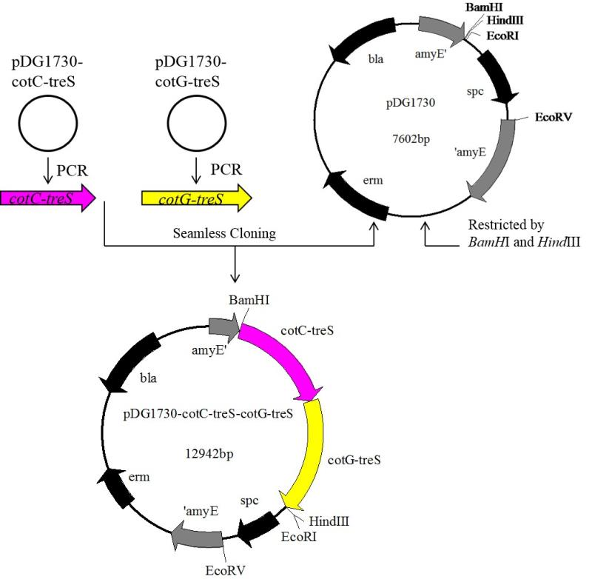
Additional file 5. Construction of recombinant plasmid pDG1730-CotC-treS -CotG-treS.

