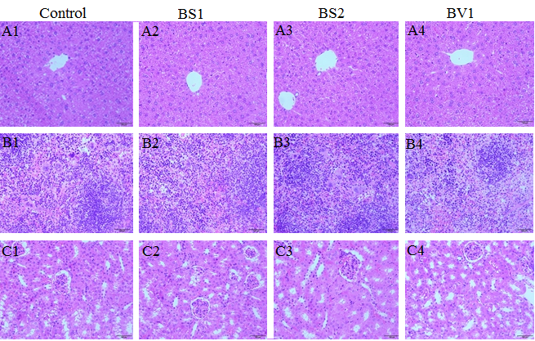
Fig. S1. Histological examination in the liver (A1-A4), kidney (B1-B4), and spleen (C1-C4)

