Additional file 1.
Metabolic perturbations in mutants of glucose transporters and their applications in metabolite production in Escherichia coli

Hwi-Min Jung^{a,1}, Dae-Kyun Im^{a,1}, Jae Hyung Lim^{b}, Gyoo Yeol Jung^{b,c}, Min-Kyu Oh^{a,*}

ª Department of Chemical and Biological Engineering, Korea University, 145 Anam-ro, Seongbuk-gu, Seoul 02841, Korea
^{b}Department of Chemical Engineering, Pohang University of Science and Technology, 77 Cheongam-ro, Nam-gu, Pohang, Gyeongbuk 37673, Korea
^{c}School of Interdisciplinary Bioscience and Bioengineering, Pohang University of Science and Technology, 77 Cheongam-ro, Nam-gu, Pohang, Gyeongbuk 37673, Korea
¹ These two authors made equal contributions to the work described in this paper.
* Corresponding author: Min-Kyu Oh (mkoh@korea.ac.kr).

Table S1. Oligomers used in this study
Name | Sequence (5` to 3`) |  | Description
ΔptsG_FKF_Fwd | AGGTCGGTAAATCGCTGATGCTGCCGGTATCCGTACTGCCTATCGCAGGT gtgtaggctggagctgcttc |  | FRT-KanR-FRT cassette PCR for ptsG mutation
ΔptsG_FKF_Rev | CAGTCGGGTCACCCGCCATATAACGCGGAATGTCGCCGTGGAAAACCTGA gtccatatgaatatcctcct |  | FRT-KanR-FRT cassette PCR for ptsG mutation
ΔptsG_C_Fwd | gtaaagttcaccgccgaaaa |  | Confirmation of ptsG mutation
ΔptsG_C_Rev | aatcgcctgaacaccagaac |  | Confirmation of ptsG mutation
ΔmglB_FKF_Fwd | CAAGATGCGAAAGCCGCGCCAGATGTTCAGCTGCTGATGAATGATTCTCA gtgtaggctggagctgcttc |  | FRT-KanR-FRT cassette PCR for mglB mutation
ΔmglB_FKF_Rev | AAAGGTCGCTTTCGCCTGGTTGTTAGCATCGTTCAGTACTGTGCCCGCCA gtccatatgaatatcctcct |  | FRT-KanR-FRT cassette PCR for mglB mutation
ΔmglB_C_Fwd | gagcttcggcgttcagtaac |  | Confirmation of mglB mutation
ΔmglB_C_Rev | gtggccggactttgaaatta |  | Confirmation of mglB mutation
ΔmalE_FKF_Fwd | ACATTATCTTCTGGGCACACGACCGCTTTGGTGGCTACGCTCAATCTGGC gtgtaggctggagctgcttc |  | FRT-KanR-FRT cassette PCR for malE mutation
ΔmalE_FKF_Rev | AAGCGGACATCTGCGGGATGTTCGGCATGATTTCACCTTTCTGGGCGTTT gtccatatgaatatcctcct |  | FRT-KanR-FRT cassette PCR for malE mutation
ΔmalE_C_Fwd | atgtgcgcatctccacatta |  | Confirmation of malE mutation
ΔmalE_C_Rev | acgccttatccgacaacaac |  | Confirmation of malE mutation
ΔgalP_FKF_Fwd | GTTCGGTGCGGCAGTCGGTGCGGTGGGCAGCGGCTGGCTCTCCTTTAAAC gtgtaggctggagctgcttc |  | FRT-KanR-FRT cassette PCR for galP mutation
ΔgalP_FKF_Rev | TGGCAAGTACGTTGGTCAGGCCGACAATCACGGTCCCCCACATTTGCTCG gtccatatgaatatcctcct |  | FRT-KanR-FRT cassette PCR for galP mutation
ΔgalP_C_Fwd | tctggcgggattactctttg |  | Confirmation of galP mutation
ΔgalP_C_Rev | caacgatcatgttggcaatc |  | Confirmation of galP mutation
ΔgabT_FKF_Fwd | ATGAGCAGCAATAAAGAGTTAATGCAGCGCCGCAGTCAGGCAGTTCCTCG gtgtaggctggagctgcttc |  | FRT-KanR-FRT cassette PCR for gabT mutation
ΔgabT_FKF_Rev | CTTTTTGCAGCAGATTTTCCTGCTCGAACACCTTCAACACTTCCAGCGCC gtccatatgaatatcctcct |  | FRT-KanR-FRT cassette PCR for gabT mutation
ΔgabT_C_Fwd | aagccaatgacaccgaattt |  | Confirmation of gabT mutation
ΔgabT_C_Rev | cttcgcctcagcaaaacact |  | Confirmation of gabT mutation
EGFP_Fwd | ATATATGGTACC atggtgagcaagggcgag |  | EGFP ORF insertion in pZA31 MCS plasmid
EGFP_Rev | ATATATGTCGAC cttctctcatccgccaaaac |  | EGFP ORF insertion in pZA31 MCS plasmid
pZA_gltB | attaaagaggagaaaggtacatgaaaccacaaggaactctac |  | gltBD insertion in pZA31 MCS plasmid
gltD_gltB |  | ttagctcactgcctccatg |  | gltBD insertion in pZA31 MCS plasmid
gltB_gltD | tcatggaggcagtgagctaatg |  | gltBD insertion in pZA31 MCS plasmid
pZA_gltD | tatcaagcttatcgataccgctagacagccagcggcac |  | gltBD insertion in pZA31 MCS plasmid
pZA_gadBm | attaaagaggagaaaggtacatggataagaagcaagtaacggatttaagg |  | gadB^{mut}/gadC^{mut} insertion in pZA31 MCS plasmid
gadCm_gadBm | atccccctaagggcccgacactcagtga |  | gadB^{mut}/gadC^{mut} insertion in pZA31 MCS plasmid
gadBm_gadCm | tgtcgggcccttagggggataatatggc |  | gadB^{mut}/gadC^{mut} insertion in pZA31 MCS plasmid
pZA_gadCm | tatcaagcttatcgataccgttatttacgatcatgaacagc |  | gadB^{mut}/gadC^{mut} insertion in pZA31 MCS plasmid
pZA_gltB_gltD_gadBm_gadCm_F | gtaggacaaatccgccgccctagatccctatcagtgatagag |  | gltB/D, gadB^{mut}/gadC^{mut} insertion in pZA31 MCS plasmid
pZA_gltB_gltD_gadBm_gadCm_R | gcctatggaaaacggctttgccgcatttgtcctactcaggag |  | gltB/D, gadB^{mut}/gadC^{mut} insertion in pZA31 MCS plasmid
Homology arm sequences for gene deletion are shown in capital. The annealing sequences for PCR amplification are shown in lower case. Sequences for restriction enzyme recognition are shown in italic.

Table S2. Transcriptome data for ST2, ST8 VS ST1. Fold change with absolute value of 2 or higher is marked in color (Mark negative in blue and positive in red). The transcriptome was classified as glycolysis, pentose phosphate pathway, acetate metabolism, anaplerotic pathway, TCA cycle, oxidative phosphorylation, glyoxylate shunt and glycolate pathway, phenylacetate degradation pathway, PTS transporters, ABC transporters, quorum sensing, chemotaxis, flagella synthesis, stress induced proteins.
Gene_Symbol | Product | ST2/ST1 (Fold) | ST8/ST1 (Fold)
Glycolysis
pgi | glucose-6-phosphate isomerase | -1.43 | -1.52
pfkA | ATP-dependent 6-phosphofructokinase | -1.35 | -1.48
pfkB | 6-phosphofructokinase II | -1.29 | 1.22
fbaA | class II fructose-bisphosphate aldolase | -1.94 | -1.85
fbaB | fructose-bisphosphate aldolase | 2.92 | 7.03
tpiA | triose-phosphate isomerase | -1.82 | -1.94
gapA | aldehyde dehydrogenase | -1.68 | -1.69
pgk | phosphoglycerate kinase | -1.52 | -1.86
gpmA | 2,3-bisphosphoglycerate-dependent phosphoglycerate mutase | -1.26 | -1.42
eno | enolase | -2.76 | -2.93
pykF | pyruvate kinase I | -4.43 | -5.41
pykA | pyruvate kinase II | 1.63 | 1.88
aceE | pyruvate dehydrogenase E1 component | -2.19 | -1.99
aceF | dihydrolipoyllysine-residue acetyltransferase component of pyruvate dehydrogenase complex | -2.24 | -1.93
lpd | dihydrolipoyl dehydrogenase | 1.16 | 1.03
Pentose phosphate pathway
zwf | glucose-6-phosphate 1-dehydrogenase | -1.15 | -1.68
pgl | 6-phosphogluconolactonase | -1.29 | 1.02
gnd | phosphogluconate dehydrogenase (NADP(+)-dependent, decarboxylating) | -1.56 | -1.58
ED pathway
edd | phosphogluconate dehydratase | -1.43 | -1.64
eda | KHG/KDPG aldolase | -1.94 | -1.78
Gluconeogenesis
fbp | fructose 1,6-bisphosphatase | 1.15 | 1.58
ppsA | phosphoenolpyruvate synthase | 5.89 | 7.11
Acetate metabolism
pta | phosphate acetyltransferase | -1.12 | 1.10
ack | acetate kinase | -1.25 | -1.05
poxB | ubiquinone-dependent pyruvate dehydrogenase | 1.93 | 3.27
actP | cation acetate symporter | 64.60 | 31.35
acs | acetyl-coenzyme A synthetase | 36.39 | 41.00
Anaplerotic pathway
ppc | phosphoenolpyruvate carboxylase | -2.64 | -2.81
pck | phosphoenolpyruvate carboxykinase (ATP) | 10.70 | 12.96
TCA cycle
gltA | type II citrate synthase | 2.69 | 2.06
acnB | bifunctional aconitate hydratase 2/2-methylisocitrate dehydratase | 2.99 | 3.72
acnA | aconitate hydratase AcnA | 2.88 | 3.58
icd | NADP-dependent isocitrate dehydrogenase | 1.88 | 2.12
sucA | 2-oxoglutarate dehydrogenase subunit E1 | 1.77 | 1.77
sucB | dihydrolipoyllysine-residue succinyltransferase | 1.56 | 1.66
sucC | succinyl-CoA ligase subunit beta | 2.89 | 2.66
sucD | succinyl-CoA ligase subunit alpha | 2.82 | 2.71
sdhC | succinate dehydrogenase cytochrome b556 subunit | 1.30 | 1.65
sdhD | succinate dehydrogenase hydrophobic membrane anchor subunit | 1.37 | 1.68
sdhA | succinate dehydrogenase flavoprotein subunit | 1.47 | 1.64
sdhB | succinate dehydrogenase iron-sulfur subunit | 1.83 | 2.08
frdD | fumarate reductase subunit D | 2.16 | 2.61
frdC | fumarate reductase subunit C | 1.76 | 2.45
frdB | fumarate reductase iron-sulfur subunit | 2.25 | 2.88
frdA | fumarate reductase flavoprotein subunit | 2.08 | 1.95
fumC | class II fumarate hydratase | 7.63 | 10.84
fumA | fumarate hydratase | 3.24 | 3.13
fumB | fumarate hydratase class I, anaerobic | 1.03 | 1.00
mdh | malate dehydrogenase | 1.66 | 2.12
Oxidative phosphorylation
nuoA | NADH-quinone oxidoreductase subunit A | -1.34 | 1.03
nuoB | NADH-quinone oxidoreductase subunit B | -1.25 | 1.02
nuoCD | NADH-quinone oxidoreductase subunit C/D | -1.34 | 1.06
nuoE | NADH-quinone oxidoreductase subunit E | -1.06 | 1.11
nuoF | NADH-quinone oxidoreductase subunit NuoF | -1.30 | -1.01
nuoG | NADH-quinone oxidoreductase subunit NuoG | 1.03 | 1.24
nuoH | NADH-quinone oxidoreductase subunit H | 1.21 | 1.54
nuoI | NADH-quinone oxidoreductase subunit I | 1.31 | 1.46
nuoJ | NADH-quinone oxidoreductase subunit J | 1.36 | 1.65
nuoK | NADH-quinone oxidoreductase subunit K | 1.11 | 1.48
nuoL | NADH-quinone oxidoreductase subunit L | 1.13 | 1.52
nuoM | NADH-quinone oxidoreductase subunit M | 1.01 | 1.27
nuoN | NADH-quinone oxidoreductase subunit N | -1.28 | 1.16
ndh | NADH dehydrogenase | -1.81 | -2.08
cyoA | cytochrome o ubiquinol oxidase subunit II | -1.18 | 1.11
cyoB | cytochrome ubiquinol oxidase subunit I | -1.23 | -1.07
cyoC | cytochrome bo(3) ubiquinol oxidase subunit 3 | -1.19 | -1.09
cyoD | cytochrome bo(3) ubiquinol oxidase subunit 4 | 1.05 | 1.11
cydA | cytochrome bd-I ubiquinol oxidase subunit 1 | 1.37 | 1.49
cydB | cytochrome bd-I ubiquinol oxidase subunit 2 | 1.17 | 1.53
atpA | ATP synthase subunit alpha | -1.02 | -1.28
atpB | ATP synthase subunit A | 1.02 | -1.26
atpC | ATP synthase epsilon chain | -1.05 | -1.38
atpD | ATP synthase subunit beta | -1.17 | -1.48
atpE | ATP synthase subunit C | 1.06 | -1.25
atpF | ATP synthase subunit B | 1.27 | -1.27
atpG | ATP synthase subunit gamma | -1.09 | -1.38
atpH | ATP synthase subunit delta | -1.46 | -2.05
Glyoxylate shunt and glycolate pathway
aceA | isocitrate lyase | 21.95 | 39.77
aceB | malate synthase A | 18.21 | 30.27
aldA | aldehyde dehydrogenase | 23.22 | 31.52
fucO | lactaldehyde reductase | 8.50 | 11.76
glcD | glycolate oxidase | 46.74 | 72.62
glcE | glycolate oxidase subunit GlcE | 28.53 | 41.40
glcF | glycolate oxidase iron-sulfur subunit | 19.09 | 24.25

PTS transporter
agaB | PTS N-acetylgalactosamine transporter subunit IIB | 1.30 | 1.27
agaC | N-acetylgalactosamine permease IIC component 1 | -1.06 | 1.30
agaD | PTS N-acetylgalactosamine transporter subunit IID | 1.49 | 1.74
agaE | PTS N-acetylgalactosamine transporter subunit IID | 3.66 | 5.81
agaF | PTS N-acetylgalactosamine transporter subunit IIA | 2.92 | 4.34
agaV | PTS N-acetylgalactosamine transporter subunit IIB | 4.40 | 6.88
agaW | PTS mannose/fructose/sorbose/N-acetylgalactosamine transporter subunit IIC | 5.79 | 9.86
ascF | PTS cellobiose/arbutin/salicin transporter subunit IIBC | 1.28 | 1.19
bcgE | PTS sugar transporter subunit IIB | 1.29 | 1.12
bcgF | PTS sugar transporter subunit IIC | -1.04 | 1.07
bcgI | PTS lactose/cellobiose transporter subunit IIA | -1.07 | -1.12
bglF | PTS beta-glucoside transporter subunit IIABC | -1.06 | -1.07
chbA | N,N'-diacetylchitobiose-specific phosphotransferase enzyme IIA component | 1.25 | -1.16
chbB | PTS sugar transporter subunit IIB | 1.44 | 2.14
chbC | N,N'-diacetylchitobiose permease IIC component | 1.53 | 1.59
cmtA | PTS mannitol cryptic EIICB component | 1.92 | 1.71
cmtB | mannitol-specific cryptic phosphotransferase enzyme IIA component | 1.50 | 1.18
fruA | PTS fructose transporter subunit IIBC | -6.97 | -3.37
fruB | bifunctional PTS fructose transporter subunit IIA/HPr protein | -1.75 | 1.51
malX | PTS maltose- and glucose EIICB component | 1.93 | 2.57
manX | PTS mannose transporter subunit EIIAB | -1.59 | -1.41
manY | PTS mannose/fructose/sorbose transporter subunit IIC | -1.56 | -1.61
manZ | PTS mannose transporter subunit IID | -1.88 | -1.94
mngA | PTS 2-O-a-mannosyl-D-glycerate transporter subunit IIABC | 1.38 | 1.77
murP | PTS N-acetylmuramic acid EIIBC component | 1.57 | 4.37
nagE | PTS N-acetyl glucosamine transporter subunit IIABC | 4.82 | 4.16
srlA | glucitol/sorbitol permease IIC component | 5.99 | 7.65
srlB | glucitol/sorbitol-specific phosphotransferase enzyme IIA component | 2.40 | 1.98
srlE | PTS sorbitol transporter subunit IIB | 4.38 | 4.60
treB | PTS trehalose transporter subunit IIBC | 13.30 | 33.72
ulaA | PTS ascorbate transporter subunit IIC | 1.51 | 1.75
ulaC | ascorbate-specific phosphotransferase enzyme IIA component | 1.09 | 1.12
ABC transporter
araF | arabinose ABC transporter substrate-binding protein | 24.77 | 39.01
araG | arabinose import ATP-binding protein AraG | 16.18 | 25.63
araH | arabinose ABC transporter permease | 5.58 | 10.69
rbsA | ribose ABC transporter ATP-binding protein RbsA | 5.52 | 7.91
rbsD | D-ribose pyranase | 9.36 | 9.36
ugpA | glycerol-3-phosphate transporter permease | 2.64 | 3.50
ugpB | branched chain amino acid ABC transporter substrate-binding protein | 2.26 | 2.82
ugpC | glycerol-3-phosphate ABC transporter ATP-binding protein | 2.94 | 3.56
ugpE | sn-glycerol 3-phosphate ABC transporter permease | 2.30 | 4.54
xylF | xylose ABC transporter substrate-binding protein | 10.06 | 16.36
xylG | xylose ABC transporter ATP-binding protein | 3.51 | 6.27
xylH | xylose ABC transporter permease | 2.16 | 3.88
yddA | ABC transporter ATP-binding protein/permease | 1.57 | 1.52
yjfF | sugar ABC transporter permease YjfF | 3.00 | 5.74
yojI | microcin J25 efflux ABC transporter YojI | -1.61 | -2.11
yphD | ABC transporter permease | 1.29 | 1.72
yphE | sugar ABC transporter ATP-binding protein | 2.25 | 2.56
yphF | sugar ABC transporter substrate-binding protein | 5.06 | 5.63
yrbB | phospholipid ABC transporter-binding protein | -1.29 | -1.10
yrbC | phospholipid-binding protein | -1.19 | -1.03
yrbD | outer membrane lipid asymmetry maintenance protein MlaD | -1.25 | -1.10
yrbE | phospholipid ABC transporter permease | -1.35 | -1.30
yrbF | phospholipid ABC transporter ATP-binding protein MlaF | -1.01 | -1.14
ytfQ | ABC transporter substrate-binding protein | 5.81 | 10.64
ytfR | sugar ABC transporter ATP-binding protein | 4.24 | 6.83
ytfT | ABC transporter permease | 3.70 | 5.77
Other transporter
exuT | hexuronate transporter | 4.61 | 5.94
glpT | glycerol-3-phosphate transporter | 11.36 | 15.44
gntT | gluconate transporter | 4.11 | 2.29
gudP | MFS transporter | 2.18 | 2.19

Quorum sensing
lsrA | autoinducer 2 ABC transporter ATP-binding protein LsrA | 3.90 | 17.16
lsrB | autoinducer 2 ABC transporter substrate-binding protein | 9.54 | 33.19
lsrC | autoinducer 2 ABC transporter permease LsrC | 5.22 | 22.19
lsrD | autoinducer 2 import system permease LsrD | 6.79 | 24.40
lsrF | 3-hydroxy-5-phosphonooxypentane-2,4-dione thiolase LsrF | 8.76 | 27.60
lsrG | autoinducer 2-degrading protein LsrG | 5.50 | 17.19
lsrK | autoinducer-2 kinase | 4.63 | 12.55
lsrR | LsrR family transcriptional regulator | 4.00 | 6.70
Chemotaxis
aer | PAS domain S-box protein | 3.14 | -3.60
cheA | chemotaxis protein CheA | 1.30 | -13.15
cheB | chemotaxis response regulator protein-glutamate methylesterase | 1.62 | -8.97
cheR | chemotaxis protein methyltransferase | 1.60 | -9.05
cheW | chemotaxis protein CheW | 1.70 | -7.28
cheY | two-component system response regulator | 1.67 | -7.57
cheZ | protein phosphatase CheZ | 1.33 | -9.90
tap | methyl-accepting chemotaxis protein | 1.88 | -6.53
tar | methyl-accepting chemotaxis protein II | 1.92 | -7.28
trg | HAMP domain-containing protein | 7.53 | -1.41
tsr | methyl-accepting chemotaxis protein | 1.04 | -13.59
Flagella synthesis
flgA | flagellar basal body P-ring formation protein FlgA | 1.78 | -3.58
flgB | flagellar biosynthesis protein FlgB | 1.94 | -3.97
flgC | flagellar basal body rod protein FlgC | 1.30 | -4.76
flgD | flagellar hook assembly protein FlgD | 1.55 | -4.59
flgE | flagellar hook protein FlgE | 1.55 | -4.30
flgF | flagellar basal body rod protein FlgF | 1.51 | -4.70
flgG | flagellar basal body rod protein FlgG | 1.50 | -4.25
flgH | flagellar L-ring protein | 1.37 | -4.96
flgI | flagellar P-ring protein | 1.65 | -4.51
flgK | flagellar hook-associated protein FlgK | 1.59 | -6.87
flgL | flagellar hook-filament junction protein FlgL | 1.56 | -5.81
flgM | anti-sigma-28 factor FlgM | 1.99 | -4.58
flgN | flagella synthesis protein FlgN | 2.00 | -5.89
flhA | flagellar biosynthesis protein FlhA | 1.43 | -3.34
flhB | flagellar biosynthetic protein FlhB | 1.56 | -6.07
flhC | flagellar transcriptional regulator FlhC | 1.22 | -2.15
flhD | flagellar transcriptional activator FlhD | -1.17 | -2.79
fliA | RNA polymerase sigma factor FliA | 2.24 | -5.41
fliC | flagellin FliC | 2.78 | -7.84
fliD | flagellar filament capping protein FliD | 1.61 | -9.44
fliE | flagellar hook-basal body complex protein FliE | 1.46 | -6.80
fliF | flagellar basal body M-ring protein FliF | 1.36 | -6.19
fliG | flagellar motor switch protein FliG | 1.43 | -5.97
fliH | flagellar assembly protein FliH | 1.40 | -6.64
fliI | flagellum-specific ATP synthase FliI | 1.41 | -7.33
fliJ | flagellar protein FliJ | 1.18 | -6.67
fliK | flagellar hook length control protein FliK | 1.60 | -5.31
fliM | flagellar motor switch protein FliM | 1.09 | -7.13
fliN | flagellar motor switch protein FliN | 1.09 | -7.63
fliO | flagellar protein FliO | 1.53 | -8.20
fliP | flagellar biosynthesis protein FliP | -1.06 | -8.87
fliQ | flagellar biosynthetic protein FliQ | -1.06 | -8.41
fliR | flagellar type III secretion system protein FliR | -1.06 | -8.26
fliS | flagella export chaperone FliS | 1.54 | -8.62
fliT | flagellar protein FliT | 1.58 | -10.60
lafA | lateral flagellin LafA | -1.04 | -1.77
lafB | flagellar hook protein | -1.03 | -1.17
motA | flagellar motor stator protein MotA | 1.65 | -9.78
motB | motility protein B | 1.43 | -10.08

Stress induced protein
appA | phytase AppA | -1.37 | -1.30
bolA | protein BolA | 1.87 | 3.27
cst | carbon starvation protein A | 22.30 | 6.31
dps | DNA starvation/stationary phase protection protein | 1.90 | 3.27
glsB | glutaminase 2 | -1.55 | -1.99
katE | catalase HPII | 2.57 | 6.32
osmB | osmotically-inducible lipoprotein B | 1.89 | 1.84
osmE | osmotically-inducible lipoprotein E | 2.00 | 3.14
otsA | trehalose-6-phosphate synthase | 1.56 | 2.80
otsB | trehalose-6-phosphate phosphatase | 2.29 | 3.36
rpoS | RNA polymerase sigma factor RpoS | 4.79 | 6.17
rspA | starvation-sensing protein RspA | 3.25 | 8.04
rspB | starvation-sensing protein RspB | 1.76 | 3.85
treA | trehalase | 2.05 | 4.03
xth | exodeoxyribonuclease III | -1.34 | -1.27

Table S3. Metabolic network model of E.coli used for 13C-MFA
Glycolysis
ST1 | Reaction | Carbon atom rearrangement | ST2/8 | Reaction | Carbon atom rearrangement
v1 | Glc_EX + PEP → G6P + Pyr | abcdef + ghi → abcdef + ghi | v1 | Glc_EX → Glc | abcdef → abcdef
v2 | G6P ↔ F6P | abcdef ↔ abcdef | v2 | Glc +ATP → G6P | abcdef → abcdef
v3 | F6P + ATP → FBP | abcdef → abcdef | v3 | G6P ↔ F6P | abcdef ↔ abcdef
v4 | FBP ↔ DHAP + GAP | abcdef ↔ cba + def | v4 | F6P + ATP → FBP | abcdef → abcdef
v5 | DHAP ↔ GAP | abc ↔ abc | v5 | FBP ↔ DHAP + GAP | abcdef ↔ cba + def
v6 | GAP ↔ 3PG + ATP + NADH | abc ↔ abc | v6 | DHAP ↔ GAP | abc ↔ abc
v7 | 3PG ↔ PEP | abc ↔ abc | v7 | GAP ↔ 3PG + ATP + NADH | abc ↔ abc
v8 | PEP → Pyr + ATP | abc → abc | v8 | 3PG ↔ PEP | abc ↔ abc
 |  |  | v9 | PEP → Pyr + ATP | abc → abc
Pentose Phosphate Pathway
ST1(ST2/8) |  | Reaction |  | Carbon atom rearrangement
v9(v10) |  | G6P → 6PG + NADPH |  | abcdef → abcdef
v10(v11) |  | 6PG → Ru5P + CO₂ + NADPH |  | abcdef → bcdef + a
v11(v12) |  | Ru5P ↔ X5P |  | abcde ↔ abcde
v12(v13) |  | Ru5P ↔ R5P |  | abcde ↔ abcde
v13(v14) |  | X5P ↔ TKC2 + GAP |  | abcde ↔ ab + cde
v14(v15) |  | F6P ↔ TKC2 + E4P |  | abcdef ↔ ab + cdef
v15(v16) |  | S7P ↔ TKC2 + R5P |  | abcdefg ↔ ab+ cdefg
v16(v17) |  | F6P ↔ TAC3 + GAP |  | abcdef ↔ abc + def
v17(v18) |  | S7P ↔ TAC3 + E4P |  | abcdefg ↔ abc + defg
Entner-Doudoroff Pathway
ST1(ST2/8) |  | Reaction |  | Carbon atom rearrangement
v18(v19) |  | 6PG → KDPG |  | abcdef → abcdef
v19(v20) |  | KDPG → Pyr + GAP |  | abcdef → abc + def
TCA Cycle
ST1(ST2/8) |  | Reaction |  | Carbon atom rearrangement
v20(v21) |  | Pyr → AcCoA + CO₂ + NADH |  | abc → bc + a
v21(v22) |  | OAC + AcCoA → Cit |  | abcd + ef → dcbfea
v22(v23) |  | Cit ↔ ICIT |  | abcdef ↔ abcdef
v23(v24) |  | ICIT ↔ AKG + CO₂ + NADPH |  | abcdef ↔ abcde + f
v24(v25) |  | AKG → SucCoA + CO₂ + NADH |  | abcde → bcde + a
v25(v26) |  | SucCoA ↔ Suc + ATP |  | abcd ↔ abcd
v26(v27) |  | Suc ↔ Fum + FADH2 |  | abcd ↔ abcd
v27(v28) |  | Fum ↔ Mal |  | abcd ↔ abcd
v28(v29) |  | Mal ↔ OAC + NADH |  | abcd ↔ abcd
Glyoxylate Shunt
ST1(ST2/8) |  | Reaction |  | Carbon atom rearrangement
v29(v30) |  | ICIT → Glyox + Suc |  | abcdef → ab + edcf
v30(v31) |  | Glyox + AcCoA → Mal |  | ab + cd → abdc
Amphibolic Reactions
ST1(ST2/8) |  | Reaction |  | Carbon atom rearrangement
v31(v32) |  | Mal → Pyr + CO₂ + NADPH |  | abcd → abc + d
v32(v33) |  | Mal → Pyr + CO₂ + NADH |  | abcd → abc + d
v33(v34) |  | PEP + CO₂ → OAC |  | abc + d → abcd
v34(v35) |  | OAC + ATP → PEP + CO₂ |  | abcd → abc + d
Acetic Acid Formation
ST1(ST2/8) |  | Reaction |  | Carbon atom rearrangement
v35(v36) |  | AcCoA ↔ Ac + ATP |  | ab ↔ ab
Amino Acid Biosynthesis
ST1(ST2/8) |  | Reaction |  | Carbon atom rearrangement
v36(v37) |  | AKG + NADPH + NH₃ → Glu |  | abcde → abcde
v37(v38) |  | Glu + ATP + NH₃ → Gln |  | abcde → abcde
v38(v39) |  | Glu + ATP + 2 NADPH → Pro |  | abcde → abcde
v39(v40) |  | Glu + CO₂ + Gln + Asp + AcCoA + 5 ATP + NADPH → Arg + AKG + Fum + Ac |  | abcde + f + ghijk + lmno + pq → abcdef + ghijk + lmno + pq
v40(v41) |  | OAC + Glu → Asp + AKG |  | abcd + efghi → abcd + efghi
v41(v42) |  | Asp + 2 ATP + NH₃ → Asn |  | abcd → abcd
v42(v43) |  | Pyr + Glu → Ala + AKG |  | abc + defgh → abc + defgh
v43(v44) |  | 3PG + Glu → Ser + AKG + NADH |  | abc + defgh → abc + defgh
v44(v45) |  | Ser ↔ Gly + MEETHF |  | abc ↔ ab + c
v45(v46) |  | Gly ↔ CO₂ + MEETHF + NADH + NH3 |  | ab ↔ a + b
v46(v47) |  | Thr → Gly + AcCoA + NADH |  | abcd → ab + cd
v47(v48) |  | Ser + AcCoA + 3 ATP + 4 NADPH + SO₄ → Cys + Ac |  | abc + de → abc + de
v48(v49) |  | Asp + Pyr + Glu + SucCoA + ATP +2 NADPH → LL-DAP + AKG + Suc |  | abcd + efg + hijkl + mnop → abcdgfe + hijkl + mnop
v49(v50) |  | LL-DAP → Lys + CO₂ |  | abcdefg → abcdef + g
v50(v51) |  | Asp + 2 ATP + 2 NADPH → Thr |  | abcd → abcd
v51(v52) |  | Asp + METHF + Cys + SucCoA + ATP + 2 NADPH → Met + Pyr + Suc + NH₃ |  | abcd + e + fgh + ijkl → abcde + fgh + ijkl
v52(v53) |  | Pyr + Pyr + Glu + NADPH → Val + CO2 + AKG |  | abc + def + ghijk → abcef + d + ghijk
v53(v54) |  | AcCoA + Pyr + Pyr + Glu + NADPH → Leu + CO₂ + CO₂ + AKG + NADH |  | ab + cde + fgh + ijklm → abdghe + c + f + ijklm
v54(v55) |  | Thr + Pyr + Glu + ATP + NADPH → Ile + CO2 + AKG |  | abcd + efg + hijkl → abfcdg + e + hijkl
v55(v56) |  | PEP + PEP + E4P + Glu + ATP + NADPH → Phe + CO₂ + AKG |  | abc + def + ghij + klmno → abcefghij + d + klmno
v56(v57) |  | PEP + PEP + E4P + Glu + ATP + NADPH → Tyr + CO₂ + AKG + NADH |  | abc + def + ghij + klmno → abcefhgij + d + klmno
v57(v58) |  | Ser + R5P + PEP + E4P + PEP + Gln + 3 ATP + NADPH → Trp + CO₂ + GAP + Pyr + Glu |  | abc + defgh + ijk + lmno + pqr + stuvw → abcedklmnoj + i + fgh + pqr + stuvw
v58(v59) |  | R5P + FTHF + Gln + Asp + 5 ATP → His + AKG + Fum + 2 NADH |  | abcde + f + ghijk + lmno → edcbaf + hgijk + lmno
One-Carbon Metabolism
ST1(ST2/8) |  | Reaction |  | Carbon atom rearrangement
v59(v60) |  | MEETHF + NADH → METHF |  | a → a
v60(v61) |  | MEETHF → FTHF + NADPH |  | a → a
Oxidative Phosphorylation
ST1(ST2/8) |  | Reaction |  | Carbon atom rearrangement
v61(v62) |  | NADH + 1/2 O₂ → 2 ATP
v62(v63) |  | FADH2 + 1/2 O₂ → ATP
Transhydrogenation
ST1(ST2/8) |  | Reaction |  | Carbon atom rearrangement
v63(v64) |  | NADH ↔ NADPH
ATP Hydrolysis
ST1(ST2/8) |  | Reaction |  | Carbon atom rearrangement
v64(v65) |  | ATP → ATP_EX
Transport
ST1(ST2/8) |  | Reaction |  | Carbon atom rearrangement
v65(v66) |  | Ac → Ac_EX
v66(v67) |  | CO₂ → CO₂_EX |  | a → a
v67(v68) |  | O₂_EX → O₂
v68(v69) |  | NH₃_EX → NH₃
v69(v70) |  | SO₄_EX → SO₄
Biomass Formation
ST1(ST2/8) |  | Reaction |  | Carbon atom rearrangement
v70(v71) |  |  | 0.488 Ala + 0.281 Arg + 0.229 Asn + 0.229 Asp + 0.087 Cys + 0.25 Glu
CO₂ exchange
ST1(ST2/8) |  | Reaction |  | Carbon atom rearrangement
v71(v72) |  | CO₂_unlabeled + CO₂ → CO₂ + CO₂_out |  | a + b → a + b

Table S4. Mass isotopomer distributions from E. coli grown in batch cultures with 12-13C-labeled glucose.
Strain | ST1 | ST2 | ST8
Ala232
m0 | 39.2 | 39.9 | 41.0
m1 | 16.7 | 17.7 | 19.2
m2 | 33.9 | 32.9 | 30.7
m3 | 7.1 | 6.7 | 6.3
m4 | 2.7 | 2.6 | 2.4
Ala260
m0 | 38.7 | 38.7 | 39.8
m1 | 11.7 | 14.8 | 16.2
m2 | 37.2 | 33.2 | 31.5
m3 | 8.5 | 9.4 | 8.9
m4 | 3.3 | 3.2 | 3.0
m5 | 0.5 | 0.6 | 0.5
Gly218
m0 | 45.7 | 47.1 | 49.2
m1 | 40.4 | 39.3 | 37.8
m2 | 10.2 | 9.8 | 9.6
m3 | 3.2 | 3.3 | 3.0
Gly246
m0 | 43.3 | 44.0 | 45.6
m1 | 40.5 | 38.3 | 37.0
m2 | 11.8 | 12.8 | 12.9
m3 | 3.7 | 3.9 | 3.7
m4 | 0.6 | 0.8 | 0.7
Val260
m0 | 20.2 | 21.2 | 22.9
m1 | 13.3 | 14.5 | 16.1
m2 | 33.4 | 33.0 | 31.8
m3 | 13.8 | 13.7 | 13.6
m4 | 14.9 | 13.7 | 12.1
m5 | 3.2 | 2.8 | 2.6
m6 | 1.1 | 1.0 | 0.9
Val288
m0 | 20.1 | 20.5 | 22.2
m1 | 10.5 | 12.5 | 13.9
m2 | 34.1 | 32.6 | 31.7
m3 | 12.8 | 14.2 | 14.1
m4 | 16.7 | 14.6 | 13.1
m5 | 4.0 | 4.1 | 3.6
m6 | 1.4 | 1.2 | 1.1
m7 | 0.2 | 0.2 | 0.2
Leu274
m0 | 12.3 | 12.6 | 14.4
m1 | 15.8 | 17.2 | 18.3
m2 | 24.7 | 24.9 | 25.0
m3 | 21.9 | 22.1 | 21.3
m4 | 14.4 | 13.5 | 12.6
m5 | 8.2 | 7.5 | 6.5
m6 | 2.1 | 1.7 | 1.5
m7 | 0.6 | 0.5 | 0.4
Ile274
m0 | 14.5 | 14.7 | 16.3
m1 | 14.8 | 16.5 | 18.0
m2 | 27.9 | 27.1 | 26.9
m3 | 19.5 | 19.9 | 19.4
m4 | 14.5 | 13.8 | 12.5
m5 | 6.6 | 6.0 | 5.3
m6 | 1.8 | 1.5 | 1.3
m7 | 0.5 | 0.4 | 0.3
Ser362
m0 | 32.9 | 32.5 | 33.0
m1 | 19.6 | 23.4 | 26.1
m2 | 31.4 | 30.1 | 27.9
m3 | 10.8 | 9.3 | 8.8
m4 | 4.2 | 3.7 | 3.4
Ser390
m0 | 31.7 | 31.7 | 32.0
m1 | 18.7 | 21.8 | 24.0
m2 | 31.8 | 29.6 | 28.0
m3 | 11.7 | 11.1 | 10.6
m4 | 4.7 | 4.5 | 4.1
m5 | 1.1 | 1.1 | 1.0
Phe302
m0 | 41.7 | 42.3 | 43.7
m1 | 40.2 | 37.6 | 36.9
m2 | 13.0 | 14.7 | 14.3
m3 | 4.0 | 4.3 | 4.1
m4 | 0.8 | 0.9 | 0.9
Phe308
m0 | 15.9 | 14.5 | 15.5
m1 | 9.8 | 11.7 | 13.0
m2 | 29.0 | 25.9 | 25.4
m3 | 14.2 | 16.5 | 16.8
m4 | 17.5 | 16.6 | 15.6
m5 | 7.5 | 8.3 | 7.8
m6 | 4.1 | 4.3 | 3.9
m7 | 1.6 | 1.8 | 1.6
m8 | 0.4 | 0.5 | 0.4
Asp302
m0 | 36.6 | 36.8 | 38.8
m1 | 31.8 | 31.5 | 30.3
m2 | 22.8 | 23.3 | 22.7
m3 | 6.5 | 6.1 | 6.0
m4 | 1.9 | 1.9 | 1.9
Asp390
m0 | 23.9 | 24.2 | 25.3
m1 | 22.8 | 24.3 | 25.4
m2 | 28.1 | 27.8 | 27.0
m3 | 16.5 | 15.8 | 14.8
m4 | 6.2 | 5.8 | 5.4
m5 | 2.0 | 1.8 | 1.6
Asp418
m0 | 20.8 | 20.8 | 22.4
m1 | 18.5 | 20.4 | 21.0
m2 | 28.1 | 27.5 | 27.3
m3 | 17.5 | 17.6 | 16.5
m4 | 10.2 | 9.5 | 8.8
m5 | 3.5 | 3.1 | 2.8
m6 | 1.1 | 1.0 | 0.9
Glu330
m0 | 16.5 | 17.3 | 18.4
m1 | 18.4 | 19.9 | 21.9
m2 | 29.3 | 29.0 | 28.1
m3 | 18.0 | 17.9 | 17.6
m4 | 13.0 | 11.9 | 10.5
m5 | 3.7 | 3.0 | 2.7
m6 | 1.1 | 0.9 | 0.8
Glu432
m0 | 12.4 | 12.8 | 14.3
m1 | 14.6 | 15.6 | 17.1
m2 | 25.2 | 25.9 | 25.8
m3 | 20.0 | 20.4 | 19.9
m4 | 15.6 | 14.8 | 13.7
m5 | 8.1 | 7.2 | 6.4
m6 | 3.0 | 2.4 | 2.1
m7 | 0.9 | 0.7 | 0.6
Tyr302
m0 | 41.7 | 42.6 | 44.2
m1 | 40.8 | 38.2 | 37.2
m2 | 13.3 | 14.8 | 14.5
m3 | 4.1 | 4.3 | 4.1

Table S5. Results of 13C-metabolic flux analysis for E. coli grown in batch cultures with 12-13C-labeled glucose.
Strain | ST1
SSR | 20.1
Flux No. | Eqn | Best fit | LB95 | UB95 | SD
1 | Glc_EX + PEP → G6P + Pyr | 100.0 | 100.0 | 100.0 | 0.0
2 | G6P ↔ F6P (net) | 72.8 | 67.6 | 78.1 | 2.6
3 | F6P + ATP → FBP | 79.1 | 76.8 | 80.8 | 1.0
4 | FBP ↔ DHAP + GAP (net) | 79.1 | 76.8 | 80.8 | 1.0
5 | DHAP ↔ GAP (net) | 79.1 | 76.8 | 80.8 | 1.0
6 | GAP ↔ 3PG + ATP + NADH (net) | 167.0 | 164.6 | 169.4 | 1.2
7 | 3PG ↔ PEP (net) | 154.0 | 150.7 | 157.4 | 1.7
8 | PEP → Pyr + ATP | 28.1 | 23.0 | 33.8 | 2.7
9 | G6P → 6PG + NADPH | 25.6 | 20.4 | 31.0 | 2.6
10 | 6PG → Ru5P + CO₂ + NADPH | 18.3 | 12.3 | 23.8 | 2.9
11 | Ru5P ↔ X5P (net) | 6.8 | 2.9 | 10.8 | 2.0
12 | Ru5P ↔ R5P (net) | 11.5 | 9.4 | 13.1 | 0.9
13 | X5P ↔ TKC2 + GAP (net) | 6.8 | 2.9 | 10.8 | 2.0
14 | F6P ↔ TKC2 + E4P (net) | -2.1 | -4.2 | -0.1 | 1.0
15 | S7P ↔ TKC2 + R5P (net) | -4.8 | -6.7 | -2.8 | 1.0
16 | F6P ↔ TAC3 + GAP (net) | -4.8 | -6.7 | -2.8 | 1.0
17 | S7P ↔ TAC3 + E4P (net) | 4.8 | 2.8 | 6.7 | 1.0
18 | 6PG → KDPG | 7.3 | 5.7 | 9.3 | 0.9
19 | KDPG → Pyr + GAP | 7.3 | 5.7 | 9.3 | 0.9
20 | Pyr → AcCoA + CO₂ + NADH | 115.6 | 109.8 | 123.2 | 3.3
21 | OAC + AcCoA → Cit | 32.1 | 25.6 | 41.9 | 4.1
22 | Cit ↔ ICIT (net) | 32.1 | 25.6 | 41.9 | 4.1
23 | ICIT ↔ AKG + CO₂ + NADPH (net) | 30.7 | 21.2 | 41.9 | 5.2
24 | AKG → SucCoA + CO₂ + NADH | 22.6 | 12.7 | 34.5 | 5.5
25 | SucCoA ↔ Suc + ATP (net) | 19.0 | 8.9 | 31.3 | 5.6
26 | Suc ↔ Fum + FADH2 (net) | 24.0 | 17.1 | 34.5 | 4.3
27 | Fum ↔ Mal (net) | 26.8 | 20.0 | 37.0 | 4.2
28 | Mal ↔ OAC + NADH (net) | 28.3 | 23.4 | 37.4 | 3.5
29 | ICIT → Glyox + Suc | 1.5 | 0.0 | 5.6 | 1.4
30 | Glyox + AcCoA → Mal | 1.5 | 0.0 | 5.6 | 1.4
31 | Mal → Pyr + CO₂ + NADPH | 0.0 | 0.0 | 4.7 | 1.2
32 | Mal → Pyr + CO₂ + NADH | 0.0 | 0.0 | 4.7 | 1.2
33 | PEP + CO₂ → OAC | 23.0 | 17.9 | 32.1 | 3.5
34 | OAC + ATP → PEP + CO₂ | 2.9 | 0.0 | 13.1 | 3.3
35 | AcCoA ↔ Ac + ATP (net) | 56.0 | 50.0 | 62.1 | 3.0
36 | AKG + NADPH + NH₃ → Glu | 49.1 | 43.8 | 53.1 | 2.3
37 | Glu + ATP + NH₃ → Gln | 5.1 | 4.5 | 5.5 | 0.2
38 | Glu + ATP + 2 NADPH → Pro | 1.6 | 1.4 | 1.7 | 0.1
39 | Glu + CO₂ + Gln + Asp + AcCoA + 5 ATP + NADPH → Arg + AKG + Fum + Ac | 2.1 | 1.9 | 2.3 | 0.1
40 | OAC + Glu → Asp + AKG | 13.7 | 12.2 | 14.8 | 0.7
41 | Asp + 2 ATP + NH₃ → Asn | 1.7 | 1.5 | 1.9 | 0.1
42 | Pyr + Glu → Ala + AKG | 3.7 | 3.3 | 4.0 | 0.2
43 | 3PG + Glu → Ser + AKG + NADH | 8.4 | 7.5 | 9.1 | 0.4
44 | Ser ↔ Gly + MEETHF (net) | 4.7 | 4.2 | 5.1 | 0.2
45 | Gly ↔ CO₂ + MEETHF + NADH + NH₃ (net) | 0.4 | 0.3 | 0.6 | 0.1
46 | Thr → Gly + AcCoA + NADH | 0.0 | 0.0 | 0.4 | 0.1
47 | Ser + AcCoA + 3 ATP + 4 NADPH + SO₄ → Cys + Ac | 1.8 | 1.6 | 1.9 | 0.1
48 | Asp + Pyr + Glu + SucCoA + ATP +2 NADPH → LL-DAP + AKG + Suc | 2.5 | 2.2 | 2.7 | 0.1
49 | LL-DAP → Lys + CO₂ | 2.5 | 2.2 | 2.7 | 0.1
50 | Asp + 2 ATP + 2 NADPH → Thr | 3.9 | 3.5 | 4.4 | 0.2
51 | Asp + METHF + Cys + SucCoA + ATP + 2 NADPH → Met + Pyr + Suc + NH₃ | 1.1 | 1.0 | 1.2 | 0.1
52 | Pyr + Pyr + Glu + NADPH → Val + CO2 + AKG | 3.0 | 2.7 | 3.3 | 0.1
53 | AcCoA + Pyr + Pyr + Glu + NADPH → Leu + CO₂ + CO₂ + AKG + NADH | 3.2 | 2.9 | 3.5 | 0.2
54 | Thr + Pyr + Glu + ATP + NADPH → Ile + CO2 + AKG | 2.1 | 1.9 | 2.2 | 0.1
55 | PEP + PEP + E4P + Glu + ATP + NADPH → Phe + CO₂ + AKG | 1.3 | 1.2 | 1.4 | 0.1
56 | PEP + PEP + E4P + Glu + ATP + NADPH → Tyr + CO₂ + AKG + NADH | 1.0 | 0.9 | 1.1 | 0.0
57 | Ser + R5P + PEP + E4P + PEP + Gln + 3 ATP + NADPH → Trp + CO₂ + GAP + Pyr + Glu | 0.4 | 0.4 | 0.4 | 0.0
58 | R5P + FTHF + Gln + Asp + 5 ATP → His + AKG + Fum + 2 NADH | 0.7 | 0.6 | 0.7 | 0.0
59 | MEETHF + NADH → METHF | 1.1 | 1.0 | 1.2 | 0.1
60 | MEETHF → FTHF + NADPH | 0.7 | 0.6 | 0.7 | 0.0
61 | NADH + 1/2 O₂ → 2 ATP | 305.4 | 271.9 | 357.7 | 21.5
62 | FADH2 + 1/2 O₂ → ATP | 24.0 | 17.1 | 34.5 | 4.3
63 | NADH ↔ NADPH (net) | 52.2 | 20.8 | 71.3 | 12.6
64 | ATP → ATP_EX | 526.9 | 419.6 | 680.9 | 65.3
65 | Ac → Ac_EX | 59.9 | 54.0 | 65.8 | 2.9
66 | CO₂ → CO₂_EX | 182.0 | 163.3 | 211.3 | 12.0
67 | O₂_EX → O₂ | 164.7 | 144.7 | 195.7 | 12.7
68 | NH₃_EX → NH₃ | 54.4 | 48.5 | 58.8 | 2.6
69 | SO₄_EX → SO₄ | 1.8 | 1.6 | 1.9 | 0.1
70 | 0.488*Ala + 0.281*Arg + 0.229*Asn + 0.229*Asp + 0.087*Cys + 0.25*Glu | 7.5 | 6.7 | 8.1 | 0.4
71 | CO₂_unlabeled + CO₂ → CO₂ + CO₂_out | 0.0 | 0.0 | 45.4 | 11.4
EXCHANGE FLUXES |  | Best fit | LB95 | UB95
2 | G6P ↔ F6P (exch) | 0.0 | 0.0 | Inf
4 | FBP ↔ DHAP + GAP (exch) | 7.3 | 0.0 | Inf
5 | DHAP ↔ GAP (exch) | 0.4 | 0.0 | Inf
6 | GAP ↔ 3PG + ATP + NADH (exch) | >1000 | 0.0 | >1000
7 | 3PG ↔ PEP (exch) | >1000 | 0.0 | Inf
11 | Ru5P ↔ X5P (exch) | 51.6 | 3.1 | Inf
12 | Ru5P ↔ R5P (exch) | 28.3 | 0.0 | Inf
13 | X5P ↔ TKC2 + GAP (exch) | 19.0 | 3.1 | Inf
14 | F6P ↔ TKC2 + E4P (exch) | 7.3 | 0.0 | 14.3
15 | S7P ↔ TKC2 + R5P (exch) | 24.5 | 0.0 | Inf
16 | F6P ↔ TAC3 + GAP (exch) | 59.6 | 4.6 | Inf
17 | S7P ↔ TAC3 + E4P (exch) | 3.9 | 0.0 | Inf
22 | Cit ↔ ICIT (exch) | 0.0 | 0.0 | Inf
23 | ICIT ↔ AKG + CO₂ + NADPH (exch) | 2.7 | 0.0 | Inf
25 | SucCoA ↔ Suc + ATP (exch) | 2.7 | 0.0 | Inf
26 | Suc ↔ Fum + FADH2 (exch) | 0.4 | 0.0 | Inf
27 | Fum ↔ Mal (exch) | 59.8 | 21.7 | Inf
28 | Mal ↔ OAC + NADH (exch) | >1000 | 23.4 | Inf
35 | AcCoA ↔ Ac + ATP (exch) | 4.3 | 0.0 | Inf
44 | Ser ↔ Gly + MEETHF (exch) | 1.8 | 1.4 | 2.2
45 | Gly ↔ CO₂ + MEETHF + NADH + NH₃ (exch) | 0.0 | 0.0 | 1.0
63 | NADH ↔ NADPH (exch) | 14.2 | 0.0 | Inf
FRACTIONALABELING OF AMINO ACIDS (G-VALUES) |  | Best fit | LB95 | UB95
1 | Fractional labeling of Ala | 98.7 | 97.0 | 100.0
2 | Fractional labeling of Gly | 99.0 | 95.5 | 100.0
3 | Fractional labeling of Val | 98.4 | 97.2 | 99.5
4 | Fractional labeling of Leu | 98.0 | 96.7 | 99.2
5 | Fractional labeling of Ile | 98.4 | 97.0 | 99.7
6 | Fractional labeling of Ser | 100.0 | 98.2 | 100.0
7 | Fractional labeling of Phe | 98.3 | 96.9 | 99.8
8 | Fractional labeling of Asp | 98.0 | 96.4 | 99.5
9 | Fractional labeling of Glu | 98.1 | 97.0 | 99.2
10 | Fractional labeling of Tyr | 99.1 | 96.4 | 100.0
Strain | ST2
SSR | 6.7
Flux No. | Eqn | Best fit | LB95 | UB95 | SD
1 | Glc_EX + ATP → Glc | 100.0 | 100.0 | 100.0 | 0.0
2 | Glc + ATP → G6P | 100.0 | 100.0 | 100.0 | 0.0
3 | G6P ↔ F6P (net) | 62.7 | 57.9 | 78.1 | 5.0
4 | F6P + ATP → FBP | 77.2 | 74.7 | 81.8 | 1.8
5 | FBP ↔ DHAP + GAP (net) | 77.2 | 74.7 | 81.8 | 1.8
6 | DHAP ↔ GAP (net) | 77.2 | 74.7 | 81.8 | 1.8
7 | GAP ↔ 3PG + ATP + NADH (net) | 161.3 | 157.5 | 167.2 | 2.4
8 | 3PG ↔ PEP (net) | 144.2 | 138.8 | 152.2 | 3.3
9 | PEP → Pyr + ATP | 115.8 | 108.5 | 124.3 | 4.0
10 | G6P → 6PG + NADPH | 35.2 | 22.4 | 40.1 | 4.4
11 | 6PG → Ru5P + CO₂ + NADPH | 33.4 | 17.0 | 39.3 | 5.6
12 | Ru5P ↔ X5P (net) | 15.2 | 3.6 | 19.8 | 4.0
13 | Ru5P ↔ R5P (net) | 18.3 | 13.1 | 20.2 | 1.8
14 | X5P ↔ TKC2 + GAP (net) | 15.2 | 3.6 | 19.8 | 4.0
15 | F6P ↔ TKC2 + E4P (net) | (5.8) | (8.3) | (0.7) | 1.9
16 | S7P ↔ TKC2 + R5P (net) | (9.4) | (11.5) | (4.5) | 1.7
17 | F6P ↔ TAC3 + GAP (net) | (9.4) | (11.5) | (4.5) | 1.7
18 | S7P ↔ TAC3 + E4P (net) | 9.4 | 4.5 | 11.5 | 1.7
19 | 6PG → KDPG | 1.8 | 0.0 | 4.0 | 1.0
20 | KDPG → Pyr + GAP | 1.8 | 0.0 | 4.0 | 1.0
21 | Pyr → AcCoA + CO₂ + NADH | 91.5 | 84.6 | 101.7 | 4.3
22 | OAC + AcCoA → Cit | 54.9 | 39.3 | 76.1 | 9.2
23 | Cit ↔ ICIT (net) | 54.9 | 39.3 | 76.1 | 9.2
24 | ICIT ↔ AKG + CO₂ + NADPH (net) | 46.9 | 22.6 | 76.1 | 13.4
25 | AKG → SucCoA + CO₂ + NADH | 36.2 | 10.7 | 67.1 | 14.1
26 | SucCoA ↔ Suc + ATP (net) | 31.6 | 5.5 | 63.1 | 14.4
27 | Suc ↔ Fum + FADH2 (net) | 44.2 | 27.3 | 67.1 | 9.9
28 | Fum ↔ Mal (net) | 47.9 | 31.4 | 70.2 | 9.7
29 | Mal ↔ OAC + NADH (net) | 55.8 | 44.5 | 70.6 | 6.5
30 | ICIT → Glyox + Suc | 8.0 | 0.0 | 18.7 | 4.7
31 | Glyox + AcCoA → Mal | 8.0 | 0.0 | 18.7 | 4.7
32 | Mal → Pyr + CO₂ + NADPH | 0.0 | 0.0 | 6.6 | 1.6
33 | Mal → Pyr + CO₂ + NADH | 0.0 | NaN | 6.6 | #VALUE!
34 | PEP + CO₂ → OAC | 46.2 | 36.3 | 60.4 | 6.0
35 | OAC + ATP → PEP + CO₂ | 25.3 | 13.8 | 37.4 | 5.9
36 | AcCoA ↔ Ac + ATP (net) | (5.1) | (5.8) | (4.3) | 0.4
37 | AKG + NADPH + NH₃ → Glu | 64.9 | 54.5 | 72.8 | 4.6
38 | Glu + ATP + NH₃ → Gln | 6.7 | 5.6 | 7.6 | 0.5
39 | Glu + ATP + 2 NADPH → Pro | 2.1 | 1.8 | 2.4 | 0.2
40 | Glu + CO₂ + Gln + Asp + AcCoA + 5 ATP + NADPH → Arg + AKG + Fum + Ac | 2.8 | 2.3 | 3.2 | 0.2
41 | OAC + Glu → Asp + AKG | 18.4 | 15.2 | 20.9 | 1.4
42 | Asp + 2 ATP + NH₃ → Asn | 2.3 | 1.9 | 2.6 | 0.2
43 | Pyr + Glu → Ala + AKG | 4.8 | 4.1 | 5.5 | 0.4
44 | 3PG + Glu → Ser + AKG + NADH | 10.9 | 9.1 | 12.6 | 0.9
45 | Ser ↔ Gly + MEETHF (net) | 6.0 | 5.0 | 7.1 | 0.5
46 | Gly ↔ CO₂ + MEETHF + NADH + NH₃ (net) | 0.7 | 0.4 | 1.1 | 0.2
47 | Thr → Gly + AcCoA + NADH | 0.4 | 0.0 | 1.2 | 0.3
48 | Ser + AcCoA + 3 ATP + 4 NADPH + SO₄ → Cys + Ac | 2.3 | 1.9 | 2.6 | 0.2
49 | Asp + Pyr + Glu + SucCoA + ATP +2 NADPH → LL-DAP + AKG + Suc | 3.2 | 2.7 | 3.7 | 0.2
50 | LL-DAP → Lys + CO₂ | 3.2 | 2.7 | 3.7 | 0.2
51 | Asp + 2 ATP + 2 NADPH → Thr | 5.6 | 4.3 | 6.6 | 0.6
52 | Asp + METHF + Cys + SucCoA + ATP + 2 NADPH → Met + Pyr + Suc + NH₃ | 1.4 | 1.2 | 1.6 | 0.1
53 | Pyr + Pyr + Glu + NADPH → Val + CO2 + AKG | 4.0 | 3.4 | 4.5 | 0.3
54 | AcCoA + Pyr + Pyr + Glu + NADPH → Leu + CO₂ + CO₂ + AKG + NADH | 4.2 | 3.6 | 4.8 | 0.3
55 | Thr + Pyr + Glu + ATP + NADPH → Ile + CO2 + AKG | 2.7 | 2.3 | 3.1 | 0.2
56 | PEP + PEP + E4P + Glu + ATP + NADPH → Phe + CO₂ + AKG | 1.7 | 1.5 | 2.0 | 0.1
57 | PEP + PEP + E4P + Glu + ATP + NADPH → Tyr + CO₂ + AKG + NADH | 1.3 | 1.1 | 1.5 | 0.1
58 | Ser + R5P + PEP + E4P + PEP + Gln + 3 ATP + NADPH → Trp + CO₂ + GAP + Pyr + Glu | 0.5 | 0.5 | 0.6 | 0.0
59 | R5P + FTHF + Gln + Asp + 5 ATP → His + AKG + Fum + 2 NADH | 0.9 | 0.8 | 1.0 | 0.1
60 | MEETHF + NADH → METHF | 1.4 | 1.2 | 1.6 | 0.1
61 | MEETHF → FTHF + NADPH | 0.9 | 0.8 | 1.0 | 0.1
62 | NADH + 1/2 O₂ → 2 ATP | 324.5 | 229.7 | 433.0 | 50.8
63 | FADH2 + 1/2 O₂ → ATP | 44.2 | 27.3 | 67.1 | 9.9
64 | NADH ↔ NADPH (net) | 52.6 | (8.3) | 112.0 | 30.1
65 | ATP → ATP_EX | 303.3 | 41.7 | 637.8 | 149.0
66 | Ac → Ac_EX | (0.0) | 0.0 | 0.1 | 0.0
67 | CO₂ → CO₂_EX | 207.1 | 154.6 | 269.2 | 28.6
68 | O₂_EX → O₂ | 184.4 | 128.7 | 250.0 | 30.3
69 | NH₃_EX → NH3 | 71.7 | 60.4 | 81.3 | 5.2
70 | SO₄_EX → SO₄ | 2.3 | 1.9 | 2.6 | 0.2
71 | 0.488*Ala + 0.281*Arg + 0.229*Asn + 0.229*Asp + 0.087*Cys + 0.25*Glu | 9.9 | 8.3 | 11.2 | 0.7
72 | CO₂_unlabeled + CO₂ → CO₂ + CO₂_out | 29.3 | 0.0 | 130.3 | 32.6
EXCHANGE FLUXES |  |  | LB95 | UB95
3 | G6P ↔ F6P (exch) | >1000 | 0.0 | Inf
5 | FBP ↔ DHAP + GAP (exch) | 1.9 | 0.0 | >1000
6 | DHAP ↔ GAP (exch) | 6.1 | 0.0 | >1000
7 | GAP ↔ 3PG + ATP + NADH (exch) | >1000 | 0.0 | Inf
8 | 3PG ↔ PEP (exch) | 12.2 | 0.0 | >1000
12 | Ru5P ↔ X5P (exch) | 56.6 | 2.7 | Inf
13 | Ru5P ↔ R5P (exch) | 0.0 | 0.0 | Inf
14 | X5P ↔ TKC2 + GAP (exch) | 47.4 | 2.7 | Inf
15 | F6P ↔ TKC2 + E4P (exch) | 16.6 | 0.0 | 47.6
16 | S7P ↔ TKC2 + R5P (exch) | 42.6 | 0.0 | Inf
17 | F6P ↔ TAC3 + GAP (exch) | 71.6 | 27.5 | >1000
18 | S7P ↔ TAC3 + E4P (exch) | 18.7 | NaN | Inf
23 | Cit ↔ ICIT (exch) | 2.0 | 0.0 | Inf
24 | ICIT ↔ AKG + CO₂ + NADPH (exch) | 0.0 | 0.0 | Inf
26 | SucCoA ↔ Suc + ATP (exch) | 4.0 | NaN | Inf
27 | Suc ↔ Fum + FADH2 (exch) | 32.5 | 0.0 | Inf
28 | Fum ↔ Mal (exch) | >1000 | 129.6 | Inf
29 | Mal ↔ OAC + NADH (exch) | 408.0 | 127.0 | Inf
36 | AcCoA ↔ Ac + ATP (exch) | 11.7 | 0.0 | >1000
45 | Ser ↔ Gly + MEETHF (exch) | 4.3 | 3.0 | 5.3
46 | Gly ↔ CO₂ + MEETHF + NADH + NH₃ (exch) | 0.2 | 0.0 | 1.9
64 | NADH ↔ NADPH (exch) | 20.3 | 0.0 | Inf
FRACTIONALABELING OF AMINO ACIDS (G-VALUES) |  | Best fit | LB95 | UB95
1 | Fractional labeling of Ala | 100.0 | 98.2 | 100.0
2 | Fractional labeling of Gly | 99.2 | 95.2 | 100.0
3 | Fractional labeling of Val | 99.1 | 97.8 | 100.0
4 | Fractional labeling of Leu | 98.5 | 97.1 | 99.8
5 | Fractional labeling of Ile | 98.7 | 97.3 | 100.0
6 | Fractional labeling of Ser | 99.2 | 97.1 | 100.0
7 | Fractional labeling of Phe | 97.9 | 96.4 | 99.6
8 | Fractional labeling of Asp | 97.5 | 95.6 | 99.4
9 | Fractional labeling of Glu | 98.0 | 96.8 | 99.2
10 | Fractional labeling of Tyr | 98.6 | 95.6 | 100.0
Strain | ST8
SSR | 6.9
Flux No. | Eqn | Best fit | LB95 | UB95 | SD
1 | Glc_EX + ATP → Glc | 100.0 | 100.0 | 100.0 | 0.0
2 | Glc + ATP → G6P | 100.0 | 100.0 | 100.0 | 0.0
3 | G6P ↔ F6P (net) | 52.0 | 48.0 | 65.2 | 4.3
4 | F6P + ATP → FBP | 75.0 | 72.2 | 79.5 | 1.8
5 | FBP ↔ DHAP + GAP (net) | 75.0 | 72.2 | 79.5 | 1.8
6 | DHAP ↔ GAP (net) | 75.0 | 72.2 | 79.5 | 1.8
7 | GAP ↔ 3PG + ATP + NADH (net) | 160.2 | 154.8 | 169.1 | 3.6
8 | 3PG ↔ PEP (net) | 144.3 | 135.9 | 158.4 | 5.6
9 | PEP → Pyr + ATP | 123.6 | 112.7 | 135.3 | 5.6
10 | G6P → 6PG + NADPH | 46.1 | 32.6 | 50.2 | 4.4
11 | 6PG → Ru5P + CO₂ + NADPH | 45.5 | 28.7 | 50.2 | 5.4
12 | Ru5P ↔ X5P (net) | 23.7 | 11.2 | 28.3 | 4.3
13 | Ru5P ↔ R5P (net) | 21.8 | 16.8 | 23.9 | 1.8
14 | X5P ↔ TKC2 + GAP (net) | 23.7 | 11.2 | 28.3 | 4.3
15 | F6P ↔ TKC2 + E4P (net) | (10.2) | (12.9) | (3.7) | 2.3
16 | S7P ↔ TKC2 + R5P (net) | (13.5) | (15.4) | (7.6) | 2.0
17 | F6P ↔ TAC3 + GAP (net) | (13.5) | (15.4) | (7.6) | 2.0
18 | S7P ↔ TAC3 + E4P (net) | 13.5 | 7.6 | 15.4 | 2.0
19 | 6PG → KDPG | 0.6 | 0.0 | 3.6 | 0.9
20 | KDPG → Pyr + GAP | 0.6 | 0.0 | 3.6 | 0.9
21 | Pyr → AcCoA + CO₂ + NADH | 102.8 | 93.2 | 119.8 | 6.6
22 | OAC + AcCoA → Cit | 59.9 | 36.2 | 101.8 | 16.4
23 | Cit ↔ ICIT (net) | 59.9 | 36.2 | 101.8 | 16.4
24 | ICIT ↔ AKG + CO₂ + NADPH (net) | 43.7 | 11.4 | 101.8 | 22.6
25 | AKG → SucCoA + CO₂ + NADH | 33.8 | 0.0 | 95.2 | 23.8
26 | SucCoA ↔ Suc + ATP (net) | 29.4 | (5.3) | 92.3 | 24.4
27 | Suc ↔ Fum + FADH2 (net) | 50.0 | 25.1 | 95.2 | 17.5
28 | Fum ↔ Mal (net) | 53.4 | 29.1 | 97.5 | 17.1
29 | Mal ↔ OAC + NADH (net) | 66.7 | 47.1 | 96.3 | 12.3
30 | ICIT → Glyox + Suc | 16.2 | (0.0) | 30.5 | 7.6
31 | Glyox + AcCoA → Mal | 16.2 | 0.0 | 30.5 | 7.6
32 | Mal → Pyr + CO₂ + NADPH | 0.0 | 0.0 | 11.4 | 2.9
33 | Mal → Pyr + CO₂ + NADH | 2.9 | NaN | 11.4 | #VALUE!
34 | PEP + CO₂ → OAC | 39.9 | 29.4 | 58.0 | 7.1
35 | OAC + ATP → PEP + CO₂ | 26.3 | 14.1 | 40.4 | 6.6
36 | AcCoA ↔ Ac + ATP (net) | (4.7) | (5.8) | (3.1) | 0.7
37 | AKG + NADPH + NH₃ → Glu | 60.5 | 40.1 | 73.7 | 8.4
38 | Glu + ATP + NH₃ → Gln | 6.2 | 4.1 | 7.5 | 0.8
39 | Glu + ATP + 2 NADPH → Pro | 1.9 | 1.3 | 2.3 | 0.3
40 | Glu + CO₂ + Gln + Asp + AcCoA + 5 ATP + NADPH → Arg + AKG + Fum + Ac | 2.6 | 1.7 | 3.1 | 0.4
41 | OAC + Glu → Asp + AKG | 17.2 | 11.2 | 21.4 | 2.6
42 | Asp + 2 ATP + NH₃ → Asn | 2.1 | 1.4 | 2.6 | 0.3
43 | Pyr + Glu → Ala + AKG | 4.5 | 3.0 | 5.4 | 0.6
44 | 3PG + Glu → Ser + AKG + NADH | 10.2 | 6.7 | 12.5 | 1.4
45 | Ser ↔ Gly + MEETHF (net) | 5.6 | 3.7 | 7.0 | 0.8
46 | Gly ↔ CO₂ + MEETHF + NADH + NH₃ (net) | 0.7 | 0.3 | 1.3 | 0.2
47 | Thr → Gly + AcCoA + NADH | 0.4 | 0.0 | 1.6 | 0.4
48 | Ser + AcCoA + 3 ATP + 4 NADPH + SO₄ → Cys + Ac | 2.2 | 1.4 | 2.6 | 0.3
49 | Asp + Pyr + Glu + SucCoA + ATP +2 NADPH → LL-DAP + AKG + Suc | 3.0 | 2.0 | 3.6 | 0.4
50 | LL-DAP → Lys + CO₂ | 3.0 | 2.0 | 3.6 | 0.4
51 | Asp + 2 ATP + 2 NADPH → Thr | 5.2 | 3.2 | 7.0 | 1.0
52 | Asp + METHF + Cys + SucCoA + ATP + 2 NADPH → Met + Pyr + Suc + NH₃ | 1.3 | 0.9 | 1.6 | 0.2
53 | Pyr + Pyr + Glu + NADPH → Val + CO2 + AKG | 3.7 | 2.5 | 4.5 | 0.5
54 | AcCoA + Pyr + Pyr + Glu + NADPH → Leu + CO₂ + CO₂ + AKG + NADH | 4.0 | 2.6 | 4.8 | 0.5
55 | Thr + Pyr + Glu + ATP + NADPH → Ile + CO2 + AKG | 2.5 | 1.7 | 3.1 | 0.3
56 | PEP + PEP + E4P + Glu + ATP + NADPH → Phe + CO₂ + AKG | 1.6 | 1.1 | 2.0 | 0.2
57 | PEP + PEP + E4P + Glu + ATP + NADPH → Tyr + CO₂ + AKG + NADH | 1.2 | 0.8 | 1.5 | 0.2
58 | Ser + R5P + PEP + E4P + PEP + Gln + 3 ATP + NADPH → Trp + CO₂ + GAP + Pyr + Glu | 0.5 | 0.3 | 0.6 | 0.1
59 | R5P + FTHF + Gln + Asp + 5 ATP → His + AKG + Fum + 2 NADH | 0.8 | 0.6 | 1.0 | 0.1
60 | MEETHF + NADH → METHF | 1.3 | 0.9 | 1.6 | 0.2
61 | MEETHF → FTHF + NADPH | 0.8 | 0.6 | 1.0 | 0.1
62 | NADH + 1/2 O₂ → 2 ATP | 374.9 | 238.2 | 589.9 | 87.9
63 | FADH2 + 1/2 O₂ → ATP | 50.0 | 25.1 | 95.2 | 17.5
64 | NADH ↔ NADPH (net) | 21.6 | (94.1) | 115.0 | 52.3
65 | ATP → ATP_EX | 442.3 | 31.2 | >1000 | 270.8
66 | Ac → Ac_EX | 0.0 | 0.0 | 0.1 | 0.0
67 | CO₂ → CO₂_EX | 233.7 | 158.1 | 356.6 | 49.6
68 | O₂_EX → O₂ | 212.4 | 132.4 | 342.5 | 52.5
69 | NH₃_EX → NH3 | 66.8 | 44.4 | 80.6 | 9.1
70 | SO₄_EX → SO₄ | 2.2 | 1.4 | 2.6 | 0.3
71 | 0.488*Ala + 0.281*Arg + 0.229*Asn + 0.229*Asp + 0.087*Cys + 0.25*Glu | 9.2 | 6.1 | 11.1 | 1.3
 | CO₂_unlabeled + CO₂ → CO₂ + CO₂_out | 172.4 | 6.9 | 883.0 | 219.0
EXCHANGE FLUXES |  | Best fit | LB95 | UB95
2 | G6P ↔ F6P (exch) | >1000 | NaN | >1000
4 | FBP ↔ DHAP + GAP (exch) | 4.4 | 0.0 | >1000
5 | DHAP ↔ GAP (exch) | 0.0 | 0.0 | >1000
6 | GAP ↔ 3PG + ATP + NADH (exch) | >1000 | 0.0 | Inf
7 | 3PG ↔ PEP (exch) | 105.5 | 0.0 | Inf
11 | Ru5P ↔ X5P (exch) | 93.6 | 0.2 | Inf
12 | Ru5P ↔ R5P (exch) | 1.9 | 0.0 | Inf
13 | X5P ↔ TKC2 + GAP (exch) | 29.0 | 0.1 | Inf
14 | F6P ↔ TKC2 + E4P (exch) | 9.4 | 0.0 | 42.5
15 | S7P ↔ TKC2 + R5P (exch) | >1000 | 0.0 | Inf
16 | F6P ↔ TAC3 + GAP (exch) | 69.9 | 4.5 | 446.0
17 | S7P ↔ TAC3 + E4P (exch) | 16.1 | NaN | Inf
22 | Cit ↔ ICIT (exch) | 0.1 | 0.0 | Inf
23 | ICIT ↔ AKG + CO₂ + NADPH (exch) | 0.0 | 0.0 | Inf
25 | SucCoA ↔ Suc + ATP (exch) | 5.3 | 0.0 | >1000
26 | Suc ↔ Fum + FADH2 (exch) | 35.3 | 0.0 | NaN
27 | Fum ↔ Mal (exch) | >1000 | NaN | Inf
28 | Mal ↔ OAC + NADH (exch) | 558.7 | 16.1 | Inf
35 | AcCoA ↔ Ac + ATP (exch) | 1.1 | 0.0 | >1000
44 | Ser ↔ Gly + MEETHF (exch) | 5.6 | 3.2 | 7.7
45 | Gly ↔ CO₂ + MEETHF + NADH + NH₃ (exch) | 0.0 | 0.0 | 3.2
63 | NADH ↔ NADPH (exch) | 34.6 | 0.0 | >1000
FRACTIONALABELING OF AMINO ACIDS (G-VALUES) |  | Best fit | LB95 | UB95
1 | Fractional labeling of Ala | 99.0 | 96.7 | 100.0
2 | Fractional labeling of Gly | 98.0 | 93.0 | 100.0
3 | Fractional labeling of Val | 97.5 | 96.1 | 98.9
4 | Fractional labeling of Leu | 96.8 | 95.4 | 98.2
5 | Fractional labeling of Ile | 96.9 | 95.3 | 98.5
6 | Fractional labeling of Ser | 96.7 | 94.3 | 99.2
7 | Fractional labeling of Phe | 96.9 | 95.2 | 98.7
8 | Fractional labeling of Asp | 95.6 | 93.2 | 98.2
9 | Fractional labeling of Glu | 96.1 | 94.8 | 97.5
10 | Fractional labeling of Tyr | 96.9 | 93.6 | 100.0
Shown are the estimated net and exchange fluxes (normalized to glucose uptake rate of 100).
Accurate 95% confidence intervals and standard deviations(SD) of fluxes (LB95 = lower bound, UB95 = upper bound) were determined by evaluating the sensitivity of the minimized SSR to flux variations (Antoniewicz et al., 2006)

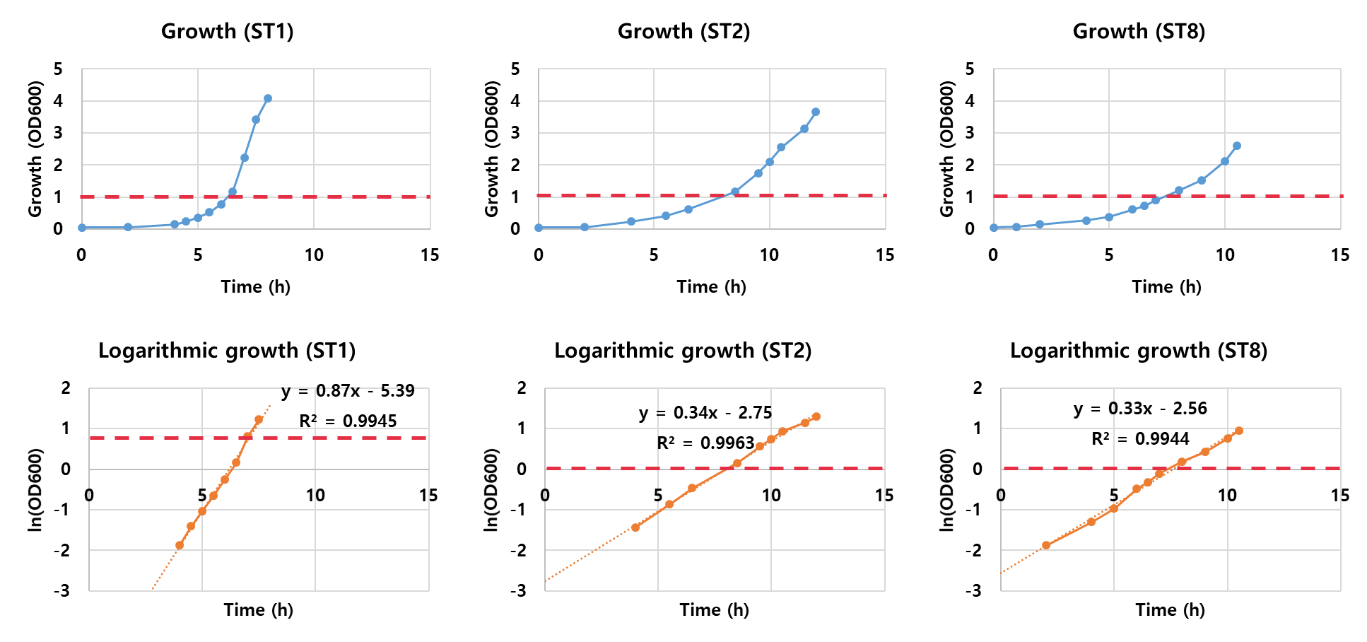

Figure S1. The growth curve of ST1, ST2, and ST8. For searching the exponentially growing section of three strains, we took a natural logarithm to the measured absorbance. The red dashed line indicates the point that OD₆₀₀ is 1 (i.e. ln[OD₆₀₀]=0). The bacterial growth was engaged in exponential phase around the point where OD₆₀₀ is 1 (i.e. ln[OD₆₀₀]=0) which is proven by well fitted linear trend line. The samples for transcriptome analysis and ¹³C MFA were acquired when OD₆₀₀ is around 1. The specific growth rate of ST1, ST2 and ST8 were shown as the slope of trend line in logarithmic graphs.

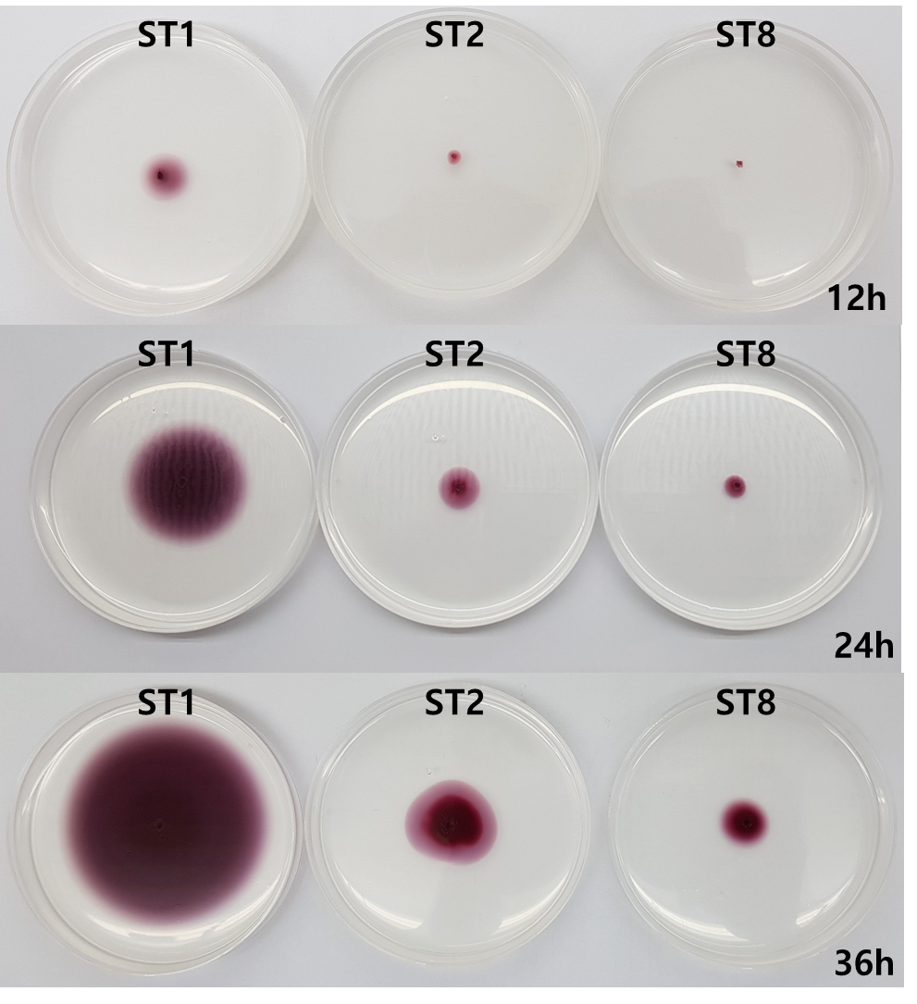

Figure S2. Motility of ST1, ST2 and ST8 was tested in M9 semi-solid agar. The fermentation broth of wild type (ST1) and mutant (ST2 and ST8) was injected by stabbing to the middle of plate and incubated in 37℃. For visualizing growth of strains, 0.05% of Triphenyltetrazolium chloride (TTC) was supplied to medium. As the cultivation progresses, ST1 rapidly spread out on the medium but it was not seen in ST2 and ST8.

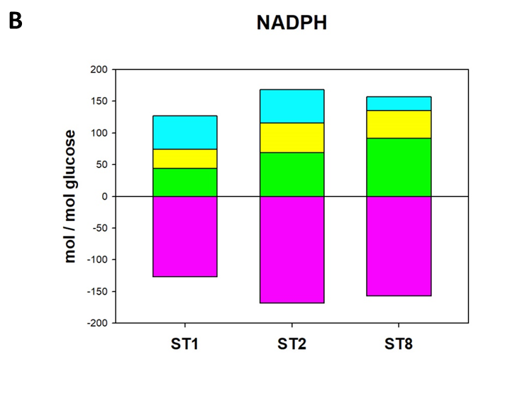
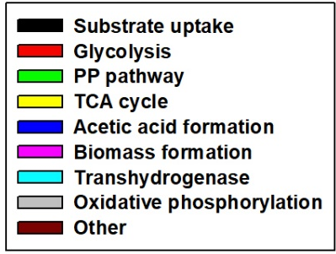
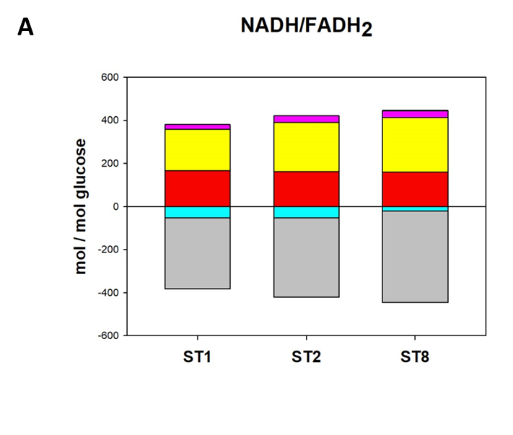
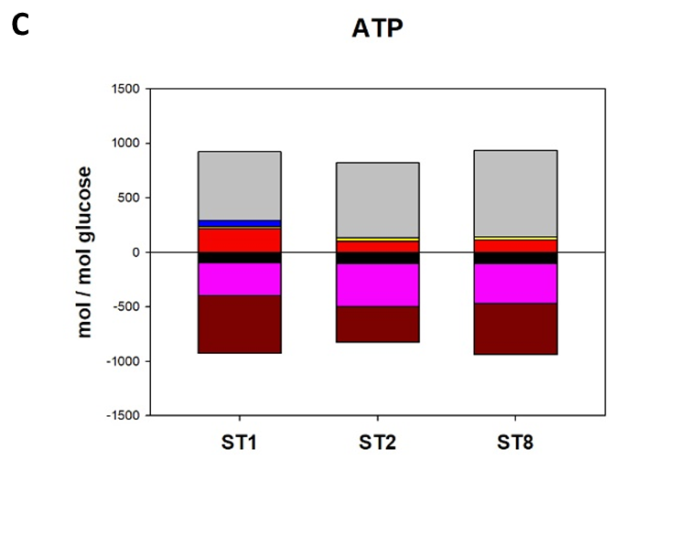
Figure S3. Normalized cofactor balance based on ¹³C MFA results. Shown are balances for (A) NADH/FADH₂, (B) NADPH, and (C) ATP. The contributions of central metabolic pathways to the generation (above 0) and consumption (below 0) of cofactors were presented. We assumed P/O ratio = 2.0 (Gonzalez et al., 2017)

References
Antoniewicz, Maciek R., Joanne K. Kelleher, and Gregory Stephanopoulos. "Determination of confidence intervals of metabolic fluxes estimated from stable isotope measurements." Metabolic engineering 8.4 (2006): 324-337.
Gonzalez, Jacqueline E., Christopher P. Long, and Maciek R. Antoniewicz. "Comprehensive analysis of glucose and xylose metabolism in Escherichia coli under aerobic and anaerobic conditions by 13C metabolic flux analysis." Metabolic engineering 39 (2017): 9-18.

