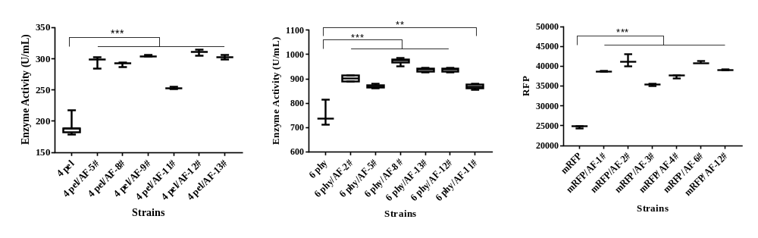
A
C
B
Additional file 1:Figure S1 The enzyme activity and RFU of pectinase strain (A), phytase (B) and mRFP (C) strain with overexpression of Fhl1p after 120 h of induction with methanol. Six constructed clones were tested to assess clonal variation. Box-plot is used to show the distribution of expression level. Medians are shownd by horizontal bars. Statistical significance was examined using a two tailed by unpaired T-test analysis. *P < 0.05, **P < 0.01, ***P < 0.001
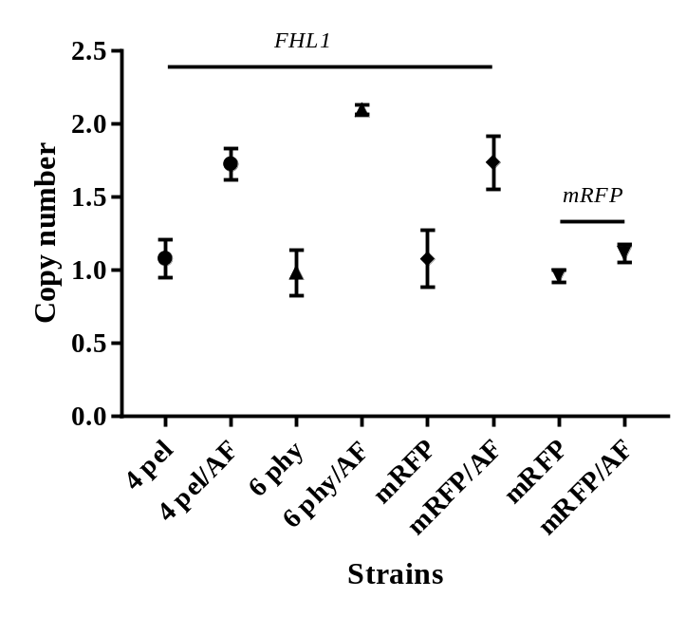
Figure S2 The copy number of FHL1 gene and mRFP gene

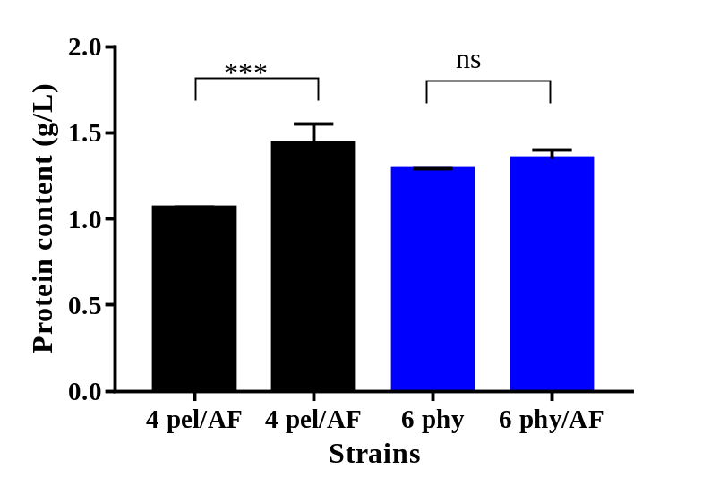
Figure S3 Effect of overexpression in protein content of pectinase and phytase after 120 h of induction with methanol. Statistical significance was examined using a two tailed by unpaired T-test analysis. *P < 0.05, **P < 0.01, ***P < 0.001, ns: no significant difference
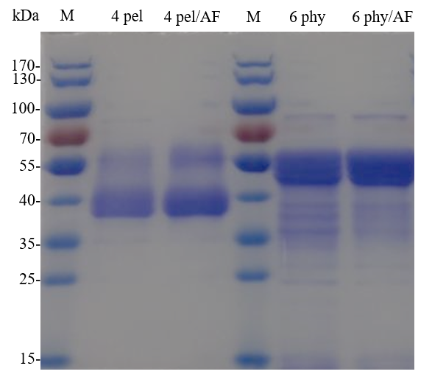
Figure S4 SDS-PAGE of pectinase and phytase after 120 h of induction with methanol

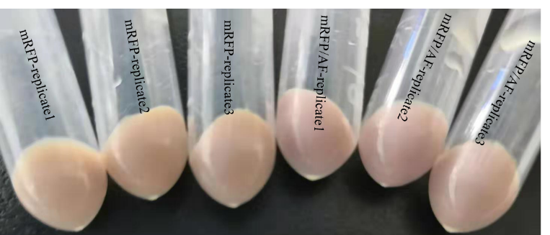
Figure S5 The comparison of mRFP and mRFP/AF in color
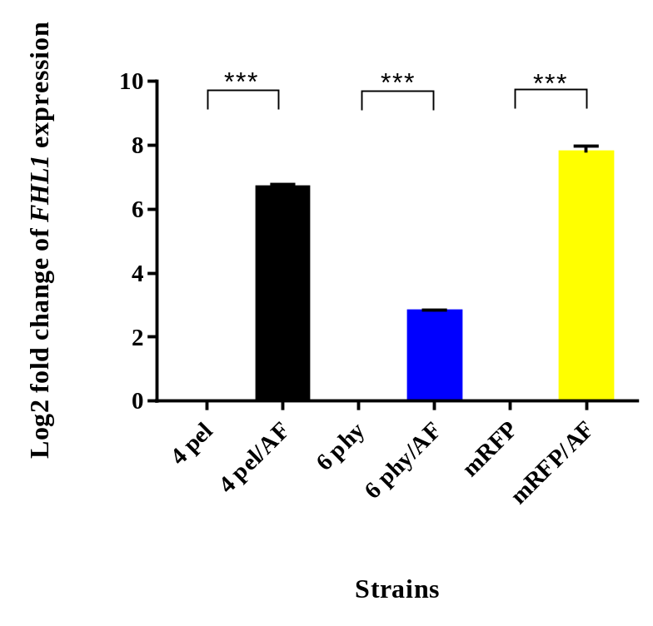
Figure S6 The transcription levels of FHL1 in pectinase, phytase and mRFP expression strains after 120 h of induction with methanol. Statistical significance was examined using a two tailed by unpaired T-test analysis. *P<0.05 and |log2ratio|≥1,**P<0.01 and |log2ratio|≥1, ***P<0.001 and |log2ratio|≥1

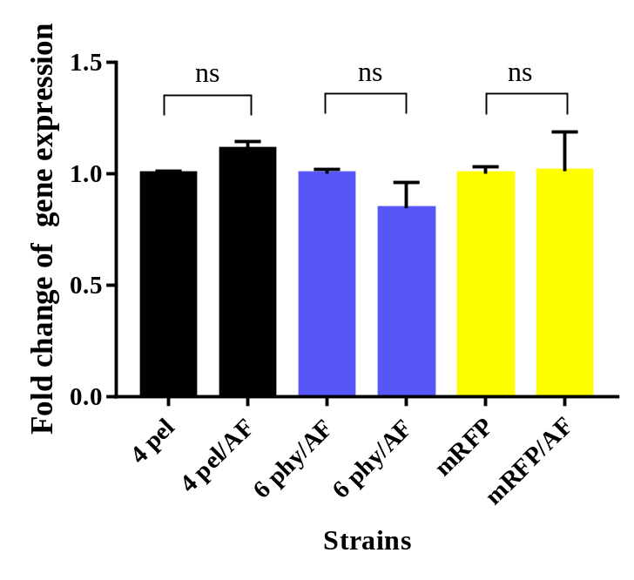
Figure S7 Effect of overexpression Fhl1p on transcription levels of pectinase, phytase and mRFP after 120 h of induction with methanol. Statistical significance was examined using a two tailed by unpaired T-test analysis. *P<0.05 and |log2ratio|≥1,**P<0.01 and |log2ratio|≥1, ***P<0.001 and |log2ratio|≥1, ns: no significant difference

