Additional Material

Table S1: Bacterial strains used in the study
Bacterial Strain | Source | Relevant features
S. marcescens mtcc7298 | MTCC Gene Bank, | Non-pigmented, aerobic, proteolytic strain isolated from Tasar (Antheraea mylitta) Gut.
E.coli DH5-α | Invitrogen | Nonpathogenic E.coli strain for cloning purposes, with high-efficiency for transformation
E.coli BL21(DE3) | Novagen, | The strain expresses T7 polymerase when induced by IPTG. It does not contain genes for lon and omp-t proteases and suitable for expression of non-toxic genes.
E.coli BL21 (DE3)-pLysS | Novagen, | Contains p15A origin pLysS plasmid, which produces T7 lysozyme to reduce basal level expression of the gene of interest provides tighter control of expression.
E.coli Rosetta (DE3)-pLysS | Novagen, | pLysS plasmid contains additional genes for the rare tRNA creating a possibility for eukaryotic protein expression.
E.coli C43(DE3) | Lucigen | Strain consists of at least one uncharacterized mutation allowing the expression of toxic and membrane proteins from all classes of organisms.

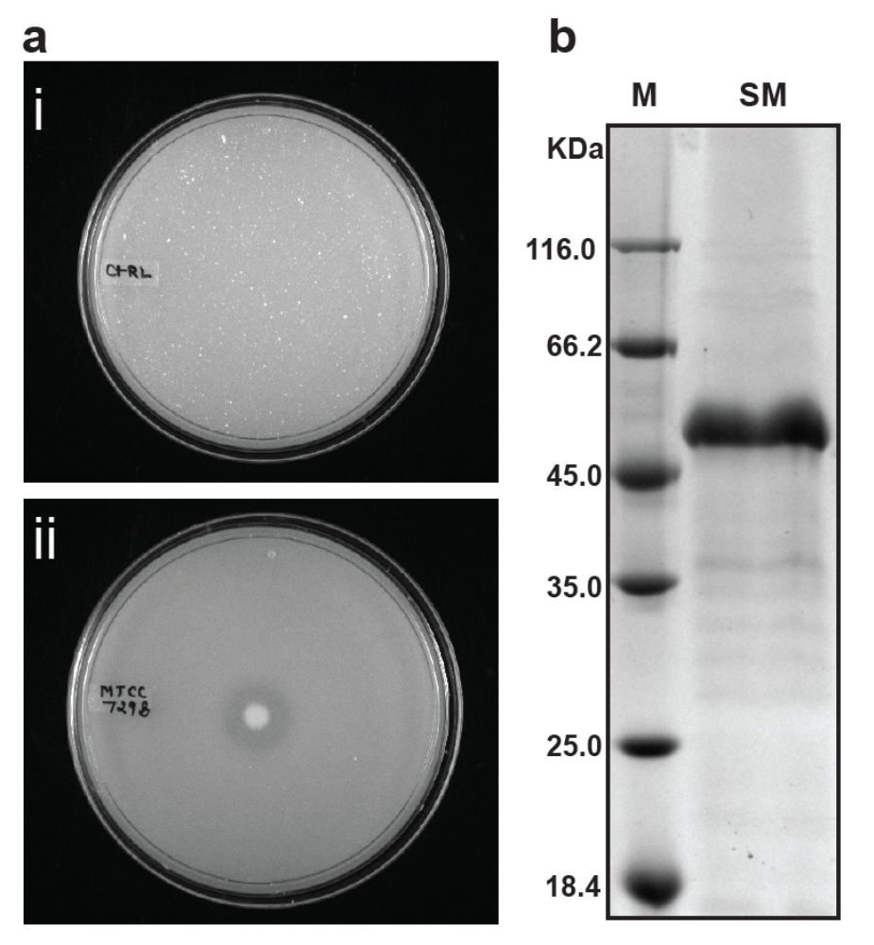
Figure S1: Extracellular secretion of Serratia marcescens mtcc7298 contains 50KDa serratiopeptidase as major secretory protein. a- Agar plates supplemented with 1% skimmed milk showing zone of hydrolysis around Serratia marcescens mtcc7298 colony, an effect of extracellular secretion of protease. b- Representative SDS-PAGE gel lane containing medium-range protein molecular weight marker (Lane-M) and extracellular medium of Serratia marcescens mtcc7298 (10µl) after 48 hours of growth (Lane- SM) shows a significant protein band around 50kDa which is possibly the serratiopeptidase.

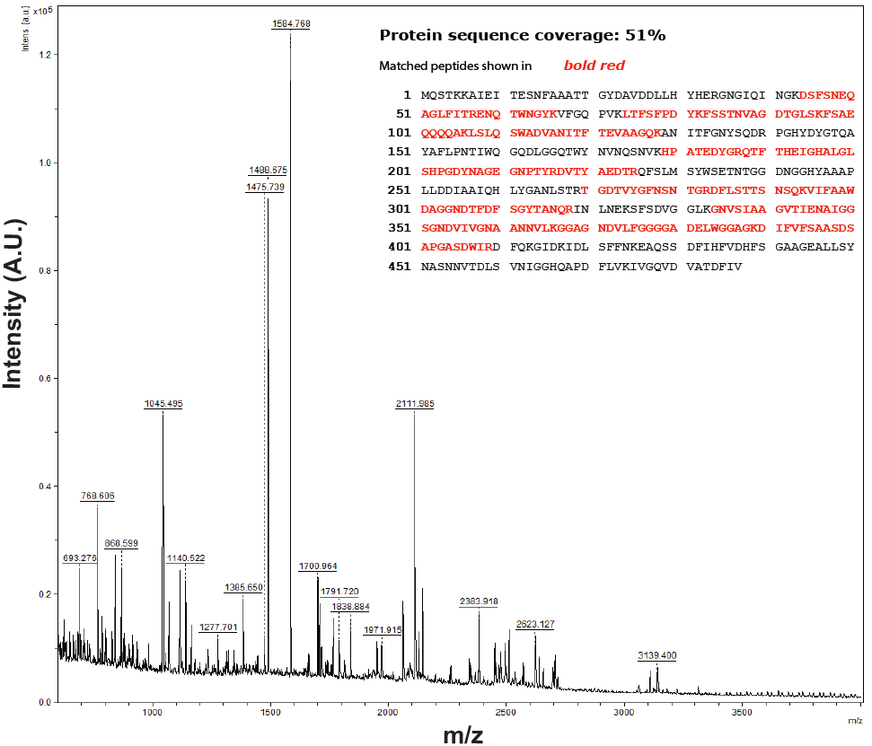

Figure S2: In gel trypsin digestion and peptide mass fingerprinting of the 50kDa protein in Serratia marcescens mtcc7298 extracellular secretion: The secreted protein shows 51% sequence coverage with Serratia marcescens serratiopeptidase protein suggesting confirming the identity of the prominent band as serratiopeptidase.

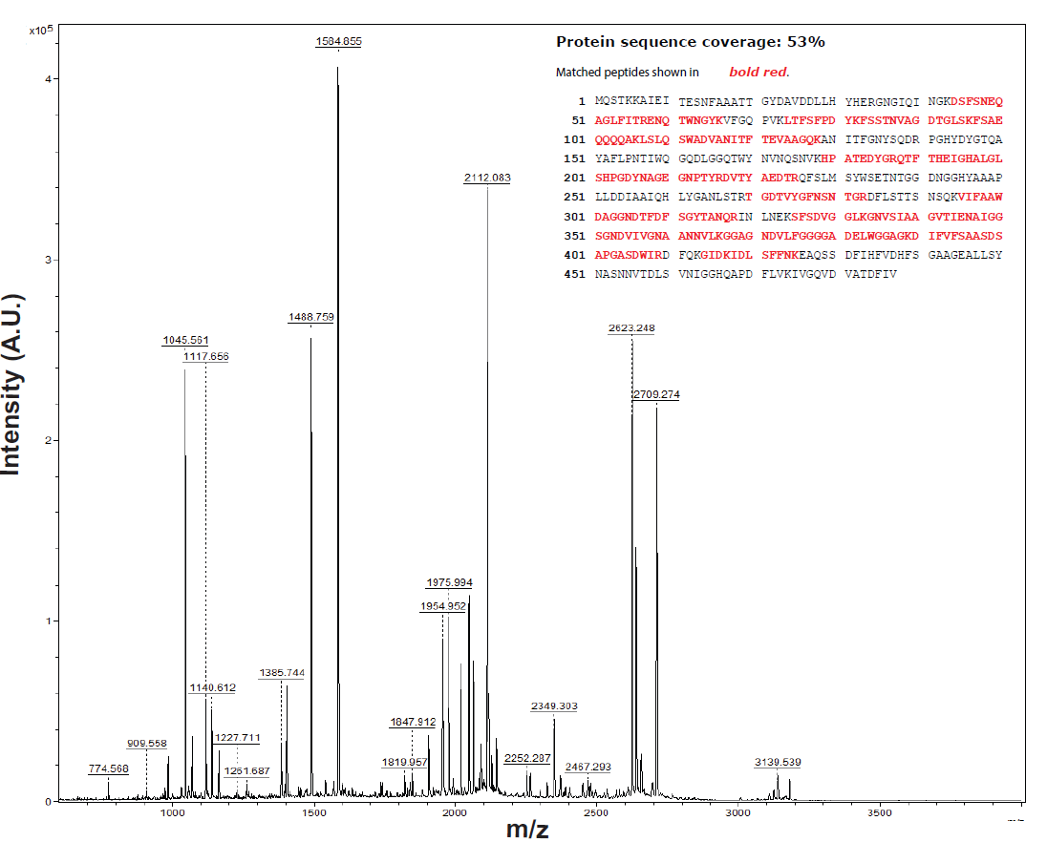
Figure S3: Peptide Mass Fingerprinting of recombinant serratiopeptidase: In-gel trypsin digestion and peptide mass fingerprinting of purified recombinant version mature serratiopeptidase shows 53% sequence coverage with serratiopeptidase protein of Serratia marcescens. There is no matched identity with the initial 16 amino acid representing the propeptide, which confirms the cloned and purified protein is mature version of serratiopeptidase.

