Additional file 1
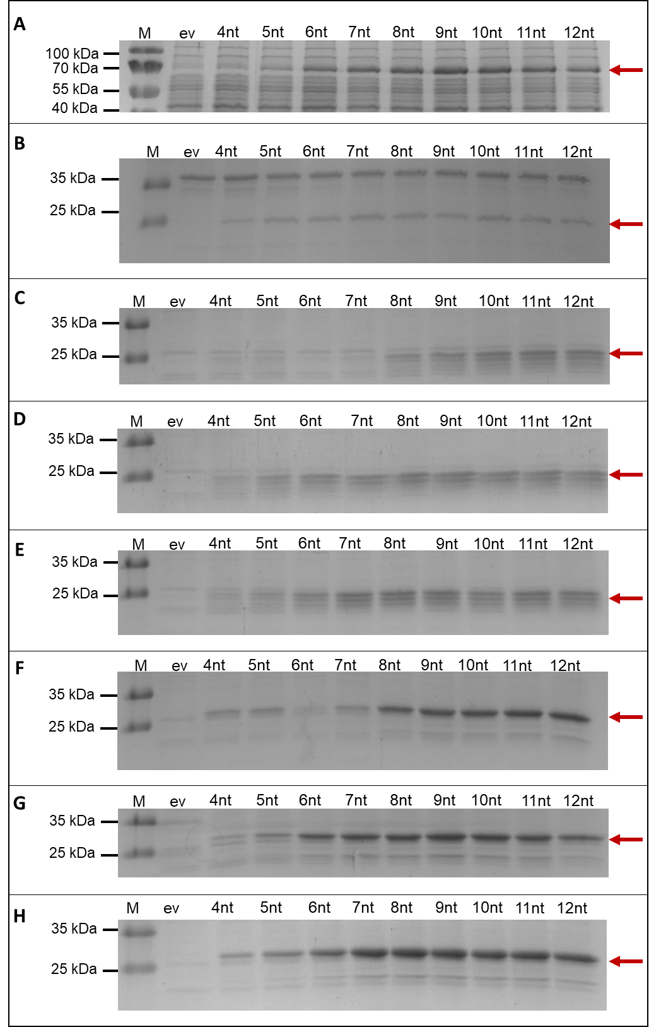
Fig. S1: Influence of spacer length on the production of target proteins. SDS-PAGE analysis of intracellular GUS (A) and GFPmut 3 (B) as well as extracellular SPEpr-Cut-11 (C), SPPel-Cut-11 (D), SPBsn-Cut-11 (E), SPEpr-EXLX1-11 (F), SPPel-EXLX1-11 (G), and SPBsn-EXLX1-11 (H). M: PageRuler™ Prestained Protein Ladder (Thermo Fisher Scientific). ev: empty vector control pBSMul1. The molecular weight of each target gene is indicated by the red arrow.

Fig. S2: Influence of spacer composition on the production of GFPmut3 and SPPel-Cut-11. X-fold change (A) in intracellular GFPmut3 fluorescence or (B) extracellular Cut-11 activity and split GFP assay of B. subtilis TEB1030 harboring one of the mutagenized expression plasmids with an NNNNCAT spacer compared to the optimized expression plasmid with an AAAACAT spacer. The spacer sequence variants were identified in a previous random mutagenesis screening.

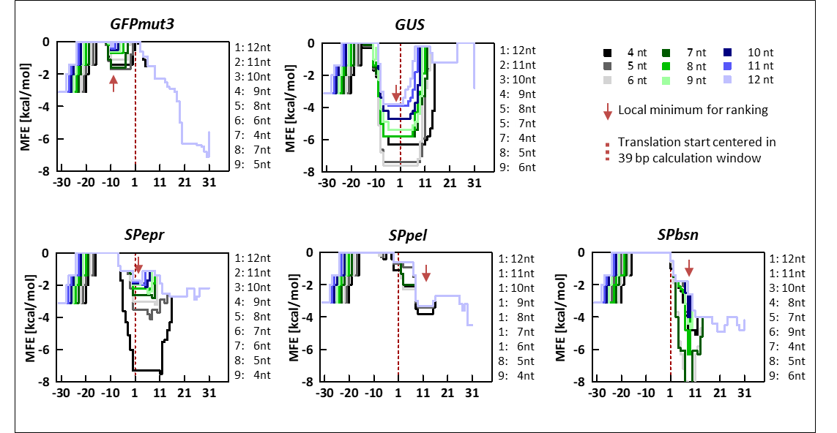
Fig. S3: In silico analysis of mRNA secondary structures. Local folding energy (minimal free energy, MFE) of a 39 bp sliding window around the start codon of the mRNA for different spacer lengths calculated for genes gfpmut3, GUS and gene fusions with signal peptide sequences SPepr, SPpel, or SPbsn (only the signal peptide sequence is embraced by the 39 bp window). Red arrows indicate the local minimum / most stable secondary structure that was used for ranking of spacer length.

Table S1: Primers used in this study.
Name | Sequence (5` → 3`, relevant sequences are underlined)
P1 | GAGATACCCAGATCACATGAAACAGCATGAC | Deletion of NdeI in pEBP41
P2 | GTCATGCTGTTTCATGTGATCTGGGTATCTC | Deletion of NdeI in pEBP41
P3 | GCCCATATGCGTAAAGGAGAAGAAC | GFPmut3 amplification
P4 | GGCTCTAGATTATTTGTATAGTTCATC | GFPmut3 amplification
P5 | GCGCATATGTTACGTCCTGTAGAAAC | GUS (uidA) amplification
P6 | GCGCTCTAGATTATTGTTTGCCTCCCTGC | GUS (uidA) amplification
P7 | GCGCATATGAAAAACATGTCTTGCAAAC | 5´-SPepr
P8 | GCGCATATGAAAAAAGTGATGTTAGCTAC | 5´-SPpel
P9 | GCGCATATGACAAAAAAAGCATGGTTTC | 5´-SPbsn
P10 | TTTCGACCTCTAGATTATGTGATGCC | 3´-GFP11 tag
P11 | GATTTACATAATAAGGAGGAACATATGAAAAACATG | 5nt spacer
P12 | CATGTTTTTCATATGTTCCTCCTTATTATGTAAATC | 5nt spacer
P13 | GATTTACATAATAAGGAGGAAACATATGAAAAACATG | 6nt spacer
P14 | CATGTTTTTCATATGTTTCCTCCTTATTATGTAAATC | 6nt spacer
P15 | GATTTACATAATAAGGAGGAAAACATATGAAAAACATG | 7nt spacer
P16 | CATGTTTTTCATATGTTTTCCTCCTTATTATGTAAATC | 7nt spacer
P17 | GATTTACATAATAAGGAGGAAAAACATATGAAAAACATG | 8nt spacer
P18 | CATGTTTTTCATATGTTTTTCCTCCTTATTATGTAAATC | 8nt spacer
P19 | GATTTACATAATAAGGAGGAAAAAACATATGAAAAACATG | 9nt spacer
P20 | CATGTTTTTCATATGTTTTTTCCTCCTTATTATGTAAATC | 9nt spacer
P21 | GATTTACATAATAAGGAGGAAAAAAACATATGAAAAACATG | 10nt spacer
P22 | CATGTTTTTCATATGTTTTTTTCCTCCTTATTATGTAAATC | 10nt spacer
P23 | GATTTACATAATAAGGAGGAAAAAAAACATATGAAAAACATG | 11nt spacer
P24 | CATGTTTTTCATATGTTTTTTTTCCTCCTTATTATGTAAATC | 11nt spacer
P25 | GATTTACATAATAAGGAGGAAAAAAAAACATATGAAAAACATG | 12nt spacer
P26 | CATGTTTTTCATATGTTTTTTTTTCCTCCTTATTATGTAAATC | 12nt spacer
P27 | GATTTACATAATAAGGAGGNNNNCATATGCGTAAAGGAG | random spacer for GFPmut3
P28 | CTCCTTTACGCATATGNNNNCCTCCTTATTATGTAAATC | random spacer for GFPmut3
P29 | GATTTACATAATAAGGAGGNNNNCATATGAAAAAAGTG | random spacer for SPpel-cut-11
P30 | CACTTTTTTCATATGNNNNCCTCCTTATTATGTAAATC | random spacer for SPpel-cut-11
P31 | AATAAGGAGGACATACGAAAAACATGTCTTG | exchange of first ATG in pBS4nt-SPepr-cut-11
P32 | CAAGACATGTTTTTCGTATGTCCTCCTTATT | exchange of first ATG in pBS4nt-SPepr-cut-11
P33 | ATAAGGAGGAACATACGAAAAACATGTCTTG | exchange of first ATG in pBS5nt-SPepr-cut-11
P34 | CAAGACATGTTTTTCGTATGTTCCTCCTTAT | exchange of first ATG in pBS5nt-SPepr-cut-11
P35 | TAAGGAGGAAACATACGAAAAACATGTCTTG | exchange of first ATG in pBS6nt-SPepr-cut-11
P36 | CAAGACATGTTTTTCGTATGTTTCCTCCTTA | exchange of first ATG in pBS6nt-SPepr-cut-11
P37 | AAGGAGGAAAACATACGAAAAACATGTCTTG | exchange of first ATG in pBS7nt-SPepr-cut-11
P38 | CAAGACATGTTTTTCGTATGTTTTCCTCCTT | exchange of first ATG in pBS7nt-SPepr-cut-11
P39 | AGGAGGAAAAACATACGAAAAACATGTCTTG | exchange of first ATG in pBS8nt-SPepr-cut-11
P40 | CAAGACATGTTTTTCGTATGTTTTTCCTCCT | exchange of first ATG in pBS8nt-SPepr-cut-11
P41 | GGAGGAAAAAACATACGAAAAACATGTCTTG | exchange of first ATG in pBS9nt-SPepr-cut-11
P42 | CAAGACATGTTTTTCGTATGTTTTTTCCTCC | exchange of first ATG in pBS9nt-SPepr-cut-11
P43 | GAGGAAAAAAACATACGAAAAACATGTCTTG | exchange of first ATG in pBS10nt-SPepr-cut-11
P44 | CAAGACATGTTTTTCGTATGTTTTTTTCCTC | exchange of first ATG in pBS10nt-SPepr-cut-11
P45 | AGGAAAAAAAACATACGAAAAACATGTCTTG | exchange of first ATG in pBS11nt-SPepr-cut-11
P46 | CAAGACATGTTTTTCGTATGTTTTTTTTCCT | exchange of first ATG in pBS11nt-SPepr-cut-11
P47 | GGAAAAAAAAACATACGAAAAACATGTCTTG | exchange of first ATG in pBS12nt-SPepr-cut-11
P48 | CAAGACATGTTTTTCGTATGTTTTTTTTTCC | exchange of first ATG in pBS12nt-SPepr-cut-11
P49 | ACATATGAAAAACACGTCTTGCAAACTTGT | exchange of second ATG in pBSxnt-SPepr-cut-11
P50 | ACAAGTTTGCAAGACGTGTTTTTCATATGT | exchange of second ATG in pBSxnt-SPepr-cut-11
Real time qPCR primers
RT-GFPmut3-fwd | GCGATGGCCCTGTCCTTTTACC
RT-GFPmut3-rev | TGCCATGTGTAATCCCAGCAGC
RT-Gus-fwd | TCTGCGACGCTCACACCGAT
RT-Gus-rev | GCCGTTTCCAAATCGCCGCT
RT-Cut-fwd | AGAACCTACAGAACCGTGGCCG
RT-Cut-rev | AAGCCAAGTGAGGTGCAGCAA
RT- EXLX1-fwd | ACTGACATCCGCGGAAAAGTTGT
RT- EXLX1-rev | AGCCGCCATCAGAGCCGATA
RT-SigA-fwd | ATCGCCTGTCTGATCCACCA
RT-SigA-rev | GGTATGTCGGACGCGGTATG

Table S2 Changes in transcript amounts of target genes with different spacer lengths. Relative changes with lower and upper range of transcript level of GUS, GFPmut3, cut-11 and EXLX1-11 (the latter two with different signal peptide sequences) in strains harboring the standard expression plasmids (4nt) and plasmids with different spacer lengths (see text for further information). Significantly increased transcript levels (p < 0.05) are marked with asterisks.

target gene | spacer length [nt] | rel. change | lower range | upper range
GUS | 4 | 1 | 0.56 | 1.80
GUS | 10 | 2.23* | 1.36 | 3.64
GFPmut3 | 4 | 1 | 0.31 | 3.20
GFPmut3 | 7 | 2.22* | 0.89 | 5,54
SPepr-cut-11 | 4 | 1 | 0.36 | 2.76
SPepr-cut-11 | 6 | 1.09 | 0.45 | 2.64
SPepr-cut-11 | 11 | 2.06* | 0.96 | 4.41
SPpel-cut-11 | 4 | 1 | 0.52 | 1.91
SPpel-cut-11 | 7 | 2.01 | 0.75 | 5,41
SPbsn-cut-11 | 4 | 1 | 0.72 | 1.39
SPbsn-cut-11 | 8 | 1.63 | 0.78 | 3.39
SPepr-EXLX1-11 | 4 | 1 | 0.49 | 2.05
SPepr-EXLX1-11 | 6 | 1.60* | 0.89 | 2,89
SPepr-EXLX1-11 | 11 | 3.23* | 1.42 | 7.47
SPpel-EXLX1-11 | 4 | 1 | 0.73 | 1.37
SPpel-EXLX1-11 | 7 | 1.58* | 0.95 | 2.64
SPbsn-EXLX1-11 | 4 | 1 | 0.59 | 1.71
SPbsn-EXLX1-11 | 8 | 1.39* | 0.94 | 2.06

