Figure S1. The rarefaction curves of all sample. (A) Observed species and (B) chao1.
(A)
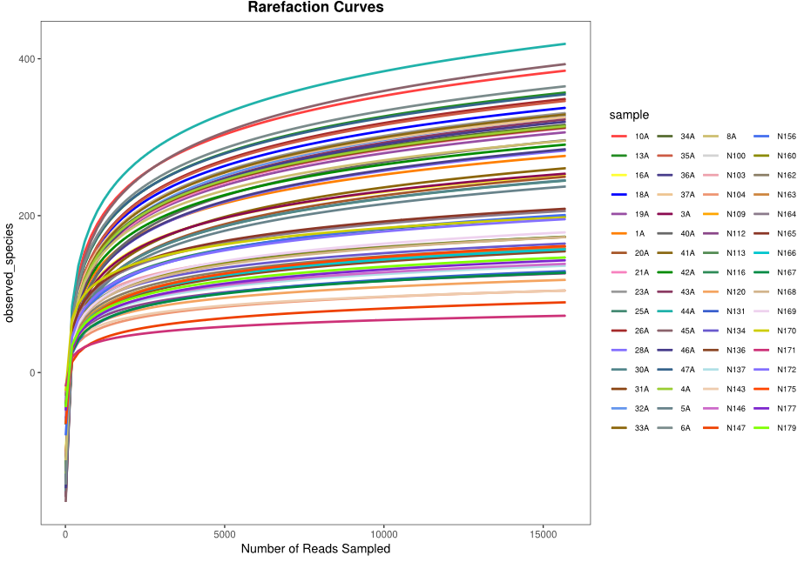
(B)
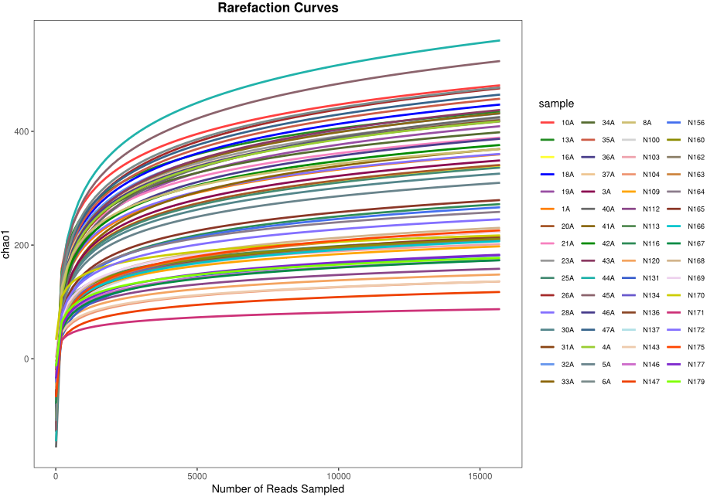

Figure S2. The bacterial community difference between AR and non-AR group. (A) The ANOSIM analysis are made to compare the intergroup and within group of samples. (B) The bacterial community variation comparison in AR and non-AR group.
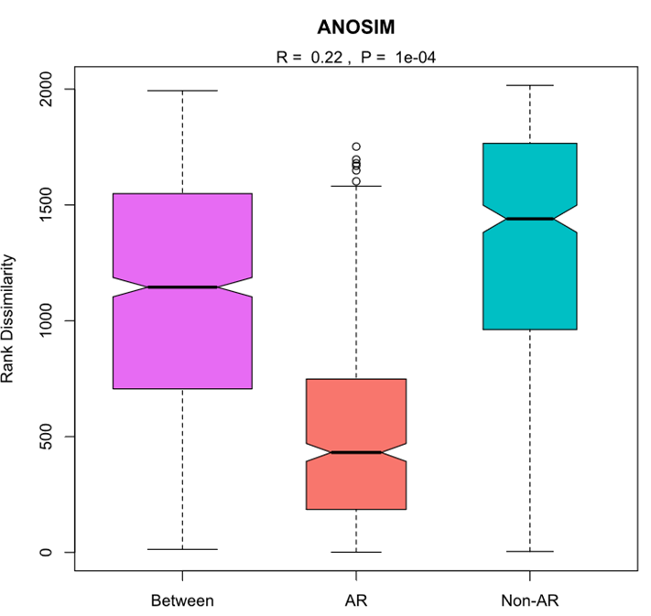
(A)
(B)
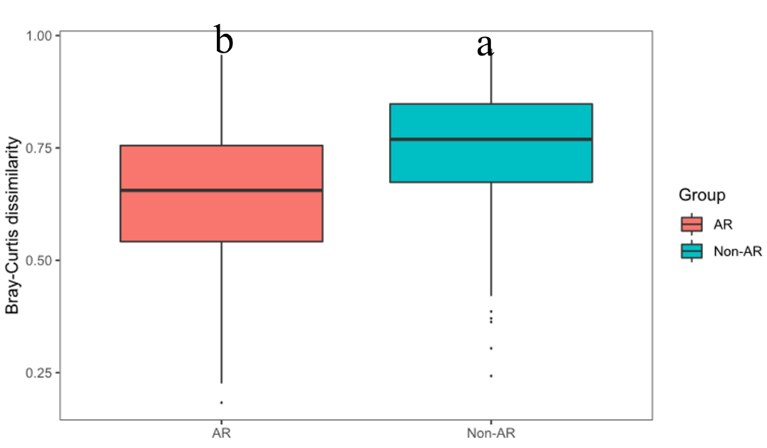
Figure S3. The predicted expression of distinguished pathway. The significantly distinguished pathway predicted by PICRUSt were screened by comparison between AR and non-AR individuals by Wilcox test and based on |logFC|>1. FC denotes fold change.

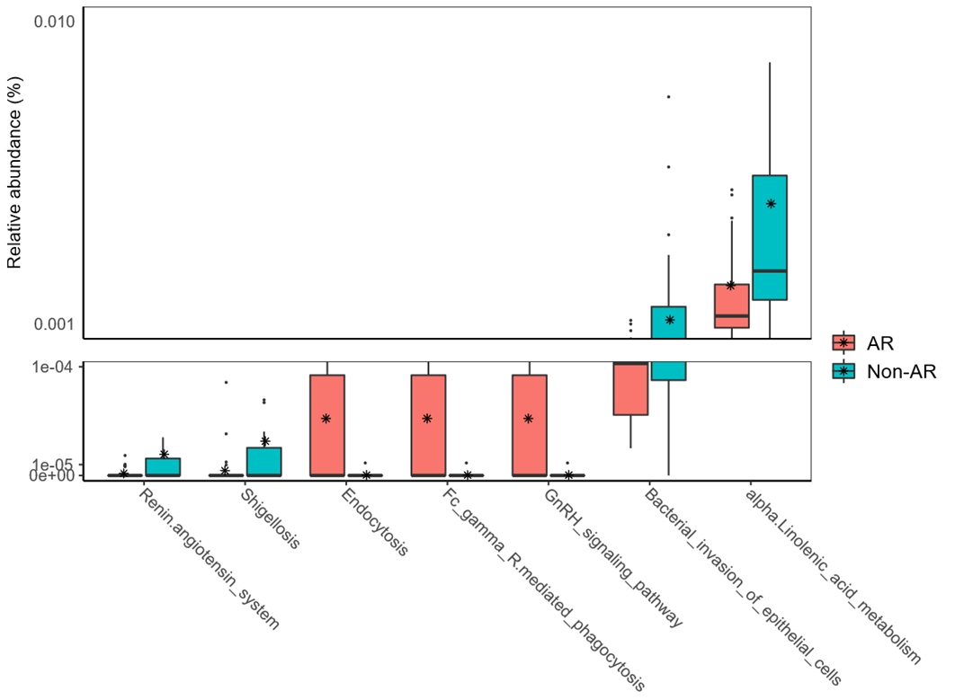

Figure S4. Comparisons of bacterial diversity between moderate and severe AR patients. (A) The bacterial α diversity indexes comparison between moderate and severe AR, including Chao1, J and Shannon. Letters indicate the ANOVA groupings. (B) Differences in bacterial community structures between moderate and severe AR patients.
(A)
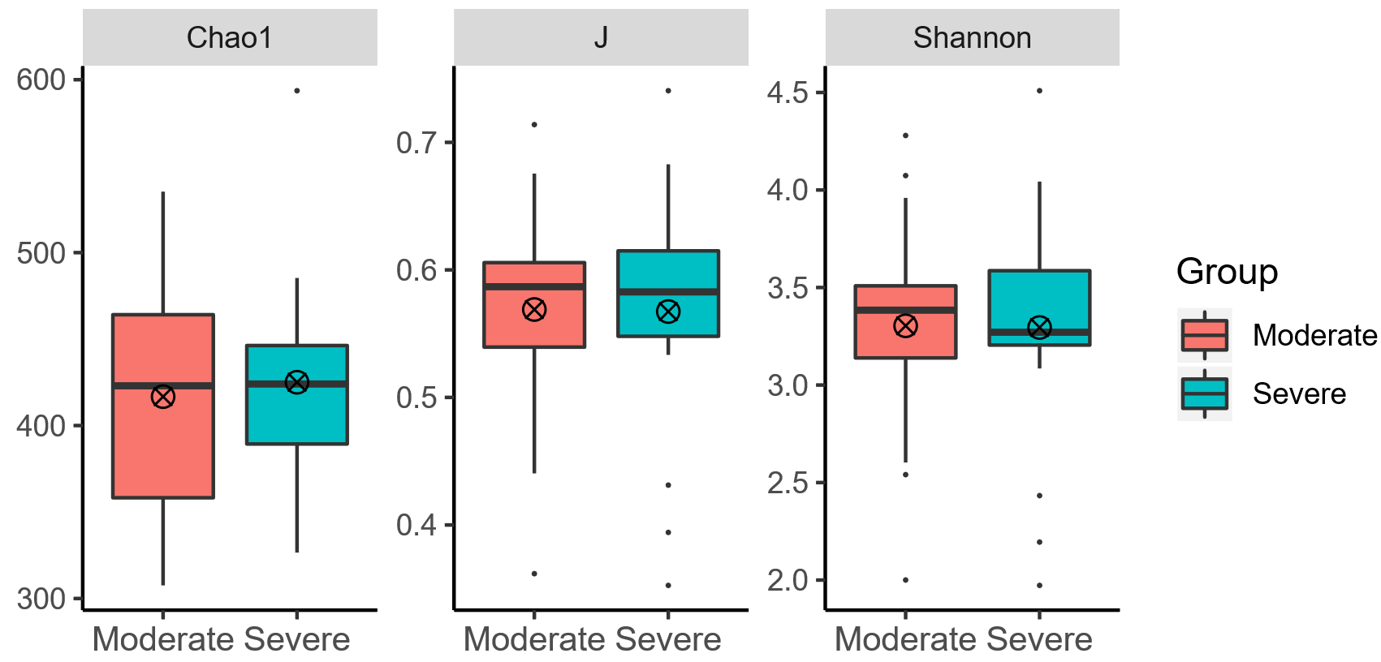
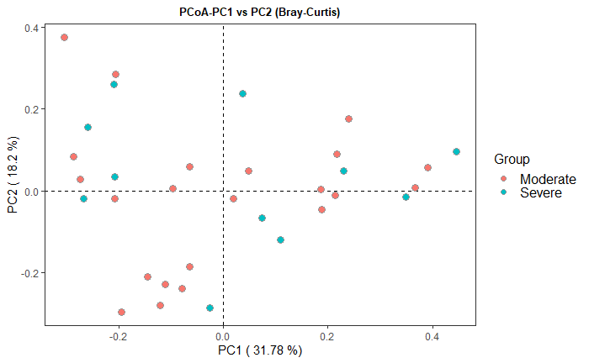
(B)

