Metabolic engineering of Rhodococcus jostii RHA1 for production of pyridine-dicarboxylic acids from lignin

Edward M. Spence, Leo Calvo-Bado, Paul Mines, and Timothy D.H. Bugg

Supporting Information

Contents
Figure S1. Vector for construction of the ΔpcaHG markerless deletion R. jostii strain

Figure S2. PCR confirmation of the ΔpcaHG markerless deletion
Figure S3. Growth characteristics of ΔpcaHG markerless deletion and wild-type R. jostii strains
Figure S4. HPLC analysis of ΔpcaHG markerless deletion and wild-type R. jostii strains grown in M9 minimal media containing 0.1% 4-hydroxybenzoic acid
Figure S5. Production of 2,4-PDCA observed by HPLC analysis in R. jostii ΔpcaHG containing pTipQC2ligAB
Figures S6. HPLC traces for production of 2,4-PDCA by R. jostii ΔpcaHG containing pTipQC2ligAB, and for production of 2,5-PDCA by R. jostii ΔpcaHG containing pTipQC2praA.
Figure S7. Agarose gels showing loss of plasmid DNA from R. jostii ΔpcaHG containing pTipQC2ligAB
Figures S8,S9. Chromosomal integration vector (S8) for insertion of ligAB or praA genes onto R. jostii chromosome, and relevant PCR primers (S9)
Figure S10. Gene expression for praA and ligAB genes for chromosomal gene insertion constructs (without promoter) by RT-PCR
Figure S11. Nucleotide sequence of constitutive promoter P_{tpc5}
Figures S12,S13. LigAB activity (S12) and protein production (S13) from pcaHG:ligAB(P_{icl}) construct, induced with 1-8% methanol
Figure S14. LigAB activity observed using R. jostii pcaHG:ligAB constructs containing four
different promoters, grown in LB media
Figure S15. Whole cell biotransformation of protocatechuic acid (PCA) to 2,4-PDCA using R. jostii pcaHG:ligAB(P_{icl}) and R. jostii pcaHG:ligAB(P_{tpc5}).
Figure S16. Production of 2,4-PDCA using R. jostii pcaHG:ligAB(P_{tpc5}) grown on M9 minimal media containing 0.1% 4-hydroxybenzoic acid and 0.1% yeast extract, analysed by HPLC.
Figure S17. Production of 2,4-PDCA from minimal media containing Green Value Protobind lignin by constructs containing chromosomal expression of ligAB genes, analysed by HPLC.
Figure S18. SDS-PAGE gel of cell extracts of R. jostii pcaHG:ligAB(P_{tpc5}) with or without pTipQC2-dyp2, showing expression of recombinant Dyp2 peroxidase
Figure S19. Production of 2,4-PDCA by R. jostii pcaHG:ligAB(P_{tpc5}) with or without pTipQC2-dyp2, grown on M9 minimal media containing 1% wheat straw lignocellulose
Figure S20. Small scale (4 mL) testing of the production of 2,4-PDCA and protocatchuic acid (PCA) by R. jostii pcaHG:ligAB(P_{tpc5}) with or without expression of Amycolatopsis dyp2 gene.
Figure S21. Titre of 2,4-PDCA vs time from 2.5L bioreactor for R. jostii pcaHG:ligAB(P_{tpc5}) grown on M9 minimal media containing 1% Green Value Protobind lignin at 30 ºC
Figures S22-S24. Isolation of 2,4-PDCA product from fermentation broth: S22, Extraction of 2,4-PDCA into isopropanol; S23, HPLC analysis of extracted product; S24, ¹H NMR analysis of isolated product.

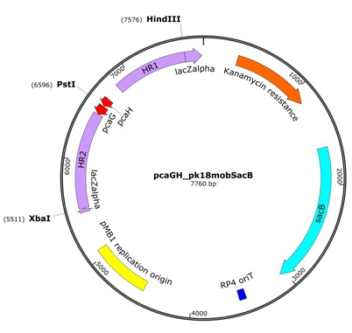
Figure S1. Vector for construction of the ΔpcaHG markerless deletion R. jostii RHA1 strain, based upon vector pK18mobsacB (van der Geize et al, 2001)

Figure S2. PCR confirmation of the ΔpcaHG markerless deletion

Figure S3. Growth characteristics of ΔpcaHG markerless deletion and wild-type R. jostii RHA1 strains in (A) LB broth (B) M9 minimal media containing 0.1% protocatechuic acid as sole carbon source, grown at 30 ºC. Error bars indicate the standard deviation from duplicate biological replicates.

C
B
A
Figure S4. HPLC analysis of (A) wild-type R. jostii RHA1 and (B) ΔpcaHG markerless deletion strains grown in M9 minimal media containing 0.1% 4-hydroxybenzoic acid (authentic standard, C) as sole carbon source, grown for 48 hr at 30 ºC, showing the accumulation of protocatechuic acid in the gene deletion strain, but not in the wild-type strain. Y-axis, mAU (270 nm); x-axis retention time (min).
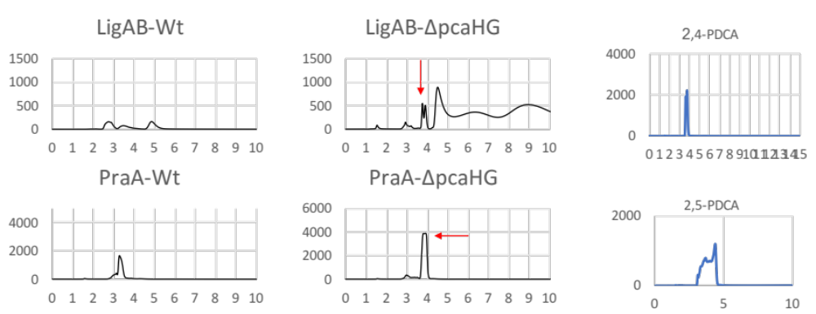

Figure S5. Effect of pcaHG gene deletion on production of 2,4-PDCA (upper panels) and 2,5-PDCA (lower panels) on M9 media containing 0.1% 4-hydroxybenzoic acid and 0.4% glucose after 144 hr at 30 ºC, observed by HPLC analysis. Upper panels: wild-type R. jostii RHA1 containing pTipQC2ligAB (upper left); R. jostii ΔpcaHG containing pTipQC2ligAB (upper middle, 486 mg/L, also visible peaks for 4-hydroxybenzoic acid and protocatechuic acid); 2,4-PDCA standard. Lower panels: wild-type R. jostii RHA1 containing pTipQC2praA (lower left); R. jostii ΔpcaHG containing pTipQC2ligAB (upper middle, 810 mg/L); 2,5-PDCA standard. Y-axis, mAU (270 nm); x-axis retention time (min).

Figure S6. HPLC traces showing production of 2,4-PDCA by R. jostii ΔpcaHG containing pTipQC2ligAB (upper panel, 200 mg/L after 168 hr), and production of 2,5-PDCA by R. jostii ΔpcaHG containing pTipQC2praA (lower panel, 287 mg/L after 168 hr), from M9 minimal media containing 1% wheat straw lignocellulose, grown for 24-168 hr at 30 ºC. Y-axis, mAU (270 nm); x-axis retention time (min).

Figure S7. Agarose gels showing loss of plasmid DNA (lanes containing no visible bands) from R. jostii ΔpcaHG-pTipQC2ligAB, from liquid and plate stocks, over 2-3 weeks.

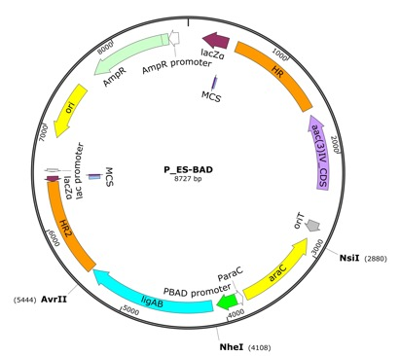
A

B
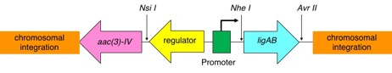

Figure S8. A. Chromosomal integration vector for insertion of ligAB or praA genes onto R. jostii RHA1 chromosome, with or without a promoter sequence. B. Construct for chromosomal expression of ligAB genes under the control of a gene promoter.

Primer name | Primer sequence 5’-3’
Fragment 1.FOR | CTTGCATGCCTGCAGGTCGACTCTAGAGGATCCCCGAGGAGAAGAACGCGCCGCC
Fragment 1.REV | AACTTCGAAGCAGCTCCAGCCTACAATGGTCAACAAAGTCTTCGC
Fragment 2.FOR | CCGTTGCGAAGACTTTGTTGACCATTGTAGGCTGGAGCTGCTTCG
Fragment 2.REV | TGATGTAGCCGTCAAGTTGTCATAAATGCATATTCCGGGGATCCGTCGACC
Fragment 3.FOR | CTGCAGGTCGACGGATCCCCGGAATATGCATTTATGACAACTTGACGGCTA
Fragment 3.REV | CGATTCTCTCTTTCTTCTCGGTCATGCTAGCATTAATTAATAACCTCCTTAGAGCTCGAATTCC
Fragment 4.FOR | GGAATTCGAGCTCTAAGGAGGTTATTAATTAATGCTAGCATGACCGAGAAGAAAGAGAG
Fragment 4.REV | CGACACCTTTCTGCGTTGTGACCGACCTAGGTCAGGCCTGGGCCAGGCTGTG
Fragment 5.FOR | CGGACACAGCCTGGCCCAGGCCTGACCTAGGTCGGTCACAACGCAGAAAGG
Fragment 5.REV | TAAAACGACGGCCAGTGAATTCGAGCTCGGTACCCCGCGGCGCGCTGCTGCTCGT
ligAB_F3 | GGCGGGAATGTCTATTTCCT
ligAB_R1 | CCGAGGCATGGTCGTTATAG

Figure S9. PCR primers for construction of chromosomal integration vector in Figure S8.

Clone | mutation | Media | Time | Gene expression
clone 2 | 04166:praA | M9/0.1%PCA | 192 hr | 0.0083 (praA)
clone 5 | pcaHG:praA | M9/0.1%PCA | 192 hr | 0.0025 (praA)
clone 20-1 | 04166:ligAB | M9/0.1%PCA | 192 hr | 0.0065 (ligAB)
wild type | none | M9/0.1%PCA | 192 hr | None for ligAB  0.1461 (pcaH)
clone 1 | pcaHG:ligAB | M9/0.1%VA | 144 hr | 0.00015 (ligAB)

Figure S10. Gene expression data for praA and ligAB genes in chromosomal gene insertion constructs (without promoter) by quantitative RT-PCR, showing very low expression of praA & ligAB, compared with wild-type pcaH.

PtipA TGTACATATCGAGGCGGGCTCCCACGGCCG -100 CCCGGGCTGAGGGAGCCGACGGCACGCGGCGGCTCACGGCGTGGCACGCG -50 GAACGTCCGGGCTTGCACCTCACGTCACGTGAGGAGGCAGCGTGGACGGC start
Ptpc5 GTATAATGGACGGC

Figure S11. Nucleotide sequence of P_{tpc5} (designated P_{nit} in Nakashima & Tamura 2004), which is a constitutive promoter based upon the inducible P_{tipA} promoter, but containing 5 mutations in -10 box

Figure S12. Intracellular LigAB activity from R. jostii pcaHG:ligAB(P_{icl}) construct, grown in LB media containing 1-8% methanol for 24 hr. Assays were carried out after cell lysis (protein concentration 0.32 mg/ml) as described in Methods section, absorbance measured at 410 nm after 10 min assay. Y-axis, absorbance change at 410 nm.

Figure S13. SDS-PAGE of cell lysates from R. jostii pcaHG:ligAB(P_{icl}) construct, induced with 1-8% methanol, compared with wild-type R. jostii RHA1 (Wt), showing overexpression of LigB (33 kDa, marked with arrow).

Figure S14. Intracellular LigAB activity observed using R. jostii pcaHG:ligAB constructs containing four different promoters for the ligAB genes, grown in LB media containing 5% methanol (P_{icl}), 0.1% ε-caprolactam (P_{nitA}), 0.1% thiostrepton (P_{tipA}), or no additive (P_{tpc5}) for 24 hr at 30 ºC. Assays were carried out after cell lysis as described in Methods section, absorbance measured at 410 nm after 10 min assay. Error bars indicate standard deviation from 3 biological replicates.

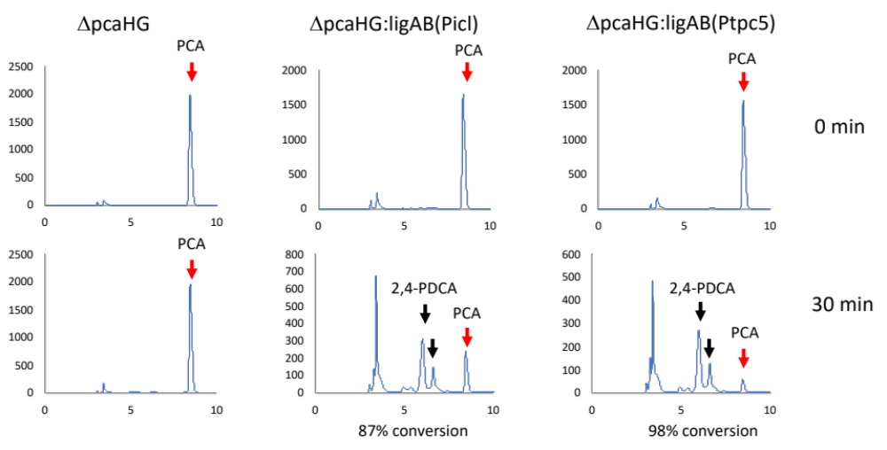

Figure S15. Whole cell biotransformation of protocatechuic acid (PCA) to 2,4-PDCA using R. jostii pcaHG:ligAB(P_{icl}) and R. jostii pcaHG:ligAB(P_{tpc5}) cells, compared with R. jostii ΔpcaHG as control, assessed by reverse phase HPLC. 0.5 mg/mL PCA (0.05%), 6 g/L NH₄Cl, 160 mg R. jostii cells (grown on LB media) in 50 mM potassium phosphate buffer pH 7.5, total volume 4.0 mL. Incubated for 30 min at 30 ºC, aliquots taken at t = 0, 30 min, supernatant after centrifugation analysed by HPLC. Y-axis, mAU (270 nm); x-axis retention time (min).

Figure S16. Production of 2,4-PDCA using R. jostii pcaHG:ligAB(P_{tpc5}) grown on M9 minimal media containing 0.1% 4-hydroxybenzoic acid and 0.1% yeast extract for 144 hr at 30 ºC, supernatant after centrifugation analysed by HPLC. Left hand panel shows 2,4-PDCA authentic standard. Y-axis, mAU (270 nm); x-axis retention time (min).

Figure S17. Production of 2,4-PDCA from M9 media containing 1% Green Value Protobind lignin by constructs containing chromosomal expression of ligAB genes, supernatant after centrifugation analysed by HPLC. A. Production of 2,4-PDCA and PCA by R. jostii pcaHG:ligAB(P_{tpc5}), compared with R. jostii ΔpcaHG lacking the ligAB genes, grown in M9 media containing 1% Green Value Protobind lignin and 0.1% yeast extract after 168 and 240 hr at 30 ºC. B. Production by R. jostii pcaHG:ligAB(P_{icl}), compared with R. jostii ΔpcaHG lacking the ligAB genes, grown in M9 media containing 1% Green Value Protobind lignin, 5% methanol and 0.1% yeast extract after 168 hr at 30 ºC. Y-axis, mAU (270 nm); x-axis retention time (min).

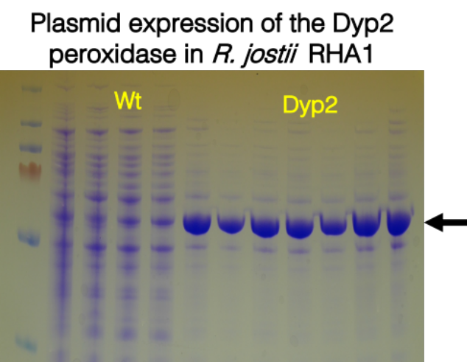

Figure S18. SDS-PAGE gel of cell extracts of R. jostii pcaHG:ligAB(P_{tpc5}) with or without pTipQC2-dyp2, grown in LB broth for 24 hr at 30 ºC, induced with 0.1% thiostrepton, showing expression of recombinant Dyp2 peroxidase (marked with arrow).

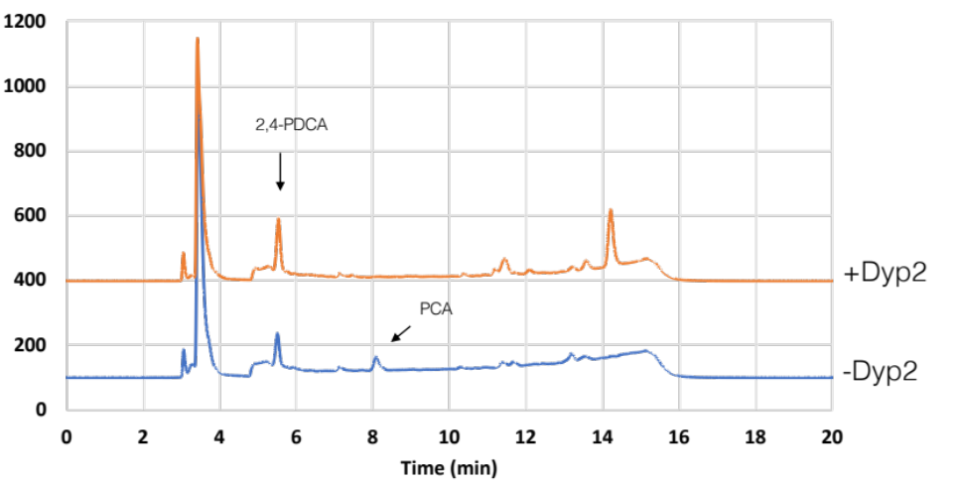

Figure S19. Production of 2,4-PDCA by R. jostii pcaHG:ligAB(P_{tpc5}) with or without pTipQC2-dyp2, grown on M9 minimal media containing 1% wheat straw lignocellulose for 120 hr at 30 ºC. 2,4-PDCA titres: 186 mg/L with pTipQC2-dyp2, 116 mg/L without pTipQC2-dyp2. Y-axis, mAU (270 nm).

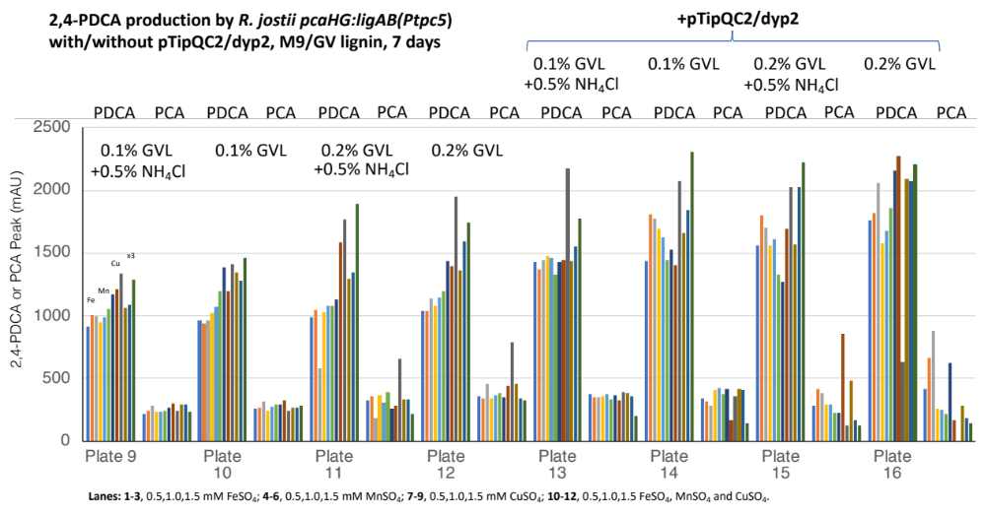

Figure S20. Small scale (4 mL) testing of the production of 2,4-PDCA and protocatechuic acid (PCA) by R. jostii pcaHG:ligAB(P_{tpc5}) with or without expression of Amycolatopsis dyp2 gene, grown on M9 minimal media containing 0.1% or 0.2% Green Value Protobind lignin, testing the addition of 0.5-1.5 mM FeSO₄, MnSO₄, and CuSO₄, and additional 0.5% NH₄Cl. Incubated for 168 hr at 30 ºC, analysed by HPLC as described in Methods.

64 hr
43 hr
39 hr
20 hr
mAU

Figure S21. Production of 2,4-PDCA by HPLC (peak height in mAU) vs time from 2.5L bioreactor for R. jostii pcaHG:ligAB(P_{tpc5})-pTipQC2-dyp2, grown on M9 minimal media containing 1% Green Value Protobind lignin at 30 ºC for 20-64 hr, showing maximum titre at 39 hr.

B
A
Figure S22. Extraction of 2,4-PDCA product (assessed by HPLC analysis, red arrow) from bioreactor fermentation broth (Panel A, R. jostii pcaHG:ligAB(P_{tpc5})-pTipQC2-dyp2 grown on M9 minimal media/1% Green Value Protobind lignin at 30 ºC for 40 hr) into isopropanol (Panel B, after isopropanol extraction), as described in Methods. Y-axis, mAU (270 nm); x-axis retention time (min).

Figure S23. HPLC analysis of solid containing 2,4-PDCA product (arrow) isolated after solvent evaporation of isopropanol extract of R. jostii pcaHG:ligAB(P_{tpc5})-pTipQC2-dyp2 bioreactor fermentation. Y-axis, mAU (270 nm); x-axis retention time (min).

Figure S24. ¹H NMR spectrum (300 MHz, d₄-MeOH) of solid containing 2,4-PDCA isolated from R. jostii pcaHG:ligAB(P_{tpc5})-pTipQC2-dyp2 bioreactor fermentation after isopropanol extraction. Assignment of 2,4-PDCA ¹H signals marked with arrows: δ_{H} 8.22 (1H, d, J = 7 Hz, H-6), 7.65 (1H, d, J = 7 Hz, H-5), 7.32 (1H, s, H-3) ppm.

