Additional file 1
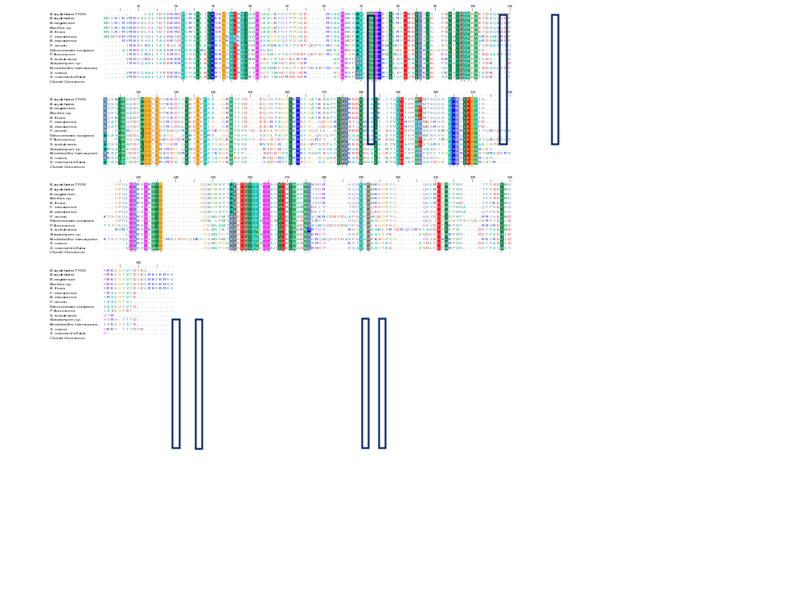

Fig. S1: MSA was performed using ClustalW program using Bioedit v. 7.2.5. The tyrosinase sequences from the various organisms and their accession numbers are given inside ear bracket are B. aryabhattai TFG5 (MW505907), B. aryabhattai (WP_043981293.1), B. megaterium (3NM8), Bacillus sp. Root147 (WP_057234811), B. flexus (WP_025750930), Fictibacillus macauensis (WP_050979754), B. macauensis ZFHKF-1 (EIT84795), Pseudomonas veronii (WP_017849537), Nitrosomonas europaea ATCC 19718 (CAD85152), P. fluorescens (WP_047297073), Streptomyces tsukubensis (WP_040914590), Streptomyces sp. NRRL S-87 (WP_030192477), Brevibacillus sp. is Brevibacillus laterosporus GI-9 (CCF17084), S. roseus (WP_048477298), S. roseoverticillatus (WP_030366439). The copper-binding His sites and Phe site are boxed. The color shades represent identical and conserved amino acids in all the organisms.

Table S1. FTIR reaction products from the phenols and the formation of additional functional groups
Monomers | Wavenumber  (cm⁻¹) | Tyrosinase from B. aryabhattai TFG5 | Wavenumber  (cm⁻¹) | Control (without enzyme)
p-Hydroxy benzoic acid | 575.647 cm⁻¹ | Alkyl halides C-Br-strong-stretching | 575.647 cm⁻¹ | Alkyl halides C-Br-strong-stretching
 | 1327.5 cm⁻¹ | strong C-N stretch-aromatic amines
 | 1635.37 cm⁻¹ | Alkenes C=C-Variable-Stretching Non conjugated C=C | 1635.37 cm⁻¹ | Alkenes C=C-Variable-StretchingNon conjugated C=C
 | 2159.98 cm⁻¹ | Akynes CΞC Stretch | 2161.81 cm⁻¹ | Akynes CΞC Stretch
 | 3341.43 cm⁻¹ | Alcohol OH-Variable-Stretching hydrogen bonded | 3341.43 cm⁻¹ | Alcohol OH-Variable-Stretching hydrogen bonded
Catechol | 575.683 cm⁻¹ | Alkyl halides C-Br-strong-stretching | 575.683 cm⁻¹ | Alkyl halides C-Br-strong-stretching
 | 1636.37 cm⁻¹ | Alkenes C=C-Variable-Stretching Non conjugated C=C | 1636.37 cm⁻¹ | Alkenes C=C-Variable-Stretching Non conjugated C=C
 | 2129.98 cm⁻¹ | Akynes CΞC Stretch
 | 3341.43 cm⁻¹ | Alcohol OH-Variable-Stretching hydrogen bonded | 3341.43 cm⁻¹ | Alcohol OH-Variable-Stretching hydrogen bonded
L- Dopa | 564.07 cm⁻¹ | Alkyl halides C-Br-strong-stretching | 530.28 cm⁻¹ | Alkyl halides C-Br-strong-stretching
 | 1636.3 cm⁻¹ | Alkenes C=C-Variable-Stretching Non conjugated C=C | 1635.3cm⁻¹ | Alkenes C=C-Variable-Stretching Non conjugated C=C
 | 1738.51cm⁻¹ | C=O Strong- stretching-saturated aliphatic aldehyde | 1738.51cm⁻¹ | C=O Strong- stretching-saturated aliphatic aldehyde
 | 2147.35 cm⁻¹ | Akynes CΞC Stretch
 | 3327.57 cm⁻¹ | Alcohol OH-Variable-Stretching hydrogen bonded | 3340.1 cm⁻¹ | Alcohol OH-Variable-Stretching hydrogen bonded
2,6 Dimethoxy phenol | 592.039 cm⁻¹ | Alkyl halides C-Br-strong-stretching | 588.182 cm⁻¹ | Alkyl halides C-Br-strong-stretching
 | 1326 cm⁻¹ | Alcohol OH Medium- Deformation | 1310.39 cm⁻¹ | Alcohol OH Medium- Deformation
 | 1636.3 cm⁻¹ | Alkenes C=C-Variable-StretchingNon conjugated C=C | 1636.3 cm⁻¹ | Alkenes C=C-Variable-StretchingNon conjugated C=C
 | 2148.35 cm⁻¹ | Akynes CΞC Stretch | 2120.35 cm⁻¹ | Akynes CΞC Stretch
 | 3340.1 cm⁻¹ | Alcohol OH-Variable-Stretching hydrogen bonded | 3340.1 cm⁻¹ | Alcohol OH-Variable-Stretching hydrogen bonded
p-Nitro phenol | 1654.62 cm⁻¹ | Alkenes C=C-Variable-StretchingNon conjugated C=C | 1635.34 cm⁻¹ | Alkenes C=C-Variable-Stretching Non conjugated C=C
 | 2191.7 cm⁻¹ | Akynes CΞC Stretch | 2183.99 cm⁻¹ | Akynes CΞC Stretch
 | 3291.89 cm⁻¹ | Alcohol OH-Variable-Stretching hydrogen bonded | 3341.07 cm⁻¹ | Alcohol OH-Variable-Stretching hydrogen bonded
p-Cresol | 540.613 cm⁻¹ | Alkyl halides C-Br-strong-stretching
 | 1367.28 cm⁻¹ | Alkanes CH rock | 1367.28 cm⁻¹ | Alkanes CH rock
 | 1655.59 cm⁻¹ | Alkenes C=C Stretching Medium
 | 2185.92 cm⁻¹ | Alkynes CΞC Stretch
 | 3451.085cm⁻¹ | Alcohol OH-Variable-Stretching hydrogen bonded | 3455.81cm⁻¹ | Alcohol OH-Variable-Stretching hydrogen bonded

Table S2. FT-IR functional groups and their corresponding wavenumber of CWW
Sample | Wave number cm⁻¹ | Corresponding functional group
Unsterilized CWW (Control) | 412.7 | Aromatic ring medium to strong deformation
 | 1449 | Aromatic ring medium stretching
 | 1492 | Aromatic ring variable stretching
 | 1580 | Aromatic ring medium stretching
 | 1605 | Aromatic ring variable stretching
Filter sterilized CWW | 722.2 | Amines NH strong wagging broad peak
 | 1143.4 | Amines C-N stretching medium
 | 1608 | Amines NH variable deformation
 | 3443 | NH weak stretching
Sterilized CWW | 696.9 | Aromatic ring strong bending out of plane ring bending
 | 747 | Aromatic ring strong deformation 6 adjacent H out of plane deformation
 | 878.6 | CH medium deformation 5 adjacent H out of plane deformation
 | 991.2 | CH weak bending in plane H bend
 | 1066.6 | CH weak bending in plane H bend
 | 1390.4 | OH medium deformation
 | 1436.4 | Ring medium stretching
 | 1492.8 | Ring variable stretching
 | 1605 | Ring variable stretching
 | 1643 | Alkenes C=C variable non conjugated C=C medium stretching
 | 3022 | Alkenes C-H medium stretching
 | 3642 | OH medium stretching in sharp peak

