Additional file 3: S3.
Figure that presents the analysis of the product quality by SDS-PAGE. Samples from fed-batch cultivations —PDF-C and UPP-C— run at A: µ_{sp} = 0.10 h⁻¹ and B: µ_{sp} = 0.05 h⁻¹ were analyzed. Different samples obtained at different feeding time (FT) supernatants were loaded on SDS-PAGE. BSA standards at different concentrations were also loaded in SDS-PAGE as reference (lanes 1-4).

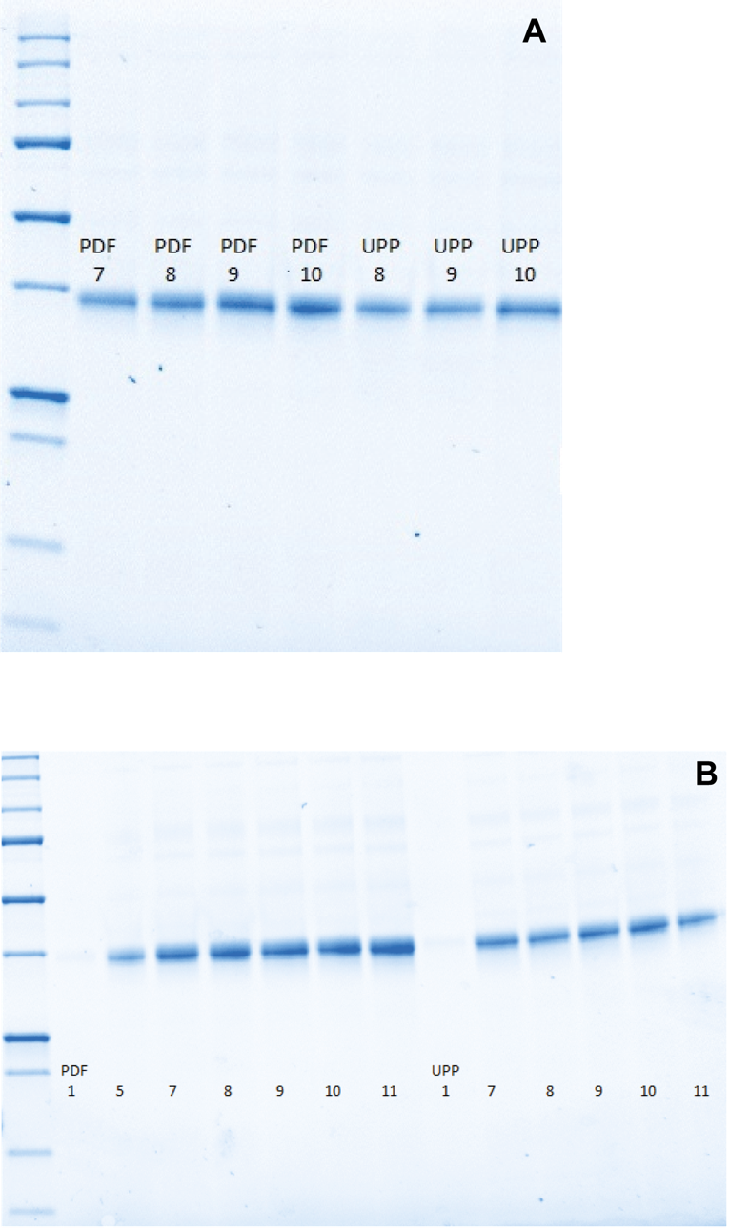
- A) µ_{sp} = 0.10 h⁻¹
PDF 7: 17h FT; PDF 8: 18h FT; PDF 9: 20h FT; PDF 10: 21h FT; UPP 8: 19h FT; UPP 9: 21h FT; UPP 10: 22h FT.

- B) µ_{sp} = 0.05 h⁻¹
PDF 1: Batch end, PDF 5: 19h FT; PDF 7: 24h FT; PDF 8: 27h FT; PDF 9: 36h FT; PDF 10: 41h FT; PDF 11: 43h FT; UPP 1: Batch end, UPP 7: 27h FT; UPP 8: 37h FT; UPP 9: 40h FT; UPP 10: 42h FT; UPP 11:44h FT.

