List of Additional Tables

Table S1: Table S1: Production of strain with just QHS1 gene (YAG111) and strain with QHS1 and FPP overproduction genes (YAG115) integrated into genome. Production was measured in 20 ml test tube with 3 ml culture overlayed with 500 μl dodecane.
Strain | β-caryophyllene (mg/g DCW) | Standard deviation
YAG111 | 0.79 | 0.09
YAG115 | 3.09 | 0.52

Table S2: Growth kinetics for strains with continuous exposure to hydrogen peroxide. Cells were grown in 96 well plate in a microplate reader for 72 hr and growth curves were calculated using grofit v1.1.1. NG: No Growth observed
Strain |  | Control | 25mM | 50mM | 75mM | 100mM
BY4741 | μ (h⁻¹) | 0.09 ± 0.00 | 0.04 ± 0.00 | 0.05 ± 0.01 | 0.02 ± 0.01 | NG
BY4741 | Lag phase (h) | 4.80 ± 0.20 | 27.24 ± 0.12 | 31.30 ± 0.09 | 27.58 ± 0.31 | NG
BY4741 | Max OD | 1.10 ± 0.01 | 0.72 ± 0.00 | 0.85 ± 0.00 | 0.48 ± 0.01 | NG
YAG110 | μ (h⁻¹) | 0.10 ± 0.01 | NG | NG | NG | NG
YAG110 | Lag phase (h) | 4.61 ± 1.14 | NG | NG | NG | NG
YAG110 | Max OD | 1.13 ± 0.10 | NG | NG | NG | NG
YAG114 | μ (h⁻¹) | 0.05 ± 0.00 | 0.02 ± 0.00 | 0.01 ± 0.00 | NG | NG
YAG114 | Lag phase (h) | 3.63 ± 0.32 | 12.35 ± 2.16 | 26.50 ± 3.32 | NG | NG
YAG114 | Max OD | 0.47 ± 0.02 | 0.33 ± 0.03 | 0.15 ± 0.01 | NG | NG
YAG111 | μ (h⁻¹) | 0.05 ± 0.00 | 0.04 ± 0.00 | 0.02 ± 0.00 | 0.02 ± 0.00 | NG
YAG111 | Lag phase (h) | 4.19 ± 0.11 | 14.82 ± 0.32 | 18.60 ± 1.28 | 33.68 ± 2.40 | NG
YAG111 | Max OD | 0.70 ± 0.03 | 0.52 ± 0.04 | 0.30 ± 0.03 | 0.22 ± 0.04 | NG
YAG115 | μ (h⁻¹) | 0.04 ± 0.00 | 0.03 ± 0.00 | 0.02 ± 0.00 | 0.01 ± 0.00 | 0.01 ± 0.00
YAG115 | Lag phase (h) | 3.89 ± 0.15 | 11.46 ± 0.25 | 12.35 ± 0.54 | 12.81 ± 2.00 | 15.09 ± 1.51
YAG115 | Max OD | 0.48 ± 0.02 | 0.40 ± 0.02 | 0.29 ± 0.01 | 0.24 ± 0.02 | 0.20 ± 0.00

Table S3: List of mutations found, frequency of each mutation in corresponding population sample is also shown. Each of these mutations were further verified using Sanger sequencing. Not available: mutation was not confirmed in Sanger sequencing. Dash - not considered for sequencing
Mutant | Frequency in population | Chromosome | Position | Mutation | Annotation | Gene | Sanger confirmation
P8M6 | 0 | 14 | 12986 | (T)_{11→14} | intergenic (-110/-281) | SNO2 ← / → SNZ2 | -
P8M6 | 0.94 | 1 | 26973 | A→G | F332F (TTT→TTC) | FLO9 ← | Confirmed
P8M6 | 0.95 | 1 | 26981 | T→C | S330G (AGC→GGC) | FLO9 ← | Confirmed
P8M6 | 0.94 | 1 | 26983 | T→G | N329T (AAC→ACC) | FLO9 ← | Confirmed
P8M6 | 0.71 | 1 | 27090 | T→C | E293E (GAA→GAG) | FLO9 ← | -
P8M6 | 0.79 | 1 | 27105 | A→G | T288T (ACT→ACC) | FLO9 ← | -
P8M6 | 0 | 13 | 87053 | (TAT)_{36→34} | intergenic (-314/+65) | PRE8 ← / ← RPM2 | -
P8M6 | 0.13 | 7 | 128474 | T→A | Y1259* (TAT→TAA) | MDS3 → | -
P8M6 | 0 | 9 | 265719 | G→C | T702S (ACT→AGT) | SYG1 ← | -
P8M6 | 0 | 4 | 273653 | (T)_{24→23} | coding (1224/1224 nt) | QRI7 ← | -
P8M6 | 0 | 7 | 400571 | (T)_{21→22} | intergenic (+411/+300) | OLE1 → / ← ERV14 | -
P8M6 | 0 | 4 | 403520 | (T)_{9→10} | intergenic (-229/+175) | MPS1 ← / ← MRX9 | -
P8M6 | 0 | 7 | 404475 | +G | intergenic (+84/-995) | MST27 → / → tR(UCU)G1 | -
P8M6 | 0 | 12 | 468701 | T→C | intergenic (-1832/-112) | RDN18-2 ← / → RDN5-2 | -
P8M6 | 0 | 7 | 531875 | (TA)_{15→17} | intergenic (+194/+8) | tD(GUC)G1 → / ← THG1 | -
P8M6 | 0 | 4 | 548565 | (T)_{19→20} | intergenic (-255/+197) | RPC11 ← / ← BAP3 | -
P8M6 | 0.64 | 13 | 908174 | 2 bp→TC | coding (811-812/3423 nt) | YMR317W → | -
P8M6 | 0.65 | 13 | 908177 | A→G | I272V (ATT→GTG) | YMR317W → | -
P8M6 | 0.67 | 13 | 908179 | T→G | I272V (ATT→GTG) | YMR317W → | -
P8M6 | 0.63 | 13 | 908185 | A→G | S274S (TCA→TCG) | YMR317W → | -
P8M6 | 0.68 | 13 | 908196 | G→C | W278S (TGG→TCG) | YMR317W → | -
P8M6 | 0.65 | 13 | 908198 | G→T | A279S (GCA→TCA) | YMR317W → | -
P8M6 | 0.61 | 13 | 908203 | G→A | T280T (ACG→ACA) | YMR317W → | -
P8M6 | 0.66 | 13 | 908218 | C→T | S285S (AGC→AGT) | YMR317W → | -
P11M1 | 0 | 8 | 2303 | (C)_{11→12} | intergenic (-406/+368) | YHL050C ← / ← YHL050C | Confimed
P11M1 | 0.36 | 1 | 12690 | A→T | intergenic (+264/+673) | YAL064W-B → / ← TDA8 | Confirmed
P11M1 | 0 | 14 | 12986 | (T)_{11→14} | intergenic (-110/-281) | SNO2 ← / → SNZ2 | Confimed
P11M1 | 0.83 | 1 | 27105 | A→G | T288T (ACT→ACC) | FLO9 ← | Confirmed
P11M1 | 0 | 11 | 43222 | G→T | T1025N (ACC→AAC) | STE6 ← | Confimed
P11M1 | 0 | 13 | 87053 | (TAT)_{36→34} | intergenic (-314/+65) | PRE8 ← / ← RPM2 | Not available
P11M1 | 0.74 | 7 | 128474 | T→A | Y1259* (TAT→TAA) | MDS3 → | Confimed
P11M1 | 0 | 3 | 151555 | +A | intergenic (-199/-1282) | tK(CUU)C ← / → MAK32 | Confirmed
P11M1 | 0 | 9 | 241053 | (A)_{21→22} | intergenic (-345/+255) | RNR3 ← / ← FIS1 | Confimed
P11M1 | 0 | 3 | 286312 | C→T | Q2066* (CAA→TAA) | CDC39 → | Confirmed
P11M1 | 0 | 7 | 404475 | +G | intergenic (+84/-995) | MST27 → / → tR(UCU)G1 | Confimed
P11M1 | 0.86 | 8 | 475932 | Δ1 bp | intergenic (-154/+67) | tV(CAC)H ← / ← KOG1 | Not available
P11M1 | 0.49 | 7 | 530034 | A→C | S257S (TCA→TCC) | MTL1 → | Confimed
P11M1 | 0.65 | 10 | 715141 | A→G | T200T (ACT→ACC) | DAN4 ← | Confirmed
P11M1 | 0 | 2 | 754982 | C→T | D709N (GAC→AAC) | RIF1 ← | Confimed
P11M1 | 1 | 13 | 908218 | C→T | S285S (AGC→AGT) | YMR317W → | Not available
P11M5 | 0.52 | 8 | 1846 | A→G | T231T (ACT→ACC) | YHL050C ← | -
P11M5 | 0 | 14 | 12986 | (T)_{11→14} | intergenic (-110/-281) | SNO2 ← / → SNZ2 | -
P11M5 | 0.79 | 1 | 27090 | T→C | E293E (GAA→GAG) | FLO9 ← | -
P11M5 | 0.83 | 1 | 27105 | A→G | T288T (ACT→ACC) | FLO9 ← | Confirmed
P11M5 | 0 | 13 | 87053 | (TAT)_{36→34} | intergenic (-314/+65) | PRE8 ← / ← RPM2 | -
P11M5 | 0.20 | 7 | 128053 | C→A | S1119* (TCG→TAG) | MDS3 → | -
P11M5 | 0 | 7 | 400571 | (T)_{21→22} | intergenic (+411/+300) | OLE1 → / ← ERV14 | -
P11M5 | 0 | 4 | 403520 | (T)_{9→10} | intergenic (-229/+175) | MPS1 ← / ← MRX9 | -
P11M5 | 0.49 | 7 | 530034 | A→C | S257S (TCA→TCC) | MTL1 → | -
P11M5 | 1 | 13 | 908174 | 2 bp→TC | coding (811-812/3423 nt) | YMR317W → | Not available
P11M5 | 1 | 13 | 908177 | A→G | I272V (ATT→GTG) | YMR317W → | Not available
P11M5 | 1 | 13 | 908179 | T→G | I272V (ATT→GTG) | YMR317W → | Not available
P11M5 | 1 | 13 | 908185 | A→G | S274S (TCA→TCG) | YMR317W → | Not available
P11M5 | 1 | 13 | 908196 | G→C | W278S (TGG→TCG) | YMR317W → | Not available
P11M5 | 1 | 13 | 908198 | G→T | A279S (GCA→TCA) | YMR317W → | Not available
P11M5 | 1 | 13 | 908203 | G→A | T280T (ACG→ACA) | YMR317W → | Not available
P11M5 | 1 | 13 | 908218 | C→T | S285S (AGC→AGT) | YMR317W → | Not available
P11M5 | 0.13 | 4 | 958000 | C→A | E114* (GAA→TAA) | YDR248C ← | -
P14M2 | 0.29 | 8 | 1846 | A→G | T231T (ACT→ACC) | YHL050C ← | -
P14M2 | 0 | 1 | 6755 | (A)_{19→20} | intergenic (+4048/+480) | YAL067W-A → / ← SEO1 | -
P14M2 | 1 | 1 | 26981 | T→C | S330G (AGC→GGC) | FLO9 ← | Confirmed
P14M2 | 1 | 1 | 26983 | T→G | N329T (AAC→ACC) | FLO9 ← | Confirmed
P14M2 | 1 | 1 | 27105 | A→G | T288T (ACT→ACC) | FLO9 ← | Confirmed
P14M2 | 1 | 2 | 34298 | G→A | E1455K (GAG→AAG) | YBL100W-B → | Confirmed
P14M2 | 0 | 13 | 87044 | (TAT)_{33→31} | intergenic (-305/+74) | PRE8 ← / ← RPM2 | -
P14M2 | 0 | 13 | 87050 | (TAT)_{36→33} | intergenic (-311/+65) | PRE8 ← / ← RPM2 | -
P14M2 | 0 | 13 | 88387 | A→C | L782W (TTG→TGG) | RPM2 ← | -
P14M2 | 1 | 7 | 128474 | T→A | Y1259* (TAT→TAA) | MDS3 → | Confirmed
P14M2 | 0 | 7 | 397854 | (A)_{20→19} | intergenic (-236/-774) | SDS23 ← / → OLE1 | -
P14M2 | 0 | 4 | 403520 | (T)_{9→10} | intergenic (-229/+175) | MPS1 ← / ← MRX9 | -
P14M2 | 0 | 7 | 404475 | +G | intergenic (+84/-995) | MST27 → / → tR(UCU)G1 | -
P14M2 | 0 | 12 | 468701 | T→C | intergenic (-1832/-112) | RDN18-2 ← / → RDN5-2 | -
P14M2 | 0 | 10 | 539401 | A→C | intergenic (+135/-2107) | HIT1 → / → tD(GUC)J4 | -
P14M2 | 0 | 12 | 612381 | T→G | S5R (AGT→AGG) | THI7 → | -
P14M2 | 0 | 4 | 930049 | T→C | E103E (GAA→GAG) | RTN1 ← | -
P14M2 | 0 | 4 | 1489588 | A→T | intergenic (+96/+10) | YDR524W-C → / ← YDR524C-B | -
P18M3 | 1 | 15 | 92 | Δ3 bp | intergenic (–/-491) | – / → YOL166W-A | Not available
P18M3 | 0.71 | 8 | 1846 | A→G | T231T (ACT→ACC) | YHL050C ← | -
P18M3 | 0 | 14 | 12986 | (T)_{11→14} | intergenic (-110/-281) | SNO2 ← / → SNZ2 | -
P18M3 | 0.92 | 1 | 26973 | A→G | F332F (TTT→TTC) | FLO9 ← | Confirmed
P18M3 | 0.92 | 1 | 26981 | T→C | S330G (AGC→GGC) | FLO9 ← | Confirmed
P18M3 | 0.92 | 1 | 26983 | T→G | N329T (AAC→ACC) | FLO9 ← | Confirmed
P18M3 | 0.71 | 1 | 27090 | T→C | E293E (GAA→GAG) | FLO9 ← | -
P18M3 | 0.82 | 1 | 27105 | A→G | T288T (ACT→ACC) | FLO9 ← | Confirmed
P18M3 | 0 | 4 | 37075 | C→A | G93G (GGC→GGA) | MFG1 → | -
P18M3 | 0 | 13 | 87053 | (TAT)_{36→34} | intergenic (-314/+65) | PRE8 ← / ← RPM2 | -
P18M3 | 0.80 | 7 | 128474 | T→A | Y1259* (TAT→TAA) | MDS3 → | Confirmed
P18M3 | 0 | 3 | 231024 | (T)_{19→20} | intergenic (+20/-476) | HCM1 → / → RAD18 | -
P18M3 | 0 | 4 | 403520 | (T)_{9→10} | intergenic (-229/+175) | MPS1 ← / ← MRX9 | -
P18M3 | 0 | 7 | 404475 | +G | intergenic (+84/-995) | MST27 → / → tR(UCU)G1 | -
P18M3 | 0.80 | 12 | 468701 | T→C | intergenic (-1832/-112) | RDN18-2 ← / → RDN5-2 | -
P18M3 | 0 | 4 | 688076 | (T)_{14→15} | intergenic (+236/-151) | APC4 → / → VBA4 | -
P18M3 | 0 | 2 | 723678 | (A)_{15→16} | intergenic (+43/+58) | SRB6 → / ← TRS20 | -
P18M3 | 0.66 | 13 | 908196 | G→C | W278S (TGG→TCG) | YMR317W → | -
P18M3 | 0.67 | 13 | 908218 | C→T | S285S (AGC→AGT) | YMR317W → | -

Table S4: Titer and yield for strains described in Figure 5. Bold: p value <0.05 using two-tailed Student’s t test compared with control.
Mutation | Titer (mg/L) | stdev | Yield (mg/g DCW) | stdev
Control | 20.78 | 0.41 | 3.40 | 0.05
CDC39 | 20.76 | 0.79 | 3.56 | 0.12
DAN4 T200T | 20.85 | 0.96 | 3.48 | 0.22
FLO9 T288T | 18.70 | 1.35 | 3.16 | 0.24
tK(CUU)C/MAK32 int | 19.97 | 2.71 | 3.44 | 0.45
MDS3 | 17.72 | 1.23 | 2.95 | 0.32
MST27/tR(UCU)G1 int | 62.13 | 4.28 | 10.27 | 0.66
MTL1 S257S | 13.14 | 1.71 | 2.25 | 0.27
RIF1 D709N | 20.59 | 2.10 | 3.37 | 0.32
RNR3/FIS1 int | 19.66 | 1.28 | 3.31 | 0.17
SNO2/SNZ2 int | 20.75 | 1.10 | 3.58 | 0.27
STE6 T1025N | 73.12 | 2.82 | 12.66 | 0.53
YAL064W-B/TDA8 int | 20.29 | 0.43 | 3.35 | 0.16
YHL050C int | 19.32 | 0.52 | 3.26 | 0.15
MST27/tR(UCU)G1 int & STE6 T1025N | 67.58 | 3.88 | 11.29 | 1.06
Table S5: List of plasmids and strains used in study
Plasmid | Description
pQHS1CEN | P_{TDH3}-QHS1-T_{TDH1}-URA3 (CEN plasmid)
pQHS12m | P_{TDH3}-QHS1-T_{TDH1}-URA3 (2μ plasmid)
pFPPCEN | P_{THD3}-tHMG1-T_{TDH1}-P_{CCW12}-HMG2(K6R)-T_{ENO2}-P_{PGK1}-UPC2-1-T_{PGK1}-P_{HHF2}-ERG20-T_{ADH3} -LEU2 (CEN Plasmid)
pFPP2m | P_{THD3}-tHMG1-T_{TDH1}-P_{CCW12}-HMG2(K6R)-T_{ENO2}-P_{PGK1}-UPC2-1-T_{PGK1}-P_{HHF2}-ERG20-T_{ADH3} -LEU2 (2μ Plasmid)
pQHS12mH | P_{TDH3}-QHS1-T_{TDH1}-HIS3 (2μ plasmid)
pSTE6 | P_{TDH3}-STE6-T_{TDH1}-URA3 (2μ plasmid)
pSTE6m | P_{TDH3}-STE6 T1025N-T_{TDH1}-URA3 (2μ plasmid)
Strains | Genotype
BY4741 | MATa his3Δ1 leu2Δ0 met15Δ0 ura3Δ0
YAG101 | BY4741 ura3::P_{TDH3}-QHS1-T_{TDH1}::URA3
YAG102 | BY4741 /pQHS1CEN
YAG103 | BY4741 /pQHS12m
YAG104 | BY4741 leu2:: P_{THD3}-tHMG1-T_{TDH1}-P_{CCW12}-HMG2(K6R)-T_{ENO2}-P_{PGK1-}UPC2-1-T_{PGK1}-P_{HHF2}-ERG20-T_{ADH1}::LEU2
YAG105 | BY4741 ura3:: P_{TDH3}-QHS1-T_{TDH1}::URA3 leu2:: P_{THD3}-tHMG1-T_{TDH1}-P_{CCW12}-HMG2(K6R)-T_{ENO2}-P_{PGK1-}UPC2-1-T_{PGK1}-P_{HHF2}-ERG20-T_{ADH2}::LEU2
YAG106 | BY4741 ura3:: P_{TDH3}-QHS1-T_{TDH1}::URA3 /pFPPCEN
YAG107 | BY4741 ura3:: P_{TDH—}QHS1-T_{TDH1}::URA3 /pFPP2m
YAG108 | BY4741 leu2:: P_{THD3}-tHMG1-T_{TDH1}-P_{CCW12}-HMG2(K6R)-T_{ENO2}-P_{PGK1-}UPC2-1-T_{PGK1}-P_{HHF2}-ERG20-T_{ADH3}::LEU2 /pQHS12m
YAG109 | BY4741 /pQHS12m /pFPP2m
YAG110 | BY4741 ctt1Δ
YAG111 | BY4741 ctt1Δ ura3:: P_{TDH3}-QHS1-T_{TDH1}
YAG112 | BY4741 ctt1Δ /pQHS1CEN
YAG113 | BY4741 ctt1Δ /pQHS12m
YAG114 | BY4741 ctt1Δ leu2::P_{THD3}-tHMG1-T_{TDH1}-P_{CCW12}-HMG2(K6R)-T_{ENO2}-P_{PGK1-}UPC2-1-T_{PGK1}-P_{HHF2}-ERG20-T_{ADH1}::LEU2
YAG115 | BY4741 ctt1Δ ura3::P_{TDH3}-QHS1-T_{TDH1}::URA3 leu2::P_{THD3}-tHMG1-T_{TDH1}-P_{CCW12}-HMG2(K6R)-T_{ENO2}-P_{PGK1-}UPC2-1-T_{PGK1}-P_{HHF2}-ERG20-T_{ADH2}::LEU2
YAG116 | YAG115 /pQHS12mH
YAG117 | Population 11 mutant 1 /pQHS12mH
YAG118 | BY4741 ctt1Δ his3:: P_{TDH3}-QHS1-T_{TDH1}::HIS3 leu2::P_{THD3}-tHMG1-T_{TDH1}-P_{CCW12}-HMG2(K6R)-T_{ENO2}-P_{PGK1-}UPC2-1-T_{PGK1}-P_{HHF2}-ERG20-T_{ADH2}::LEU2
YAG119 | BY4741 ctt1Δ leu2:: P_{THD3}-tHMG1-T_{TDH1}-P_{CCW12}-HMG2(K6R)-T_{ENO2}-P_{PGK1-}UPC2-1-T_{PGK1}-P_{HHF2}-ERG20-T_{ADH1}::LEU2, CDC39
YAG120 | BY4741 ctt1Δ leu2:: P_{THD3}-tHMG1-T_{TDH1}-P_{CCW12}-HMG2(K6R)-T_{ENO2}-P_{PGK1-}UPC2-1-T_{PGK1}-P_{HHF2}-ERG20-T_{ADH1}::LEU2, DAN4 T200T
YAG121 | BY4741 ctt1Δ leu2:: P_{THD3}-tHMG1-T_{TDH1}-P_{CCW12}-HMG2(K6R)-T_{ENO2}-P_{PGK1-}UPC2-1-T_{PGK1}-P_{HHF2}-ERG20-T_{ADH1}::LEU2, FLO9 T288T
YAG122 | BY4741 ctt1Δ leu2:: P_{THD3}-tHMG1-T_{TDH1}-P_{CCW12}-HMG2(K6R)-T_{ENO2}-P_{PGK1-}UPC2-1-T_{PGK1}-P_{HHF2}-ERG20-T_{ADH1}::LEU2, tK(CUU)C/MAK32 int
YAG123 | BY4741 ctt1Δ leu2:: P_{THD3}-tHMG1-T_{TDH1}-P_{CCW12}-HMG2(K6R)-T_{ENO2}-P_{PGK1-}UPC2-1-T_{PGK1}-P_{HHF2}-ERG20-T_{ADH1}::LEU2, MDS3
YAG124 | BY4741 ctt1Δ leu2:: P_{THD3}-tHMG1-T_{TDH1}-P_{CCW12}-HMG2(K6R)-T_{ENO2}-P_{PGK1-}UPC2-1-T_{PGK1}-P_{HHF2}-ERG20-T_{ADH1}::LEU2, MST27/tR(UCU)G1 int
YAG125 | BY4741 ctt1Δ leu2:: P_{THD3}-tHMG1-T_{TDH1}-P_{CCW12}-HMG2(K6R)-T_{ENO2}-P_{PGK1-}UPC2-1-T_{PGK1}-P_{HHF2}-ERG20-T_{ADH1}::LEU2, MTL1 S257S
YAG126 | BY4741 ctt1Δ leu2:: P_{THD3}-tHMG1-T_{TDH1}-P_{CCW12}-HMG2(K6R)-T_{ENO2}-P_{PGK1-}UPC2-1-T_{PGK1}-P_{HHF2}-ERG20-T_{ADH1}::LEU2, RIF1 D709N
YAG127 | BY4741 ctt1Δ leu2:: P_{THD3}-tHMG1-T_{TDH1}-P_{CCW12}-HMG2(K6R)-T_{ENO2}-P_{PGK1-}UPC2-1-T_{PGK1}-P_{HHF2}-ERG20-T_{ADH1}::LEU2, RNR3/FIS1 int
YAG128 | BY4741 ctt1Δ leu2:: P_{THD3}-tHMG1-T_{TDH1}-P_{CCW12}-HMG2(K6R)-T_{ENO2}-P_{PGK1-}UPC2-1-T_{PGK1}-P_{HHF2}-ERG20-T_{ADH1}::LEU2, SNO2/SNZ2 int
YAG129 | BY4741 ctt1Δ leu2:: P_{THD3}-tHMG1-T_{TDH1}-P_{CCW12}-HMG2(K6R)-T_{ENO2}-P_{PGK1-}UPC2-1-T_{PGK1}-P_{HHF2}-ERG20-T_{ADH1}::LEU2, STE6 T1025N
YAG130 | BY4741 ctt1Δ leu2:: P_{THD3}-tHMG1-T_{TDH1}-P_{CCW12}-HMG2(K6R)-T_{ENO2}-P_{PGK1-}UPC2-1-T_{PGK1}-P_{HHF2}-ERG20-T_{ADH1}::LEU2, YAL064W-B/TDA8 int
YAG131 | BY4741 ctt1Δ leu2:: P_{THD3}-tHMG1-T_{TDH1}-P_{CCW12}-HMG2(K6R)-T_{ENO2}-P_{PGK1-}UPC2-1-T_{PGK1}-P_{HHF2}-ERG20-T_{ADH1}::LEU2, YHL050C int
YAG132 | BY4741 ctt1Δ his3:: P_{TDH3}-QHS1-T_{TDH1}::HIS3 leu2:: P_{THD3}-tHMG1-T_{TDH1}-P_{CCW12}-HMG2(K6R)-T_{ENO2}-P_{PGK1-}UPC2-1-T_{PGK1}-P_{HHF2}-ERG20-T_{ADH1}::LEU2, CDC39
YAG133 | BY4741 ctt1Δ his3:: P_{TDH3}-QHS1-T_{TDH1}::HIS3 leu2:: P_{THD3}-tHMG1-T_{TDH1}-P_{CCW12}-HMG2(K6R)-T_{ENO2}-P_{PGK1-}UPC2-1-T_{PGK1}-P_{HHF2}-ERG20-T_{ADH1}::LEU2, DAN4 T200T
YAG134 | BY4741 ctt1Δ his3:: P_{TDH3}-QHS1-T_{TDH1}::HIS3 leu2:: P_{THD3}-tHMG1-T_{TDH1}-P_{CCW12}-HMG2(K6R)-T_{ENO2}-P_{PGK1-}UPC2-1-T_{PGK1}-P_{HHF2}-ERG20-T_{ADH1}::LEU2, FLO9 T288T
YAG135 | BY4741 ctt1Δ his3:: P_{TDH3}-QHS1-T_{TDH1}::HIS3 leu2:: P_{THD3}-tHMG1-T_{TDH1}-P_{CCW12}-HMG2(K6R)-T_{ENO2}-P_{PGK1-}UPC2-1-T_{PGK1}-P_{HHF2}-ERG20-T_{ADH1}::LEU2, tK(CUU)C/MAK32 int
YAG136 | BY4741 ctt1Δ his3:: P_{TDH3}-QHS1-T_{TDH1}::HIS3 leu2:: P_{THD3}-tHMG1-T_{TDH1}-P_{CCW12}-HMG2(K6R)-T_{ENO2}-P_{PGK1-}UPC2-1-T_{PGK1}-P_{HHF2}-ERG20-T_{ADH1}::LEU2, MDS3
YAG137 | BY4741 ctt1Δ his3:: P_{TDH3}-QHS1-T_{TDH1}::HIS3 leu2:: P_{THD3}-tHMG1-T_{TDH1}-P_{CCW12}-HMG2(K6R)-T_{ENO2}-P_{PGK1-}UPC2-1-T_{PGK1}-P_{HHF2}-ERG20-T_{ADH1}::LEU2, MST27/tR(UCU)G1 int
YAG138 | BY4741 ctt1Δ his3:: P_{TDH3}-QHS1-T_{TDH1}::HIS3 leu2:: P_{THD3}-tHMG1-T_{TDH1}-P_{CCW12}-HMG2(K6R)-T_{ENO2}-P_{PGK1-}UPC2-1-T_{PGK1}-P_{HHF2}-ERG20-T_{ADH1}::LEU2, MTL1 S257S
YAG139 | BY4741 ctt1Δ his3:: P_{TDH3}-QHS1-T_{TDH1}::HIS3 leu2:: P_{THD3}-tHMG1-T_{TDH1}-P_{CCW12}-HMG2(K6R)-T_{ENO2}-P_{PGK1-}UPC2-1-T_{PGK1}-P_{HHF2}-ERG20-T_{ADH1}::LEU2, RIF1 D709N
YAG140 | BY4741 ctt1Δ his3:: P_{TDH3}-QHS1-T_{TDH1}::HIS3 leu2:: P_{THD3}-tHMG1-T_{TDH1}-P_{CCW12}-HMG2(K6R)-T_{ENO2}-P_{PGK1-}UPC2-1-T_{PGK1}-P_{HHF2}-ERG20-T_{ADH1}::LEU2, RNR3/FIS1 int
YAG141 | BY4741 ctt1Δ his3:: P_{TDH3}-QHS1-T_{TDH1}::HIS3 leu2:: P_{THD3}-tHMG1-T_{TDH1}-P_{CCW12}-HMG2(K6R)-T_{ENO2}-P_{PGK1-}UPC2-1-T_{PGK1}-P_{HHF2}-ERG20-T_{ADH1}::LEU2, SNO2/SNZ2 int
YAG142 | BY4741 ctt1Δ his3:: P_{TDH3}-QHS1-T_{TDH1}::HIS3 leu2:: P_{THD3}-tHMG1-T_{TDH1}-P_{CCW12}-HMG2(K6R)-T_{ENO2}-P_{PGK1-}UPC2-1-T_{PGK1}-P_{HHF2}-ERG20-T_{ADH1}::LEU2, STE6 T1025N
YAG143 | BY4741 ctt1Δ his3:: P_{TDH3}-QHS1-T_{TDH1}::HIS3 leu2:: P_{THD3}-tHMG1-T_{TDH1}-P_{CCW12}-HMG2(K6R)-T_{ENO2}-P_{PGK1-}UPC2-1-T_{PGK1}-P_{HHF2}-ERG20-T_{ADH1}::LEU2, YAL064W-B/TDA8 int
YAG144 | BY4741 ctt1Δ his3:: P_{TDH3}-QHS1-T_{TDH1}::HIS3 leu2:: P_{THD3}-tHMG1-T_{TDH1}-P_{CCW12}-HMG2(K6R)-T_{ENO2}-P_{PGK1-}UPC2-1-T_{PGK1}-P_{HHF2}-ERG20-T_{ADH1}::LEU2, YHL050C int
YAG145 | BY4741 ctt1Δ his3:: P_{TDH3}-QHS1-T_{TDH1}::HIS3 leu2:: P_{THD3}-tHMG1-T_{TDH1}-P_{CCW12}-HMG2(K6R)-T_{ENO2}-P_{PGK1-}UPC2-1-T_{PGK1}-P_{HHF2}-ERG20-T_{ADH1}::LEU2, STE6 T1025N, MST27/tR(UCU)G1 int
YAG146 | BY4741 ctt1Δ his3:: P_{TDH3}-QHS1-T_{TDH1}::HIS3 leu2:: P_{THD3}-tHMG1-T_{TDH1}-P_{CCW12}-HMG2(K6R)-T_{ENO2}-P_{PGK1-}UPC2-1-T_{PGK1}-P_{HHF2}-ERG20-T_{ADH1}::LEU2, ste6∆
YAG147 | BY4741 ctt1Δ his3:: P_{TDH3}-QHS1-T_{TDH1}::HIS3 leu2:: P_{THD3}-tHMG1-T_{TDH1}-P_{CCW12}-HMG2(K6R)-T_{ENO2}-P_{PGK1-}UPC2-1-T_{PGK1}-P_{HHF2}-ERG20-T_{ADH1}::LEU2, /pSTE6
YAG148 | BY4741 ctt1Δ his3:: P_{TDH3}-QHS1-T_{TDH1}::HIS3 leu2:: P_{THD3}-tHMG1-T_{TDH1}-P_{CCW12}-HMG2(K6R)-T_{ENO2}-P_{PGK1-}UPC2-1-T_{PGK1}-P_{HHF2}-ERG20-T_{ADH1}::LEU2, /pSTE6m
YAG149 | BY4741 ctt1Δ his3:: P_{TDH3}-ZSS1-T_{TDH1}::HIS3 leu2::P_{THD3}-tHMG1-T_{TDH1}-O_{CCW12}-HMG2(K6R)-T_{ENO2}-P_{PGK1-}UPC2-1-T_{PGK1}-P_{HHF2}-ERG20-T_{ADH1}::LEU2
YAG150 | BY4741 ctt1Δ his3:: P_{TDH3}-ZSS1-T_{TDH1}::HIS3 leu2::P_{THD3}-tHMG1-T_{TDH1}-O_{CCW12}-HMG2(K6R)-T_{ENO2}-P_{PGK1-}UPC2-1-T_{PGK1}-P_{HHF2}-ERG20-T_{ADH1}::LEU2, /pSTE6m

Table S6: Donor sequence for reconstruction of mutations
Mutation | Donor sequence
CDC39 | CTTTGGTCTCACCAAAACCTAATTGTTGTAAAATTAGTTTAATTTCGGGAACACTTTATACAAAGGGCAGGTCTAAAAGATTAATATCGTTATTGTTTATCAACTGAGTAAAGAAAACGAACACTTTGTACAAAGGGCGTTTTAGAGAGAGACCTTTC
DAN4 T200T | CTTTGGTCTCACCAAAACGTGGTAGAAGTAGTAGAGGTTGTAGGAGTAGTCGATGTGGTAGAGGTTGTAGGAGTGGTAGAAGTAGTAGAGGTTGTAGGAGTAGTCGATGTGGTAGAAGGTCGATGTGGTAGAAGTTGTGTTTTAGAGAGAGACCTTTC
FLO9 T288T | CTTTGGTCTCACCAAAACGTTGGTACCGGTGACGGTGGTCATTTCAGTAGATGTAGAGGTGAAAGTACCGGTCCATGGTTCCGTTGTAGTTATGGTAGTACTGACAGTATAATTTGAAAGATGTAGAAGTGAAAGTACGTTTTAGAGAGAGACCTTTC
tK(CUU)C/MAK32 int | CTTTGGTCTCACCAAAACCCGTATATGATAATATATTGATAATATAACTATTAGTTGATAGACGATAGTGGATTTTTATTCCAACAATTCTATATACGTAAAATTATAGCCTTTACCACTATAGTTGATAGACGATAGGTTTTAGAGAGAGACCTTTC
MDS3 | CTTTGGTCTCACCAAAACTGTTAGTGCTACTGCTGCTGATGGAACCTTAATTCATATCAAACAAATGAAGATTAAAACTTCCGATGTTGGTTTGTTGATCATCGTTATCATCAAAACTAATTCATATCAAACAAATGAGTTTTAGAGAGAGACCTTTC
MST27/tR(UCU)G1 int | CTTTGGTCTCACCAAAACAAATGGGTCCAACACGAATCGACTTTTCGAGGCTTCCTTCGGCCGTTTTCGGGCCAGTTAGTGCTGATTATATATCATACTCTAGTTTATGTTCGCTTTAAGGCTTCTTCGGCCGTTTTCGTTTTAGAGAGAGACCTTTC
MTL1 S257S | CTTTGGTCTCACCAAAACTGTGGAGAGGGTGAAATATGATGATGATGATGATGATGAGGATGAGGATGAGGATGATGATGAGGATGATGAGGATGAGGATGATGAAAATGAGGAGGAGTGATGATGATGATGAGGATGGTTTTAGAGAGAGACCTTTC
RIF1 D709N | CTTTGGTCTCACCAAAACGATGATCTGCGGGGGCAGGCTTGAAATGTTTTTTAACTTTACACCTTCTGAAGCTATAACACTCATTGGGTGAATATGCTTTTTATATTTTCTTTCCAATTTTTAACTTTACACCTTCTGGTTTTAGAGAGAGACCTTTC
RNR3/FIS1 int | CTTTGGTCTCACCAAAACCAACATTGCGTGCCGTTGTTCTTTTGTTTTTTTTTTTTTTTTTTTTTTCGTTGTTGTCGCAGCAACGACACCTAGGCGCTGCTCAAAGGGGCAAAAACCCTTTTTTTTTTTTTTTTTTCGGTTTTAGAGAGAGACCTTTC
SNO2/SNZ2 int | CTTTGGTCTCACCAAAACCAGCAACCGGGGTCATGGTAAGTGTGCTTGCTACTCAAACAGAAAAAAATGGTCTTTTATCAATGAATAACTTTTTTTTTTTGTAGCTGAATGATGACTACTCAAACAGAAAAAAATGTTTTAGAGAGAGACCTTTC
STE6 T1025N | CTTTGGTCTCACCAAAACTGCTGCCAGTTGGATCTATAGGATTCTTGATGAAAAGCATAATAACCTAGAGGTTGAAAACAATAATGCTAGAACAGTGGGAATAGCTGGTCACACCTACTGAAAAGCATAATACCCTAGGTTTTAGAGAGAGACCTTTC
YAL064W-B/TDA8 int | CTTTGGTCTCACCAAAACGGTGGTAATGATGAAGTAATTTCCTGACTTGTTGTTGTACTGGTAACAGGGGGTAATGATGAAGTAATTTCCTGACTTGTTGTTGCACTGGTAACAGGTGGTTGTTGTACTGGTAACAGGGTTTTAGAGAGAGACCTTTC
YHL050C int | CTTTGGTCTCACCAAAACAAGAGATGGGGGGGGGGGGCTCTGTTATCTATTATCTAGAAAAAACAGTCGGGCCGCAAGGAATCGTAAGGGTGAATTGCCACCAATTAAGGAAGGCTGTATTATCTAGAAAAAACAGTTGTTTTAGAGAGAGACCTTTC

List of Additional Figures

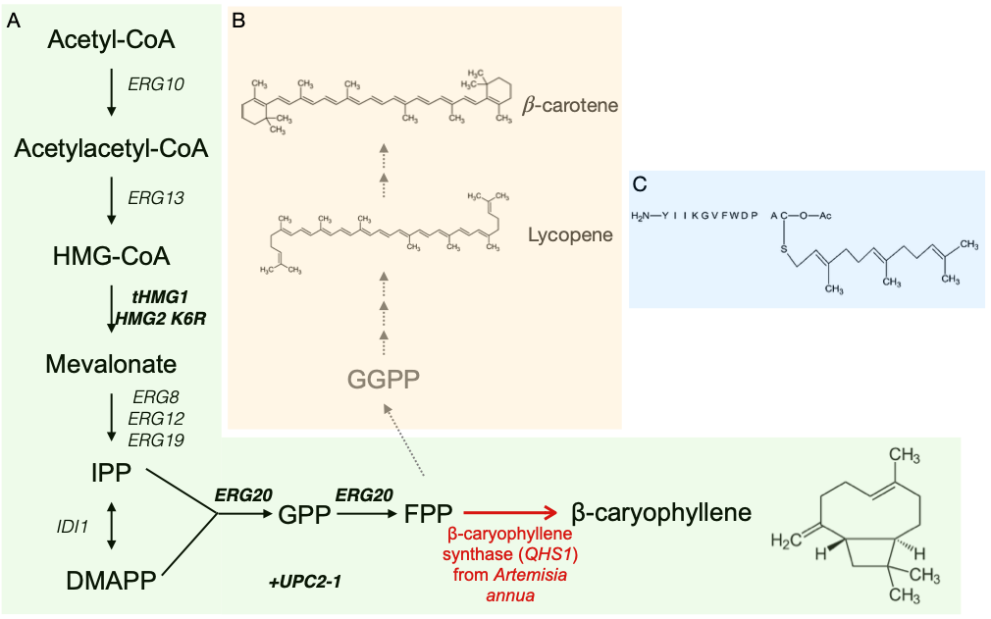
Figure S1: Biosynthesis pathway for and structure of beta-caryophyllene. A) Biosynthesis of beta-caryophylene starting from acetyl-CoA. Bolded genes are overexpressed in the FPP overproduction cassette. QHS1 is the codon optimized beta-caryophyllene synthase from Artemisia annua. B) Relation of beta-caryophyllene to other commonly targeted carotenoids lycopene and beta-carotene. C) Structure of a-factor, the target for Ste6.

Figure S2: Antioxidant potential of β-caryophyllene, 3 biologic replicates for each strain were exposed to various hydrogen peroxide concentrations, and spot assay were done with serial 1/10X dilutions.

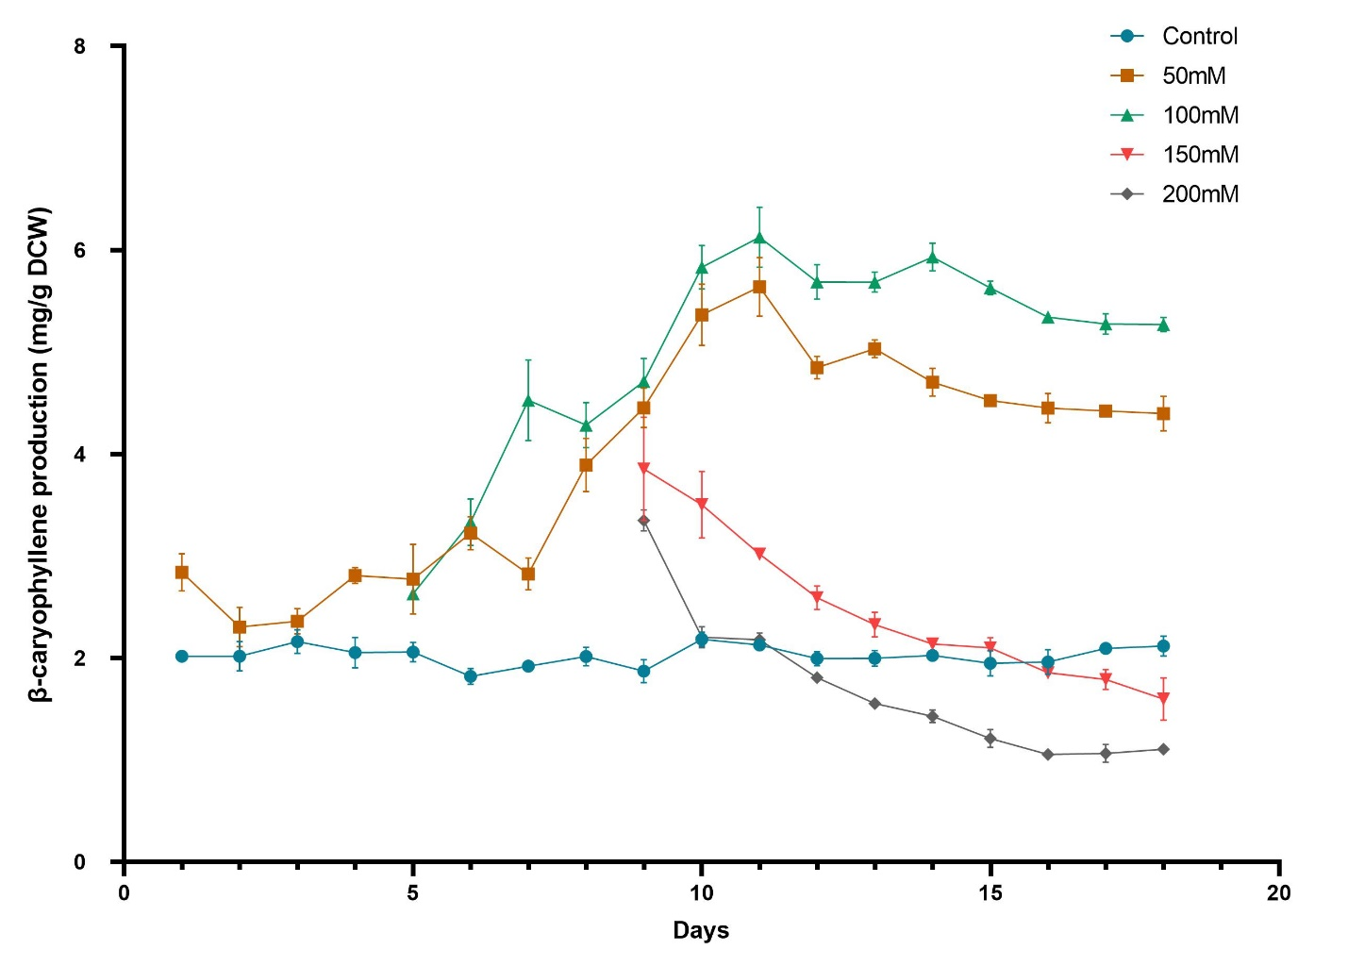
Figure S3: Production observed during evolution experiments. Production was measured in 20 ml test tube with 3 ml culture overlayed with 500 μl dodecane. 200 μl of the culture was transferred daily from the previous culture to inoculate in fresh media after oxidative stress challenge (if any). 100 μl of the dodecane layer is sampled for β-caryophyllene quantification.

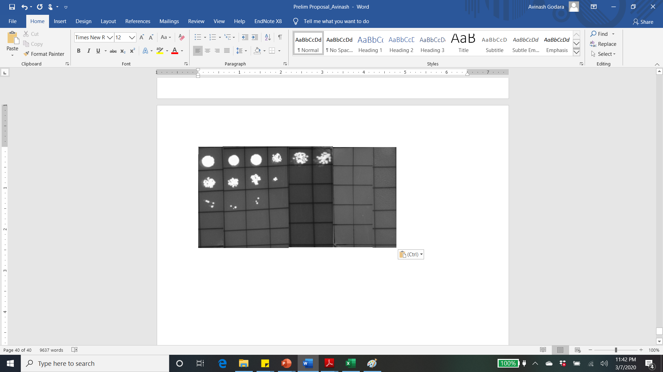
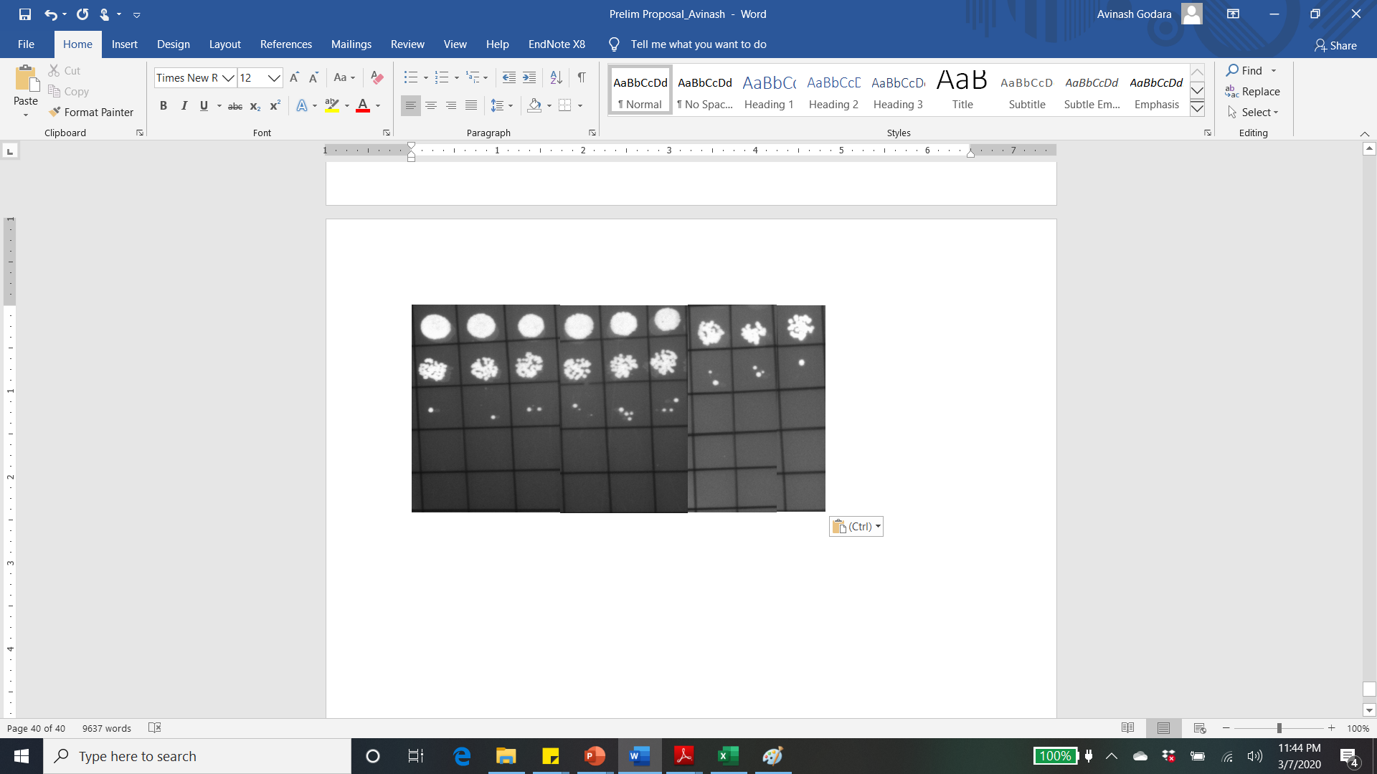
Figure S4: Spot assays for parental strain as well as the best population sample from evolution experiment. Cells were exposed to different hydrogen peroxide concentrations for 30 min and spotted.

10⁻²
10⁻³
10⁻⁴
10⁻⁵
Control
500mM
1M
Dilution
YAG115
Strain
10⁻¹
10⁻²
10⁻³
10⁻⁴
10⁻⁵
Control
500mM
1M
Dilution
P2 day 11

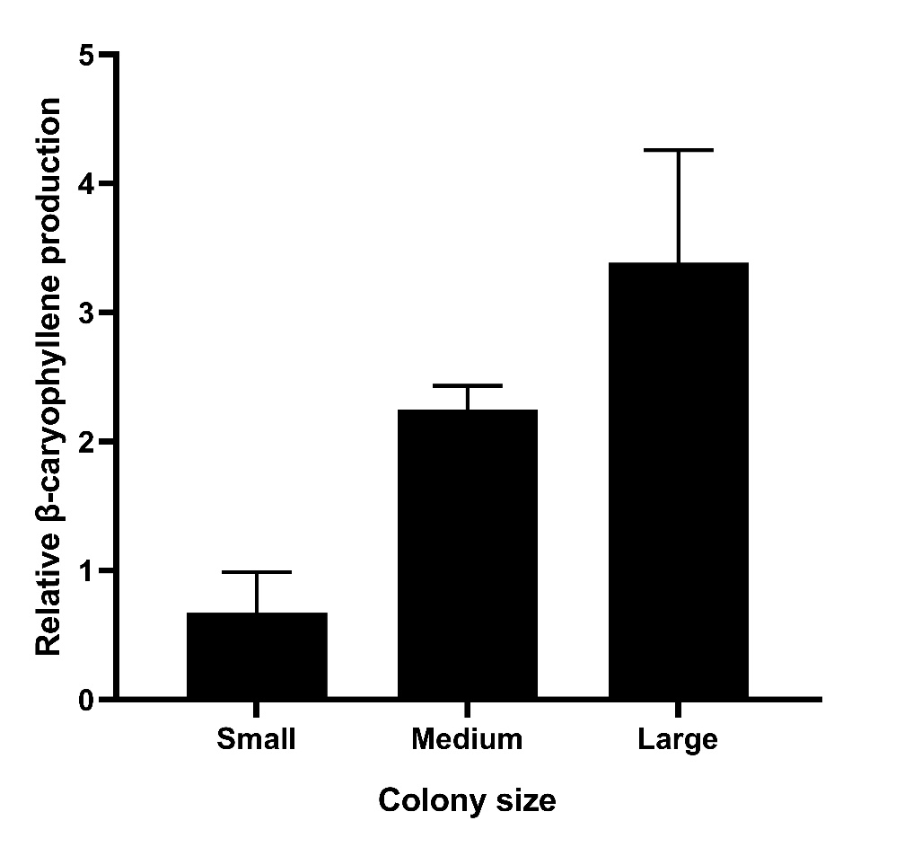
Figure S5: Relative caryophyllene production between average of 3 colonies picked of various sizes isolated from screening. Production was measured in 20 ml test tube with 3 ml culture overlayed with 500 μl dodecane.
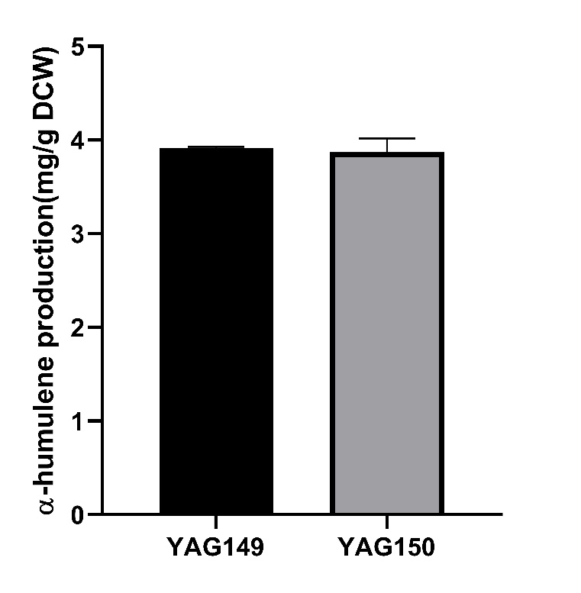
Figure S6: alpha humulene production under overexpressed STE6 T1025N. Production was measured in 20 ml test tube with 3 ml culture overlayed with 500 μl dodecane.

