Additional file 1

Effects of acuC on the growth development and spinosad biosynthesis of Saccharopolyspora spinosa
Zhudong Liu#, Jie Xiao#, Jianli Tang, Yang Liu, Ling Shuai, Li Cao, Ziyuan Xia, Xuezhi Ding, Jie Rang and Liqiu Xia*
State Key Laboratory of Development Biology of Freshwater Fish, Hunan Provincial Key Laboratory for Microbial Molecular Biology, College of Life Science, Hunan Normal University, Changsha, China.

*Correspondence: Liqiu Xia, Hunan Provincial Key Laboratory for Microbial Molecular Biology, State Key Laboratory of Development Biology of Freshwater Fish, College of Life Science, Hunan Normal University, Lushan Road 36, Changsha 410081, China. Tel/ Fax: +86 073188872298.

E-mail address: xialq@hunnu.edu.cn

Table S1 Strains and plasmids used in this study
 | Relative description |  | Sources
Strains
E.coli Top10 | Host for general cloning | Lab store
E.coli S17-1 | Donor strains for conjugation | Lab store
S. spinosa | The producer strains of spinosad | Lab store
S.spinosa-△acuC  S.spinosa-acuC | S. spinosa harboring pOJ260-acuC  S. spinosa harboring pOJ260-P_{ermE}-acuC | This work  This work
Plasmids
pOJ260 | E.coli cloning vector, containing pUC18 replicon, oriT, Apra^{R} | Lab store
pOJ260-cm-P_{ermE} | Containing P_{ermE} sequence | Lab store
pOJ260-acuC  pOJ260-P_{ermE} -acuC | acuC inserted into pOJ260 by EcoR Ⅰand Hind Ⅲ  P_{ermE}-acuC inserted into pOJ260 by EcoRⅤ and Hin d Ⅲ | This work  This work

Table S2 Nucleotide sequences of primers
Primer | sequence(5′→ 3′)
acuC-F | GGGAAGCTTGGGTCGATCTCGTCCTCCC (HindⅢ)
acuC-R  acuC-A  acuC-B | CCGGAATTCGTTCGTAGATGTCCGGTTCTG (EcoR Ι)  CCATGCAACGGAAACACC  GAGTCCGTGCTCGGCTAC
P_{ermE}-F | CGAAGCTTCTGGACTTCTAGAGCTAGCC (HindⅢ)
P_{ermE}-R | GCATGCCGGTCGACTCTA
P_{ermE}-acuC-F | CGGTTGGTAGGATCCTCTAGAGTCGACCGGCATGCCTTCCAGGTTGTCGATGACC
P_{ermE}-acuC-R  Apr-F  Apr-R | AGTGATATCCTGTACGAGTGCGTGAAGGA (EcoRⅤ)  GCTCATCGGTCAGCTTCTCAAC  CTTCGCATCCCGCCTCTG
whiA-F | CCGACGGGCTGAGGTTTC
whiA-R | GTGCCCGAACAGCTCGTG
ssgA-F | CGAGGGCGACGTGACGAT
ssgA-R | AGGTTCTCGTTGCCAGGCAC
bldD-F | TCGTCGGGTCCTATGAGCG
bldD-R | TCACAACTTTGGTGGCAGGC
Note: Restriction enzyme sites were italic, overlaping sequences were underlined.

Figure S1. Construction and verification of S. spinosa-ΔacuC
A.Construction of the gene knockout vector pOJ260-ΔacuC; B. 1.1 kb acuC Fragment amplification by using the S. spinosa genome as the template and the acuC-F and acuC-R as the primer pair; C. The restriction enzyme analysis and PCR amplification of pOJ260-ΔacuC; D. The schematic diagram of acuC gene knockout; E. PCR validation of 1.1 kb acuC fragment with the primer pair acuC-A and acuC-B; F. PCR validation of Apra resistance gene around 720 bp with the primer pair Apr-F and Apr-R.

Figure S2. Construction and verification of S. spinosa-acuC
A.Construction of the gene overexpression vector pOJ260-P_{ermE}-acuC; B. The complete acuC gene fragment around 1.3 kb was ampified by using the genome of S. spinosa as the template and the P_{ermE}-acuC-F and P_{ermE}-acuC-R were used as primer pair; C. The vector pOJ260-P_{ermE}-acuC was confirmed via restriction enzyme analysis and PCR amplification; D. The schematic diagram of acuC geneoverexpression; E. PCR validation of the P_{ermE}-acuC fragment around 1.6 kb with the primer pair P_{ermE}-F and P_{ermE}-acuC-R; F. PCR validation of Apra resistance gene around 720 bp with the primer pair Apr-F and Apr-R.

Figure S3. The insecticidal activity of the wild-type and mutant strains on H. armigera.

Figure S4. The content of Acetyl-CoA between the wild-type and overexpression strains in 48 h, 96 h and 192 h. Error bars represent the standard deviation of the mean. * and ** indicated P<0.05 and P<0.01, respectively.

Figure S5. The acetate content remained in bacteria between the wild-type and overexpression strains during fermentation. Values are averages of triplicate bilogical samples. Error bars represent the standard deviation of the mean.

Figure S6. The consumption curve of glucose content in the fermentation medium between the wild-type and overexpression strains during fermentation. Values are averages of triplicate biological samples. Error bars represent the standard deviation of the mean.
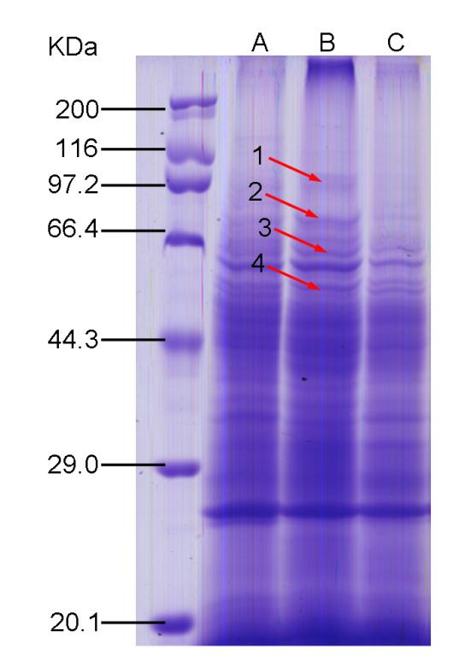
Figure S7. The SDS-PAGE analysis of whole-cell proteins of the wild-type and two mutant strains at 48 h. A. S. spinosa; B. S. spinosa-acuC; C. S. spinosa-ΔacuC.

Figure S8. Comparison of acuC protein sequences among different bacteria. The same color indicated that the amino acid residues from the N-terminus of the proteins were conserved. 1. The acuC protein sequence in S. spinosa; 2-22. The acuC protein sequences of related proteins in different bacteria.

