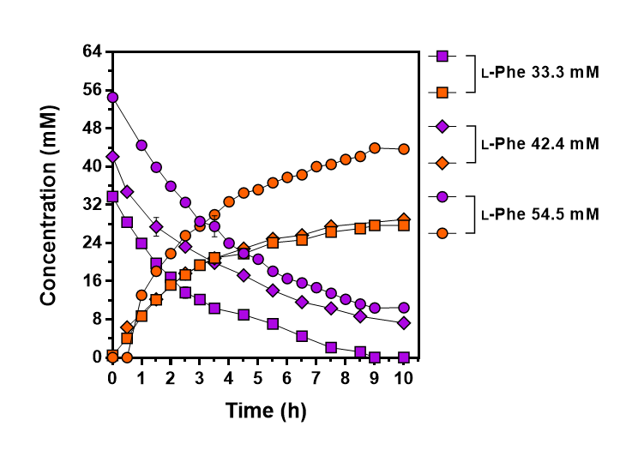
Figure S3 Evaluation of bioconversion into t-CA at a bioreactor scale (2 L) with various concentrations of L-Phe as a substrate. Conversion reaction was performed at pH 8.5 (10 M NaOH) and 50 °C conditions. Symbols: closed square, 33.3 mM of L-Phe; closed diamond, 42.4 mM of L-Phe; closed circle, 54.5 mM of L-Phe. Purple indicates concentration of L-Phe and orange indicates concentration of t-CA. Results are the mean of duplicate experiments and error bars indicates standard deviations.

