Additional Information

Characterization of three glutamate decarboxylases from Bacillus spp. for efficient γ-aminobutyric acid production

Lei Sun¹, Yingguo Bai¹, Xiu Zhang², Cheng Zhou², Jie Zhang¹, Xiaoyun Su¹, Huiying Luo¹, Bin Yao¹, Yuan Wang^{1,}*, Tao Tu^{1,}*

¹State Key Laboratory of Animal Nutrition, Institute of Animal Sciences, Chinese Academy of Agricultural Sciences, 100193 Beijing, China
²North Minzu University, Ningxia Key Laboratory for the Development and Application of Microbial Resources in Extreme Environments, 750021 Yinchuan, China

* Corresponding authors. State Key Laboratory of Animal Nutrition, Institute of Animal Sciences, Chinese Academy of Agricultural Sciences, 100193 Beijing, China. Tel.: +86 10 82106053; fax: +86 10 82106054.
E-mail addresses: tutao@caas.cn; wangyuan08@caas.cn.

Additional Figures
Figure S1 The effect of metal ions and chemical reagents (1 mM and 10 mM) on enzyme activity.
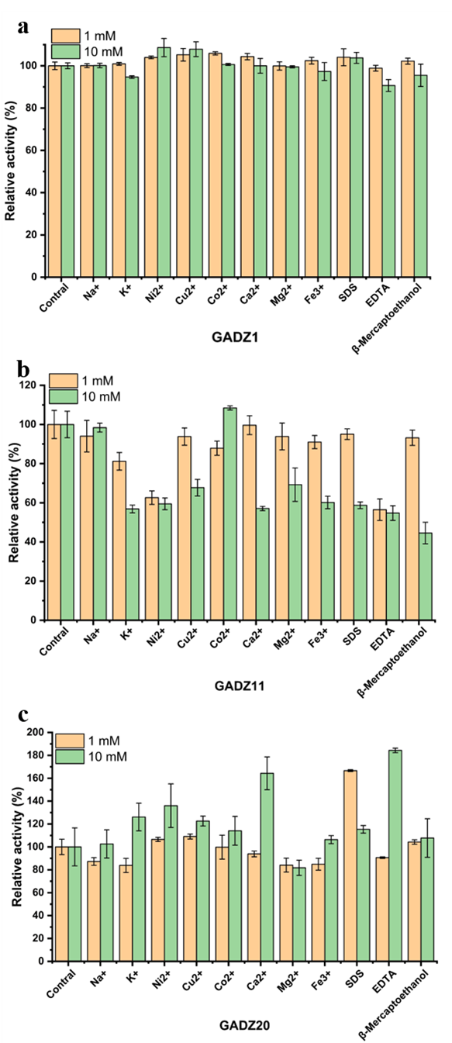

Figure S2 The comparison of GABA production efficiencies between the three Bacillus sp. strains and of E. coli recombinant strains.
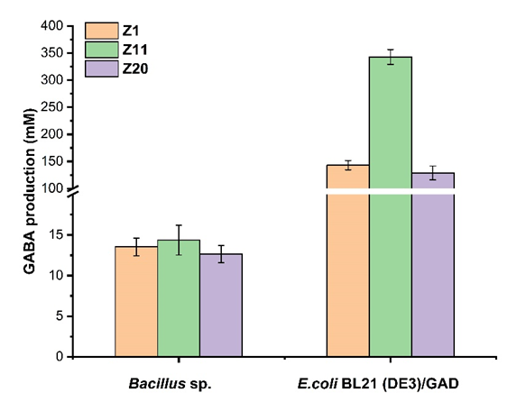

Figure S3 Multiple sequence alignment of GADZ1, GADZ11 and GADZ20.
