Promoters | The length of intergenic region (bp) | Schematic diagram
P_{GAP} | 1576 | 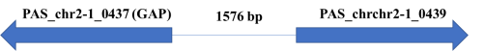
P_{AOX1} | 998 | 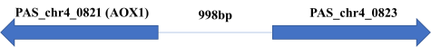
P_{GCW14} | 857 | 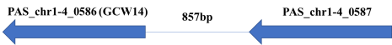
P₀₀₁₉ | 2448 | 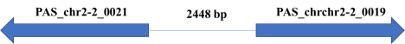
P₀₁₀₇ | 811 | 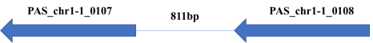
P₀₂₃₀ | 529 | 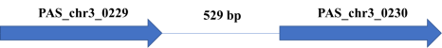
P₀₃₉₂ | 295 | 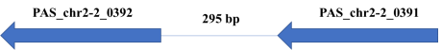
P₀₇₈₅ | 1194 | 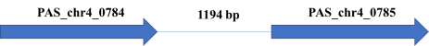
P₀₂₀₈ | 397 | 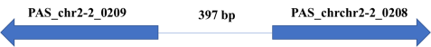
P₀₄₀₇ | 1543 | 
P₀₆₂₇ | 665 | 