Table S1. Bacterial strains and plasmids used in this study
Strain/plasmid | Relevant characteristics | Reference/source
Strains
E. coli
DH10B | F‾mcrA Δ(mrr-hsdRMS-mcrBC) φ80lacZΔM15 ΔlacX74 recA1 endA1 araD139Δ(ara, leu)7697 galU galK λ-rpsL nupG | [1]
ET12567 | dam dcm hsd, restriction-deficient | [2]
BL21DE3 | F⁻ ompT hsdSB(r_{B} ⁻ m_{B} ⁻) gal dcm (DE3) | Merck
HL1669 | BL21DE3 harboring pSL581, Km^{R} | This study
HL1727 | DH10B harboring pKK223-3 and pSL553, Ap^{R}, Tet^{R} | This study
HL1728 | DH10B harboring pKK223-3 and pSL594, Ap^{R}, Tet^{R} | This study
HL1729 | DH10B harboring pKK223-3 and pSL595, Ap^{R}, Tet^{R} | This study
HL1730 | DH10B harboring pSL592 and pSL594, Ap^{R}, Tet^{R} | This study
HL1731 | DH10B harboring pSL592 and pSL595, Ap^{R}, Tet^{R} | This study
C. glutamicum
AS019 | Spontaneous rifampicin-resistant mutant of C. glutamicum ATCC13059 | [3]
AS019E12 | Restriction-deficient mutant of AS019 | [4]
HL1638 | C. glutamicum AS019E12 derivative, ΔosnR | [5]
HL1643 | C. glutamicum AS019E12 carrying pSL579, Km^{R} | [5]
HL1653 | C. glutamicum AS019E12 carrying pSL580, Km^{R} | This study
Plasmids
pSL360 | Overexpression vector pSK1CAT carrying P_{180,} Km^{R} | [6]
pSL579 | Overexpression vector carrying P₁₈₀-osnR | [5]
pSL580 | Overexpression vector carrying P₁₈₀-myc-osnR | This study
pET28a | N-terminal His₆ tag expression vector, Km^{R}, IPTG inducible | Merck
pSL581 | His₆-tagged OsnR expression vector, Km^{R,} IPTG inducible | This study
pKK223-3 | Expression vector, Ap^{R}, P_{tac} | Amersham  Pharmacia
pSL592 | pKK223-3 carrying osnR | This study
pRS415 | Promoter-less lac operon fusion vector | [7]
pACYA184 | Low copy-number cloning vector carrying p15A replication origin;  Cm^{r}, Tc^{r} | New England BioLabs
pSL553 | pACYC184 carrying pRS415[T14+MCS+lac operon], Tet^{R} | This study
pSL594 | pSL553 carrying osnR promoter | This study
pSL595 | pSL553 carrying sigH promoter | This study
pSL596 | pSL553 carrying sigB promoter | This study
*ATCC, American Type Culture Collection.
Table S2. Oligonucleotides used in this study
Oligonucleotides | Sequence (5′→3′)
For construction of the plasmid expressing Myc-fused OsnR
myc_osnRF | CTGCAGTGACCATTGATAGATGGAACAGAAACTGATTAGCGAAGAAGACCTG  ATGTGTCAAAACATATATTTGG (PstI site underlined)
myc_osnRR | CTGCAGGTTATTTATTAAGGGTTG (PstI site underlined)
For construction of the plasmid expressing His₆-fused OsnR
pET28a_osnRF | GGGAATTCCATATGATGTGTCAAAAC (NdeI site underlined)
pET28a_osnRR | CGGAATTCAAGGGTTGGATGCTATGCG (EcoRI site underlined)
For construction of the Lac operon fusion plasmid
pRS415_F | GCCACTCATCGCAGTACT AATAGGCGTATCACGAGGCCC (ScaI site underlined)
pRS415_R | ATGAATTACAACAGTACT TGGTGTGTGGGTTAGGTCTGG (ScaI site underlined)
pKK223-3_osnRF | GAATTCGGAAAGCCAAACAGTGACCA (EcoRI site underlined)
pKK223-3_osnRR | CTGCAG ATTAAGGGTTGGATGCTATG (PstI site underlined)
pSL553_ osnRF | GGGATCGGAATTCCCGGGCACTAGAAATTCAG (SmaI site underlined)
pSL553_ osnRR | GTTGTCCGGATCCCCGGGGTGGAAAAAGTGGGATTGGC (SmaI site underlined)
pSL553_ sigHF | GGGATCGGAATTCCCGGGATCATCGTCATCTTTGGG (SmaI site underlined)
pSL553_ sigHR | GTTGTCCGGATCCCCGGGCATAATAAACCACCATCC (SmaI site underlined)
pSL553_ sigBF | GGGATCGGAATTCCCGGGCAGTCAATCCTAAGAGCTTG (SmaI site underlined)
pSL553_ sigBR | GTTGTCCGGATCCCCGGGCCTCCTGGATAAGATCCAG (SmaI site underlined)
qRT-PCR
RT_16S_F | ACCCTTGTCTTATGTTGCCAG
RT_16S_R | TGTACCGACCATTGTAGCATG
RT_mshA_F | CAGGAGGAGATGCAGGATTTG
RT_mshA_R | GCGATCATTTCCAGGGCTATAA
RT_mshB_F | GGGTTTAGGATCCATGAGCTTTA
RT_mshB_R | TGCAGGATCACCAACCATAC
RT_mshC_F | TGTCGATGACCCTCTGTTTG
RT_mshC_R | ATGCTCAGGGCTTCCATATC
RT_mshD_F | GGACTTGGTCACTCCCATTT
RT_mshD_R | AGTTCCGTGGTTTCCTCATC
RT_mca_F | GAGCACAGATGGCTAGGTTATG
RT_mca_R | GGGTGACTTTATCCGAGTCTTC
RT_katA_F | GGACGTATCCGAATACACCAAG
RT_katA_R | CTCACCAGCAACAGTAGAGAAG
RT_mtr_F | CCCTTACATCCCTGAAGCTATT
RT_mtr_R | GCCACCAACAATCACCAAAG
RT_cg0026_F | GCAAAGTGGAGCGATGAAAC
RT_cg0026_R | GCTCAGATGGTTCTCCAAAGA
RT_cg0165_F | GTGGTAGGCCTTCTGTTGTATG
RT_cg0165_R | CCCAGAGAGTGGCGTAAATG
RT_cg1715_F | GTTCGACTACGCCACATGAT
RT_cg1715_R | GTAGTGCGCGAGTTCTTTCT
RT_sigA_F | CAACCTTCGTCTGGTTGTCT
RT_sigA_R | GAACTTGTAGCCCTTGGAGTAG
RT_sigH_F | GAATCAACTCAGCCCGGAATA
RT_sigH_R | GAGTGGAACGTCCATGATCTC
RT_rshA_F | ATCGGAGTTTCGTAGTCTGTTG
RT_rshA_R | TATTCCAGATGATGCTCGACAC
RT_sigB_F | TGCCACTGCTGGATCTTATC
RT_sigB_R | GTTGCGTAGGTGGAGAACTTA
RT_sigE_F | TAGTCGCAGAACATGCAGATAG
RT_sigE_R | TGTTTCTTGGGTCAGGTCTTC
RT_oxyR_F | CCGCCAAGACTTAGAACTATCC
RT_oxyR_R | CAGCAGTAGTGGAGCTAATGG
RT_ftn_F | AGGCACAGAGCAAAGAAGAG
RT_ftn_R | GATAGCGGAGGTGACATCAAG
RT_dps_F | CACCGACTACAACGATCTTCAC
RT_dps_R | GTCAGCATAGCCACGAACAA
EMSA
EM_osnR(ORF)_F1 | CAAGATTACGAGGACGCTTCCG
EM_osnR(ORF)_R1 | GGCGAGGCCACGTTCAATCTTG
EM_osnR_F2 | ATTGTCTTGCTACTCGGCGGATA
EM_osnR_R2 | GCCAATTCGCGAGACAAGTAAAAG
EM_osnR_F3 | CCCTCAACGCTGGAGAAAACTCA
EM_osnR_R3 | CTATCAATGGTCACTGTTTGGC
EM_osnR_F4 | GCTGGGCCAGGGCCTTTACGAA
EM_osnR_R4 | CGGGCTCGCTTAATTTCAG
EM_cg0026_F | CAAGCGTGGGGATTCCTGGCTC
EM_cg0026_R | ACCAGTGTCGGTACGAGCCA
EM_cg0026(ORF)_F | CATCTTTGGAGAACCATCTGAGC
EM_cg0026(ORF)_R | GAAAGCTGGGGTGGAGTAGGCG
EM_cg0165_F | TTTGGTGGTGGGCAATGCTGCGA
EM_cg0165_R | CAGTGCCGGCATTGGTTTGACG
EM_cg0165(ORF)_F | GGCAGGCGCATTGGTGTCATCAG
EM_cg0165(ORF)_R | AAGTCCAGCGAATCAGCCTGC
EM_mtr_F | ATCATCGACAACGCTCGCCACGA
EM_mtr_R | GGCTGCTCAGACATAAGATG
EM_mtr(ORF) _F | GTGAAGATCTCCACCGACACC
EM_mtr(ORF)_R | CTGCAGGTCATTAGGGTTGGC
EM_cg0404_F | ACCGCTTCTAAGCACCCAACTC
EM_cg0404_R | CGCCTCGACGACTGAAAGTG
EM_cg0404(ORF)_F | CAAAATAGCCCCAATCGTCACA
EM_cg0404(ORF)_R | GTTGGAAACAGAGTCATGGTAG

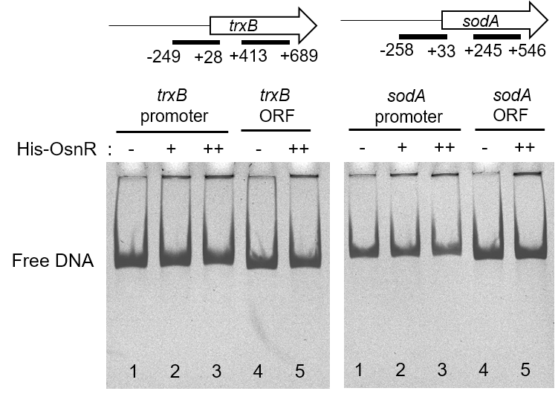
Fig S1. Binding of the purified OsnR protein on the promoter regions of the trxB and sodA genes. The promoter and ORF regions are indicated with bars. Lanes 1 and 4 contained no protein, while lanes 2, 3, and 5 contained 0.6, 1.2, and 1.2 μg His₆-OsnR, respectively.

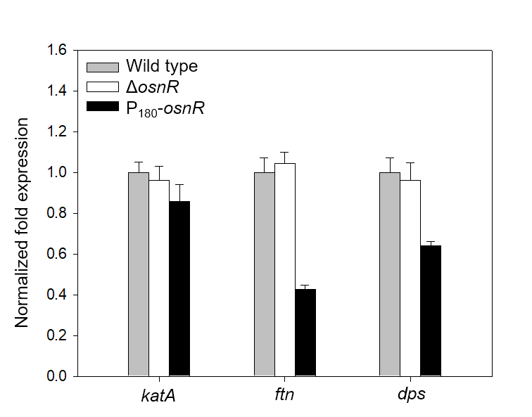
Fig S2. The mRNA levels of genes linked to iron homeostasis in C. glutamicum cells. C. glutamicum wild-type, osnR-deleted (ΔosnR), and osnR-overexpressing (P₁₈₀-osnR) cells were grown in minimal media and the mRNA levels of the genes indicated were measured using qRT-PCR.

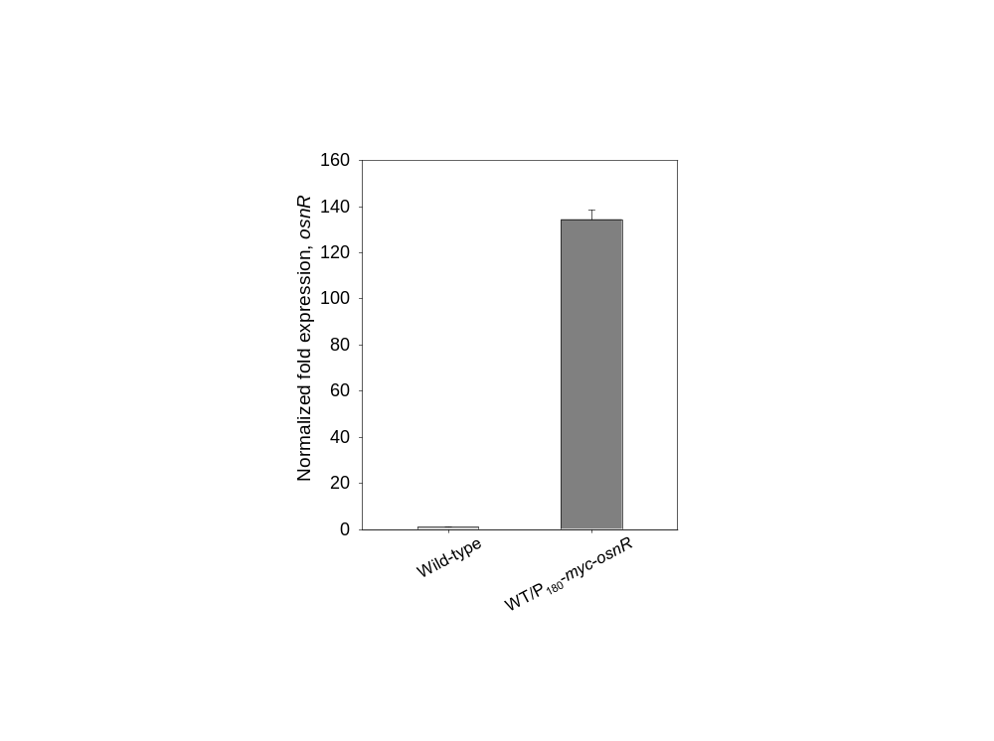
Fig. S3. Transcription of the myc-osnR fusion gene as measured by qRT-PCR. C. glutamicum cells were grown in minimal media. Bars indicate the levels of transcription in wild-type and myc-osnR-overexpressing (P₁₈₀-myc-osnR) strains. The value for the wild-type strain was arbitrarily set to 1. The data represent one of the three independent experiments. Error bars indicate standard deviation of three replicates from a representative experiment.

Supplementary Reference
1. Grant SG, Jessee J, Bloom FR, Hanahan D. Differential plasmid rescue from transgenic mouse DNAs into Escherichia coli methylation-restriction mutants. Proc Natl Acad Sci USA. 1990;87:4645-9.
2. MacNeil DJ, Gewain KM, Ruby CL, Dezeny G, Gibbons PH, MacNeil T. Analysis of Streptomyces avermitilis genes required for avermectin biosynthesis utilizing a novel integration vector. Gene. 1992;111:61-8.
3. Yoshihama M, Higashiro K, Rao EA, Akedo M, Shanabruch WG, Follettie MT, Walker GC, Sinskey AJ. Cloning vector system for Corynebacterium glutamicum. J Bacteriol. 1985;162:591-7.
4. Follettie MT, Peoples OP, Agoropoulou C, Sinskey AJ. Gene structure and expression of the Corynebacterium glutamicum N13 ask-asd operon. J Bacteriol. 1993;175:4096-103.
5. Jeong H, Kim Y, Lee HS. The osnR gene of Corynebacterium glutamicum plays a negative regulatory role in oxidative stress responses. J Ind Microbiol Biotechnol. 2019;46:241-8.
6. Park SD, Lee SN, Park IH, Choi JS, Jeong WK, Kim Y, Lee HS. Isolation and characterization of transcriptional elements from Corynebacterium glutamicum. J Microbiol Biotechnol. 2004;14:789-95.
7. Simon RV, Houman F, Kleckner N. Improved single and multicopy lac-based cloning vectors for protein and operon fusions. Gene. 1987;53:85-96.

