Additional file

Table S1: Strains and plasmids used in this study
Strains | Genotype | Source
E. coli
NEB10β | Δ(ara-leu) 7697 araD139 fhuA ΔlacX74 galK16 galE15e14- ϕ80dlacZΔM15 recA1 relA1 endA1 nupG rpsL (Str^{R}) rph spoT1 Δ(mrr-hsdRMS-mcrBC) | New England Biolabs
PH04 | W3110 ∆lacU169 tna-2 ∆luxS ∆ptsH | ¹
ZK126 | E. coli K-12 substr. W3110 ΔlacU169 tna-2 | Laboratory Stock
LW7 | W3110 ∆lacU169 tna-2 ∆luxS::Kan | ²
SW101 | ZK126 ΔsoxRS | This study
Plasmids | Relevant Property | Source
pZE12MCS | colEI origin, LlacO-1 promoter followed by multi-cloning site, Ap^{r} | ExpresSys
pZE-phzAG | pZE12MCS derivative, containing phzA1-G1 under LlacO-1 promoter, Ap^{r} | This study
pZE-phzMS | pZE12MCS derivative, containing phzM and phzS under LlacO-1 promoter, Ap^{r} | This study
pZE-LacZα | pZE12MCS derivative, containing lacZα under LlacO-1 promoter, Ap^{r} | This study
pZE-phzAG-ptsH | pZE-phzAG derivative, containing growth control module (ptsH under lasI promoter, and dsRedExpress2 and LasR under constitutive T5 promoter) | This study
pZE-phzMS-ptsH | pZE-phzAG derivative, containing growth control module (ptsH under lasI promoter, and dsRedExpress2 and LasR under constitutive T5 promoter) | This study
pET-DsRed | pET200 derivative, containing dsRed_Express_DR | ³
pCT10 | pFZY1, soxR, soxR and soxS intergenic region, T7 RNA polymerase | This study
pTT01 | pBR322, soxR gene and the overlapping divergent soxR and soxS promoters, phiLOV downstream of soxS promoter, Ap^{r} | ⁴
pSox-LasI | pTT01 derivate, containing lasI under soxS promoter, Ap^{r} | ¹

Table S2: Primers used in this study
Primer | Sequence
PciI-t7-term-RVS | TCGTACATGTCAAAAAACCCCTCAAGACCCGT
PciI-ptsH-RVS | ATCTACATGTTACTCGAGTTCCGCCATCAG
HindIII-phzM-RVS | cctagtAAGCTTTCATCAGGCCCTGGCA
HindIII-phzM-FWD | cactgAAGCTTATGAATAATTCGAATCTTGCTGCTGC
KpnI-phzA-FWD | tgcatGGTACCATGAACGGTCAGCGGTAC
HindIII-phzG1-RVS | CATACAAGCTTCACGGTTGCAGGTAGC
KpnI-HindIII-RBS-phzS-FWD | tacgtGGTACCAAGCTTAAAGAGGAGAAAGCACCCATGAGCGAA
BamHI-phzS-RVS | aagtaGGATCCTAGCGTGGCCGTTC
Fsoxp | GTTCTAGGATCCTTAGTTTTGTTC ATCTTCCAGCAAGCG
Rsoxp | GACTTTAAGCTTAAATCTGCCTCT TTTCAGTGTTCAGTTC
soxHP1 | GTTCATCTTCCAGCAAGCGTGCGCCGGTACCTTCTTCTCCTAAGCGGTCGGTGTAGGCTGGAGCTGCTTC
soxHP2 | CAATGGATGGAGCAATTACCCGCGCGGGAGTTAACGCGCGGGCAATAAAACATATGAATATCCTCCTTAG

Figure S1: Product Calibration and Standardization
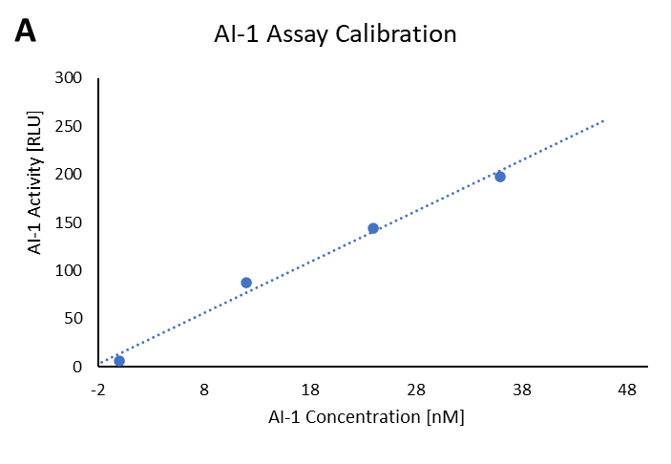
Population C end products (AI-1, DsRed, and eGFP) were calibrated to standard measurements, then standardized in response to PYO and PCA in M9 and LB media. a) Linear region of standard curve from AI-1 luminescent reporter assay as described in Methods. b-e) Cultures of PH04 pCT10 pET-eGFP and PH04 pCT10-DsRed were inoculated from an overnight seed culture at a 1:20 ratio in either M9 or LB media, with a concentration of 1µM PYO or PCA. These samples were incubated at 30⁰C overnight, then measured for OD₆₀₀ and fluorescence. f-h) PH04 pSox-LasI, PH04 pCT10 pET-eGFP, and PH04 pCT10 pET-DsRed were grown for 4 hours during log-phase in either LB or M9 with PYO or PCA at the concentrations indicated (ranging 0-1 µM), then eGFP, DsRed expression were measured using fluorescence and AI-1 was measured a cell based reporter assay (see Methods). eGFP measurements were normalized by subtracting background fluorescence from uninduced cells, then taking its fold increase over blank media.
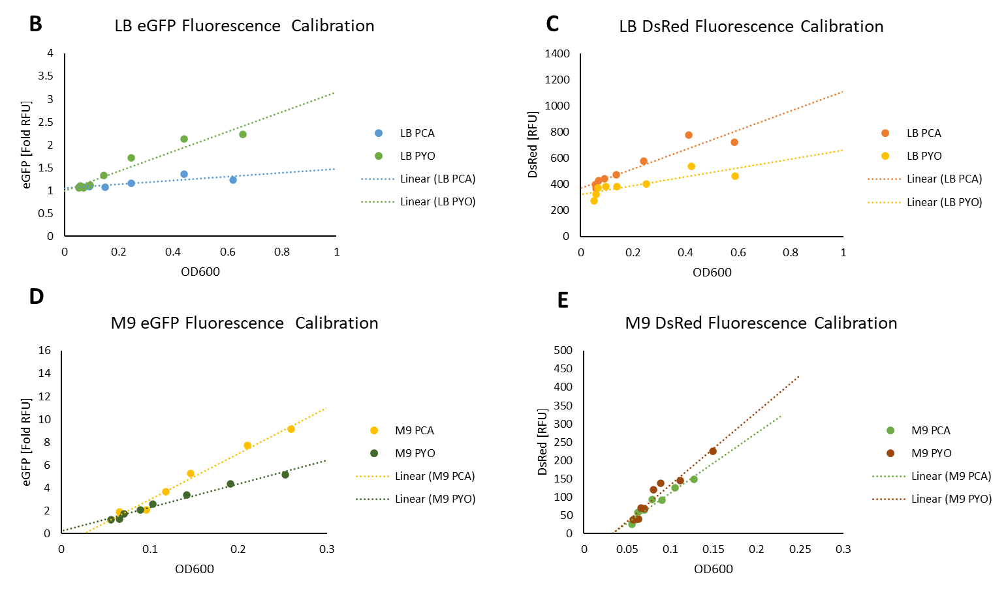

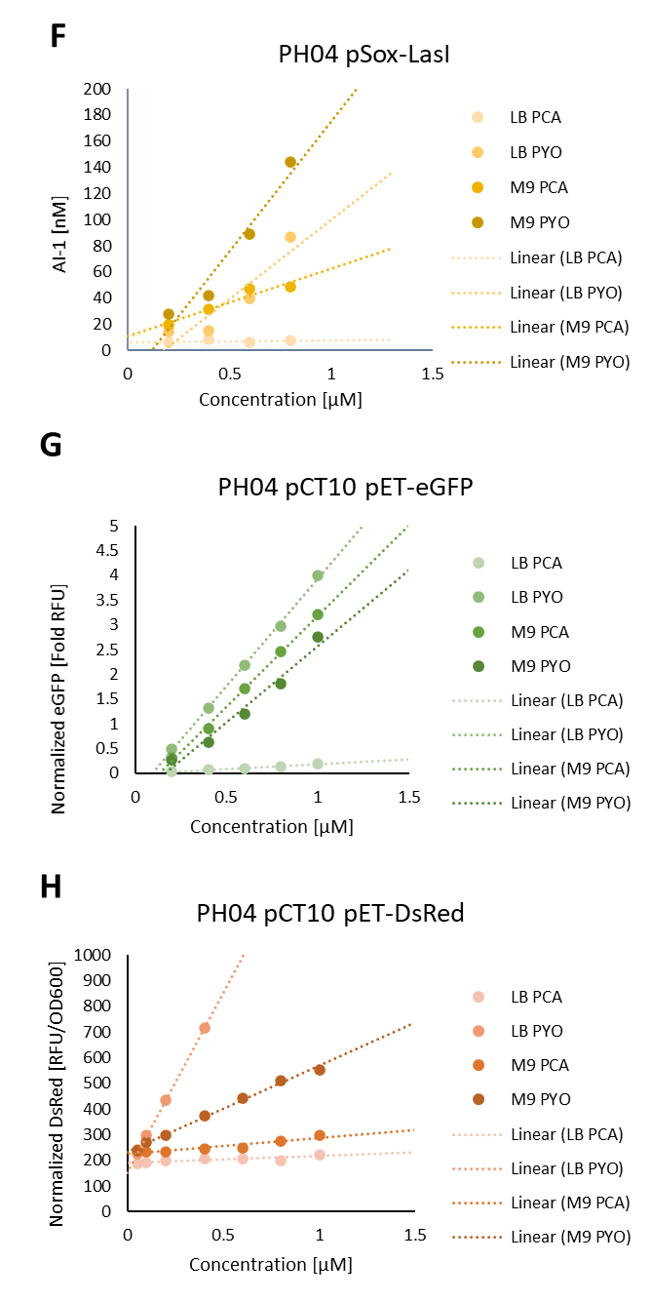

Figure S2: Tri-culture Growth
Population A (E. coli PH04 pZE-phzAG-ptsH-DsRed) and Population B (E. coli PH04 pZE-phzMS) were co-cultured together at initial inoculation ratios as indicated on the x-axis and with nanomolar AI-1 concentrations as indicated in the legend. After overnight growth, 20 µL of the PYO producing co-culture (~1.5 OD₆₀₀) was added to a culture of ~0.2 OD₆₀₀ Population C (PH04 pCT10-pET-eGFP) with 200 µL final volume in fresh media. The tri-strain culture was then incubated for 4.5 hours, measuring OD₆₀₀ every 30 minutes.

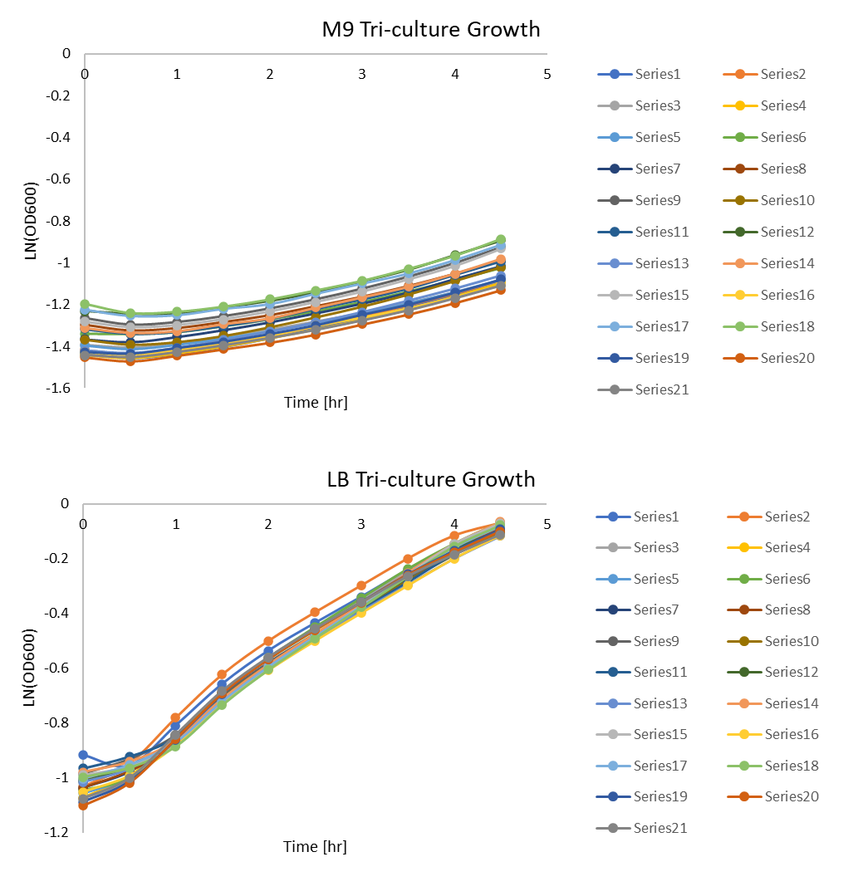

Table S3: Tri-culture Growth Rates
The average growth rates and their standard error for tri-cultures were calculated from timepoints spanning 1 to 4.5 hours (Figure 2).
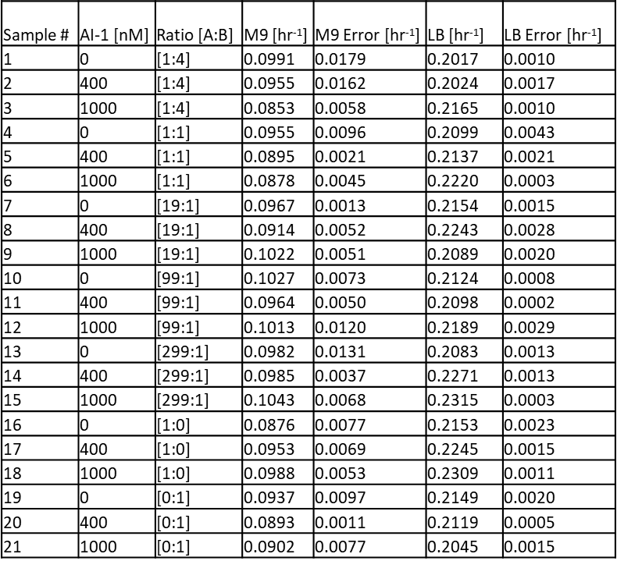

References

1. Stephens, K., Pozo, M., Tsao, C.Y., Hauk, P. & Bentley, W.E. Bacterial co-culture with cell signaling translator and growth controller modules for autonomously regulated culture composition. Nature communications 10, 4129 (2019).
2. Wang, L., Hashimoto, Y., Tsao, C.Y., Valdes, J.J. & Bentley, W.E. Cyclic AMP (cAMP) and cAMP receptor protein influence both synthesis and uptake of extracellular autoinducer 2 in Escherichia coli. Journal of bacteriology 187, 2066-2076 (2005).
3. Wang, S., Tsao, C.Y., Motabar, D., Li, J., Payne, G.F., Bentley, W.E. A Redox-based Autoinduction Strategy to Facilitate Expression of 5xCys-tagged Proteins for Electrobiofabrication. Frontiers in Microbiology 12, 1473 (2021).
4. Tschirhart, T. et al. Electronic control of gene expression and cell behaviour in Escherichia coli through redox signalling. Nature communications 8, 14030 (2017).

