Additional file

Fig. S1

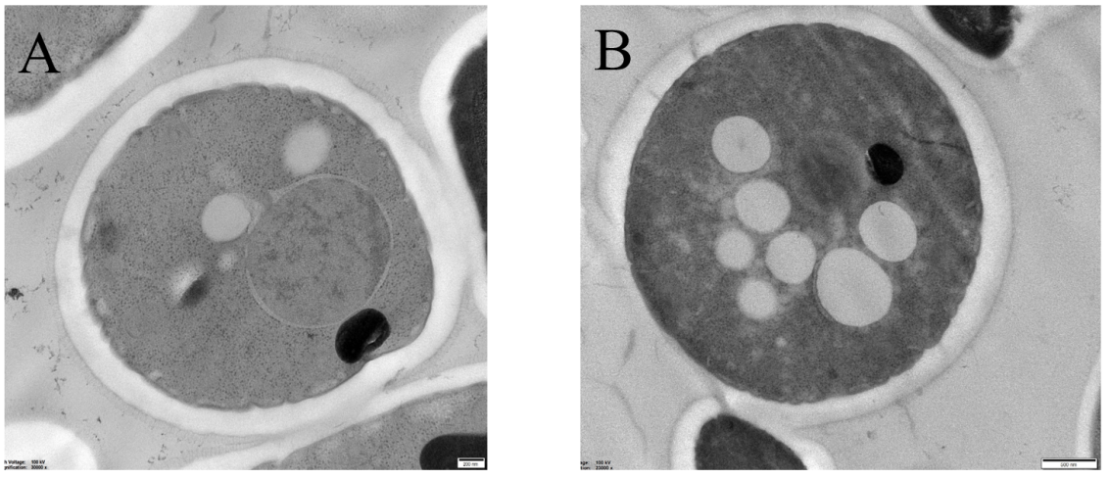
Fig. S1. Observation of yeast lipid droplets by transmission electron microscopy
(A) Transmission electron micrograph of the wild-type strain YBX-B, bar: 200 nm; (B) Transmission electron micrograph of β-carotene synthesizing strain YBX-01, bar: 500 nm

Fig. S2

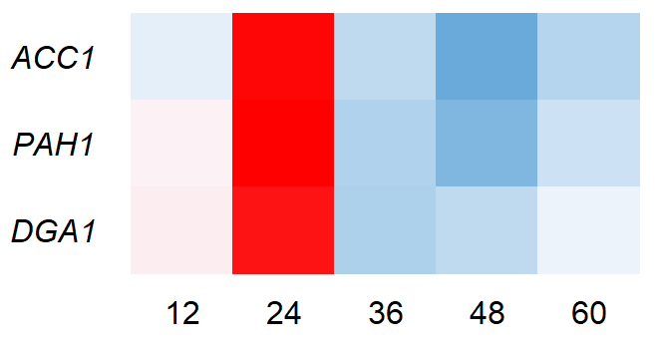
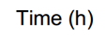
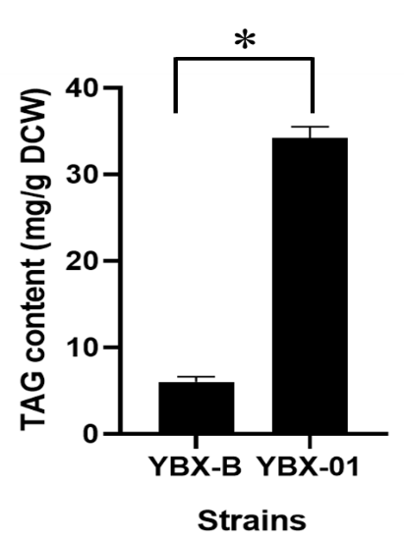
2
1
0

Fig. S2. The intracellular TAG content (A) and the relative expression of lipid droplets synthesis genes (B) between the wild-type strain YBX-B and β-carotene synthesizing strain YBX-01

Fig. S3

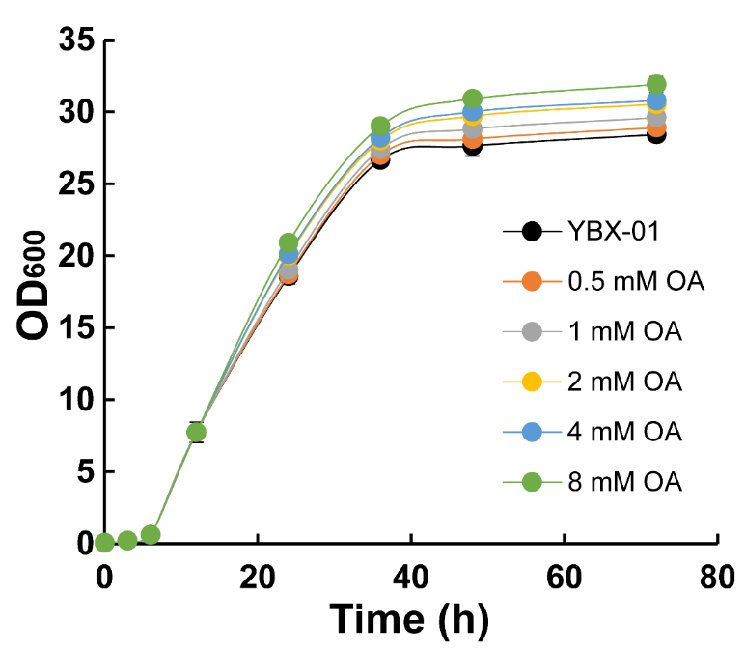

Fig. S3. Effects of adding different concentration of oleic acid on cell growth of the parent strain YBX-01

Fig. S4

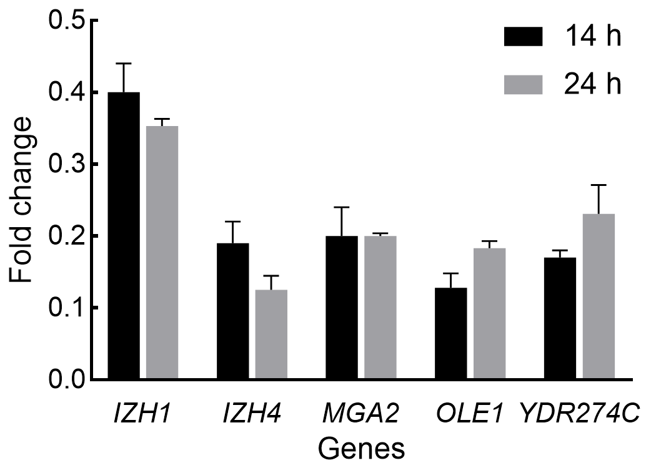
Fig. S4. The relative expression of target genes in strain YBX-01 after treated with 2 mM of OA for 2 h and 12 h relative to the control without addition by qRT-PCR

Table S1 Primers used for plasmid construction in this work
Primers | Sequence（5’-3’） | Note
Amplification of structural genes
CrtYB F (SacI) | GGATGACGACGATAAGATCTGAGCTATGACGGCTCTCGCATATTA | CrtYB
CrtYB R (SacI) | GGCGAAGAATTGTTAATTAAGAGCTTTACTGCCCTTCCCATCCGC | CrtYB
CrtI F (XhoI) | AGTTGATTTCCGAAGAAGACCTCGAATGGGAAAAGAACAAGATCAGG | CrtI
CrtI R (XhoI) | TAGCCGCGGTACCAAGCTTACTCGATCAGAAAGCAAGAACACCAAC | CrtI
CrtE F (EcoRI) | GTAAGAATTTTTGAAAATTCGAATTATGGATTACGCGAACATCCT | CrtE
CrtE R (EcoRI) | GCCGCCCTTTAGTGAGGGTTGAATTTCACAGAGGGATATCGGCTAG | CrtE
DGA1 F | GTAAGAATTTTTGAAAATTCGAATTATGTCAGGAACATTCAATGATATAAG | DGA1 ORF
DGA1 R | GCCGCCCTTTAGTGAGGGTTGAATTTTACCCAACTATCTTCAATTCTGCAT | DGA1 ORF
PAH1 F | CGTCAAGGAGAAAAAACCCCGGATCATGCAGTACGTAGGCAGAG | PAH1 ORF
PAH1 R | CCTATAGTGAGTCGTATTACGGATCTTAATCTTCGAATTCATCTTCGTCGAA | PAH1 ORF
ACC1 F1 | CGTCAAGGAGAAAAAACCCCGGATCAGTTTCTACCATGAGCGAAGAAAGC | ACC1 (the first part)
ACC1 R1 | AAAAGACCACCATCAGCTAGTTGACGCAGTA | ACC1 (the first part)
ACC1 F2 | TACTGCGTCAACTAGCTGATGGTGGTCTTTT | ACC1 (the second part)
ACC1 R2 | CATATGACAAATCTGAAACAGCAACAGCCCTGTTCATA | ACC1 (the second part)
ACC1 F3 | TATGAACAGGGCTGTTGCTGTTTCAGATTTGTCATATG | ACC1 (the third part)
ACC1 R3 | CCTATAGTGAGTCGTATTACGGATCCTTTACAAGGTTTATTTCAAAGTCTTCAACAAT | ACC1 (the third part)
Amplification of promoters
TEF1 F | GCCGCCCTTTAGTGAGGGTTGAATTCACACACCATAGCTTCAAAATG | TEF1 promoter
TEF1 R | CTATAGTGAGTCGTATTACGGATCTTGTAATTAAAACTTAGATTAGATTGCTATGCT | TEF1 promoter
PYK1 pro F | TGACCATACGTAGGAAAGTTTTTCCGGCAAGCTAA | PYK1 promoter
PYK1 pro R | CCTTTAGTGAGGGTTGAATTTGTGATGATGTTTTATTTGTTTTGA | PYK1 promoter
TPI1 pro F | CGGAAAAACTTTCCTACGTATGGTCATTTCTTC | TPI1 promoter
TPI1 pro R | CCTATAGTGAGTCGTATTACGGATCTTTTAGTTTATGTATGTGTTTTTTGTA | TPI1 promoter
Amplification of homology arms
DGA1 left F | GTTGTTGTTGGAAGGCCTATGGCCATATAGGCCTCTCTGCAGGCAACTAAGTT | DGA1 homologous arm
DGA1 left R | AGGGAACAAAAGCTGGAGCTGGCCTTGTAGACTTATTCTCATGCCTTTCG | DGA1 homologous arm
DGA1 right F | GGCGTAATAGCGAAGAGGCCTACAAACTACTTATTGGCGTTAGGT | DGA1 homologous arm
DGA1 right R | GGCGTAATAGCGAAGAGGCCTACAAACTACTTATTGGCGTTAGGT | DGA1 homologous arm
LRO1 left F | ATCAACAAACTGGCAATTGCGGCCATATAGGCCCTCCTCAGGAGTTATTTGACCT | LRO1 homologous arm
LRO1 left R | AGGGAACAAAAGCTGGAGCTGGCCGAATGTGGTTTCTGCTCTCTC | LRO1 homologous arm
LRO1 right F | GGCGTAATAGCGAAGAGGCCTTGAGCCAGTGGGTTTCTCA | LRO1 homologous arm
LRO1 right R | AGGTCAAATAACTCCTGAGGAGGGCCTATATGGCCGCAATTGCCAGTTTGTTGAT | LRO1 homologous arm
ARE1 left F | GCAAAGAGCTCCTAGGTCTATGGCCATATAGGCCCACTATGTATGTGCTGCTCAT | ARE1 homologous arm
ARE1 left R | AGGGAACAAAAGCTGGAGCTGGTCAGTCGACTCCACTCCTTC | ARE1 homologous arm
ARE1 right F | GGCGTAATAGCGAAGAGGCCAGATATTTCTACGGCGACTG | ARE1 homologous arm
ARE1 right R | ATGAGCAGCACATACATAGTGGGCCTATATGGCCATAGACCTAGGAGCTCTTTGC | ARE1 homologous arm
ARE2 left F | GCAACTGTTCTGTGGAGCTAGGCCATATAGGCCGAGACTCGAGAAAGAGGGAAG | ARE2 homologous arm
ARE2 left R | AGGGAACAAAAGCTGGAGCTGGCCCGGAGAAATTGTTCGTTCTCC | ARE2 homologous arm
ARE2 right F | GGCGTAATAGCGAAGAGGCCTGAACTGTGTGGCTGAATTGAC | ARE2 homologous arm
ARE2 right R | CTTCCCTCTTTCTCGAGTCTCGGCCTATATGGCCTAGCTCCACAGAACAGTTGCA | ARE2 homologous arm
TGL3 left F | GAGGAATGAACAGAAGCATCGGGCCATATAGGCCCGCTCCCTTGTTTAATAGCTT | TGL3 homologous arm
TGL3 left R | AGGGAACAAAAGCTGGAGCTGGCCATACACTACACGCAGTATCCA | TGL3 homologous arm
TGL3 right F | GGCGTAATAGCGAAGAGGCCAGATTGCTGTGGTACCAAG | TGL3 homologous arm
TGL3 right R | AAGCTATTAAACAAGGGAGCGGGCCTATATGGCCCGATGCTTCTGTTCATTCCTC | TGL3 homologous arm
TGL4 left F | GGGTTGGTACTAATGCTGGAGGCCATATAGGCCGCGCTTCAAAAAGTCATTAGG | TGL4 homologous arm
TGL4 left R | AGGGAACAAAAGCTGGAGCTGGCTCCACCCTTTCAACATCTGA | TGL4 homologous arm
TGL4 right F | GGCGTAATAGCGAAGAGGCCTTCAGGCGTCATAGCATTGATGG | TGL4 homologous arm
TGL4 right R | CCTAATGACTTTTTGAAGCGCGGCCTATATGGCCTCCAGCATTAGTACCAACCC | TGL4 homologous arm
TGL5 left F | CCTAATGACTTTTTGAAGCGCGGCCTATATGGCCTCCAGCATTAGTACCAACCC | TGL5 homologous arm
TGL5 left R | AGGGAACAAAAGCTGGAGCTGGCCATTTGACTGATGGATCAGCG | TGL5 homologous arm
TGL5 right F | CAGGAGTGTTGGAAAGTTCGGGCCTATATGGCCCAGCTCCTTGAATGATAGTACG | TGL5 homologous arm
TGL5 right R | CAGGAGTGTTGGAAAGTTCGGGCCTATATGGCCCAGCTCCTTGAATGATAGTACG | TGL5 homologous arm
FLD1 left F | AAATAATGAGGACACCCCGCGGCCACTAGGGCCGACTGGAATTACAGCGCAAC | FLD1 homologous arm
FLD1 left R | AGGGAACAAAAGCTGGAGCTGGCCCTGTAATGGACGGGATACATTGA | FLD1 homologous arm
FLD1 right F | GGCGTAATAGCGAAGAGGCCTATCACAGGTTGCACTGCATTC | FLD1 homologous arm
FLD1 right R | GTTGCGCTGTAATTCCAGTCGGCCCTAGTGGCCGCGGGGTGTCCTCATTATTT | FLD1 homologous arm
HO left F | AAATTCAGCGGTCATCACTGGACGTCGACTTAAAATGGCGTGGCAG | HO homologous arm
HO left R | AGGGAACAAAAGCTGGAGCTGGCCGATGTATCTCATCGCAGGCA | HO homologous arm
HO right F | GGCCTCTTCGCTATTACGCCCCATTATGGACGGAATTGTC | HO homologous arm
HO right R | CTGCCACGCCATTTTAAGTCGACGTCCAGTGATGACCGCTGAATTT | HO homologous arm
Ty4 left F | GTGTATGCAAAATGGACAAGAACGGCCATATAGGCCGCTTTCGCAAATACACCAATG | Ty4 homologous arm
Ty4 left R | AGGGAACAAAAGCTGGAGCTGGACAGCGTTACCAATATGGTATG | Ty4 homologous arm
Ty4 right F | GGCGTAATAGCGAAGAGGCGGATAGTGGAACACATTCCAAG | Ty4 homologous arm
Ty4 right R | CATTGGTGTATTTGCGAAAGCGGCCTATATGGCCGTTCTTGTCCATTTTGCATACAC | Ty4 homologous arm
DPP1 left F | GGAAGCAGTTGAGTAGCTGAGGCCATATAGGCCCCAACGTTGGATAACCTCA | DPP1 homologous arm
DPP1 left R | AGGGAACAAAAGCTGGAGCTGGGTTCGAACGGTTGTTGGTAA | DPP1 homologous arm
DPP1 right F | GGCGTAATAGCGAAGAGGCCTTCCCACCCATTGATGATC | DPP1 homologous arm
DPP1 right R | TGAGGTTATCCAACGTTGGGGCCTATATGGCCTCAGCTACTCAACTGCTTCC | DPP1 homologous arm
LPP1 left F | CACGCCAGATATTAACCGAAGGGCCATATAGGCCCGTGAAACCTGACAACTTATAG | LPP1 homologous arm
LPP1 left R | AGGGAACAAAAGCTGGAGCTGGCTTGTCAAACATGCAGGTCC | LPP1 homologous arm
LPP1 right F | GGCGTAATAGCGAAGAGGCATGTTGTCTCTGGAGCTGTT | LPP1 homologous arm
LPP1 right R | CTATAAGTTGTCAGGTTTCACGGGCCTATATGGCCCTTCGGTTAATATCTGGCGTG | LPP1 homologous arm
The promoter primers of replace ERG9 original promoter
OLE1 pro F | TAGGCCTCTTCGCTATTACGCCAGTGATGTTCTGAGGTATTCGTATCGC | OLE1 promoter
OLE1 pro R | AATTGTAATAGCTTTCCCATCTTTGTTGTAATGTTTTAGTGCTGTTT | OLE1 promoter
MGA2 pro F | TAGGCCTCTTCGCTATTACGCCAGGCCCTCAACGTAGACAAGTC | MGA2 promoter
MGA2 pro R | AATTGTAATAGCTTTCCCATAACGAAATGTTCTGTTCGCC | MGA2 promoter
IZH1 pro F | TAGGCCTCTTCGCTATTACGCCAGGCAATATCTCAAAGCCATTAAT | IZH1 promoter
IZH1 pro R | GCCAATTGTAATAGCTTTCCCATTTTTTTTCTTCTTTTATCTTGC | IZH1 promoter
IZH4 pro F | TAGGCCTCTTCGCTATTACGCCAGCGCTTCCATTTGGGGTTATT | IZH4 promoter
IZH4 pro R | AATTGTAATAGCTTTCCCATACTGTCAATATATATGTACCTTTATACC | IZH4 promoter
YDR274C pro F | TAGGCCTCTTCGCTATTACGCCAGCGACTCGTGAATGATTTTTCGA | YDR274C promoter
YDR274C pro R | AATTGTAATAGCTTTCCCATGTACGAGGGAAGAGAAGG | YDR274C promoter
ERG9-FF | CACGACTACGACGTGTACTGGGATCCGGTCTGCAGGGGAGAACTTA | ERG9 F
ERG9-FR | GTTATATTAAGGGTTGTCGAGCGCGCAAAACCGATAACGCCTTCC | ERG9 F
ERG9-OLE1-RF | ACTAAAACATTACAACAAAGATGGGAAAGCTATTACAATTGGC | ERG9 R-OLE1
ERG9-MGA2-RF | GGCGAACAGAACATTTCGTTATGGGAAAGCTATTACAATTGGC | ERG9 R-MGA2
ERG9-IZH1-RF | CAAGCAAGATAAAAGAAGAAAAAAAATGGGAAAGCTATTACAATTGGC | ERG9 R-IZH1
ERG9-IZH4-RF | GGTATAAAGGTACATATATATTGACAGTATGGGAAAGCTATTACAATTGGC | ERG9 R-IZH4
ERG9-YDR274C-RF | CCTTCTCTTCCCTCGTACATGGGAAAGCTATTACAATTGGC | ERG9 R-YDR274C
ERG9-RR* | TAAGTTCTCCCCTGCAGACCGGATCCCAGTACACGTCGTAGTCGTG
* ERG9-RR: A universal primer for the amplification of ERG9 R from yeast genomic DNA，including fragment ERG9 R-OLE1，ERG9 R-MGA2，ERG9 R-IZH1，ERG9 R-IZH4 and ERG9 R-YDR274.

Table S2 Primers for genotype identification of promoter replaced strains
Primer | Sequence（5’-3’） | Theoretical band size
YZJYZ OLE1pro F | TGGGGATGGCACACAAAGGT | around 1050 bp
YZJYZ MGA2pro F | ATCTGGCACTTTGTCTCAGGG | around 1140 bp
YZJYZ IZH1pro F | CGACCGATGGATGCAGCAAT | around 1100 bp
YZJYZ IZH4pro F | CGGACAATTCGGACAGCACT | around 1060 bp
YZJYZ YDR274pro F | GGATGCAGATGCCTGGCAAG | around 1070 bp
YZJYZ ERG9 R* | CAGTCCAACCCCAGTTGTTCG | --
*YZJYZ ERG9 R: a reverse universal primer for verifying the genome of ERG9 promoter replacement strain，including the strains YBX-01-OLE1, YBX-01-MGA2, YBX-01-IZH1, YBX-01-IZH4 and YBX-01-YDR274

Table S3 Primers for quantitative real-time PCR in this work
Primer | Sequence（5’-3’） | Product size
qACT1-F | TGCAAAAGGAAATCACCGC | 98 bp
qACT1-R | GATAGAACCACCAATCCAGACG | 98 bp
qACC1-F | GTTGTCGTTGGTAGAGCCCG | 163 bp
qACC1-R | TGAAGGCGGAGTTTGGATGC | 163 bp
qDGA1-F | AACTCTGGCTGTAGCATGGC | 81 bp
qDGA1-R | AGTGCTGGTGTCGAGATTGC | 81 bp
qPAH1-F | AAAGACTGGACGCACTTGGG | 195 bp
qPAH1-R | CGCAGCCATCGTTCTATCGG | 195 bp
qERG9-F | GAAACCTGAAAACGAACAACTGG | 145 bp
qERG9-R | CATAACTTGGGGAATGGCACA | 145 bp
qOLE1-F | TTCTACTACGCTGTCGGTGG | 128 bp
qOLE1-R | CCTTCAACGGAAGCACAACC | 128 bp
qMGA2-F | TTCCTCCTGAACGGGTCTCC | 127 bp
qMGA2-R | CGAAAGACAACAGGTTGGGC | 127 bp
qIZH1-F | CTGCTGCAAGGCAACGAGAG | 153 bp
qIZH1-R | AGTGTTTCACGAACGTACCCG | 153 bp
qIZH4-F | GACGGACAAACTCATTTCCTCG | 172 bp
qIZH4-R | CAAAGCCACAAGTTCCCACG | 172 bp
qYDR274C-F | AAACGCAAGACCGAGCATTC | 94 bp
qYDR274C-R | CGAAACGTCCTTTTGCACGG | 94 bp

Table S4 Down-regulated genes in strain YBX-01 after treated with oleic acid for 2 h and 12 h by transcriptome analysis
Systematic name | Standard name | FPKM ratio* 2 h | FPKM ratio* 12 h | Description
YGL055W | OLE1 | 0.1594 | 0.2450 | Delta(9) fatty acid desaturase
YIR033W | MGA2 | 0.3914 | 0.3861 | ER membrane protein involved in regulation of OLE1 transcription
YDR492W | IZH1 | 0.4735 | 0.4348 | Membrane protein involved in zinc ion homeostasis
YOL101C | IZH4 | 0.1665 | 0.2831 | Membrane protein involved in zinc ion homeostasis
YDR274C | - | 0.1858 | 0.2246 | Putative protein of unknown function
YCR018C | SRD1 | 0.4949 | 0.4563 | Protein involved in the processing of pre-rRNA to mature rRNA
YOL104C | NDJ1 | 0.3148 | 0.1872 | Protein that regulates meiotic SPB cohesion and telomere clustering
YGR161W-B | - | 0.0000 | 0.0588 | Retrotransposon TYA Gag and TYB Pol genes
YGR259C | - | 0.4756 | 0.3837 | Dubious open reading frame unlikely to encode a functional protein
YJL136W-A | - | 0.0952 | 0.4976 | Putative protein of unknown function
YPL197C | - | 0.4328 | 0.3048 | Dubious open reading frame unlikely to encode a functional protein
YLR302C | - | 0.4793 | 0.1990 | Putative protein of unknown function
YPR076W | - | 0.1917 | 0.4875 | Dubious open reading frame unlikely to encode a functional protein
YEL053W-A | - | 0.0000 | 0.2792 | Dubious open reading frame unlikely to encode a functional protein
YOR329W-A | - | 0.1928 | 0.1940 | Dubious open reading frame unlikely to encode a functional protein
YIL068W-A | - | 0.4769 | 0.4520 | Dubious open reading frame unlikely to encode a functional protein
YGL069C | - | 0.0000 | 0.4717 | Dubious open reading frame unlikely to encode a functional protein
YER038W-A | - | 0.4787 | 0.0000 | Mitochondrial protein of unknown function
YER067C-A | - | 0.1881 | 0.0000 | Dubious open reading frame unlikely to encode a functional protein
YJR018W | - | 0.0000 | 0.0000 | Dubious open reading frame unlikely to encode a functional protein
YLL030C | RRT7 | 0.4888 | 0.3531 | Putative protein of unknown function
*FPKM ratio: The ratio of FPKM between oleic acid added group and the control group

