Additional file 1: Table S1. List of primers
Primer | Sequence (5'→3')
AT031 | CCTCTAGAGTCGACCGATCCCCGGGTACCGGTCGC
AT044 | GCATCAAGGAACTCCTTGGAATTCTAGAGTCGCGG
AT097 | ATGGTGAGCAAGGGCGAGGAGCTGTTCACC
AT098 | GGGGATCCTCTAGAGGATCGACTTCGACCTCTTG
AT099 | GCCCTTGCTCACCATGGTCTGCTCCTTGACGATG
AT141 | GCCCTTGCTCACCATGGTCTGTTTCCTGTGTG
AT142 | GGGGATCCTCTAGAGTGGTGCAAAACCTTTCGC
AT143 | GGGGATCCTCTAGAGGGTCGCTCTAGGGAGTGC
AT144 | GCCCTTGCTCACCATGAGACACCTCCTACGTTG
AT170 | TCGGTGAACTGGATCTGAATTCGAGCTCGGTACCC
AT171 | ACTCGAGTAAGGATCATGATTACGCCAAGCTCGAG
MM05 | CGAGCTCTTGAGATCCTTTTTTTCTGCG
MM06 | GATCTCAAGAGCTCGGTACCCAGAAGCC
MM12 | AAGGAACTTCAGGTCGAGGTGGCCCG
MM21 | TACGCCAAGCTCGAGATTCCTGTAGAAATTAGCGG
MM22 | TACGCCAAGCTCGAGGCTTCCGGCCCTTTTCTCTA
MM24 | TAGAGTCGACCCGGGCCTACCGCTGTTTGGCTTCG
MM26 | CCCGGGTCGACTCTAGAGGATCCC
MM27 | CTCGAGCTTGGCGTAATCATGGTC
MM28 | GACCTGAAGTTCCTTCCTACCGCTGTTTGGCTTCG
MM29 | GATTTCATTTTAGCTTCCTTAGCTCCTG
MM31 | AAGCTAAAATGAAATCTAACAATGCGCTCA
MM54 | AGTTCCTTGATGCCGACGTC
MM55 | ATGGTGATGATGATGGTGGTGCATGGTCTGCTCCTTGACGATG
MM60 | CATCATCATCACCATATGAAGGCAACCAGGCGGTC
MM61 | CGGCATCAAGGAACTTCAGTAGTCCTCGTACCAGC
MM62 | CATCATCATCACCATATGCGTCTCGATTCCGTCGT
MM63 | CGGCATCAAGGAACTCTACTTCTCCAGCAACAGCG
MM70 | CATCATCATCACCATATGTCCGACGCCCTGAACCA
MM71 | CGGCATCAAGGAACTTTAATCTCCGTCGTGTAGCC
MM80 | CATCATCATCACCATGTGTCCTGTGATTCACCGCT
MM81 | CGGCATCAAGGAACTTCAGCTTACCGCCAGCTCCT
MM82 | CGGGCTGGTATAATCGCCGC
MM83 | CCCGGTACCTTAGCTTGCCG
MM84 | CATCATCATCACCATATGCAAGCCTATCAGCGGGA
MM85 | CGGCATCAAGGAACTTCACTCGGCGGCGACACCGT
YA_cas9a | AGGAAACAGACCATGGATAAGAAATACTCAATAGG
YA_cas9b | CAAAACAGCCAAGCTTTAGTCACCTCCTAGCTGAC
YA_cas9c | GGCTTCTGGGTACCGCTCGAGTGCTTAATTTGATGCCTGGC
YA_cas9d | ATTGCCGCACAAGCTATCGATCTGTCAGACCAAGTTTACTC
YA_pChl1 | TCGAGCTCGGTACCCAGAAGCCACTGGAGCACCTC
YA_pChl2 | CTCTAGAGGATCCCCACCAGGCGTTTAAGGGCACC
YA_pHA3_3 | GAGTCGACCTGCAGGAGTTCCTTGATGCCGACGTC
YA_pHA3_4 | ATTACGCCAAGCTTGTGCGGCAATGGTCACAGTGC
YT01 | CAACGTGCATGCCAGCGGTGTTTTAGAGCTAGAAA
YT02 | CGCTGGCATGCACGTTGAACTAGTATTATACCTAG

Additional file 1: Table S2. Transformation efficiency of Halomonas strains
host | vector | colony formation / µg of DNA | Reference
O-1 | pBBR1MCS-5 (gen^{r}) | 10⁴ | Harris et al. (2016) [1]
O-1 | pBBR1MCS (cm^{r}) | 10³ | Harris et al. (2016) [1]
O-1 | pBBR1MCS-3 (tet^{r}) | Not obtained | Harris et al. (2016) [1]
KM-1 | pBBR1MCS (cm^{r}) | 40 | This work
KM-1 | pUCpHAw (cm^{r}) | 10²⁻³ | This work
KM-1 | pHA1AT_32 (tet^{r}) | 10³ | This work
KM-1 | pTHA(Cas9) | 4 | This work
KM-1  + pTHA(Cas9) | pHA1AT_32 | 10⁻¹ | This work
KM-1  + pTHA(Cas9) | pgRNAHA | 10⁻¹ | This work
KM-1  + pTHA(Cas9) | pgRNAHA_pyrF | 10⁻¹ | This work

Additional file 1: Table S3. N-terminal amino acid sequences and predicted proteins
N-terminal amino acid sequence* | pI | kDa | Annotation of predicted protein
PTP-YI (PTPCYI) | 5 | 20 | hemolysin coregulated protein (Hcp) family type Ⅵ secretion system effector
SKTQDK | 7 | 14 | phasin (polyhydroxyalkanoate-associated protein)
*N-terminal amino acid sequences were determined by Edman degradation.

Additional file 1: Table S4. Results of screening of gene disruption mutants.
target gene | 1st screening | 2nd screening | subjected to DNA sequencing
target gene | 1st screening | 2nd screening | ΔpyrF | ΔpyrE | unknown
mock | 200 | 0 | 0 | 0 | 0
pyrF | 1624 | 45 | 39 | 2 | 4

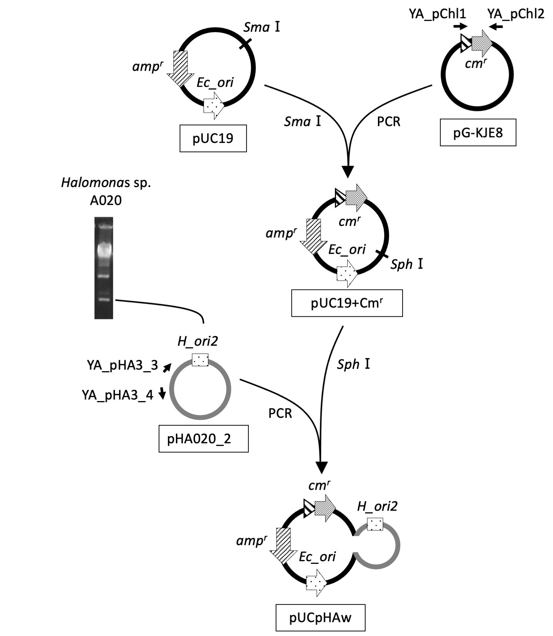

Additional file 1: Fig. S1. Construction of a shuttle vector, pUCpHAw
A shuttle vector, pUCpHAw, was constructed using pUC19, cm^{r} from pG-KJE8, and pHA020_2. PCR amplified cm^{r} with primers (YA_pChl1 and YA_pChl2) was cloned into a SmaⅠ site of pUC19, resulting in pUC19+cm^{r}. A whole pHA020_2 was amplified by PCR with primers (YA_pHA3_3 and YA_pHA3_4) and cloned into an SphⅠ site of the pUC19+cm^{r}, resulting in pUCpHAw.

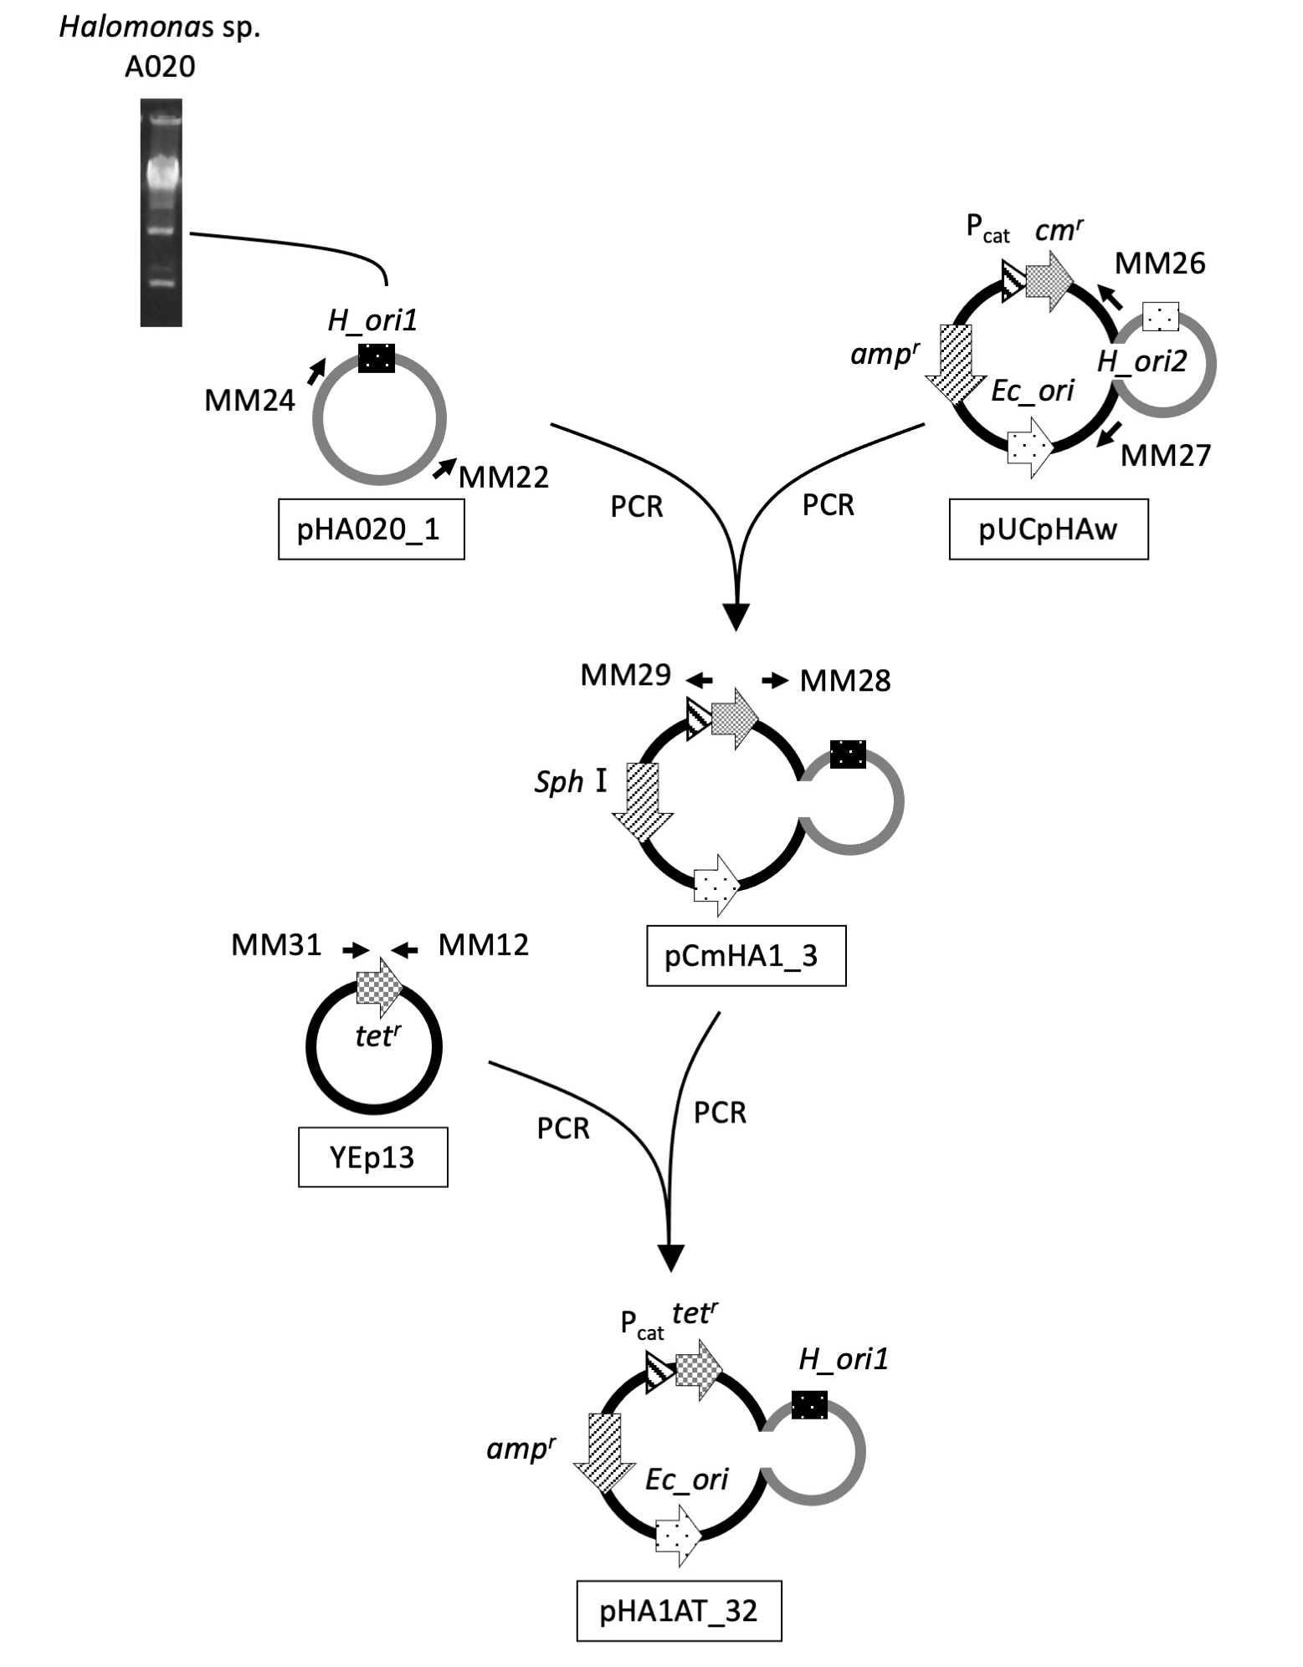

Additional file 1: Fig. S2. Construction of pHA1AT_32
A shuttle vector, pHA1AT_32, was constructed from pUCpHAw by substitution of the replication origin and selection marker gene. The pHA020_2 region in pUCpHAw was removed by PCR with primers (MM26 and MM27) and exchanged with an origin region of pHA020_1, which was amplified by PCR with primers (MM22 and MM24). Then cm^{r} was removed by PCR with primers (MM28 and MM29) and substituted with tet^{r} of YEp13 amplified by PCR with primers (MM12 and MM31).

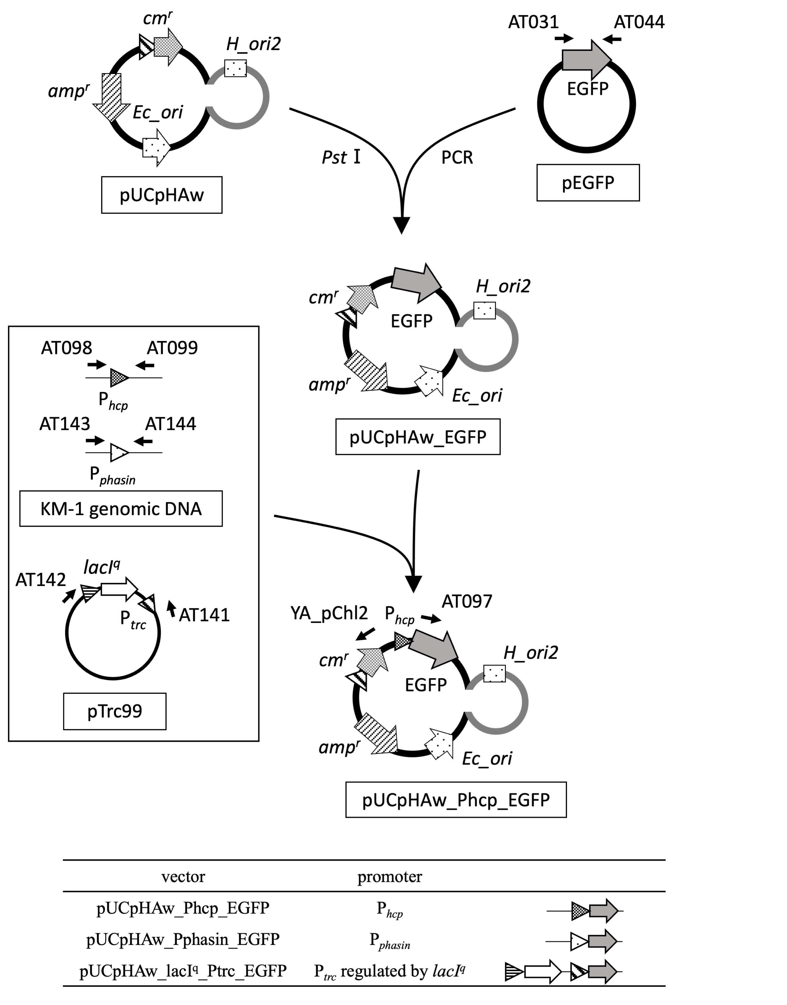

Additional file 1: Fig. S3. Construction of EGFP expression vectors
EGFP was amplified by PCR with primers (AT031 and AT044) and cloned into a PstⅠ site of pUCpHAw, resulting in pUCpHAw_EGFP. Three promoter regions, upstream regions of hcp and phasin genes of KM-1, and trc promoter with lacI^{q} of pTrc99a vector, were amplified by PCR using primers (AT098 and AT099), (AT143, AT144), and (AT141 and AT142), respectively. Those DNA fragments were assembled with a DNA fragment of pUCpHAw_EGFP, which was amplified by PCR with primers (YA_pChl2 and AT097), resulting in three vectors, pUCpHAw_Phcp_EGFP, pUCpHAw_Pphasin_EGFP, and pUCpHAw_lacI^{q}_Ptrc_EGFP.

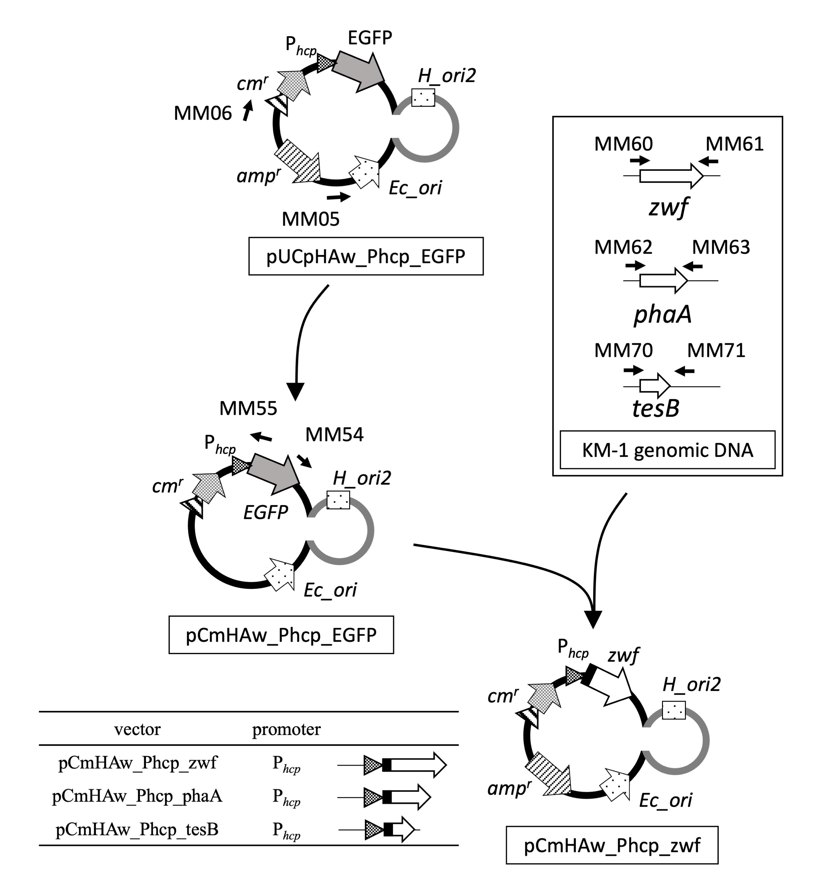

Additional file 1: Fig. S4. Construction of gene expression vectors
The pUCpHAw_Phcp_EGFP was amplified by PCR with primers (MM05 and MM06) and assembled to remove amp^{r}, resulting in pCmHAw_Phcp_EGFP. KM-1 genes, such as zwf, phaA, and tesB, were amplified by PCR with primers (MM60 and MM61), (MM62 and MM63), and (MM70 and MM71), respectively. The 7×His-tag sequence (shown in a black square) was added at the N-terminal end of each gene. The EGFP in pCmHAw_Phcp_EGFP was exchanged with the DNA fragments, resulting in pCmHAw_Phcp_zwf, pCmHAw_Phcp_phaA, and pCmHAw_Phcp_tesB.

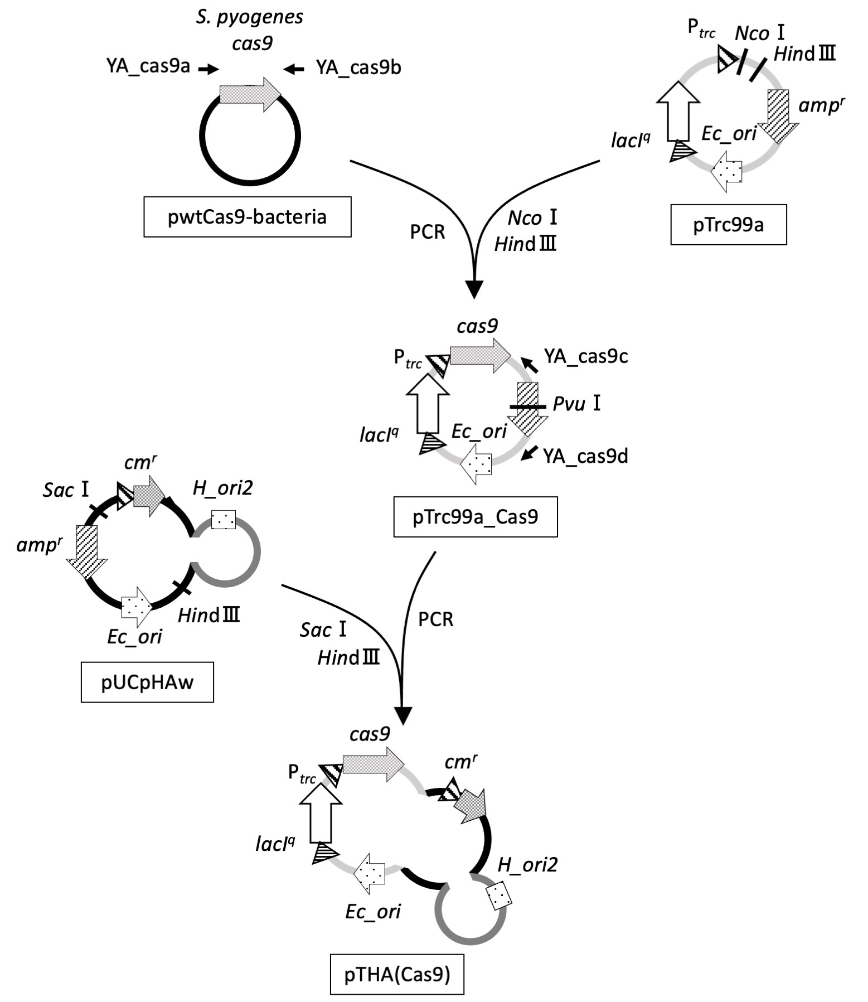

Additional file 1: Fig. S5. Construction of pTHA(Cas9)
The cas9 gene fragment, which was amplified by PCR using pwtCas9-bacteria and primers (YA_cas9a and YA_cas9b), was cloned by In-Fusion at a NcoⅠ-HindⅢ site of pTrc99a vector, resulting in pTrc99a_Cas9. A DNA fragment containing lacI^{q}, trc promoter, and cas9 was amplified by PCR using pTrc99a_Cas9 and primers (YA_cas9c and YA_cas9d) and cloned by In-Fusion at a SacⅠ-HindⅢ site of pUCpHAw, resulting in pTHA(Cas9).

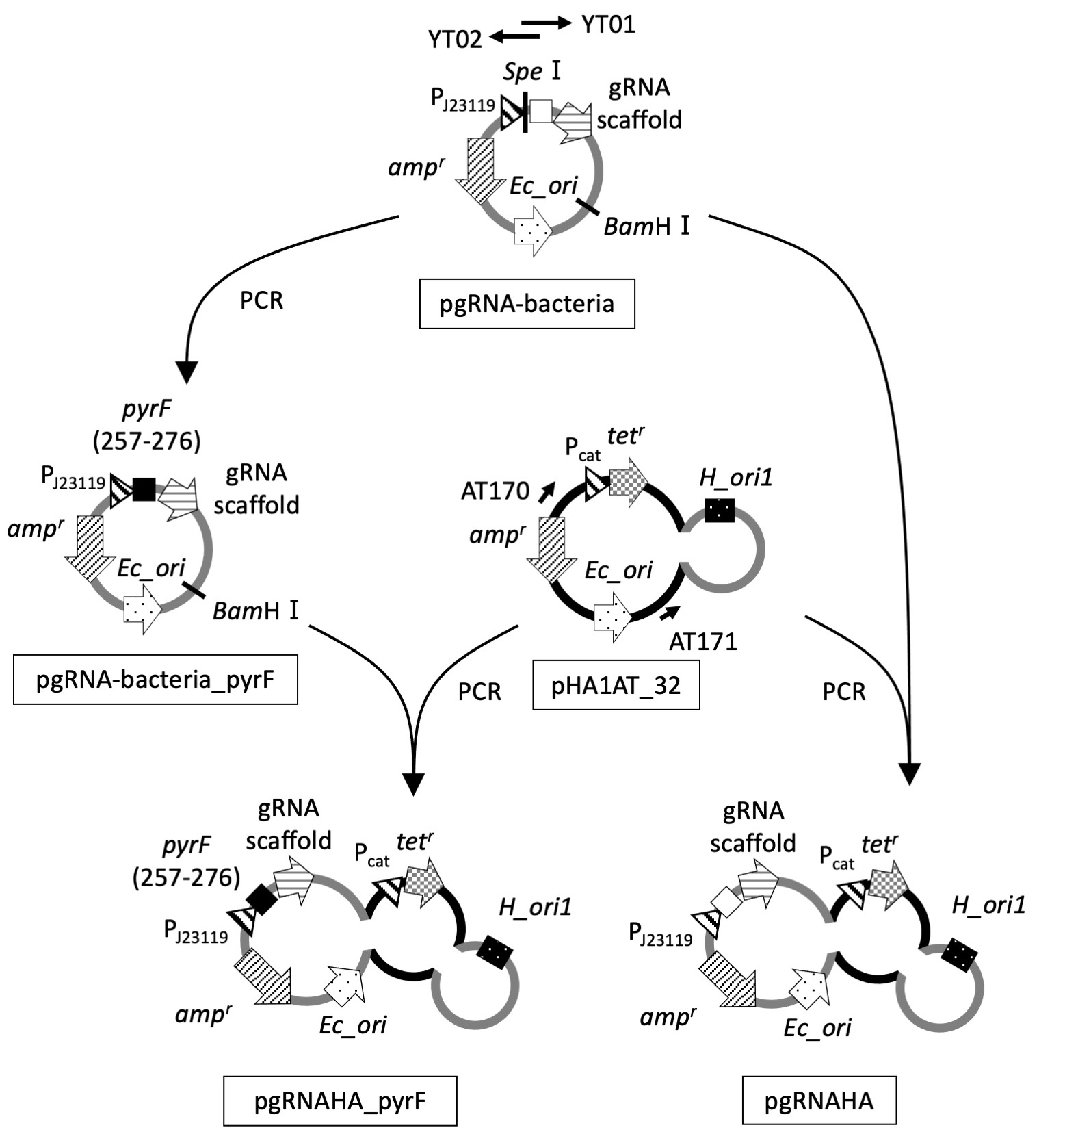

Additional file 1: Fig. S6. Construction of guide RNA expression vectors
A 20-base DNA fragment in pyrF adjacent to a PAM sequence was cloned into pgRNA-bacteria by PCR with primers (YT01 and YT02), resulting in pgRNA-bacteria_pyrF. After BamHⅠ digestion of pgRNA-bacteria_pyrF, the DNA fragment was cloned by In-Fusion with the pHA1AT_32 fragment, which was amplified by PCR with primers (AT170 and AT171), resulting in pgRNAHA_pyrF. To construct a control vector, pgRNAHA, pgRNA-bacteria was digested with BamHⅠ and the DNA fragment was cloned by In-Fusion with pHA1AT_32 in the same way as gRNAHA_pyrF construction.

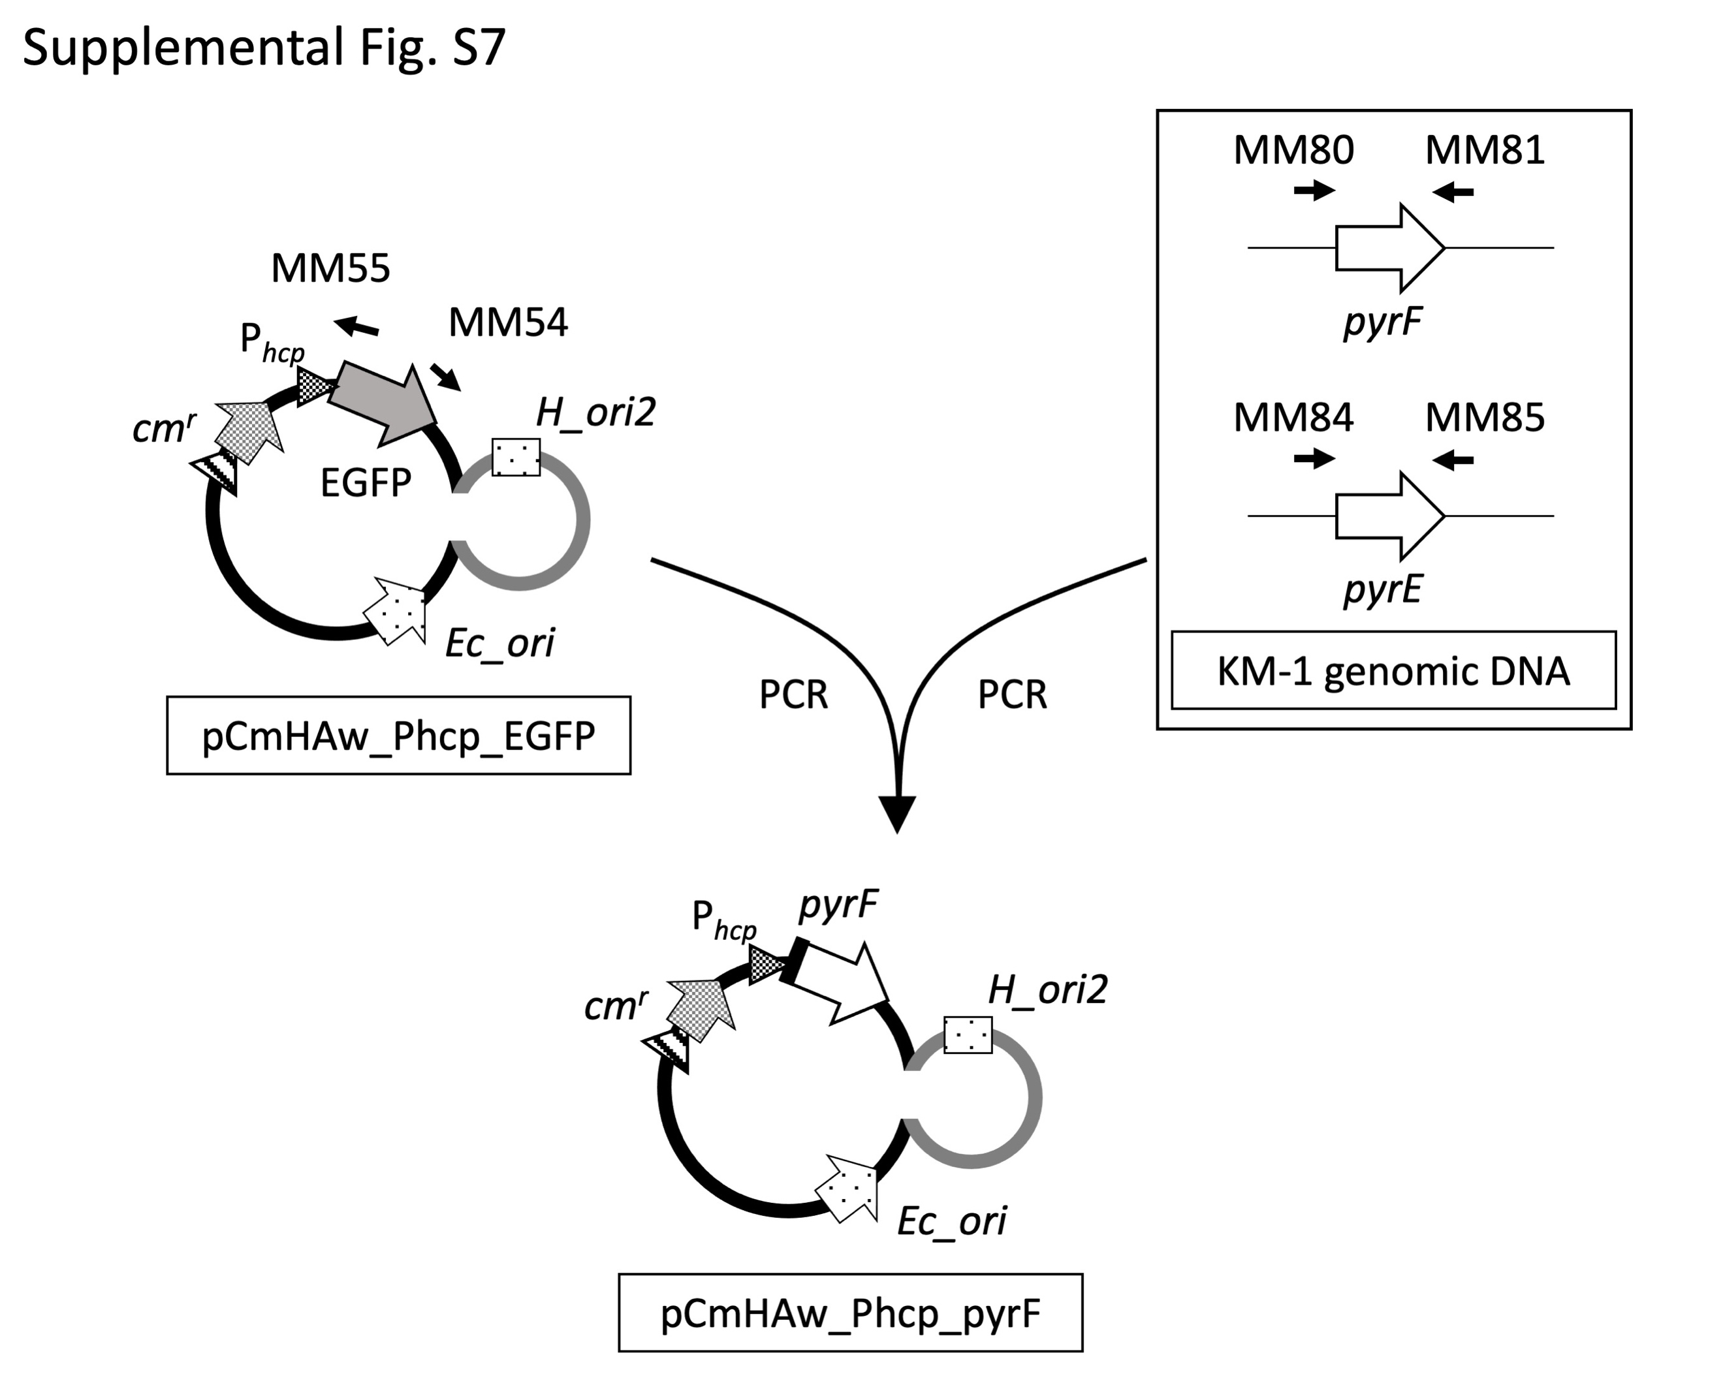

Additional file 1: Fig. S7. Complementation of pyrF gene in ΔpyrF mutants
Expression vectors, pCmHAw_Phcp_pyrF and pCmHAw_Phcp_pyrE, were constructed by replacemant of the EGFP gene in pCmHAw_Phcp_EGFP with KM-1 pyrF and pyrE genes, respectively in the same way as pCmHAw_Phcp_zwf construction described in Additional file 1: Fig. S5.

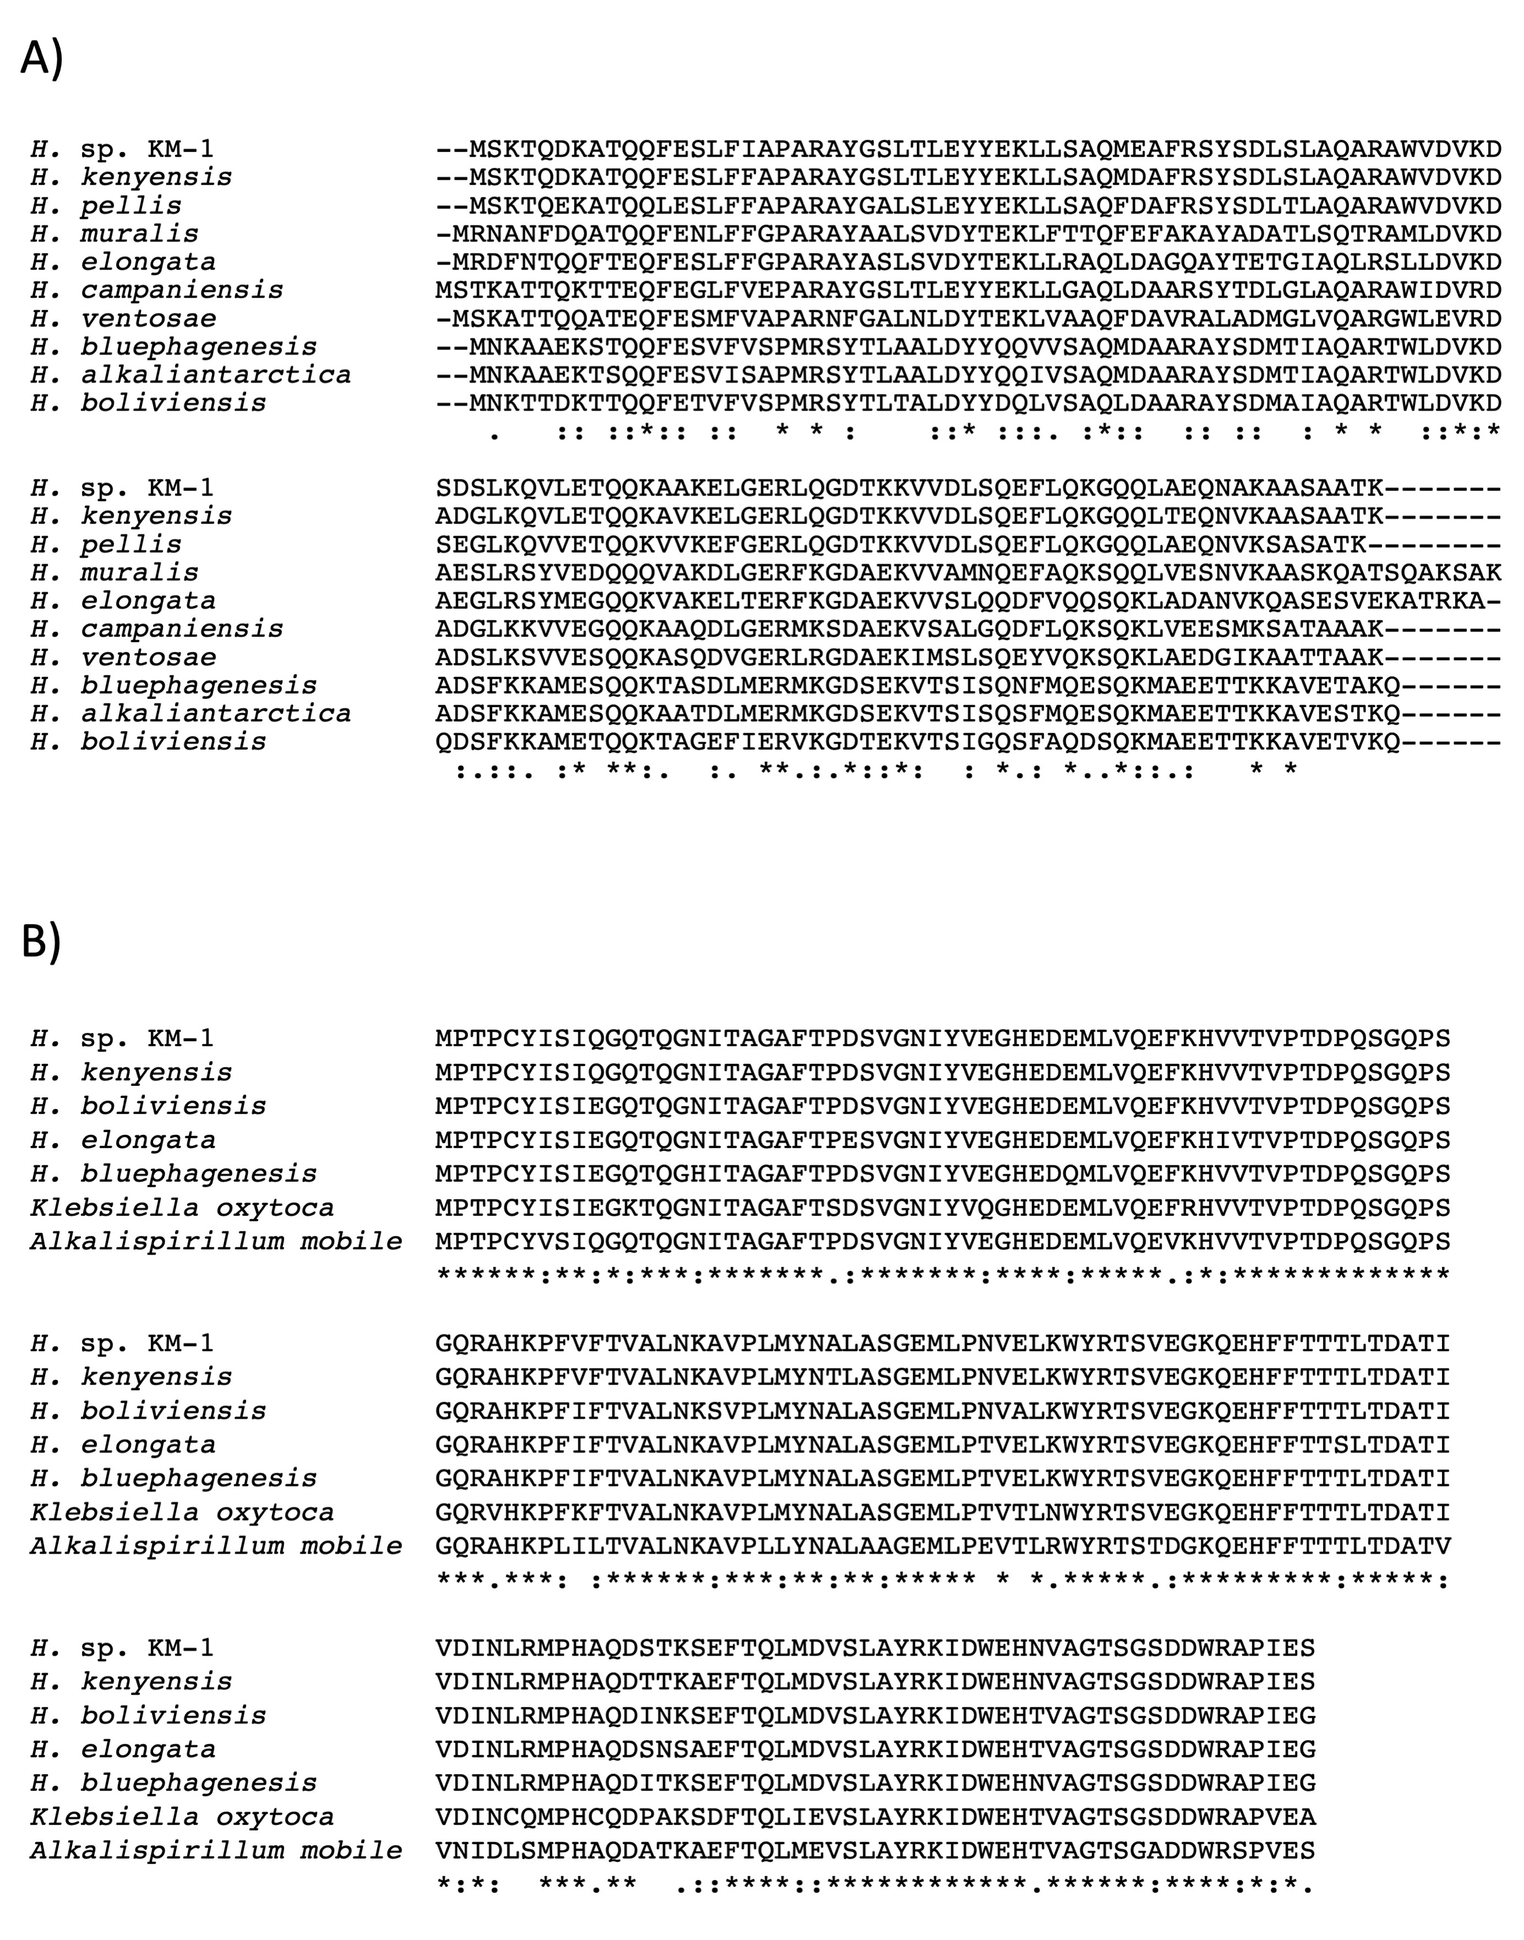

Additional file 1: Fig. S8. Multiple sequence alignments of Phasin and Hcp
A) Multiple sequence alignment of Phasin proteins was performed using ClustalW ver. 2.1 [2] and 10 Phasin proteins; accession numbers were Halomonas sp. KM-1 (LC677174), Halomonas kenyensis (WP_181514615), Halomonas pellis (WP_149327764), Halomonas campaniensis (WP_183329477), Halomonas ventosae (WP_106230852), Halomonas bluephagenesis (WP_009721314), Halomonas boliviensis (WP_040481094), Halomonas alkaliantarctica (WP_030073995), Halomonas muralis (WP_089729872), and Halomonas elongata (WP_013332053).
B) Multiple sequence alignment of Hcp was performed using ClustalW ver. 2.1 [2] and Halomonas and Gammaproteobacteria species; accession numbers were Halomonas sp. KM-1 (LC677173), Halomonas kenyensis (WP_181517154), Halomonas bluephagenesis (WP_009722783), Halomonas boliviensis (WP_040480043), Halomonas elongata (WP_065241715), Alkalispirillum mobile (WP_121442090), and Klebsiella oxytoca (HAT1682916).

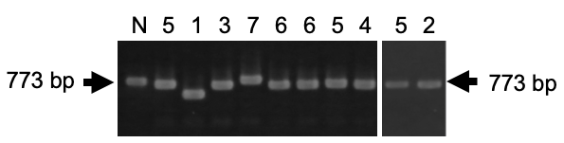

Additional file 1: Fig. S9. DNA electrophoresis of pyrF gene disruption mutants.
Genomic DNA regions including the pyrF gene (shown in Fig. 4A) of KM-1 wild type and mutants were amplified using the primers, MM82 and MM83, and analyzed using the agarose gel electrophoresis. The length of the natural pyrF gene was indicated by 773 bp and arrows. Numbers on the top of photos indicate mutation types shown in Fig. 4B, and N shows the natural pyrF gene.

References
1. Harris JR, Lundgren BR, Grzeskowiak BR, Mizuno K, Nomura CT: A rapid and efficient electroporation method for transformation of Halomonas sp. O-1. J Microbiol Methods 2016, 129:127-132.
2. Larkin MA, Blackshields G, Brown NP, Chenna R, McGettigan PA, McWilliam H, Valentin F, Wallace IM, Wilm A, Lopez R, et al: Clustal W and Clustal X version 2.0. Bioinformatics 2007, 23:2947-2948.

