Additional file 1
Identification of the sesquiterpene synthase AcTPS1 and high production of (-)-germacrene D in metabolically engineered Saccharomyces cerevisiae
Jiajia Liu^{1#}, Chang chen^{1#}, Xiukun Wan¹, Ge Yao¹, Shaoheng Bao¹, Fuli Wang¹, Kang Wang¹, Tianyu Song¹, Penggang Han¹ and Hui Jiang¹*

¹ State Key Laboratory of NBC Protection for Civilian, Academy of Military Sciences, Beijing, 102205, People’s Republic of China
# These authors contributed equally to this work, * Correspondence

Email addresses of authors:
Jiajia Liu, Email: jiajialiu0802@163.com
Chang Chen, Email: chenchang9@qq.com
Xiukun Wan, Email: xiukunwan@126.com
Ge Yao, Email: bzyaoge@163.com
Shaoheng Bao, Email: 603716673@qq.com
Fuli Wang, Email: 88082136@qq.com
Kang Wang, Email: yiyongjun1949@163.com
Tianyu Song, Email: songtianyu90@foxmail.com
Penggang Han, Email: hanpeng1021@163.com
Hui Jiang, Email: ylplkmc@163.com
Content
Table S1 Germacrene D synthases from different organisms.
Table S2 Strains and plasmids used in this study.
Table S3 Primers used in this study.
Table S4 Terpene synthases used for phylogenetic analysis.
Table S5 The specific rotation of the product of AcTPS1 and (-)-Germacrene D standard.
Table S6 The germacrene D production in different engineered yeast strains.
Fig. S1 Amino acids alignment of the sesquiterpene synthases from Acremonium chrysogenum.
Fig. S2 Amino acids alignment of STC1, AcTPS1 and AcTPS3.
Fig. S3 The transcription of Actps1to Actps5 in A. chrysogenum.
Fig. S4 GC spectrum and the corresponding Mass spectra of sesquiterpenes biosynthesized by AcTPS5.
Fig. S5 GC spectrum and the corresponding Mass spectra of sesquiterpenes biosynthesized by AcTPS2.
Fig. S6 GC spectrum and the corresponding Mass spectra of sesquiterpenes biosynthesized by AcTPS3.
Fig. S7 (-)-Germacrene D standard mass spectrum detected by GC-MS.
Fig. S8 Purified AcTPS1 protein from recombinant Escherichia coli.
Fig. S9 The mass spectra of the AcTPS1 enzymatic product.
Fig. S10 ¹³C NMR spectra of (-)-Germacrene D (400 MHz, CDCl₃).
Fig. S11 ¹H NMR spectrum of (-)-Germacrene D (400 MHz, CDCl₃).
Fig. S12 The schematic of gene editing with CRISPR/Cas9 system mediated by a recyclable gRNA plasmid.
Fig. S13 GC spectrum of SC1-SC12.
Fig. S14 GC spectrum of SC13-SC21, JCR27 and germacrene D standard.

Table S1 Germacrene D synthases from different organisms.
ID No. | Protein | Accession No. | Organism | Strain | Reference
1 | SSLH2 | AF279456.1 | Lycopersicon esculentum | SC1 | [1]
2 | Can’t find | MG673512.1 | Rosa Hybrida | — | [2]
3 | SCO6073 | NP_630182.1 | Streptomyces coelicolor A3(2) | — | [3]
4 | PtdTPS1 | AAR99061.1 | Populus trichocarpa X Populus deltoides | SC2 | [4]
5 | Sc19 | AJ583448.1 | Solidago canadensis | SC3 | [5]
6 | ObGDS | AAV63786.1 | Ocimum basilicum | SC4 | [6]
7 | Sc11 | AJ583447.1 | Solidago canadensis | SC5 | [5]
8 | VvGerD | AAS66357.1 | Vitis vinifera L. | SC6 | [7]
9 | PatTpsBF2 | AAS86320.1 | Pogostemon cablin | SC7 | [8]
10 | PatTpsB15 | AAS86322.1 | Pogostemon cablin | — | [8]
11 | unknown | AY860846.1 | Zingiber oYcinale | — | [9]
12 | AdGDS1 | AY789791.1 | Actinidia deliciosa | SC8 | [10]
13 | VvGwGerD | HM807377.1 | Vitis vinifera | SC9 | [11]
14 | OvTPS3 | ADK73619.1 | Origanum vulgare | SC10 | [12]
15 | PtTS1 | AEI52901.1 | Populus trichocarpa | — | [13]
16 | VMPSTS | ABX57720.1 | Orchid Fragrance | — | [14]
17 | VoTPS1 | J9RLZ7.1 | Valeriana officinalis | — | [15]
18 | MrTPS5 | AFM43738.1 | Matricaria chamomilla | SC11 | [16]
19 | MdGDS-RG1 | JX848730.1 | Malus domestica | SC12 | [17]
20 | OrTPS1 | AIJ00876.1 | Oryza rufipogon | — | [18]
21 | LaGERDS | U3LVL5.1 | Lavandula angustifolia | SC13 | [19]
22 | TlTPS7414 | KR822706.1 | Nicotiana benthamiana | SC14 | [20]
23 | XsTPS1 | KT317705.1 | Xanthium strumarium | SC15 | [21]
24 | PnTPS3 | MF104556.1 | Black pepper | SC16 | [22]
25 | ZpTPS2 | BBD88589.1 | Zanthoxylum piperitum | SC17 | [23]
26 | STC1 | XM_023573743.1 | Fusarium fujikuroi | SC18 | [24]
27 | VvShirazTPS07 | NP_001268063.1 | Vitis vinifera L. | — | [25]
28 | SgSTPS2 | Can’t find | Sindora Glabra | — | [26]
29 | AscTps2a | LC387450.1 | Chengiopanax sciadophylloides | — | [27]
30 | TcTPS8 | QGN65614.1 | Taiwania cryptomerioides | SC19 | [28]
31 | PvTPS55 | Can’t find | Panicum virgatum L. | — | [29]
32 | McGDS2 | Unigene24738 | Matricaria chamomilla L | — | [30]
33 | DcTPS7 | Can’t find | Daucus carota L. | SC20 | [31]
34 | AkTps1 | LC506578.1 | Angelica keiskei | — | [32]
35 | FcTPS1 | MT086603.1 | Ficus carica | — | [33]
36 | CaSTS2 | Can’t find | Celastrus angulatus | — | [34]
37 | ZaTPS1 | UJH94377.1 | Zanthoxylum ailanthoides | — | [35]
38 | ZaTPS2 | UJH94378.1 | Zanthoxylum ailanthoides | — | [35]
39 | ZaTPS3 | UJH94379.1 | Zanthoxylum ailanthoides | — | [35]
40 | Cop1 | XP_001832573.1 | Coprinus cinereus | — | [36]
41 | Cop3 | XP_001832925.1 | Coprinus cinereus | — | [36]
42 | Cop4 | XP_001836356.1 | Coprinus cinereus | — | [36]
Table S2 Strains and plasmids used in this study.
Strains or plasmids | Characteristics | Source
Strains
JCR27 | ChrXII-2Δ:: HygR-P_{TEF1}-Cas9; ChrXI-3Δ:: P_{GAL1}-ERG8, P_{GAL10}-tHMG1, P_{GAL7}-ERG12; ChrX-3Δ:: P_{GAL1}-ERG13, P_{GAL10}-tHMG1; ChrXII-4Δ:: PGAL1-IDI1, PGAL10-ERG10, PGAL7-MVD1 | [37]
LSc1 | pGAL1-Actps1, free replicating plasmid | This study
LSc2 | pGAL1-Actps2, free replicating plasmid | This study
LSc3 | pGAL1-Actps3, free replicating plasmid | This study
LSc4 | pGAL1-Actps4, free replicating plasmid | This study
LSc5 | pGAL1-Actps5, free replicating plasmid | This study
SC1 | rox1Δ:: P_{GAL1}-SSLH2 | This study
SC2 | rox1Δ:: P_{GAL1}-PtdTPS1 | This study
SC3 | rox1Δ:: P_{GAL1}-Sc19 | This study
SC4 | rox1Δ:: P_{GAL1}-ObGDS | This study
SC5 | rox1Δ:: P_{GAL1}-Sc11 | This study
SC6 | rox1Δ:: P_{GAL1}-VvGerD | This study
SC7 | rox1Δ:: P_{GAL1}-PatTpsBF2 | This study
SC8 | rox1Δ:: P_{GAL1}-AdGDS1 | This study
SC9 | rox1Δ:: P_{GAL1}-VvGwGerD | This study
SC10 | rox1Δ:: P_{GAL1}-OvTPS3 | This study
SC11 | rox1Δ:: P_{GAL1}-MrTPS5 | This study
SC12 | rox1Δ:: P_{GAL1}-MdGDS-RG1 | This study
SC13 | rox1Δ:: P_{GAL1}-LaGERDS | This study
SC14 | rox1Δ:: P_{GAL1}-TlTPS7414 | This study
SC15 | rox1Δ:: P_{GAL1}-XsTPS1 | This study
SC16 | rox1Δ:: P_{GAL1}-PnTPS3 | This study
SC17 | rox1Δ:: P_{GAL1}-ZpTPS2 | This study
SC18 | rox1Δ:: P_{GAL1}-STC1 | This study
SC19 | rox1Δ:: P_{GAL1}-TcTPS8 | This study
SC20 | rox1Δ:: P_{GAL1}-DcTPS7 | This study
SC21 | rox1Δ:: P_{GAL1}-Actps1 | This study
LSc53 | rox1Δ:: P_{GAL10}-Actps1, P_{GAL1}-tHMG1, P_{GAL7}-ERG20 | This study
LSc54 | rox1Δ:: P_{GAL10}-Actps1, P_{GAL1}-tHMG1, P_{GAL7}-ERG20; exg1Δ:: P_{GAL1}-Actps1, P_{GAL10}-tHMG1; dpp1Δ:: P_{GAL1}-Actps1, P_{GAL10}-tHMG1 | This study
LSc81 | rox1Δ:: P_{GAL10}-Actps1, P_{GAL1}-tHMG1, P_{GAL7}-ERG20; exg1Δ:: P_{GAL1}-Actps1, P_{GAL10}-tHMG1; dpp1Δ:: P_{GAL1}-Actps1, P_{GAL10}-tHMG1; ERG9Δ:: P_{HXT1}-ERG9 | This study
Escherichia coli DH5α | Used for routine cloning | Gibco BRL
Escherichia coli Rosseta | Used for protein expression | TransGen
LEc1 | T7-Actps1, AcTPS1 protein expression strain | This study
Plasmids
pRS462 | Routine cloning and expressing vector, 2 μ origin, Amp^{R}, URA | this lab
pEASY-Blunt | Routing cloning vector | TransGen
pET-45b | Protein expression vector | TransGen
pCas | Expressing Cas9 and gRNA vector for genome editing | [38]
SgRNA | contain the sequences of tRNA and gRNA scaffold | [38]
KlURA3 | contain the truncated URA3 | [38]
pLJJ1 | pRS426, pGAL1-Actps1, URA, AmpR | This study
pLJJ2 | pRS426, pGAL1-Actps2, URA, AmpR | This study
pLJJ3 | pRS426, pGAL1-Actps3, URA, AmpR | This study
pLJJ4 | pRS426, pGAL1-Actps4, URA, AmpR | This study
pLJJ5 | pRS426, pGAL1-Actps5, URA, AmpR | This study
pLJJ6 | pET-45b, T7-Actps1, AmpR | This study
pLJJ7 | Blunt, pGAL1- SSLH2, AmpR | This study
pLJJ8 | Blunt, pGAL1- PtdTPS1, AmpR | This study
pLJJ9 | Blunt, pGAL1- Sc19, AmpR | This study
pLJJ10 | Blunt, pGAL1- ObGDS, AmpR | This study
pLJJ11 | Blunt, pGAL1- Sc11, AmpR | This study
pLJJ12 | Blunt, pGAL1- VvGerD, AmpR | This study
pLJJ13 | Blunt, pGAL1- PatTpsBF2, AmpR | This study
pLJJ14 | Blunt, pGAL1- AdGDS1, AmpR | This study
pLJJ15 | Blunt, pGAL1- VvGwGerD, AmpR | This study
pLJJ16 | Blunt, pGAL1- OvTPS3, AmpR | This study
pLJJ17 | Blunt, pGAL1- MrTPS5, AmpR | This study
pLJJ18 | Blunt, pGAL1- MdGDS-RG1, AmpR | This study
pLJJ19 | Blunt, pGAL1- LaGERDS, AmpR | This study
pLJJ20 | Blunt, pGAL1- TlTPS7414, AmpR | This study
pLJJ21 | Blunt, pGAL1- XsTPS1, AmpR | This study
pLJJ22 | Blunt, pGAL1- PnTPS3, AmpR | This study
pLJJ23 | Blunt, pGAL1- ZpTPS2, AmpR | This study
pLJJ24 | Blunt, pGAL1- STC1, AmpR | This study
pLJJ25 | Blunt, pGAL1- TcTPS8, AmpR | This study
pLJJ26 | Blunt, pGAL1- DcTPS7, AmpR | This study
pLJJ27 | Blunt, pGAL1- Actps1, AmpR | This study
pLJJ28 | pCas, gRNA_rox1, AmpR | This study
pLJJ29 | pRS426, pGAL10- Actps1, pGAL1- ERG20, pGAL7-tHMG1, URA, AmpR | This study
pLJJ30 | pCas, gRNA_exg1, gRNA_dpp1, AmpR | This study
pLJJ31 | pCas, gRNA_EGR9, AmpR | This study
pLJJ32 | pRS426, pGAL1- Actps1, pGAL10- tHMG1, URA, AmpR | This study
pLJJ33 | pRS426, pGAL1- Actps1, pGAL10- tHMG1, URA, AmpR | This study
pLJJ34 | pRS426, pHXT1- ERG9 | This study

Table S3 Primers used in this study.
Primer name | Primer sequence 5’-3’
RT-Actps1-F | ATGACCCAGACGGTCACACGCCC
RT-Actps1-R | TCAACCTCTTACTAGAACAGTCTCCTCCTT
RT-Actps2-F | ATGTCCCAGGCTGTGCTTACAACCA
RT-Actps2-R | CTATAGAATAAACGTTTGGCTTCCATCCTC
RT-Actps3-F | ATGCCCACAGCAAAGCAAACCAAG
RT-Actps3-R | TTATAGCGTGACCACGACGCCGC
RT-Actps4-F | ATGTCTGTGAGCATGACAGTCTCGT
RT-Actps4-R | CTAGAGCGTGATCGATACACCGCCT
RT-Actps5-F | ATGGTATGAACCGTTTGAAAAAGCAAACA
RT-Actps5-R | TCAGGCTCTGCAAGTCTGCATCAGA
RTActin-F | AGTCCAAGCGTGGTATCC
RTActin-R | TAGAAGGCAGGGGCGTTG
pLJJ1-1-F | AAAAGCTGGAGCTCTAGTAGTTTAAACAGTCATGTAGCCGCCTAGCGAGCCTGGG
pLJJ1-1-R | GTTTTGGGACGCTCGAAGGCTTTAATTTGCGTAGTGCTGTCTGAACAGAATAAATG
pLJJ1-2-F | GCAAATTAAAGCCTTCGAGCGTCCCAAAAC
pLJJ1-2-R | ACAGGCCCCTTTTCCTTTGTCGATATCATGT
pLJJ1-3-F | ATGATATCGACAAAGGAAAAGGGGCCTGTTCAACCTCTGACCAAGACGGTTTCTTC
pLJJ1-3-R | AGTAAGAATTTTTGAAAATTCAATATAAATGACACAAACTGTTACCAGACCAGTTCC
pLJJ1-4-F | TATATTGAATTTTCAAAAATTCTTACTT
pLJJ1-4-R | TTGAGCGGTCCATTCGTCTATTAAGATTATAGTTTTTTCTCCTTGACGTTAAAGTAT
pLJJ1-5-F | TTTAACGTCAAGGAGAAAAAACTATAATCTTAATAGACGAATGGACCGCTCAAG
pLJJ1-5-R | CATTCAGGCTGCGCAACTGTTGTTTAAACGAGAAACTAGGCTAGTTTTAGCGGTG
pLJJ1-6-F | AGCCTAGTTTCTCGTTTAAACAACAGTTGCGCAGCCTGAATGGCGAATGGCGCGAC
pLJJ1-6-R | CCCAGGCTCGCTAGGCGGCTACATGACTGTTTAAACTACTAGAGCTCCAGCTTTTG
pLJJ2-3-F | ATATCGACAAAGGAAAAGGGGCCTGTTCATAAGATGAAAGTTTGAGAACCATC
pLJJ2-3-R | GTGGTGGTCAAAACAGCTTGGGACATTTATATTGAATTTTCAAAAATTCTT
pLJJ3-3-F | ATATCGACAAAGGAAAAGGGGCCTGTTCATAGAGTGACAACAACACCAC
pLJJ3-3-R | AAGAATTTTTGAAAATTCAATATAAATGCCAACCGCTAAGCAAACCAAGGCT
pLJJ4-3-F | ATGATATCGACAAAGGAAAAGGGGCCTGTCAAAGTAATAGAAACACCACCCTCC
pLJJ4-3-R | TAAGAATTTTTGAAAATTCAATATAAATGTCTGTCTCTATGACTGTCTCTTCT
pLJJ5-3-F | TGATATCGACAAAGGAAAAGGGGCCTGTCTCGAGAGCTCTACAAGTTTGCA
pLJJ5-3-R | TAAGAATTTTTGAAAATTCAATATAAATGGCTGCTGATCCAACTGTTACT
pLJJ6-F | CAGGCGCGCCGTGTACACGAGCTCTCAACCTCTGACCAAGACGGTTTCTTCCTTTTC
pLJJ6-R | AGAGTCCGGATCCCAATTGGGAGCTCATGACACAAACTGTTACCAGACCAGTT
pLJJ7-F | TATCGACAAAGGAAAAGGGGCCTGTTTAAATCTTGACAGACTCAATCAAA
pLJJ7-R | AAGAATTTTTGAAAATTCAATATAAATGGCTGCTTCTTTCGCTAATAAGT
pLJJ8-F | TATCGACAAAGGAAAAGGGGCCTGTTTACATTGGAACTGGGTCAATCAAC
pLJJ8-R | AAGAATTTTTGAAAATTCAATATAAATGTCTGTCGAGGGTTCTGCTATTT
pLJJ9-F | ATCGACAAAGGAAAAGGGGCCTGTTTAGACGGAAATGGCGTTGATGAAGC
pLJJ9-R | AAGAATTTTTGAAAATTCAATATAAATGGCTGCTAAACAAGGTGAAGTTG
pLJJ10-F | ATCGACAAAGGAAAAGGGGCCTGTTTATTTAATTGGATGGACCAAGACAC
pLJJ10-R | AAGAATTTTTGAAAATTCAATATAAATGACTAATATGTTTGCTTCTGCTG
pLJJ11-F | TCGACAAAGGAAAAGGGGCCTGTTTAGACAGACATGGCGTTAATGAAGC
pLJJ11-R | GCTTCGACATGTTTAGCAGCCATTTATATTGAATTTTCAAAAATTCTT
pLJJ12-F | TCGACAAAGGAAAAGGGGCCTGTTTAAATTGGGACTGGGTCAATCAGC
pLJJ12-R | TAAGAATTTTTGAAAATTCAATATAAATGTCTGTTCAGTCTTCTGGTGT
pLJJ13-F | TCGACAAAGGAAAAGGGGCCTGTTTAGGGAATTGGGTGGATGTACAAC
pLJJ13-R | TAAGAATTTTTGAAAATTCAATATAAATGGAGCTGAAAAATCAGTCTGTC
pLJJ14-F | ATATCGACAAAGGAAAAGGGGCCTGTTTAGTTAATTGGCATAGAGTCAA
pLJJ14-R | AAGAATTTTTGAAAATTCAATATAAATGCAATTGCCATGTGCTCAAGC
pLJJ15-F | GACAAAGGAAAAGGGGCCTGTTTAAATGACGGCGTTAATCAAGAC
pLJJ15-R | GTAAGAATTTTTGAAAATTCAATATAAATGTCTGGTCAAGTTTTGGCTTC
pLJJ16-F | TCGACAAAGGAAAAGGGGCCTGTTTAATGGCTGAAATTTGTGCTTCTGC
pLJJ16-R | AAGAATTTTTGAAAATTCAATATAAAATATGATACTCAATAGAGTGAATT
pLJJ17-F | ATCGACAAAGGAAAAGGGGCCTGTTTACAAAGCGACTGGCTCGACCAGA
pLJJ17-R | AAGAATTTTTGAAAATTCAATATAAATGTCTTCTGTCGAAGTTCCATTGT
pLJJ18-F | ATCGACAAAGGAAAAGGGGCCTGTTTAAATAGTCAATGGCTCGACGAAA
pLJJ18-R | GTAAGAATTTTTGAAAATTCAATATAAATGGAGATTCATTCTTCTGTTGT
pLJJ19-F | ATCGACAAAGGAAAAGGGGCCTGTTTAGACTGGGACGGGGTCCAACAAA
pLJJ19-R | AAGAATTTTTGAAAATTCAATATAAATGGCTATGTGTGTCAATTCTACT
pLJJ20-F | ATCGACAAAGGAAAAGGGGCCTGTTTAAATGGACATGGAGATAATGAA
pLJJ20-R | AGAATTTTTGAAAATTCAATATAAATGGAAGTTAAGCAAGAGGTTTTAA
pLJJ21-F | ATCGACAAAGGAAAAGGGGCCTGTTTACAATGGAATTGGTTGAACCAAA
pLJJ21-R | AAGAATTTTTGAAAATTCAATATAAATGGGTTTTTCTTTCGTCACTAA
pLJJ22-F | ATCGACAAAGGAAAAGGGGCCTGTTTACAATGGAATTGGTTGAACCAAA
pLJJ22-R | GAATTTTTGAAAATTCAATATAAATGGGTTTTTCTTTCGTCACTAATG
pLJJ23-F | ATCGACAAAGGAAAAGGGGCCTGTTTACAATGGAACTGGGTTAATCAAC
pLJJ23-R | AGAATTTTTGAAAATTCAATATAAATGTCTTGTAATGTCTCTGCTGCTC
pLJJ24-F | TCGACAAAGGAAAAGGGGCCTGTTTAACCCTTCAAAATGGTGAAGTAGA
pLJJ24-R | AAGAATTTTTGAAAATTCAATATAAATGGCTTACAAACCAGGTAGAGA
pLJJ25-F | ATCGACAAAGGAAAAGGGGCCTGTTTAAATTTGAATTGGGTCAATCAA
pLJJ25-R | GTCGTCACCTTTCAAAGAAGTCATTTATATTGAATTTTCAAAAATTCT
pLJJ26-F | TCGACAAAGGAAAAGGGGCCTGTTTAAATTGGGAAGGGGTCCAACAA
pLJJ26-R | AGAATTTTTGAAAATTCAATATAAATGTATGTCAATTCTACTTCTGGT
pLJJ28-1-F
  GGTCTCGGATCTGTTCAGACAGCACTACCACGTTTTAGAGCTAGAAATAGCA
pLJJ28-1-R
  GGTCTCTTGCGCAAGCCCGGAATCGAACC
pLJJ28-2-F
  GGTCTCACGCATTTTTTTGGATCCATCTAAAGTCATTTCA
pLJJ28-2-R | GGTCTCAAAACCTTTTTCGATGATGTAGTTTCTGG
pLJJ29-4-R | TCTCTCCTAATTTCTTTTTCTGAAGCCATTATAGTTTTTTCTCCTTGACGTT
pLJJ29-5-F | AACGTCAAGGAGAAAAAACTATAATGGCTTCAGAAAAAGAAATTAGGAGAGA
pLJJ29-5-R | CTATTTGCTTCTCTTGTAAACTTTGTTCAAG
pLJJ29-6-F | GAACAAAGTTTACAAGAGAAGCAAATAGTTTGCCAGCTTACTATCCTTCTTG
pLJJ29-6-R | GAAATGACTGTTTTATTGGTTAAAACCATTTTTGAGGGAATATTCAACTG
pLJJ29-7-F | ATGGTTTTAACCAATAAAACAGTCATTTCTGG
pLJJ29-7-R | TTAGGATTTAATGCAGGTGACGGACCC
pLJJ29-8-F | GGGTCCGTCACCTGCATTAAATCCTAAGCGAATTTCTTATGATTTATGATT
pLJJ29-8-R | CCGGTAGAGGTGTGGTCAATAAGAGC
pLJJ29-9-F | GCTCTTATTGACCACACCTCTACCGGATCTTAATAGACGAATGGACCGCTCAAGGTGT
pLJJ29-9-R | CGCCATTCGCCATTCAGGCTGCGCAACTGTTGTTTAAACGAGAAACTAGG
pLJJ30-1-F | GGTCTCACGCACCAATCCGTGGTGTCAACATGTTTTAGAGCTAGAAATAGCA
pLJJ30-1-R | GGTCTCTATCCAAAAAAATGCGCAAGCCCGGAATCGAACCG
pLJJ30-2-F | GGTATCAGGATCCATCTAAAGTCATTTCAAC
pLJJ30-2-R | GGTCTCTGAGGGATCATTTATCTTTCACTGCGGAGAA
pLJJ30-3-F | GGTCTCACCTCATCCGGGATCCTCTGAGTTTTAGAGCTAGAAATAGCAAGTTAAA
pLJJ30-3-R | GGTCTCAAAACAAAAAAATGCGCAAGCCCGGAATCGAACCGG
pLJJ31-1-F | GGTCTCGGATCGAGCAGCGAGAACACGACCACGGGTTTTAGAGCTAGAAATAGCAAG
pLJJ31-1-R | GGTCTCTTGCGCAAGCCCGGAATCGAACC
pLJJ31-2-F | GGTCTCACGCATTTTTTTGGATCCATCTAAAGTCATTTCA
pLJJ31-2-R | GGTCTCAAAACCTTTTTCGATGATGTAGTTTCTGG
pLJJ32-1-F | CAAAAGCTGGAGCTCTAGTAGTTTAAACTAATAGTACGTAATGTAGGGAGCCTGCTTC
pLJJ32-1-R | TTTGGGACGCTCGAAGGCTTTAATTTGCTTGACACCACGGATTGGTTCTCCGAGGGAA
pLJJ32-2-F | GCAAATTAAAGCCTTCGAGCGTCCCAAA
pLJJ32-2-R | ACAGGCCCCTTTTCCTTTGTCGAT
pLJJ32-3-F | ATCGACAAAGGAAAAGGGGCCTGTTTAGGATTTAATGCAGGTGACGGACCCA
pLJJ32-3-R | ATGGTTTTAACCAATAAAACAGTCA
pLJJ32-4-F | TGACTGTTTTATTGGTTAAAACCATTTATATTGAATTTTCAAAAATTCTTAC
pLJJ32-4-R | TATAGTTTTTTCTCCTTGACGTTAAAGT
pLJJ32-5-F | ACTTTAACGTCAAGGAGAAAAAACTATAATGACACAAACTGTTACCAGACCA
pLJJ32-5-R | CGATTTCAATTCAATTCAATTCAACCTCTGACCAAGACGGTTTCTTCCTTT
pLJJ32-6-F | ATTGAATTGAATTGAAATCGATAGAT
pLJJ32-6-R | AACGAACGCAGAATTTTCGAGTTATTAAA
pLJJ32-7-F | TTTAATAACTCGAAAATTCTGCGTTCGTTTGGTTGGTTACTTCTTGAACCA
pLJJ32-7-R | CCATTCGCCATTCAGGCTGCGCAACTGTTGTTTAAACTTGTAACACCAGATAATCCAA
pLJJ32-8-F | TGGATTATCTGGTGTTACAAGTTTAAACAACAGTTGCGCAGCCTGAATGGCGAATGGC
pLJJ32-8-R | GAAGCAGGCTCCCTACATTACGTACTATTAGTTTAAACTACTAGAGCTCCAGCTTTTG
pLJJ33-1-F | TTTTATTGTTTCCTGTTGTTTTTCTCTTTC
pLJJ33-1-R | TGGGACGCTCGAAGGCTTTAATTTGCGAGGATCCCGGATGAGGAATTACATCCT
pLJJ33-2-F | GCAAATTAAAGCCTTCGAGCGTCCCAAA
pLJJ33-7-R | AACGAACGCAGAATTTTCGAGTTATTAAAC
pLJJ33-8-F | TTTAATAACTCGAAAATTCTGCGTTCGTTGTGACTGCTTCCTCCAGGGTGACATCTGA
pLJJ33-8-R | CCATTCGCCATTCAGGCTGCGCAACTGTTGTTTAAACTTTGTCGATCGGTTGTATATT
pLJJ33-9-F | AATATACAACCGATCGACAAAGTTTAAACAACAGTTGCGCAGCCTGAATGGCGAATGG
pLJJ33-9-R | AAAGAGAAAAACAACAGGAAACAATAAAAGTTTAAACTACTAGAGCTCCAGCTT
pLJJ34-1-F | GTTTAAACGTTCCGATTGCAGTTGGAATGCAAATG
pLJJ34-1-R | CAGGAGGGGGGAATTATATAAAAGAAAAAGGGCAAAGCAAATAGGATGGTAAG
pLJJ34-2-F | GCTTTGCCCTTTTTCTTTTATATAATTCCCCCCTCCTGAAGCAAA
pLJJ34-2-R | GGATGCAATGCCAATTGTAATAGCTTTCCCATGATTTTACGTATATCAACTAGTTGAC
pLJJ34-3-F | ATGGGAAAGCTATTACAATTGGCATTGCATCC
pLJJ34-3-R | GTTTAAACTTGATTTCAAAATTAAATAGCAGGTAGTAC

Table S4 Terpene synthases used for phylogenetic analysis.
Organism | Accession number
Arabidopsis thaliana | AT2G24210
 | AT4G16740
 | AT4G16730
 | AT1G61680
 | AT1G79460
 | AT1G61120
 | AT3G25820
populus trichocarpa | Pt0004s02970
 | Pt0004s03810
 | Pt0002s05300
 | Pt0005s23190
 | Pt0008s08190
Selaginella moellendorffii | Selmol_112927
 | Selmol_402351
 | Selmol_407280
 | Selmol_412139
 | Selmol_418910
Ginkgo biloba | AAL09965
Abies grandis | AAF61453
 | AAF61454
 | AAB71085
 | AAB70707
 | AAC05727
 | AAC05728
 | AAC24192
 | AAB05407

Table S5 The specific rotation of the product of AcTPS1 (G) and (-)-Germacrene D standard (S).
NO. | Name | C (mg/mL) | L (dm) | [α] | solvent | Temp
1 | G | 0.25 | 1 | -28 | CHCl₃ | 20.00
2 | G | 0.25 | 1 | -32 | CHCl₃ | 20.00
3 | G | 0.25 | 1 | -32 | CHCl₃ | 20.00
4 | S | 0.26 | 1 | -42.307 | CHCl₃ | 20.00
5 | S | 0.26 | 1 | -46.153 | CHCl₃ | 20.00
6 | S | 0.26 | 1 | -46.153 | CHCl₃ | 20.00

Table S6 The germacrene D production in different engineered yeast strains
Strain | Production (mg/L) | Protein | Organism
SC1 | 2.3±0.1 | SSLH2 | Lycopersicon esculentum
SC2 | 7.4±0.1 | PtdTPS1 | Populus trichocarpa X Populus deltoides
SC3 | 134.3±14.1 | Sc19 | Solidago canadensis
SC5 | 2.5±0.4 | Sc11 | Solidago canadensis
SC9 | 2.3±0.1 | VvGwGerD | Vitis vinifera
SC12 | 2.3±0.3 | MdGDS-RG1 | Malus domestica
SC13 | 11.4±0.1 | LaGERDS | Lavandula angustifolia
SC15 | 40.3±4.6 | XsTPS1 | Xanthium strumarium
SC18 | 2.2±0.1 | STC1 | Fusarium fujikuroi
SC20 | 7.6±0.1 | DcTPS7 | Daucus carota L.
SC21 | 344.4±32.6 | AcTPS1 | Acremonium chrysogenum

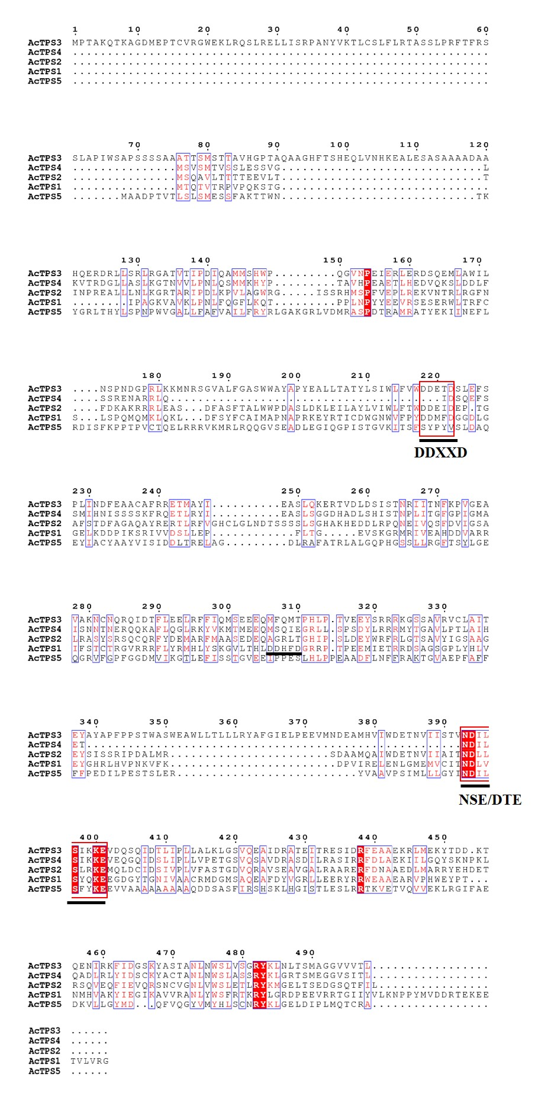
Fig. S1 Amino acids alignment of the sesquiterpene synthases from Acremonium chrysogenum. The conserved motifs are marked respectively.
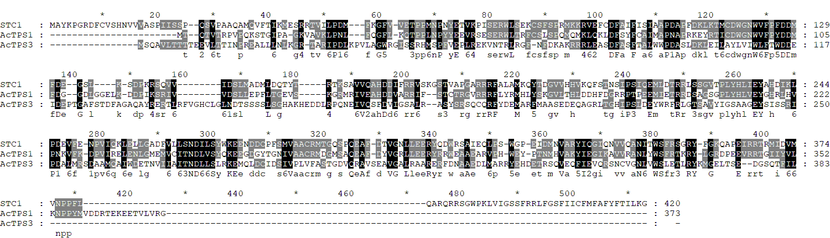
Fig. S2 Amino acids alignment of STC1, AcTPS1 and AcTPS3.

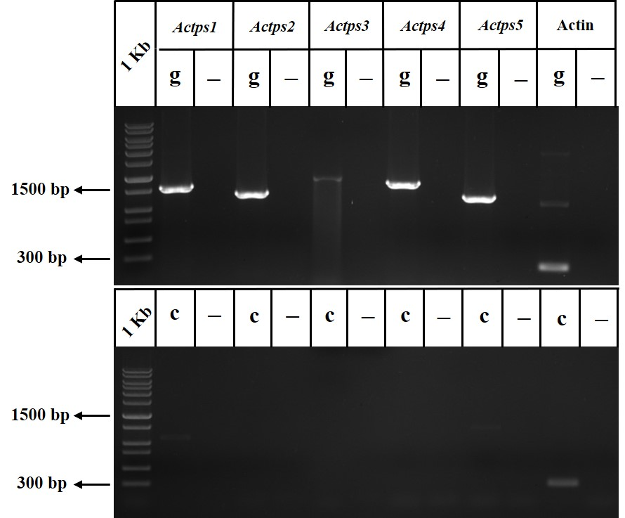

Fig. S3 The transcription of Actps1 to Actps5 in Acremonium chrysogenum. g, genome DNA; c, cDNA; -, negative control.

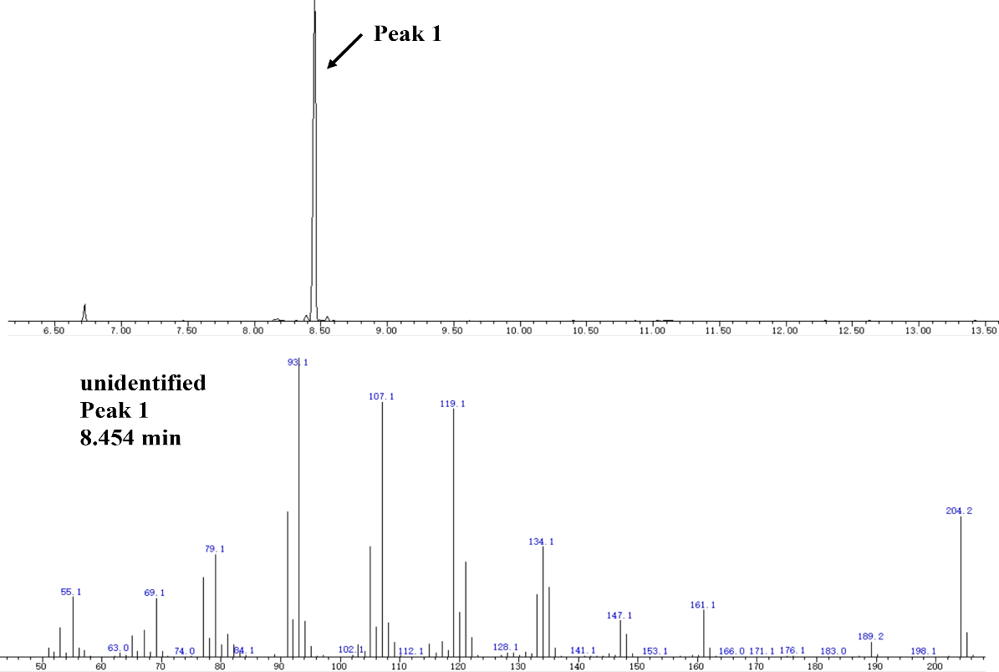
Fig. S4 GC spectrum and the corresponding Mass spectra of sesquiterpenes biosynthesized by AcTPS5. The retention time of the main peak1 is shown with the corresponding Mass spectra.

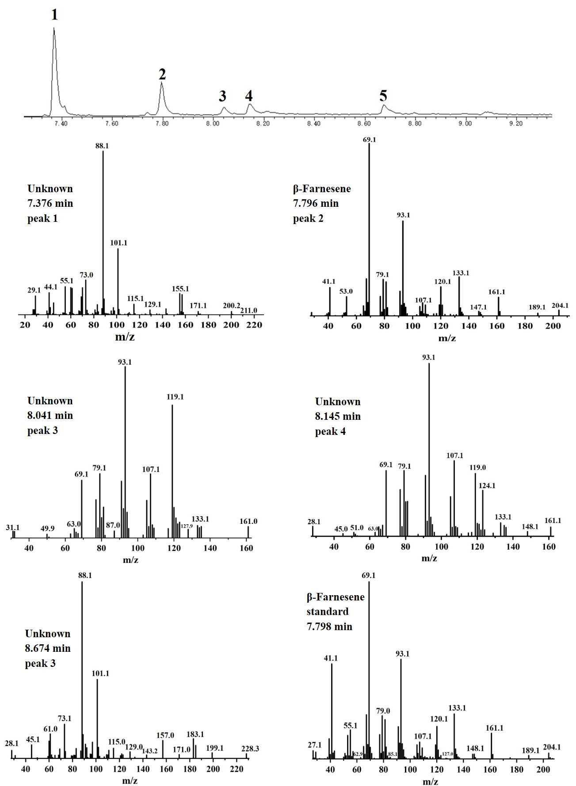

Fig. S5 GC spectrum and the corresponding Mass spectra of sesquiterpenes biosynthesized by AcTPS2. Peak 1 to peak 5 represent multiple products synthesized. their retention times are shown with the corresponding Mass spectra. Compounds were identified by comparison with the NIST database (National Institute of Standards and Technology) library and β-farnesene standard.

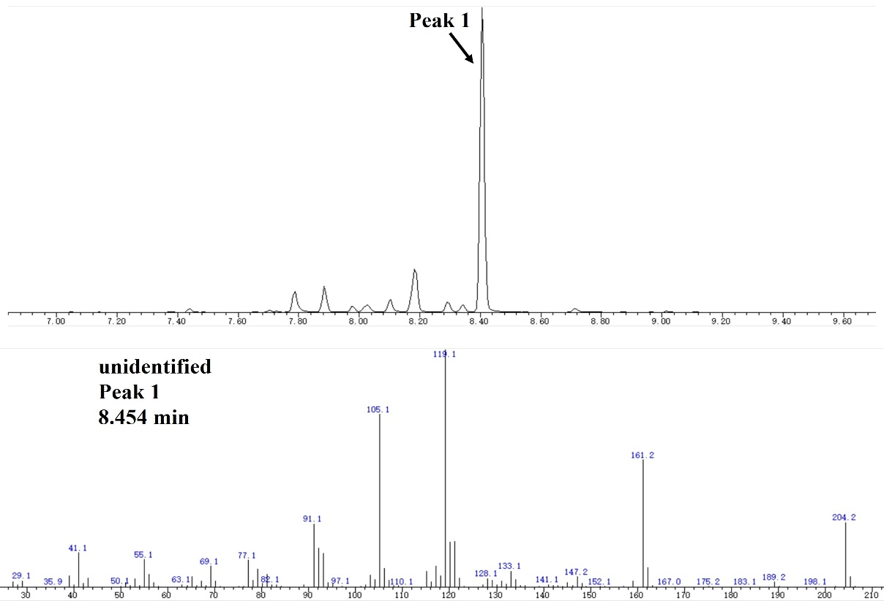
Fig. S6 GC spectrum and the corresponding Mass spectra of sesquiterpenes biosynthesized by AcTPS3. The retention time of the main peak1 is shown with the corresponding Mass spectra.

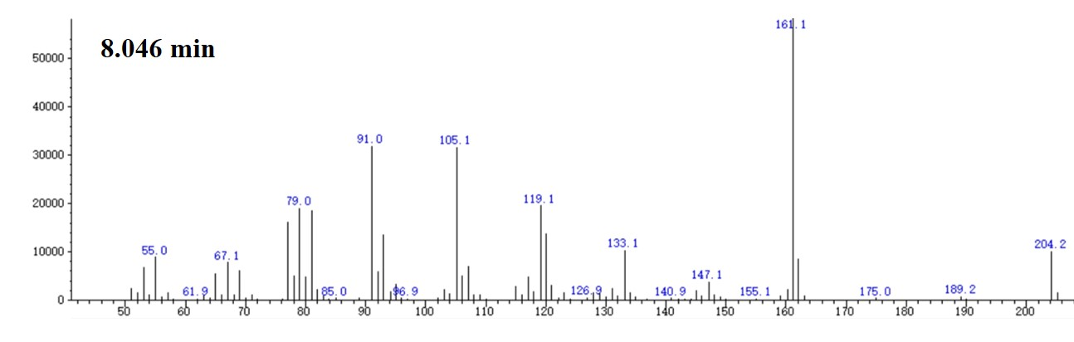
Fig. S7 (-)-Germacrene D standard mass spectrum detected by GC-MS. shown by the 204 m/z ion in the chromatographic trace.
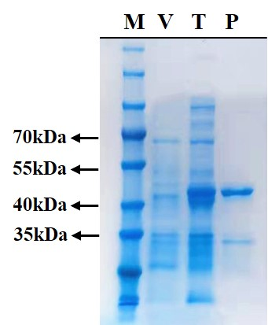
Fig. S8 Purified AcTPS1 protein from recombinant Escherichia coli. M refers to the protein marker, V refers to the pET-45b total cell disruption components, T refers to the AcTPS1 total cell disruption components, P refers to the purified AcTPS1 protein.

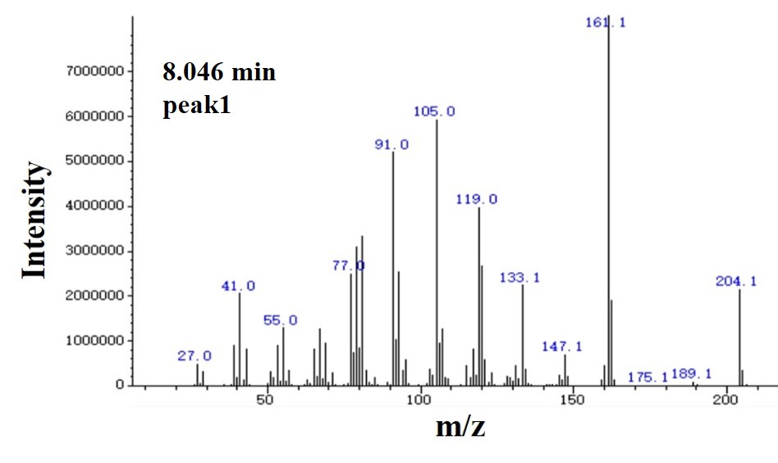
Fig. S9 The mass spectra of the AcTPS1 enzymatic product.

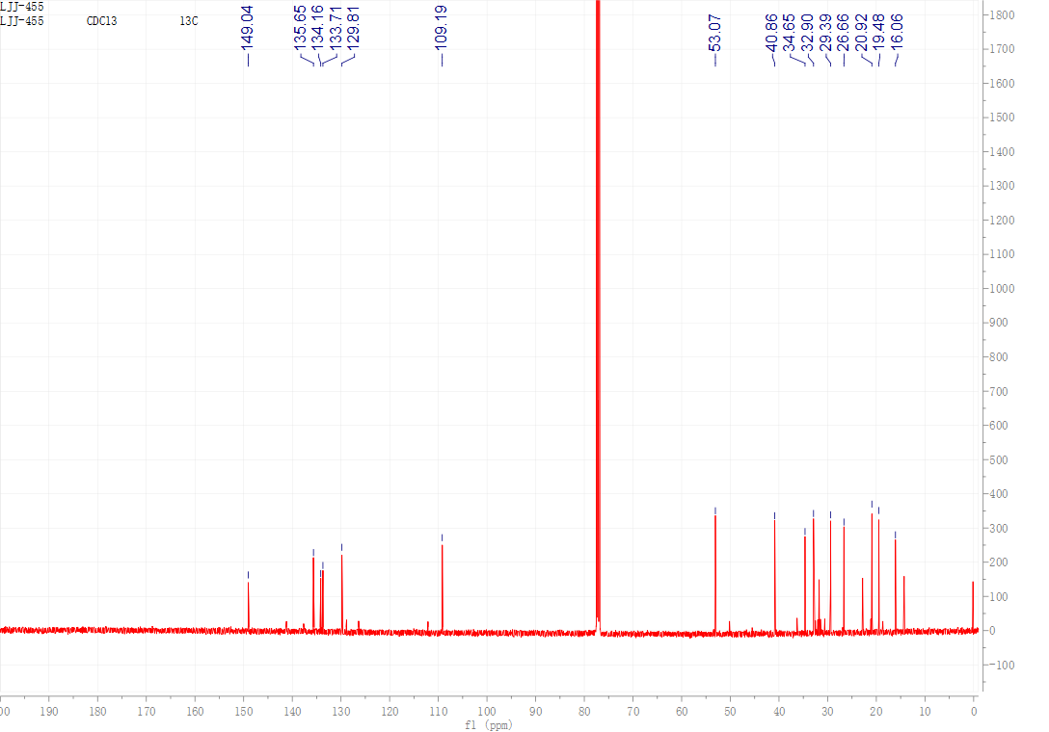
Fig. S10 ¹³C NMR spectra of (-)-Germacrene D (400 MHz, CDCl₃).

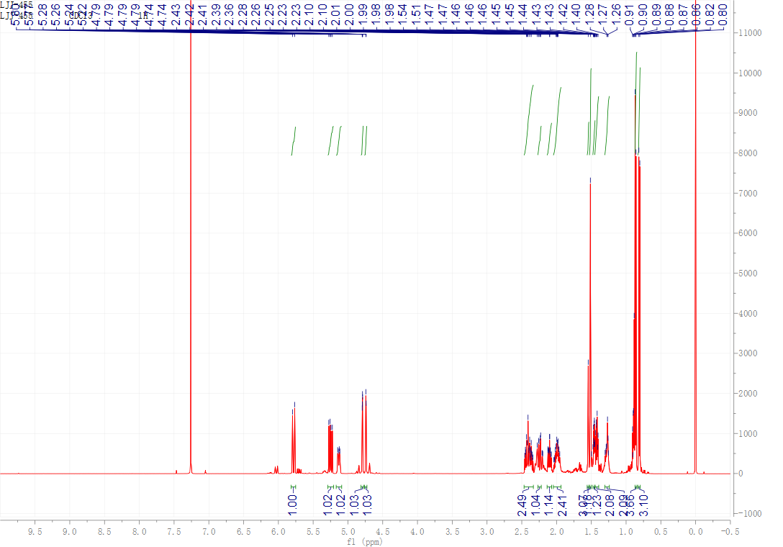
Fig. S11 ¹H NMR spectrum of (-)-Germacrene D (400 MHz, CDCl₃).

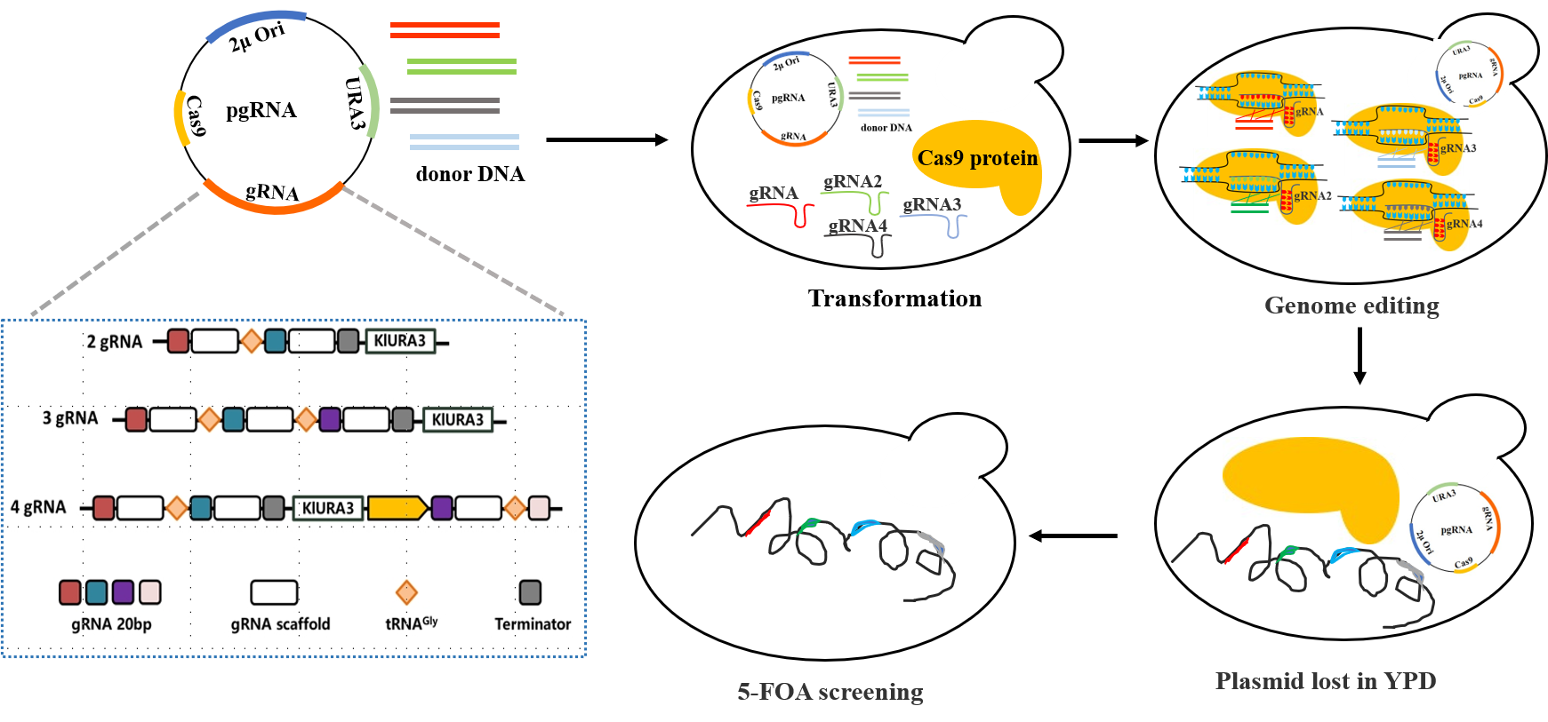
Fig. S12 The schematic of gene editing with CRISPR/Cas9 system mediated by a recyclable gRNA plasmid. The gRNA plasmid pgRNA with URA3 gene as the selective marker and the donor DNA were transformed together into S. cerevisiae for genome editing. Then the gRNA plasmid pgRNA was lost by cultured in YPD medium combining screened with 5-FOA to fulfill recyclable utilization.
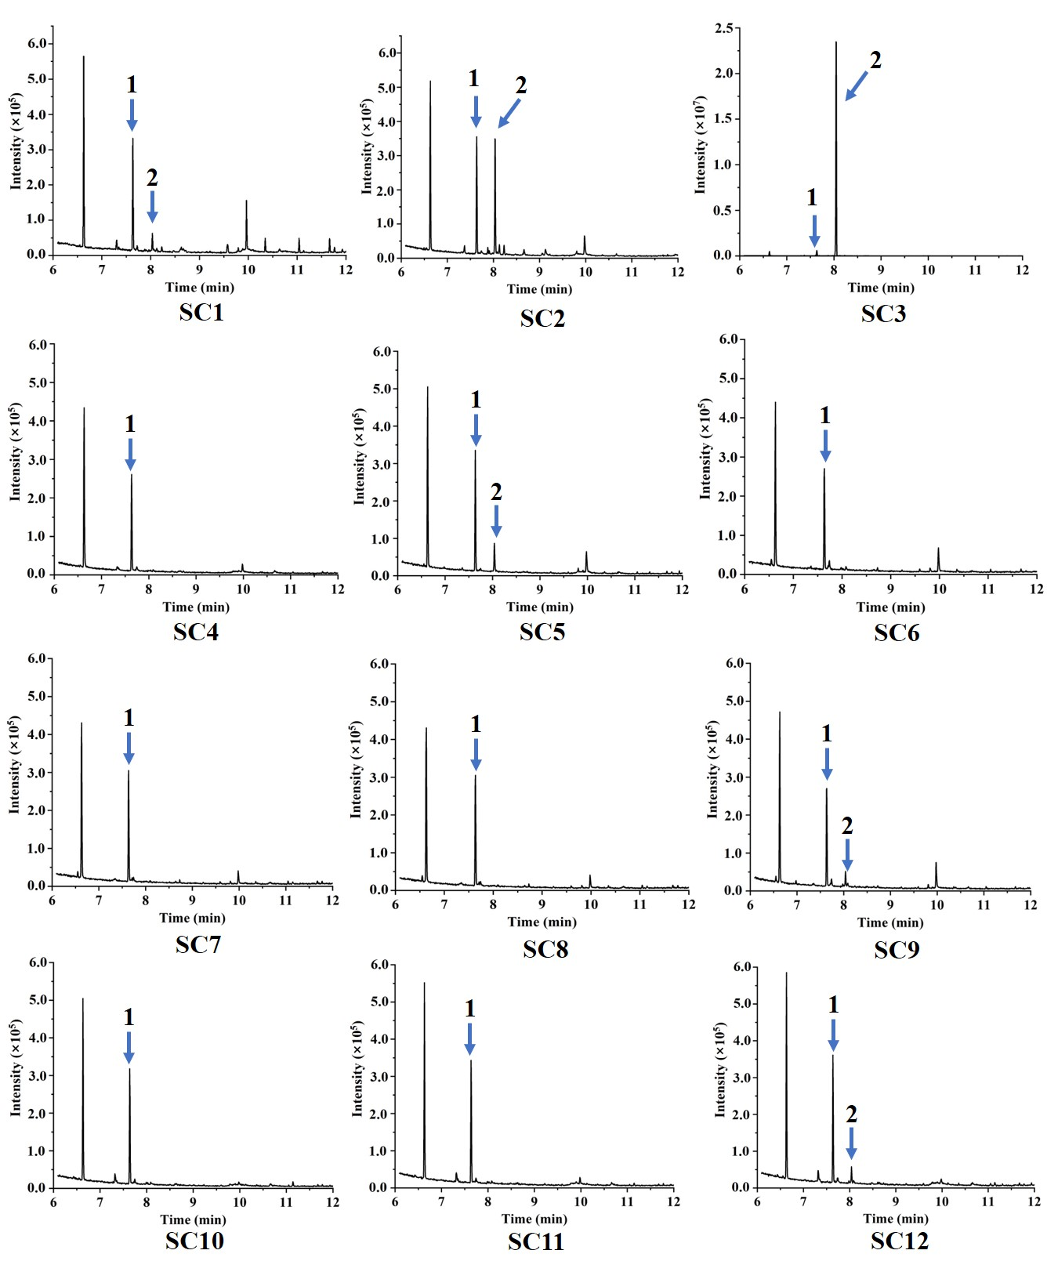
Fig. S13 GC spectrum of Sc1-Sc12. Peak1, the internal standard β-caryophyllene (CAS# 87-44-5); Peak 2, germacrene D.

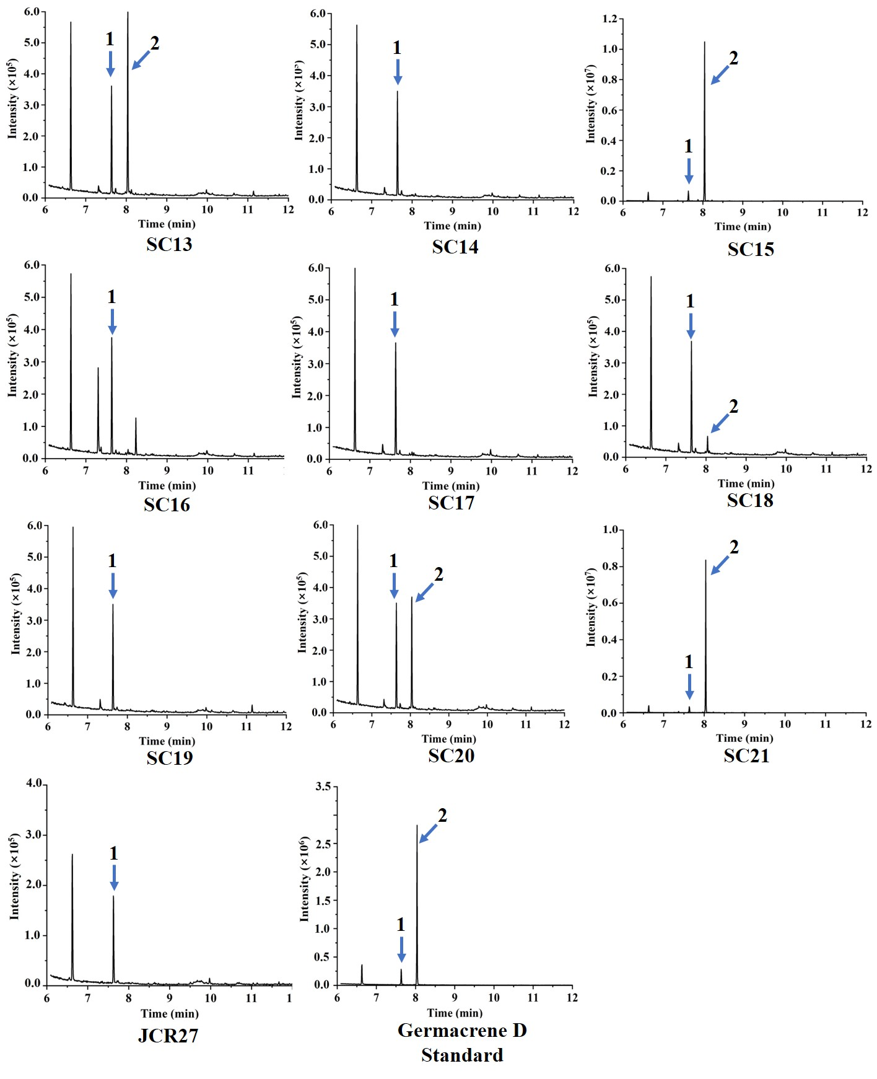
Fig. S14 GC spectrum of Sc13-Sc21, JCR27 and germacrene D standard. The organic phase of SC21 cultures was diluted tenfold for quantitative analysis. Peak1, the internal standard β-caryophyllene (CAS# 87-44-5); Peak 2, germacrene D. JCR27, the start stain used in this study; Germacrene D standard, CAS# 37839-63-7.

Supplementary references
[1] Rutger S. van der H, Antonio JM, David B, Steven DT, John CS. Genetic control and evolution of sesquiterpene biosynthesis in Lycopersicon esculentum and L. hirsutum. Plant Cell. 2000; 12:2283-2294.
[2] Inna G, Moshe S, Naama M, Dan P, Mery DY, Gil S, Einat B, Olga D, Mariana O, Michal E, Wang JH, Zach A, Eran P, Efraim L, Dani Z, Alexander V, David W. Rose scent: genomics approach to discovering novel floral fragrance-related genes. Plant Cell. 2002; 14:2325-38.
[3] He XF, David E. Mechanism and stereochemistry of the germacradienol/germacrene D synthase of Streptomyces coelicolor A3(2). J Am Chem Soc. 2004; 126:2678-9.
[4] Gen-Ichiro A, Dezene H, Jörg B. Forest tent caterpillars (Malacosoma disstria) induce local and systemic diurnal emissions of terpenoid volatiles in hybrid poplar (Populus trichocarpa x deltoides): cDNA cloning, functional characterization, and patterns of gene expression of (-)-germacrene D synthase, PtdTPS1. Plant J. 2004; 37:603-16.
[5] Ian P, Iris GA, Andy LP, Wilfried AK, Harro JB, Michael HB. Enantiospecific (+)- and (-)-germacrene D synthases, cloned from goldenrod, reveal a functionally active variant of the universal isoprenoid-biosynthesis aspartate-rich motif. Arch Biochem Biophys. 2004; 432:136-44.
[6] Yoko I, Rachel DR, Eyal F, David RG, Einat B, Efraim L, Eran P. The biochemical and molecular basis for the divergent patterns in the biosynthesis of terpenes and phenylpropenes in the peltate glands of three cultivars of basil. Plant Physiol. 2004; 136: 3724-3736.
[7] Joost L, Pat B, Jörg B. Vitis vinifera terpenoid cyclases: functional identification of two sesquiterpene synthase cDNAs encoding (+)-valencene synthase and (-)-germacrene D synthase and expression of mono- and sesquiterpene synthases in grapevine flowers and berries. Phytochemistry. 2004; 65:2649-59.
[8] Fabienne D, Laurence P, Wu SQ, Anthony C, Joseph C, Michel S. The diverse sesquiterpene profile of patchouli, Pogostemon cablin, is correlated with a limited number of sesquiterpene synthases. Arch Biochem Biophys. 2006; 454:123-36.
[9] Picaud S, Olsson ME, Brodelius M, Brodelius PE. Cloning, expression, purification and characterization of recombinant (+)-germacrene D synthase from Zingiber officinale. Arch Biochem Biophys. 2006; 452:17-28.
[10] Niels JN, Mindy YW, Adam JM, Sol AG, Chen XY, Yar-Khing Y, Lesley LB, Dinesh AN, Natalia D, Ross GA. Two terpene synthases are responsible for the major sesquiterpenes emitted from the flowers of kiwifruit (Actinidia deliciosa). J Exp Bot. 2009; 60:3203-19.
[11] Diane MM, Sébastien A, Marina BS, Laurent D, Michel S, Omid T, Steven TL, Jörg B. Functional annotation, genome organization and phylogeny of the grapevine (Vitis vinifera) terpene synthase gene family based on genome assembly, FLcDNA cloning, and enzyme assays. BMC Plant Biol. 2010; 21:10-226.
[12] Christoph C, Julia A, Johannes N, Jonathan G, Jörg D. Terpene synthases of oregano (Origanum vulgare L.) and their roles in the pathway and regulation of terpene biosynthesis. Plant Mol Biol. 2010; 73:587-603.
[13] Holger D, G Andreas B, Sandra Ir, Joshua SY, Chen F, Jonathan G, Sybille BU, Tobias GK. Four terpene synthases produce major compounds of the gypsy moth feeding-induced volatile blend of Populus trichocarpa. Phytochemistry. 2011; 72:897-908.
[14] Adelene LSong, Janna OA, Mohd PA, Norazizah S, Raha AR. Functional expression of an orchid fragrance gene in Lactococcus lactis. Int J Mol Sci. 2012; 13:1582-97.
[15] Bryan WP, Hue TT, Benjamin P, Tegan MH, Gao ZZ, Gillian M, John CV, Soo-Un K, Dae-Kyun R. Enzymatic synthesis of valerena-4,7(11)-diene by a unique sesquiterpene synthase from the valerian plant (Valeriana officinalis). FEBS J. 2012; 279:3136-46.
[16] Sandra I, Sandra TK, Grit K, Jonathan G, Jörg D, Tobias GK. The organ-specific expression of terpene synthase genes contributes to the terpene hydrocarbon composition of chamomile essential oils. BMC Plant Biol. 2012; 12: 84.
[17] Niels JN, Sol AG, Chen XY, Estelle JB, Adam JM, Mindy YW, Ross GA. Functional genomics reveals that a compact terpene synthase gene family can account for terpene volatile production in apple. Plant Physiol. 2013; 161:787-804.
[18] Chen H, Li GL, Tobias GK, Qidong J, Jonathan G, Feng C. Positive Darwinian selection is a driving force for the diversification of terpenoid biosynthesis in the genus Oryza. BMC Plant Biol. 2014;14: 239.
[19] Frédéric J, Sandrine M, Aurélie B, Sylvain L, Cécile P, Tarek B, Kévin P, Sébastien F, Yann G, Florence N, Sylvie B, Jean-Louis M. Isolation and functional characterization of a τ-cadinol synthase, a new sesquiterpene synthase from Lavandula angustifolia. Plant Mol Biol. 2014; 84:227-41.
[20] A Trine，C Federico，S Henrik. Optimization of biochemical screening methods for volatile and unstable sesquiterpenoids using HS-SPME-GC-MS. Chromatography. 2015; 2:277-292.
[21] Li YJ, Chen FF, Li ZQ, Li CF, Zhang YS. Identification and functional characterization of sesquiterpene synthases from Xanthium strumarium. Plant Cell Physiol. 2016; 57:630-41.
[22] Jin ZH, Moonhyuk K, Ah-Reum L, Dae-Kyun R, Juraithip W, Soo-Un K. Molecular cloning and functional characterization of three terpene synthases from unripe fruit of black pepper (Piper nigrum). Arch Biochem Biophys. 2018. 15; 638:35-40.
[23] Fujita Y, Koeduka T, Aida M, Suzuki H, Iijima Y, Matsui K. Biosynthesis of volatile terpenes that accumulate in the secretory cavities of young leaves of Japanese pepper (Zanthoxylum piperitum): Isolation and functional characterization of monoterpene and sesquiterpene synthase genes. Plant Biotechnol. 2017; 34:17-28.
[24] Niehaus EM, Schumacher J, Burkhardt I, Rabe P, Spitzer E, Münsterkötter M, Güldener U, Sieber CM, Dickschat JS, Tudzynski B. The GATA-type transcription factor Csm1 regulates conidiation and secondary metabolism in Fusarium fujikuroi. Front Microbiol. 2017; 8:1175.
[25] Bjørn D, Damian PD, Crystal S, Henrik TS. In planta and in silico characterization of five sesquiterpene synthases from Vitis vinifera (cv. Shiraz) berries. Planta. 2019; 249:59-70.
[26] Niu Y, Yang JC, Yin GT, Li RS, Zou WT. Transcriptome analysis of oleoresin-producing tree Sindora Glabra and characterization of sesquiterpene synthases. Front Plant Sci. 2018; 9:1619.
[27] Jun IH, Kazutoshi S, Tetsuya S, Norihiko M. Isolation and functional characterization of new terpene synthase genes from traditional edible plants. J Oleo Sci. 2018; 67:1235-1246.
[28] Ma LT, Yi RL, Liu PL, Cheng YT, Tz-Fan S, Nai WT, Wang SY, Chu FH. Phylogenetically distant group of terpene synthases participates in cadinene and cedrane-type sesquiterpenes accumulation in Taiwania cryptomerioides. Plant Sci. 2019; 289: 110277.
[29] Andrew M, Chen X, John TL, Tobias GK, Kyle AP, Philipp Z, Meredith R, LeMar C, Suzanne L, Chen F, Dorothea T. Biosynthesis and emission of stress-induced volatile terpenes in roots and leaves of switchgrass ( Panicum virgatum L.). Front Plant Sci. 2019; 10: 1144.
[30] Ling CC, Zheng LJ, Yu XR, Wang HH, Wang CX, Wu HY, Zhang J, Yao P, Tai YL, Yuan Y. Cloning and functional analysis of three aphid alarm pheromone genes from German chamomile (Matricaria chamomilla L.). Plant Sci. 2020; 294: 110463.
[31] Andrew M, Mwafaq I, Shelby E, Mossab Y, Bhagwat N, Suzanne L, Douglas S, Philipp S, Susan RW, Dorothea T. Diversity and function of terpene synthases in the production of carrot aroma and flavor compounds. Sci Rep. 2020; 10: 9989.
[32] Kurin I, Jun-Ichiro H, Norihiko M, Kazutoshi S. cDNA cloning and functional analyses of ashitaba (Angelica keiskei) sesquiterpene synthase genes. J Oleo Sci. 2020; 69:711-718.
[33] Bhagwat N, Liora SH, Mosaab Y, Anas K, Rika K, Tejas CB, Mwafaq I. Characterization of terpene synthase genes potentially involved in black fig fly (Silba adipata) interactions with Ficus carica. Plant Sci. 2020; 298: 110549.
[34] Lian DM, Li WG, Yan XG, Qinggele C, Zhao GR, Qiao JJ. Molecular and functional evolution of the spermatophyte sesquiterpene synthases. Int J Mol Sci. 2021; 22: 6348.
[35] Chuang CW, Wen CH, Wu TJ, Li CC, Nien TC, Ma LT,Chen LH, Gene ST, Chin CT, Yi RL, Fang HC. Sesquiterpene synthases of Zanthoxylum ailanthoides: sources of unique aromas of a folklore plant in Taiwan. J Agric Food Chem. 2021; 69: 12494-12504.
[36] Sean A, Fernando LG, Claudia SD. Diversity of sesquiterpene synthases in the basidiomycete Coprinus cinereus. Molecular Microbiology. 2009; 72: 1181-1195.
[37] Siemon T, Wang ZQ, Bian GK, Seitz T, Ye ZL, Lu Y, Cheng S, Ding YK, Huang YL, Deng ZX, Liu TG, Christmann M. Semisynthesis of plant-derived englerin A enabled by microbe engineering of guaia-6,10(14)-diene as building block. J Am Chem Soc. 2020; 142:2760-2765.
[38] Zhang YP, Wang J, Wang ZB, Zhang YM, Shi SB, Nielsen J, Liu ZH. A gRNA-tRNA array for CRISPR-Cas9 based rapid multiplexed genome editing in Saccharomyces cerevisiae. Nat Commun. 2019; 5:1053.

