Supplementary Information

Display of a novel carboxylesterase CarCby on Escherichia coli cell surface for carbaryl pesticide bioremediation

Yan Liu, Xiaoliang Wang, Sujin Nong, Zehui Bai, Nanyu Han, Qian Wu, Zunxi Huang, Junmei Ding⚹

Engineering Research Center of Sustainable Development and Utilization of Biomass Energy, Ministry of Education, Yunnan Normal University, Kunming, Yunnan, 650500, China

⚹Correspondence should be addressed to J.M. Ding: djm3417@163.com.

Additional file 1: Fig. S1 Phylogenetic analysis of CarCby with other carboxylesterases from different microorganisms.
Additional file 2: Fig. S2 SDS-PAGE analysis of CarCby mutants.
Additional file 3: Table S1 Kinetic parameters of recombinant CarCby and catalytic triads mutants at 30 °C.
Additional file 4: Fig. S3 Membrane sensitive to 2 mM EDTA.
Additional file 5: Fig. S4 Mass spectrum of the metabolites in the reaction.
Additional file 6: Fig. S5 Proposed metabolic pathway of carbaryl by B. velezensis sd.
Additional file 7: Table S2 Predicted proteins involved in carbaryl metabolism in B. velezensis sd.
Additional file 8: Fig. S6 Schematic diagram of different expressional plasmids construction.

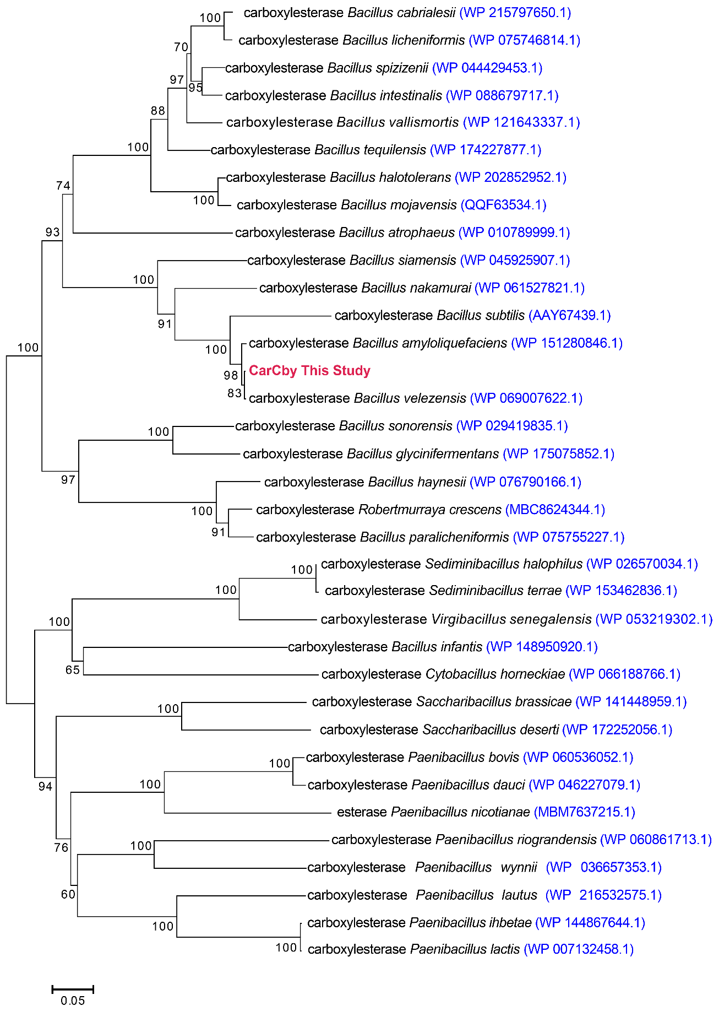
Additional file 1: Fig. S1. Phylogenetic analysis of CarCby with other carboxylesterases from different microorganisms. Sequences are obtained from GenBank and their source strains together with accession numbers are given behind

