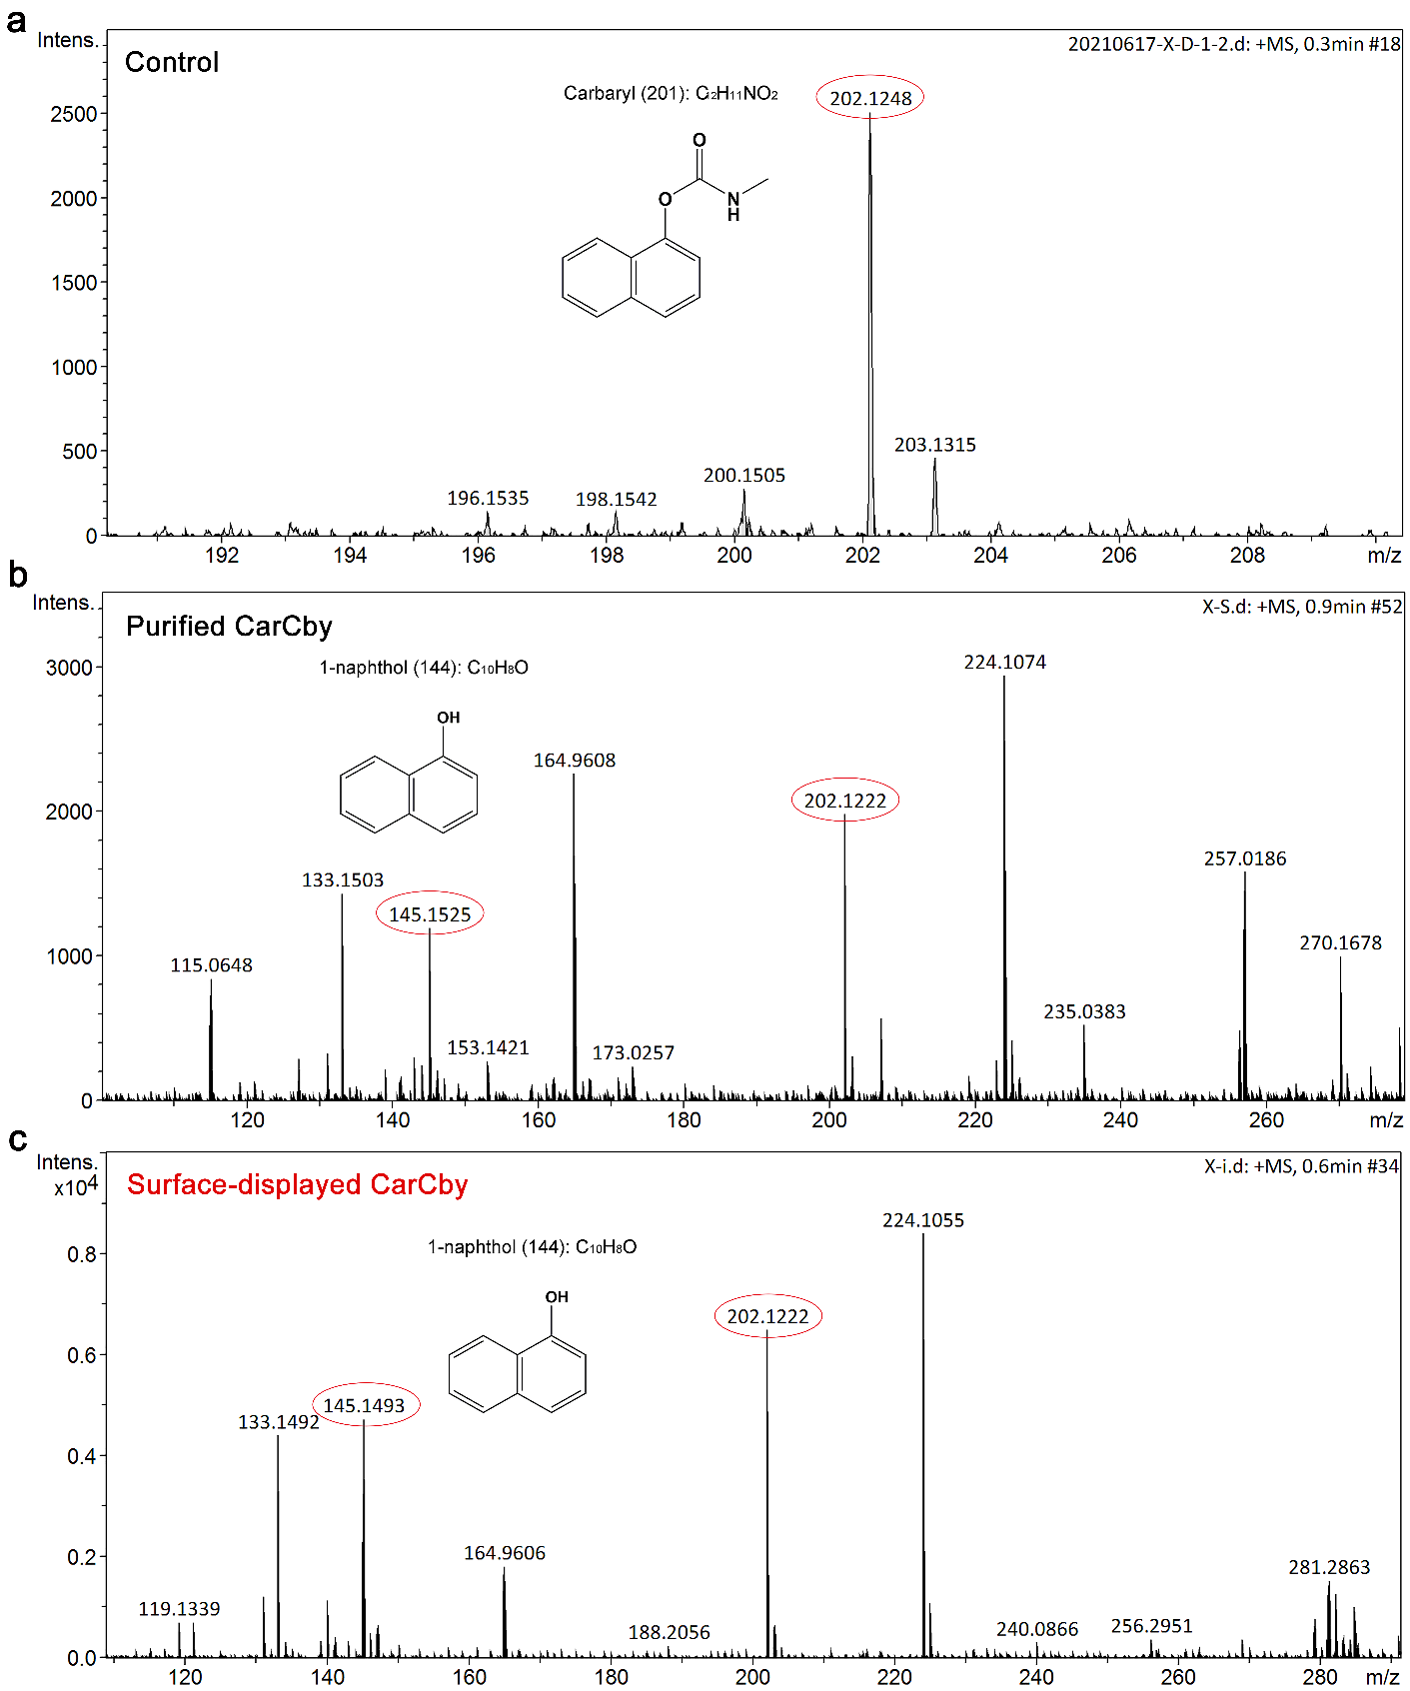
Additional file 5: Fig. S4. Mass spectrum of the metabolites in the reaction. a Carbaryl (control). b Reaction with carbaryl and purified CarCby. c Reaction with carbaryl and surface-displayed CarCby. 1-naphthol with an m/z [M+H]⁺ of 145 was detected in both reactions b and c

