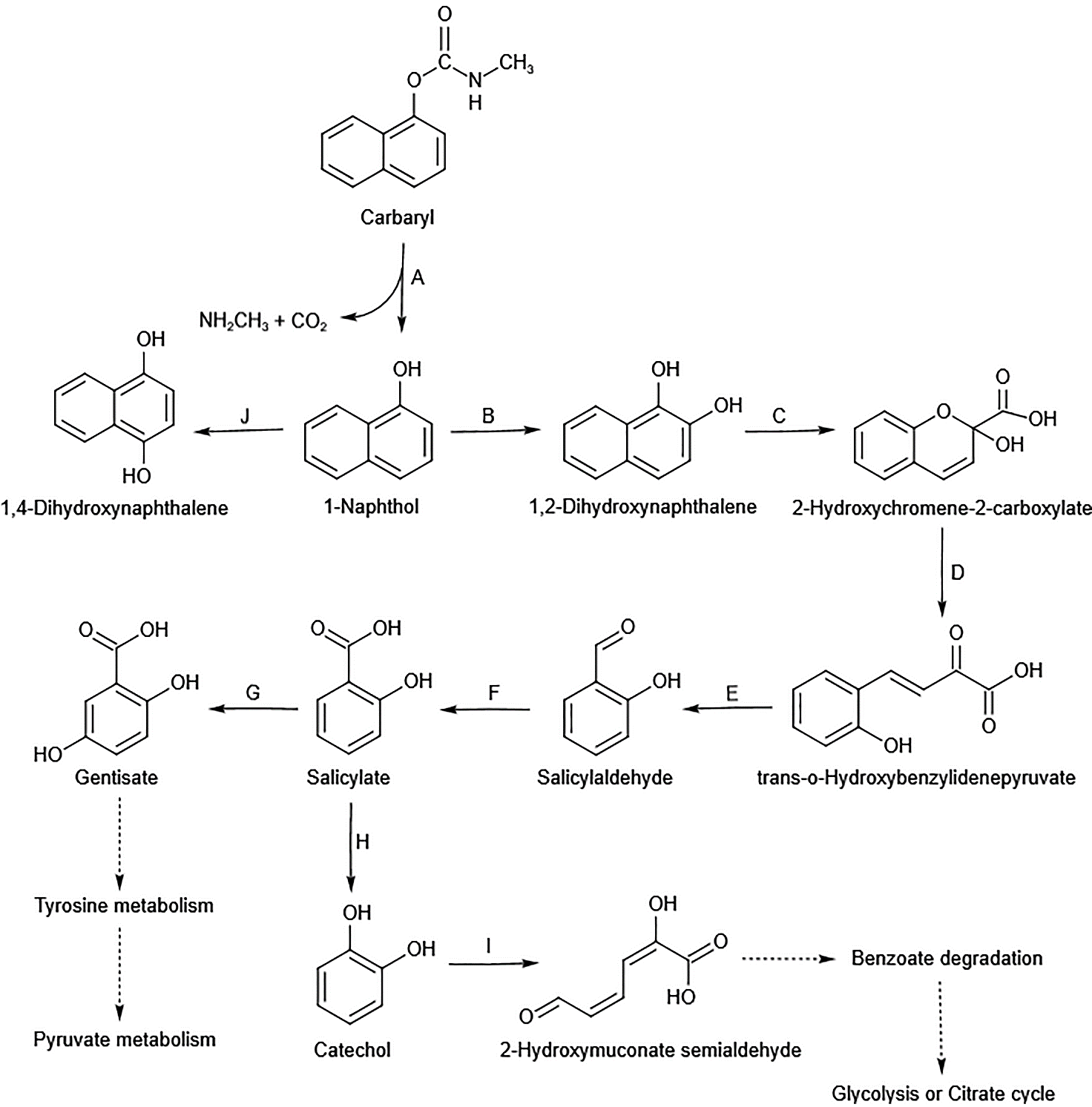

Additional file 6: Fig. S5. Proposed metabolic pathway of carbaryl by B. velezensis sd. A-J represent the predicted enzymes involved in each metabolic step

