Supporting materials for

Engineered Bacillus subtilis for the de novo production of 2′-fucosyllactose
Quanwei Zhang^{1,2}, Zhenmin Liu³, Hongzhi Xia⁴, Ziyang Huang⁵, Yonglian Zhu^{1,2}, Linfeng Xu^{1,2}, Yanfeng Liu^{1,2}, Jianghua Li^{1,2}, Guocheng Du^{1,2}, Xueqin Lv^{1,2,3}, Long Liu^{1,2*}

¹ Key Laboratory of Carbohydrate Chemistry and Biotechnology, Ministry of Education, Jiangnan University, Wuxi 214122, China.
² Science Center for Future Foods, Jiangnan University, Wuxi 214122, China.
³ State Key Laboratory of Dairy Biotechnology, Shanghai Engineering Research Center of Dairy Biotechnology, Dairy Research Institute, Bright Dairy & Food Co., Ltd, Shanghai, 200436, China.
⁴ Nantong Licheng Biological Engineering Co., Ltd., Shanghai 200000, China.
⁵ Yixing Institute of Food Biotechnology Co., Ltd., Yixing, 214200, China.

*Corresponding author: Long Liu, Tel.: +86-510-85918312, Fax: +86-510-85918309, E-mail: longliu@jiangnan.edu.cn
Table S1 Plasmids used in this study
Plasmid | Characterization | Source
pcrF19NM | CRISPR/Cpf1 gene editing plasmid | lab stock
pHT-XCR6 | CRISPR/Cpf1 gene editing plasmid | ¹
pP43NMK | P₄₃ promoter gene expression plasmid | lab stock
pcrF19NM-P₄₃-manB | P₄₃-manB expression cassette and crRNA | this work
pcrF19NM-P₄₃-manC | P₄₃-manC expression cassette and crRNA | this work
pcrF19NM-P₄₃-gmd | P₄₃-gmd expression cassette and crRNA | this work
pcrF19NM-P₄₃-wcaG | P₄₃-wcaG expression cassette and crRNA | this work
pcrF19NM-P₄₃-futC | P₄₃-futC expression cassette and crRNA | this work
pP43NMK-P₄₃-manB | P₄₃-manB expression cassette | this work
pP43NMK-P₄₃-manC | P₄₃-manC expression cassette | this work
pP43NMK-P₄₃-gmd | P₄₃-gmd expression cassette | this work
pP43NMK-P₄₃-wcaG | P₄₃-wcaG expression cassette | this work
pcrF19NM-P_{xylA}-manC | P_{xylA}-manC expression cassette and crRNA | this work
pcrF19NM-ΔyesZ | homologous arms (ΔyesZ) and crRNA | this work
pcrF19NM-ΔganA | homologous arms (ΔganA) and crRNA | this work
pcrF19NM-P_{native}-ndk | P_{native}-ndk expression cassette and crRNA | this work
pcrF19NM-P_{xylA}-ndk | P_{xylA}-ndk expression cassette and crRNA | this work
pcrF19NM-P_{hbs}-ndk | P_{hbs}-ndk expression cassette and crRNA | this work
pcrF19NM-P₄₃-ndk | P₄₃-ndk expression cassette and crRNA | this work
pcrF19NM-P_{native}-yvyI | P_{native}-yvyI expression cassette and crRNA | this work
pP43NMK-P₄₃-yvyI | P₄₃-yvyI expression cassette | this work
pcrF19NM-P_{native}-manA | P_{native}-manA expression cassette and crRNA | this work
pcrF19NM-P₁ | P₁::P_{xylA} and crRNA | this work
pcrF19NM-P₂ | P₂::P_{xylA} and crRNA | this work
pcrF19NM-P₃ | P₃::P_{xylA} and crRNA | this work
pcrF19NM-P₄ | P₄::P_{xylA} and crRNA | this work
pcrF19NM-P₅ | P₅::P_{xylA} and crRNA | this work
pcrF19NM-P₆ | P₆::P_{xylA} and crRNA | this work
pcrF19NM-P₇ | P₇::P_{xylA} and crRNA | this work

Table S2 Primers and promoters used in this study
Primer | Sequence | Template or Description
mB-UF | AGTTAGCTTGGCCAGTGCCTTTTGGAGAAGCGACAAGACGC | B. subtilis genome
mB-UR | AGTTAGCTTGGCCAGTGCCTTTTGGAGAAGCGACAAGACGC | B. subtilis genome
mB-P43U | CTTACTTTTCAAACCTATCCCTTGCTGAGTCTGGCTTTCGG | pP43NMK
mB-P43R | AGCTTTAAAGCAAGTTAGCATGTGTACATTCCTCTCTTACCTATAATGGTACCG | pP43NMK
mB-U | GGTAAGAGAGGAATGTACACATGCTAACTTGCTTTAAAGCTTATGATATTCGC | E. coli BL31(DE3) genome
mB-R | GTCGACCTGCAGTTAGTGGTGATGGTGATGATGCTTGTTCA | E. coli BL31(DE3) genome
mB-DF | ATCACCATCACCACTAACTGCAGGTCGACGTCCCC | B. subtilis genome
mB-DR | GATCTGCCGTTCGTAACAGGTTGCTGATGATAATCGAGAGCTG | B. subtilis genome
pcrF19NM-mB-F | CAGCTCTCGATTATCATCAGCAACCTGTTACGAACGGCAGA | pcrF19NM
pcrF19NM-mB-R | TCGCTTCTCCAAAAGGCACTGGCCAAGCTAACTAAGT | pcrF19NM
mB-crRNA-F | AGATCTATATGCGGATACTTAATATTC | synthetic DNA
mB-crRNA-R | AATTGAATATTAAGTATCCGCATATAG | synthetic DNA
mC-UF | AGTTAGCTTGGCCAGTGCCTAGAAACTCCTGGGCTTTTATCCC | B. subtilis genome
mC-UR | GACTCAGCAAGCAGGCACCCTTGTTAGCTGT | B. subtilis genome
mC-P43U | ACAAGGGTGCCTGCTTGCTGAGTCTGGCTTTCGG | pP43NMK
mC-P43R | GGAATAAGAGGTGAGCTCATGTGTACATTCCTCTCTTACCTATAATGGTACCG | pP43NMK
mC-U | GGTAAGAGAGGAATGTACACATGAGCTCACCTCTTATTCCGGTTAT | E. coli BL31(DE3) genome
mC-R | CGACCTGCAGTCAGTGGTGATGGTGATGATGATCTTCAAATC | E. coli BL31(DE3) genome
mC-DF | ACCATCACCACTGACTGCAGGTCGACGTCCCC | B. subtilis genome
mC-DR | TGATCTGCCGTTCGTAACAGGTGTGTTGAACTATTGAACAGCGG | B. subtilis genome
pcrF19NM-mC-F | CAATAGTTCAACACACCTGTTACGAACGGCAGATCAGAA | pcrF19NM
pcrF19NM-mC-R | CAGGAGTTTCTAGGCACTGGCCAAGCTAACTAAGTTTGAA | pcrF19NM
mC-crRNA-F | AGATGGCACCCTTGTTCTTTAAAAAAG | synthetic DNA
mC-crRNA-R | AATTCTTTTTTAAAGAACAAGGGTGCC | synthetic DNA
gd-UF | CTTGGCCAGTGCCTCTCCTAGTGCCGTCATATGTTAAAGTTAGAGG | B. subtilis genome
gd-UR | CCAGACTCAGCAAGACATCCGCTCATAACAACAGCG | B. subtilis genome
gd-P43U | TGTTGTTATGAGCGGATGTCTTGCTGAGTCTGGCTTTCGG | pP43NMK
gd-P43R | ATGTAAAATATAAAGTGATAGCGGTACCATTATAGGAGGAGTTTACATGTCAAAAGTCGCTCTCA | pP43NMK
gd-U | CGGTGATGAGAGCGACTTTTGACATGTAAACTCCTCCTATAATG | E. coli BL31(DE3) genome
gd-R | CACTTGGGGAAACCCTAGTGGTGATGGTGATGATGTGACTCCAGCG | E. coli BL31(DE3) genome
gd-DF | ACCATCACCACTAGGGTTTCCCCAAGTGTTTAGTGACATGA | B. subtilis genome
gd-DR | GATCTGCCGTTCGTAACAGGAGACTTCCAGCCTAATGCTAC | B. subtilis genome
pcrF19NM-gd-F | ATAGCAGTAGCATTAGGCCCTGTTACGAACGGCAGATCAGAATTTTGTAATA | pcrF19NM
pcrF19NM-gd-R | ATGACGGCACTAGGAGAGGCACTGGCCAAGCTAACTAAGTT | pcrF19NM
gd-crRNA-F | AGATAATACATGAATTTGATGCTGGTG | synthetic DNA
gd-crRNA-R | AATTCACCAGCATCAAATTCATGTATT | synthetic DNA
wG-UF | AGTTAGCTTGGCCAGTGCCTTCAAAGCGGAGAAACAGCAGACAG | B. subtilis genome
wG-UR | ACTCAGCAAGGGCTCTCCGGTTTTCGGATTTC | B. subtilis genome
wG-P43U | ACCGGAGAGCCCTTGCTGAGTCTGGCTTTCGG | pP43NMK
wG-P43R | ACTCGTTGTTTACTCATGTGTACATTCCTCTCTTACCTATAATGGTACCG | pP43NMK
wG-U | GTACCATTATAGGTAAGAGAGGAATGTACACATGAGTAAACAACGAGTTTTTATTGCTGGTC | E. coli BL31(DE3) genome
wG-R | ACATTGTAAGTGCGTCAGTGGTGATGGTGATGATGCC | E. coli BL31(DE3) genome
wG-DF | CACCATCACCACTGACGCACTTACAATGTACTTGTGGGAT | B. subtilis genome
wG-DR | GATCTGCCGTTCGTAACAGGACGCGTTTTTTATATCTTGGGCCAT | B. subtilis genome
pcrF19NM-wG-F | CCTGTTACGAACGGCAGA | pcrF19NM
pcrF19NM-wG-R | CTCCGCTTTGAAGGCACTGGCCAAGCTAACTAAGTTTGA | pcrF19NM
wG-crRNA-F | AGATTTGACAATTAATAAAGGGCAAAG | synthetic DNA
wG-crRNA-R | AATTCTTTGCCCTTTATTAATTGTCAA | synthetic DNA
fC-UF | AGCTTGGCCAGTGCCTATACAGGTCCATCTTGGAAACTGTCCCGC | B. subtilis genome
fC-UR | CCAGACTCAGCAAGGGATCATTGGGAGCAGCAGGC | B. subtilis genome
fC-P43U | GCTCCCAATGATCCCTTGCTGAGTCTGGCTTTCGG | pP43NMK
fC-P43R | AACAACCTTAAATGCCATGTGTACATTTCACCTCCTTTGGTACCGCTATCACTTTATATTTTACAT | pP43NMK
fC-U | GGAGGTGAAATGTACACATGGCATTTAAGGTTGTTCAGATTTGC | E. coli BL31(DE3) genome
fC-R | AGCGCTAAAGTTAGTGGTGATGGTGATGATGTGCATTATATTTTTGTGATTTAACTTCAAAATGTGATTCAAT | E. coli BL31(DE3) genome
fC-DF | ACATCATCACCATCACCACTAACTTTAGCGCTCCTTTCATTTAAAAGGTG | B. subtilis genome
fC-DR | CCGTTCGTAACAGGCCAGCTGTCATCGCGAACAACTTTGACT | B. subtilis genome
pcrF19NM-fC-F | TCGCGATGACAGCTGGCCTGTTACGAACGGCAGATCAGAAT | pcrF19NM
pcrF19NM-fC-R | GACCTGTATAGGCACTGGCCAAGCTAACTAAGTTTGAAA | pcrF19NM
fC-crRNA-F | AGATCAATCGTACACATGAGATTCACG | synthetic DNA
fC-crRNA-R | AATTCGTGAATCTCATGTGTACGATTG | synthetic DNA
PxylA-mC-F | GGAAATGGGATCCATGAGCTCACCTCTTATTCCGGTTAT | pcrF19NM-P₄₃-manC
PxylA-mC-R | CGACCTGCAGTCAGTGGTGATGGTGATGATGATCTTCAAATC | pcrF19NM-P₄₃-manC
PxylA-F | ACCATCACCACTGACTGCAGGTCGACGTCCCC | synthetic DNA
PxylA-R | CGGAATAAGAGGTGAGCTCATGGATCCCATTTCCCCCTTTGATTTTTAGATATCA | synthetic DNA
ΔyesZ-UF | CGTATCTATACAACAACACATCTCAC | B. subtilis genome
ΔyesZ-UR | TTCGATACAACACATTTTCACCTTTCTTTGATGAT | B. subtilis genome
ΔyesZ-DF | TGAAAATGTGTTGTATCGAATCAGCTTTTTTCTATGG | B. subtilis genome
ΔyesZ-DR | GATTTCCAGTGCTGAAGGATAT | B. subtilis genome
ΔyesZ-crRNA-F | AGATTTAAAACTGAGCCTCACCGGGGA | synthetic DNA
ΔyesZ-crRNA-F | AATTTCCCCGGTGAGGCTCAGTTTTAA | synthetic DNA
ΔganA-UF | GCTCCGATTATCATTACTCAGTTTACGT | B. subtilis genome
ΔganA-UR | GCGGAGCATCAGCTTAGCCCTTCGTTCCGCCTG | B. subtilis genome
ΔganA-DF | CGAAGGGCTAAGCTGATGCTCCGCTCGATATG | B. subtilis genome
ΔganA-DR | GTATTCAGCAGCATAGCTGGACG | B. subtilis genome
ΔganA-crRNA-F | AGATTCATACGAATACGTTTTCTGTCG | synthetic DNA
ΔganA-crRNA-F | AATTCGACAGAAAACGTATTCGTATGA | synthetic DNA
P1mCPD-F | CTGAGAAAGGAGGTGATAAAAATGAGCTCACCTCTTATTCCGGTTAT | synthetic DNA
P1mCPD-R | GCGATTAAGTTGGGTCAGTGGTGATGGTGATGATGATCTTCAAATC | synthetic DNA
P1mCZT-F | ATCACCATCACCACTGACCCAACTTAATCGCCTTGCAGCAC | pcrF19NM-P₄₃-manC
P1mCZT-R | GGAATAAGAGGTGAGCTCATTTTTATCACCTCCTTTCTCAGTTTTAATATTATTATCTACTACG | pcrF19NM-P₄₃-manC
P2mCPD-F | ATGTGACTATAAAGGAGGTGATAAAAATGAGCTCACCTCTTATTCCGGTTAT | synthetic DNA
P2mCPD-R | GCGATTAAGTTGGGTCAGTGGTGATGGTGATGATGATCTTCAAATC | synthetic DNA
P2mCZT-F | ATCACCATCACCACTGACCCAACTTAATCGCCTTGCAGCAC | pcrF19NM-P₄₃-manC
P2mCZT-R | AGAGGTGAGCTCATTTTTATCACCTCCTTTATAGTCACATTTATTTTTACGC | pcrF19NM-P₄₃-manC
P3mCPD-F | CATAATGAAAGTAATTTAAAGGAGGTGATAAAAATGAGCTCACCTCTTATTCCGGTTAT | synthetic DNA
P3mCPD-R | GCGATTAAGTTGGGTCAGTGGTGATGGTGATGATGATCTTCAAATC | synthetic DNA
P3mCZT-F | ATCACCATCACCACTGACCCAACTTAATCGCCTTGCAGCAC | pcrF19NM-P₄₃-manC
P3mCZT-R | AGAGGTGAGCTCATTTTTATCACCTCCTTTAAATTACTTTCATTATGAGTTAAATTTCC | pcrF19NM-P₄₃-manC
P4mCPD-F | GAGATTAAAGGAGGTGATAAAAATGAGCTCACCTCTTATTCCGGTTAT | synthetic DNA
P4mCPD-R | GCGATTAAGTTGGGTCAGTGGTGATGGTGATGATGATCTTCAAATC | synthetic DNA
P4mCZT-F | ATCACCATCACCACTGACCCAACTTAATCGCCTTGCAGCAC | pcrF19NM-P₄₃-manC
P4mCZT-R | CGGAATAAGAGGTGAGCTCATTTTTATCACCTCCTTTAATCTCTTCCCCCACTTC | pcrF19NM-P₄₃-manC
P5mCPD-F | ATCGTTGAAAGGAGGTGATAAAAATGAGCTCACCTCTTATTCCGGTTAT | synthetic DNA
P5mCPD-R | GCGATTAAGTTGGGTCAGTGGTGATGGTGATGATGATCTTCAAATC | synthetic DNA
P5mCZT-F | ATCACCATCACCACTGACCCAACTTAATCGCCTTGCAGCAC | pcrF19NM-P₄₃-manC
P5mCZT-R | ATCGTTGAAAGGAGGTGATAAAAATGAGCTCACCTCTTATTCCGGTTAT | pcrF19NM-P₄₃-manC
P6mCPD-F | AGATACATATCCTTAATAAAGGAGGTGATAAAAATGAGCTCACCTCTTATTCCGGTTAT | synthetic DNA
P6mCPD-R | GCGATTAAGTTGGGTCAGTGGTGATGGTGATGATGATCTTCAAATC | synthetic DNA
P6mCZT-F | ATCACCATCACCACTGACCCAACTTAATCGCCTTGCAGCAC | pcrF19NM-P₄₃-manC
P6mCZT-R | AGAGGTGAGCTCATTTTTATCACCTCCTTTATTAAGGATATGTATCTATTTCTCT | pcrF19NM-P₄₃-manC
P7mCPD-F | ATCAGAAAGGAGGTGATAAAAATGAGCTCACCTCTTATTCCGGTTAT | synthetic DNA
P7mCPD-R | GCGATTAAGTTGGGTCAGTGGTGATGGTGATGATGATCTTCAAATC | synthetic DNA
P7mCZT-F | ATCACCATCACCACTGACCCAACTTAATCGCCTTGCAGCAC | pcrF19NM-P₄₃-manC
P7mCZT-R | CGGAATAAGAGGTGAGCTCATTTTTATCACCTCCTTTCTGATAATATAACATATTCTCA | pcrF19NM-P₄₃-manC
Promoter P1 | TCATAGACCTGAAAAGGTCTTTTTTTGTACTCTTAATAATAAAAAGAAGATGAAACTTGTTTAAGGATTGAACGTAGTAGATAATAATATTAAAACTGAGAAAGGAGGTGATAAAA
Promoter P2 | ATTATTCTTAACTTTTACGAAACTTTGATATAATAACAAACGTATATATTAGTAATTTACGGCTTATTTTCCTTGTGAGCGTAAAAATAAATGTGACTATAAAGGAGGTGATAAAA
Promoter P3 | AAACAATGAAACTTTTTTTTATAAAAAACGACTATTTTAGGATTTCATTCTTGTATTAAATAGAGTTGTATTTATTGGAAATTTAACTCATAATGAAAGTAATTTAAAGGAGGTGATAAAA
Promoter P4 | TTTTCTTGACGCCCTTTTGAGGGAGGAGTAAAATGAAATTGTCAATAAATCTTAATAAAGTGCTTACAATTGAAAGAAGTGGGGGAAGAGATTAAAGGAGGTGATAAAA
Promoter P5 | TTTTCGAATGATTAAATTTTTTGTTTTTTATAAAGGTTTTTTACTATTTTGTGAACAATCAAGGTAGAATCAAATTGCAAACAGTGGTAAAATATCGTTGAAAGGAGGTGATAAAA
Promoter P6 | AAACAAAATTCGACAAAGTTCACTGAATTTTCACAAAAGATTTATGTTTCAGCAGGAATTGTAAAGGGTAAAAGAGAAATAGATACATATCCTTAATAAAGGAGGTGATAAAA
Promoter P7 | AAAAAACGGCCTCTCGAAATAGAGGGTTGACACTCTTTTGAGAATATGTTATATTATCAGAAAGGAGGTGATAAAA

Figure legends
Figure S1. The SDS-PAGE analysis of cell extracts from single-gene expression strain. The white rectangular frame indicates the target protein in the supernatant after cell disruption.
Figure S2. Production of 2′-FL in the shake flakes by the engineered strain BS2.

Figure S1.

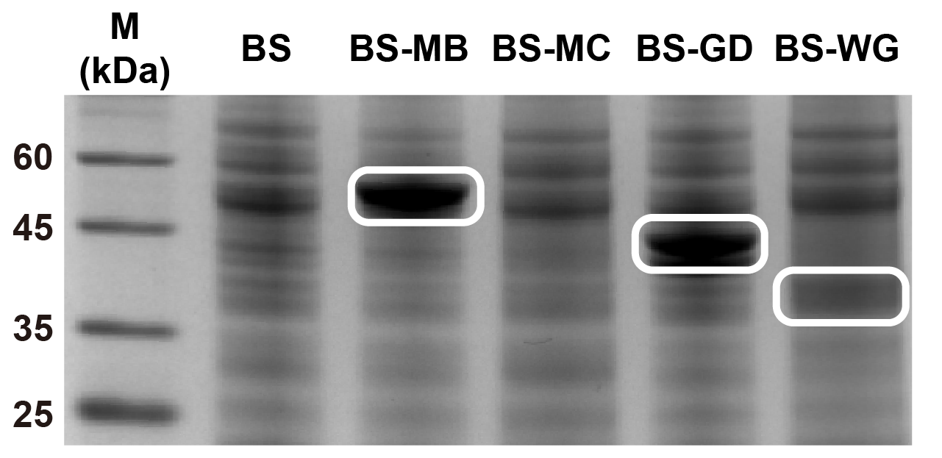

Figure S2.

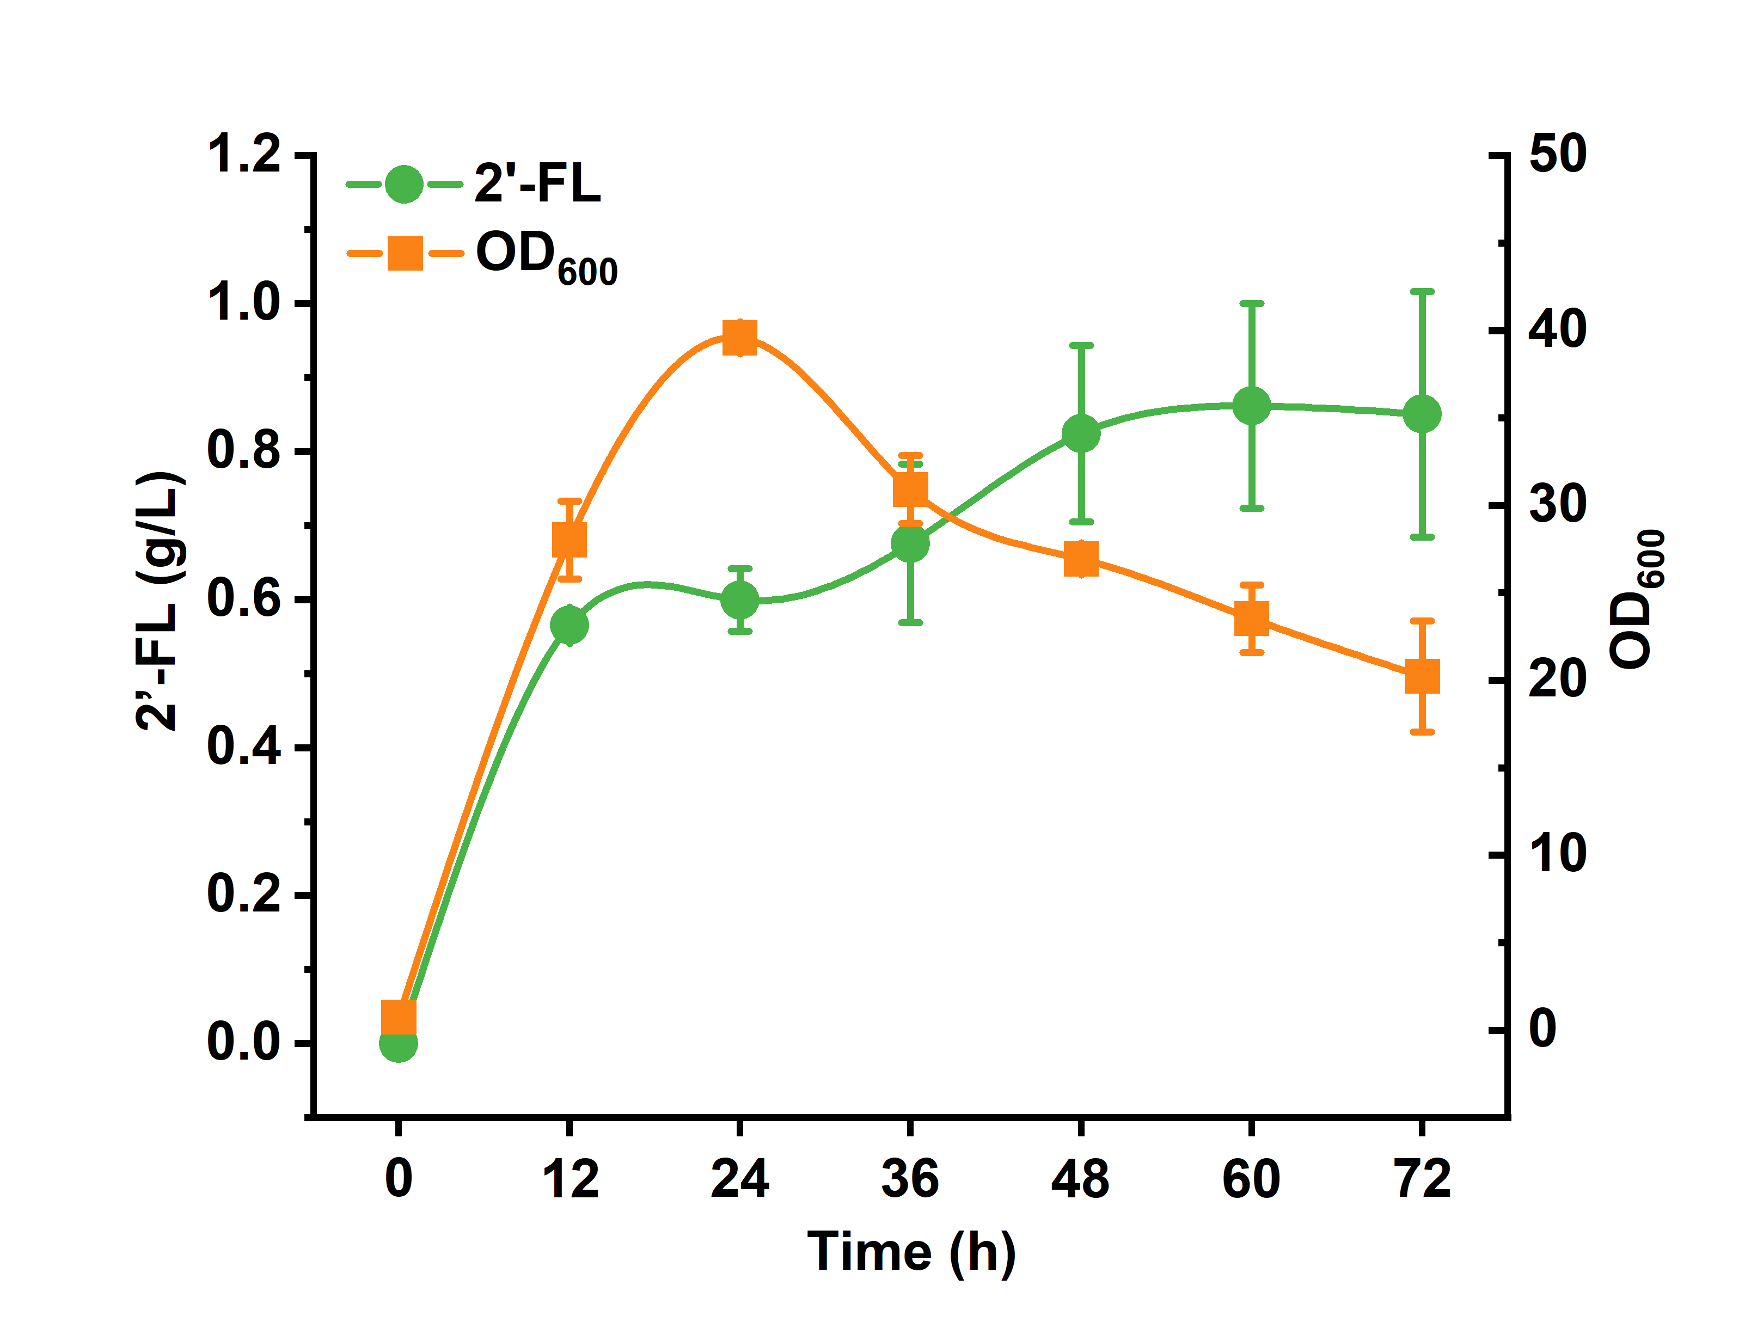

References
(1) Wu, Y.; Liu, Y.; Lv, X.; Li, J.; Du, G.; Liu, L. CAMERS-B: CRISPR/Cpf1 assisted multiple-genes editing and regulation system for Bacillus subtilis. Biotechnology and bioengineering 2020, 117 (6), 1817-1825. DOI: 10.1002/bit.27322.

