Additional file 1

Optimizing the downstream of MVA pathway using a combination optimization strategy to increase lycopene yield in Escherichia coli

Tao Cheng ^{1, 3*}, Lili Wang ², Chao Sun ^{1, 3}, Congxia Xie ^{1*}
¹State Key Laboratory Base of Eco-Chemical Engineering, College of Chemistry and Molecular Engineering, Qingdao University of Science and Technology, Qingdao 266042, China
²Department of Pathology, the Affiliated Hospital of Qingdao University, Qingdao University, Qingdao 266000, China
³CAS Key Laboratory of Bio-based Materials, Qingdao Institute of Bioenergy and Bioprocess Technology, Chinese Academy of Sciences, Qingdao 266101, China

*Corresponding author.
Tao Cheng, No. 189 Songling Road, Laoshan District, Qingdao Institute of Bioenergy and Bioprocess Technology, Qingdao, China 266101. Tel: +86 532 80662681. mail address: chengtao@qibebt.ac.cn
Congxia Xie, No. 53 Zhengzhou Road, College of Chemistry and Molecular Engineering, Qingdao University of Science and Technology, Qingdao, China 266042. Tel: +86 532 84023927. Email address: xiecongxia@126.com

Table S1: Primers used in this study

Primers | Sequence (5’ to 3’)
BsaI_IDI_F | CCGCCAGTAGAGGTCTCG CTGCCGACAACAATAGTATG
IDI_R | CTGTTCGACTTAAGCATTAT TTATAGCATTCTATGAATTT
pACY_F | ATAATGCTTAAGTCGAACAG
pACY_R | CGAGACCTCTACTGGC GGGGTCTCAAAGTTAAACAAAATTATTT
MVK_F | ATGTCATTACCGTTCTTAAC
MVK_R | TTATGAAGTCCATGGTAAATTCG
PMK_F | ATGTCAGAGTTGAGAGCCTT
PMK_R | TTATTTATCAAGATAAGTTTCCGG
MVD_F | ATGACCGTTTACACAGCATC
MVD_R | TTATTCCTTTGGTAGACCAG
CrtE_F | AAAGGCACAGCGTCTCATGCTT
CrtI_R | ATCTACCACCTGCGTGCGCT
pTrc_F | AGCGCACGCAGGTGGTAGAT TAAACGGTCTCCAGCTTGGC
pTrc_R | AAGCATGAGACGCTGTGCCTTT CTCATTTCAGAATATTTGCC

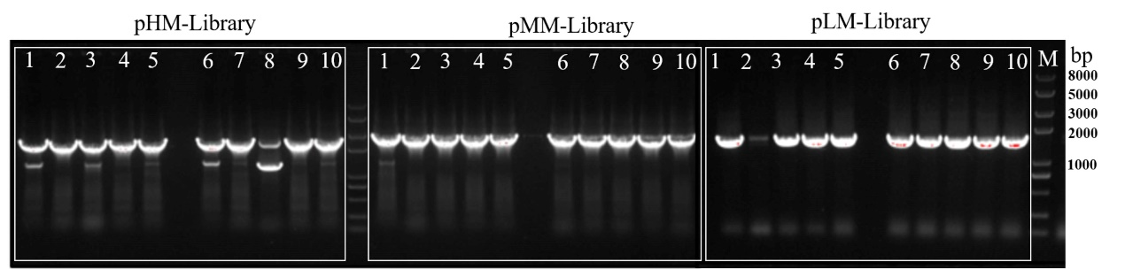
Figure S1 Ten colonies were randomly picked and analyzed by colony PCR to determine ratio of successfully assembled pHM-library, pMM-library, and pLM-library. M marker.

