Supplemental Data

The TetR-Type regulator AtsR is involved in multidrug response in Corynebacterium glutamicum
Tao Su^{1#*}, Chengchuan Che^{1#}, Jiyu Han¹,Yuying Zhao¹, Zihan Zhang¹, Guangdi An¹, Meiru Si¹, Can Chen^{2*}
¹College of Life Sciences, Qufu Normal University, Qufu, Shandong 273165, China;
² Key Laboratory of Plant Genetics and Molecular Breeding, College of Life Science and Agronomy, Zhoukou Normal University, Zhoukou, Henan 466001, China

Running title: Multidrug-sensing mechanism of AtsR

# These authors contributed equally to this work.

* Corresponding authors:
Tao Su, Can Chen

E-mail vincenttao2@163.com; chenc02@126.com
Tel: 86-15563718633;86-18736207816

Table S1. Bacterial strains and plasmids used in this study.
Strains or plasmids | Relevant genotype description | References
Strains
Corynebacterium glutamicum
RES167 | Restriction-deficient mutant of ATCC13032, Δ(cglIM-cglIR-cglIIR) | [1]
ΔatsR | atsR deleted in RES167 | This study
Δncgl0884 | ncgl0884 deleted in RES167 | This study
Δncgl0887 | ncgl0887 deleted in RES167 | This study
WT(pXMJ19) | C. glutamicum RES167 parental strain (WT) transformed with the empty plasmid pXMJ19 | This study
ΔatsR(pXMJ19) | ΔatsR transformed with empty plasmid pXMJ19 | This study
ΔatsR(pXMJ19-atsR) | ΔatsR transformed with plasmid pXMJ19-atsR | This study
WT(pXMJ19-atsR) | C. glutamicum RES167 parental strain transformed with plasmid pXMJ19-atsR | This study
ΔatsR(pXMJ19-atsR:C123SC187S) | The ΔatsR mutant expressed pXMJ19-atsR:C123SC187S | This study
E. coli
BL21(DE3) | E. coli expression host, hsdS gal (λcIts857 ind-l Sam7 nin-5 lac UV5-T7 gene 1) | Novagen
JM109 | recA1 supE44 endA1 hsdR17 gyrA96 relA1 thi Δ(lac-proAB)F′(traD36 proABlacI^{q} lacΔZM15) | Stratagene
Plasmids
pK18mobsacB | Suicide plasmid carrying sacB for selecting double crossover in C. glutamicum, Km^{r} | [2]
pK18mobsacB-ΔatsR | Construct used for in-frame deletion of atsR | This study
pK18mobsacB-Δncgl0884 | Construct used for in-frame deletion of ncgl0884 | This study
pK18mobsacB-Δncgl0887 | Construct used for in-frame deletion of ncgl0887 | This study
pK18mobsacB-P_{ncgl0887}::lacZY | P_{ncgl0887}::lacZY fusion in pK18mobsacB | This study
pK18mobsacB-P_{ncgl0884}::lacZY | P_{ncgl0884}::lacZY fusion in pK18mobsacB | This study
pXMJ19 | Shuttle vector (P_{tac} lacI^{q} pBL1 oriV_{C. glutamicum} pK18 oriV_{E. coli}) | [3]
pXMJ19-atsR | atsR cloned into pXMJ19 for complementation | This study
pXMJ19-atsR:C123SC187S | atsR:C123SC187S cloned into pXMJ19 for complementation
pXMJ19-ncgl0884 | ncgl0884 cloned into pXMJ19 for complementation | This study
pXMJ19-ncgl0887 | ncgl0887 cloned into pXMJ19 for complementation | This study
pET28a | Expression vector with N-terminal hexahistidine affinity tag | Novagen
pET28a-SUMO | Expression vector with N-terminal hexahistidine affinity tag and SUMO | This study
pET28a-pup1 | pup1 in pET28a | This study
pET28a-atsR | atsR in pET28a | This study
pET28a-atsR:C123SC187S | atsR:C123SC187S in pET28a | This study
pET28a-SUMO-atsR | atsR in pET28a-SUMO | This study
pET28a-ncgl0887 | ncgl0887 in pET28a | This study
pET28a-SUMO-atsR:C123SC187S | atsR:C123SC187S in pET28a-SUMO | This study
Additional References
- Tauch A, Kirchner O, Löffler B, Götker S, Pühler A, Kalinowski J. Efficient electrotransformation of Corynebacterium diphtheriae with a mini-replicon derived from the Corynebacterium glutamicum plasmid pGA1. Curr. Microbiol. 2002; 45 : 362-367.
- Jakoby M, Ngouoto-Nkili CE, Burkovski A. Construction and application of new Corynebacterium glutamicum vectors. Biotechnol Tech.1999;113: 437-441.
- Karimova G, Pidoux J, Ullmann A, Ladant D. A bacterial two-hybrid system based on a reconstituted signal transduction pathway. Proc Natl Acad Sci U S A. 1998;95:5752-5756.

Table S2. Primers used in this study.
Primers | 5’-3’ sequence
atsR_{com}-F1 | CGCGGATCCAAAGGAGGACAACCGTGTCGGGGCTTAGAGAAAC (BamHI) | For cloning atsR wild type and mutants into pXMJ19
atsR_{com}-R1 | CAAGAATTCTTATTTCTTAATCCAGGCGC (EcoRI) | For cloning atsR wild type and mutants into pXMJ19
OatsR-F | CAAGAATTCATGGGTCGCGGATCCGAATTCGTGTCGG  GGCTTAGAGAAACAA (EcoRI) | For cloning atsR wild type into pET28a
OatsR-R | CCGCTCGAGTTATTTCTTAATCCAGGCGCATGC (XhoI) | For cloning atsR wild type into pET28a
OatsR-F1 | CGCGGATCCGTGTCGGGGCTTAGAGAAACAA (BamHI) | For cloning atsR wild type and mutant into pET28a-SUMO
DatsR-F1 | CAAGAATTCCTATGACATGATTACGAATTCCAGAATTTGATGCGATCGATGA (EcoRI) | To generate pK18mobsacB-ΔatsR
DatsR-R1 | GGATCAATGCGACTCCATCTTCGGGCCTTCCATCAAG | To generate pK18mobsacB-ΔatsR
DatsR-F2 | GATGGAAGGCCCGAAGATGGAGTCGCATTGATCC | To generate pK18mobsacB-ΔatsR
DatsR-R2 | CGCGGATCC CAGGTCGACTCTAGAGGATCCATCGGT  GCTGAACTTTGCGA (BamHI) | To generate pK18mobsacB-ΔatsR
Dncgl0884-F1 | GGAAGATCTTCAACTCATCAAGGTCGGTGCGGG (BglII) | To generate pK18mobsacB-Δncgl0884
Dncgl0884-R1 | CTCGCCCCAATTGGGCAGCAAATG | To generate pK18mobsacB-Δncgl0884
Dncgl0884-F2 | CATTTGCTGCCCAATTGGGGCGAGATGGCTACGCACTCACCGTTGAGG | To generate pK18mobsacB-Δncgl0884
Dncgl0884-R2 | CCCAAGCTTTCGCCAAACTTTTGATAGCGTAGC (HindIII) | To generate pK18mobsacB-Δncgl0884
Dncgl0887-F1 | CGCGGATCCTGTCTTGGAAGCATTTCACGGTGG (BamHI) | To generate pK18mobsacB-Δncgl0887
Dncgl0887-R1 | AGGGTCTTGCCTTCCGGTGCCTG
Dncgl0887-F2 | CAGGCACCGGAAGGCAAGACCCTTTTCAAGCACGGTGCCCGCGTGG
Dncgl0887-R2 | CCCAAGCTTATGAACTCAAGCAACGGAGCAATG (HindIII)
ncgl0884 _{com}-F | CGCGGATCCAAAGGAGGACAACCATGGAAATTCCGCTGCCCACATC (BamHI) | For cloning ncgl0884 into pXMJ19
ncgl0884 _{com}-R | CCCAAGCTTCTAGCCCACCTTTGTTAAATGCTC (EcoRI) | For cloning ncgl0884 into pXMJ19
ncgl0887 _{com}-F | CCGGAATTCAAAGGAGGACAACCGTGGCGAAATTCCTGTATAAGT (EcoRI) | For cloning ncgl0887 into pXMJ19
ncgl0887 _{com}-R | CCCAAGCTTCTACATTTTCCTTCAGTTCCTC (HindIII)
Oncgl0887-F | CGGAATTCGTGGCGAAATTCCTGTATAAGTTAGGC (EcoRI) | To generate pET28a-ncgl0887
Oncgl0887-R | CCCAAGCTTCTAAGCCCCGACACCTACATTTTCC (HindIII)
OatsR-C123S-F | CTTGACCCCATCAAGAGTGTTATCGATAAGG | To generate atsR:C123S DNA fragment
OatsR-C123S-R | CCTTATCGATAACACTCTTGATGGGGTCAAG | To generate atsR:C123S DNA fragment
OatsR-C187S-F | TGATCCGTCGGGCAAGCGCCTGGATTAAG | To generate atsR:C187S DNA fragment
OatsR-C187S-R | CTTAATCCAGGCGCTTGCCCGACGGATCA | To generate atsR:C187S DNA fragment
pET28aMCS-F | CCGGCGTAGAGGATCGAGATCTCG | To generate atsR:C187S DNA fragment
pET28aMCS-R | AGTGTTGTTCCAGTTTGGAACAAG | To generate atsR:C187S DNA fragment
P _{ncgl0887}-F | TCCCCCGGGTTACTGCTTAATTGGCGCCTCGGTG (SmaI) | To generate pK18mobsacB-P _{ncgl0887}::lacZY
P _{ncgl0887}-R | ACTAGTCAGGAATTTCGCCACGATTATC (SpeI) | To generate pK18mobsacB-P _{ncgl0887}::lacZY
lacZY-F1 | GATAATCGTGGCGAAATTCCTGACTAGT ATGACCATGATTACGGATTC(SpeI) | To generate pK18mobsacB-P _{ncgl0887}::lacZY
lacZY-R | AAAACTGCAGCAGACAACACCGAACCGAATCC (PstI) | To generate pK18mobsacB-P _{ncgl0887}::lacZY
P_{ncgl0884}-F | TCCCCCGGGCATGAGGAATGTTTCCCACTGTTGC (SmaI) | To generate pK18mobsacB-P_{ncgl0884}::lacZY
P_{ncgl0884}-R | CAGCGGAATTTCCATACCTTTAAG | To generate pK18mobsacB-P_{ncgl0884}::lacZY
lacZY-F2 | CTTAAAGGTATGGAAATTCCGCTGACTAGT ATGACCATGATTACGGATTC(SpeI) | To generate pK18mobsacB-P_{ncgl0884}::lacZY
Qncgl0884-F | GCCGCTCGACGATGATCTGATCAC | RT-PCR
Qncgl0884-R | GGTCAGTTCCAGGCTTCAGCGC | RT-PCR
P_{ncgl0887}-mutation-F | GATTTGAACGCGAACAACACGTTTTAACG | To produce 768-bp P_{ncgl0887M}
P_{ncgl0887}-mutation-R | CGTTAAAACGTGTTGTTCGCGTTCAAATG | To produce 768-bp P_{ncgl0887M}
QatsR-F | GTGTCGGGGCTTAGAGAAAC | RT-PCR
QatsR-R | GGGCCTTCCATCAAGGCGATC
Qncgl0887-F | CCGTTGTGGATCCTGTGTTGGC | RT-PCR
Qncgl0887-R | GTGACCTTCTCACGATCCTCTG
Encgl0887-F | GCCCACAGCATAGAACTAAAACAG | To produce the 232-bp EMSA promoter DNA
Encgl0887-R | GTTGACTGTTCTTCTGGGCTTTCC | To produce the 232-bp EMSA promoter DNA
Control-F1 | CAGGGTGTGGCTGCTCAGATG | To produce the 232-bp EMSA control DNA
Control-R1 | GTTGTAGACAACAGTCAGATC | To produce the 232-bp EMSA control DNA
Encgl0884-F | CGAATCCAATAGAACTAGCAACCG | To produce the 205-bp EMSA promoter DNA
Encgl0884-R | GTGGGCAGCGGAATTTCCATACC | To produce the 205-bp EMSA promoter DNA
Control-F2 | GAGTGGGTCAGCACGCGCGGTG | To produce the 205-bp EMSA control DNA
Control-R2 | CTTCGATGAGCGTGCGACGGATAC | To produce the 205-bp EMSA control DNA
16 S rRNA-F | ACCCTTGTCTTATGTTGCCAG | RT-PCR
16 S rRNA-R | TGTACCGACCATTGTAGCATG
Underlined sites indicated restriction enzyme cutting sites added for cloning. Letters in italic denoted the mutation sites in overlap PCR for site-directed mutation.

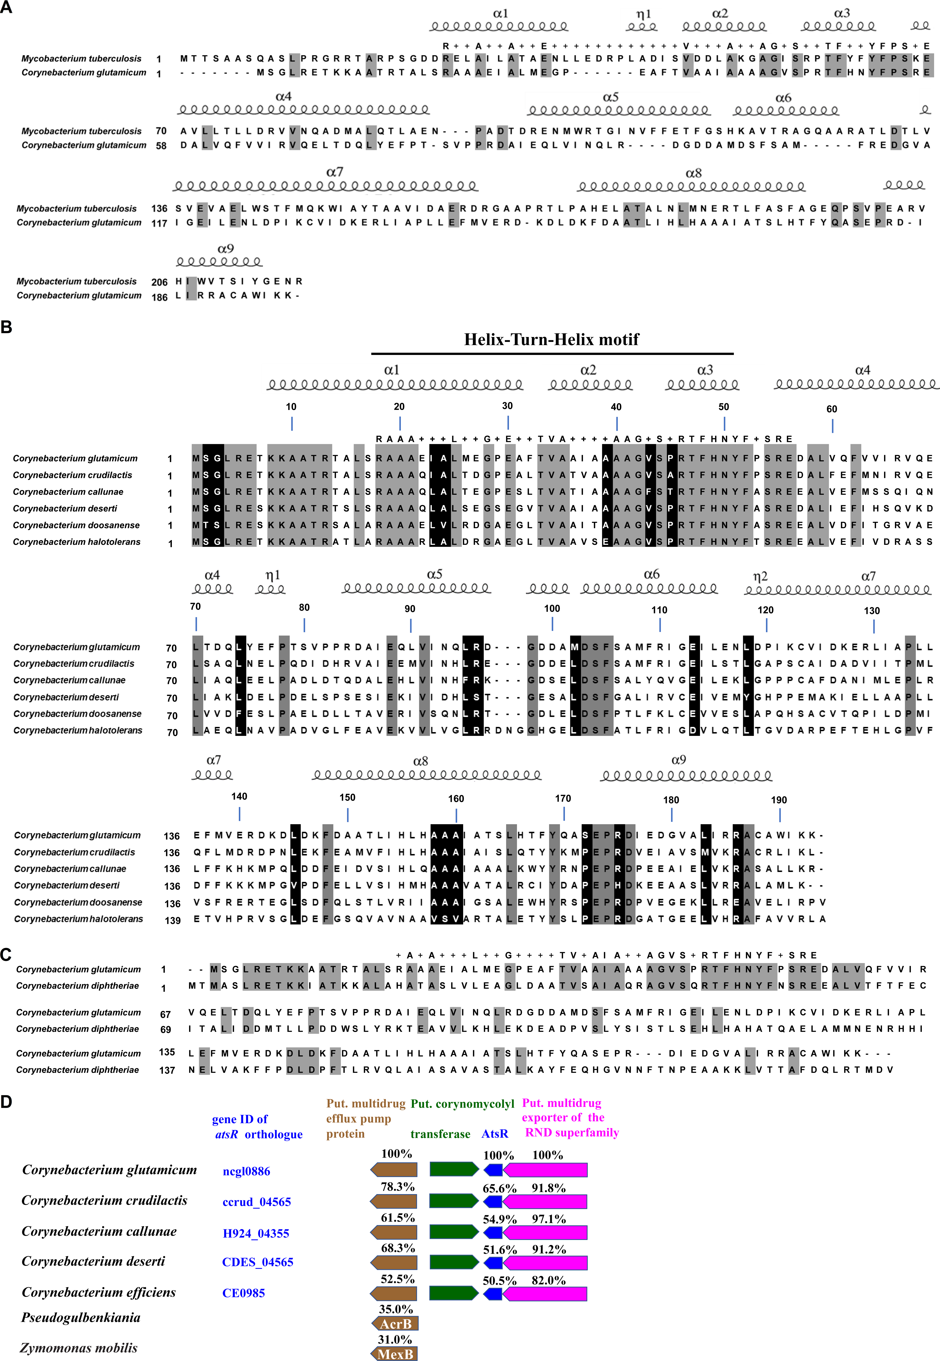
Figure S1 Multiple sequence alignment. (A) Sequence alignment of AtsR with the TetR-type protein EthR from Mycobacterium tuberculosiss and secondary structure assignment. Amino acids identical were shaded in gray background. Reference sequences were retrieved from the NCBI Database, including C. glutamicum ATCC AtsR (CAF19629) and M. tuberculosis EthR (AJF05222). The amino acids of the N-terminal region of the EthR protein (amino acids 29-73) identical to those of the N-terminal region in the AtsR protein (amino acids 18-57) were shown above the alignment. (B) Sequence alignment of AtsR with TetR-type protein from several species of the genera Corynebacterium and secondary structure assignment of AtsR protein. Amino acids identical in all sequences were shaded in gray background, other conserved amino acids in black background. Reference sequences were retrieved from the NCBI Database, including C. glutamicum ATCC AtsR (CAF19629), C. crudilactis TetR (A ANE03558); C. callunae TetR (AGG66317); C. deserti TetR (ALC05358); C. doosanense TetR (AIT59905); C. halotolerans TetR (AGF71927). The N-terminal region of the AtsR proteins (amino acids 18-57) showed clear similarity to the N-terminal part of the TetR family of the other regulatory proteins (TetR-N; PFAM00440). The amino acids identical to those of the N-terminal region in the AtsR protein were shown above the alignment. (C) Multiple sequence alignment of AtsR with TetR-type protein from C. diphtheriae. Residues that were identical in 2 sequences were depicted on the gray background. Reference sequences were retrieved from the NCBI Database, including C. glutamicum ATCC AtsR (CAF19629); C. diphtheriae TetR (AEX46079). The amino acids of the N-terminal region of the C. diphtheriae TetR protein (amino acids 20-59) identical those of the N-terminal region in the AtsR protein were shown above the alignment. (D) Genomic organization of the atsR gene in several corynebacterial species. Homologous genes were presented in the same color. The amino acid sequence similarities (expressed as percentages) of the corresponding proteins in C. glutamicum with those in other strains were shown. Reference sequences were retrieved from the NCBI Database, including Pseudogulbenkiania sp. NH8B (BAK77170) and Zymomonas mobilis subsp. mobilis CP4 (AHJ72432).

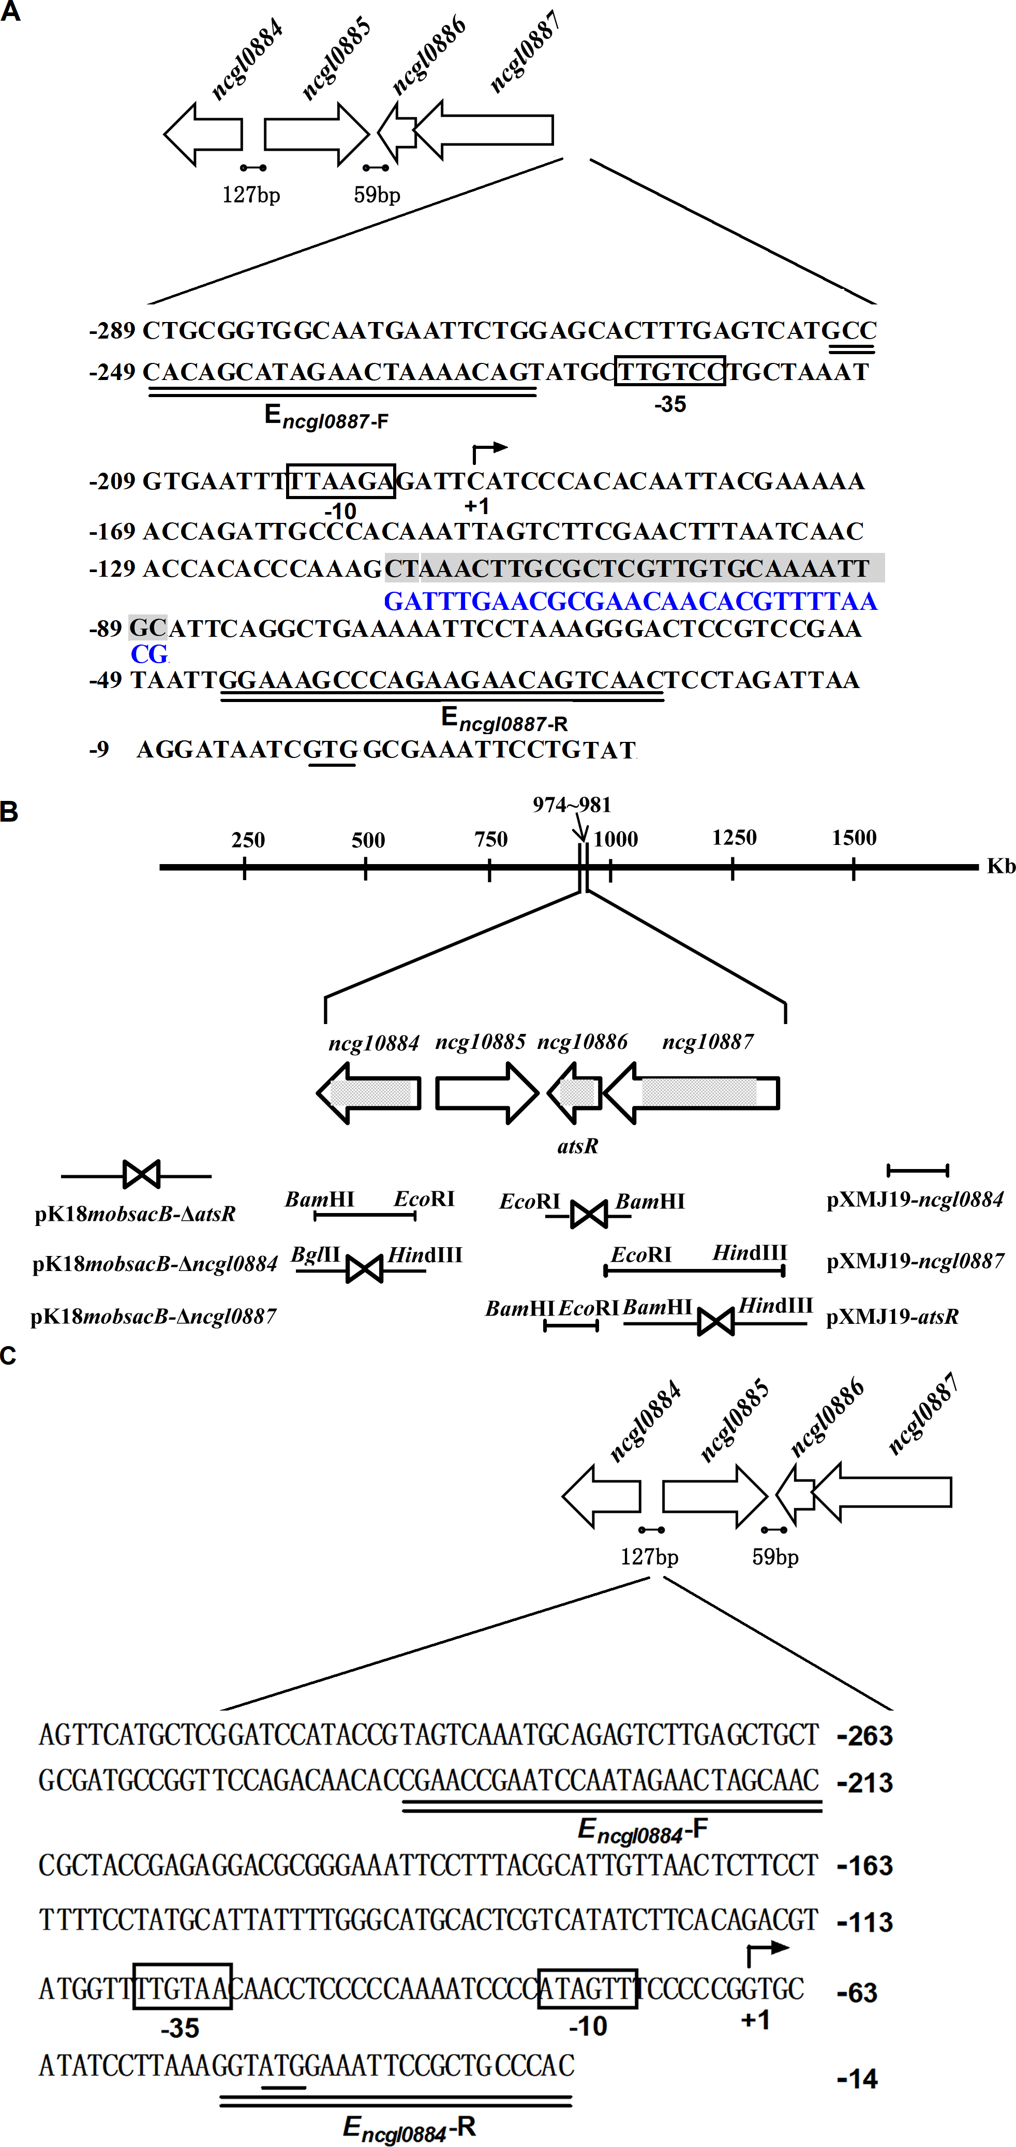
Figure S2 Detailed genetic maps. (A) The promoter region was upstream of the ncgl0887-atsR operon. Gray shaded box indicated the 29 bp sequences, which was assumed to contain the AtsR binding site. The deduced -35 and -10 promoter regions found by PROM-Prediction of bacterial promoters were boxed. The start codon of ncgl0887 was underlined. The sequences used to replace the 29 bp sequences were shown in blue below the promoter sequence. EMSA DNA promoter fragment was obtained using primers E_{ncgl0887}-F and E_{ncgl0887}-R, which was double underlined. (B) Physical map of ncgl0884 and ncgl0887-atsR operon in Corynebacterium glutamicum RES167 parental strain and construction of plasmids for gene disruption (pK18mobsacB derivatives) or complementation (pXMJ19 derivatives). Open reading frames (ORFs) were marked by open arrows, and the deleted regions were in grey. The restriction sites were indicated. (C) The promoter region was upstream of ncgl0884 gene. The deduced -35 and -10 promoter regions found by PROM-Prediction of bacterial promoters were boxed. The start codon of ncgl0884 was underlined. EMSA DNA promoter fragment was obtained using primers Encgl0884-F and Encgl0884-R, which was double underlined.

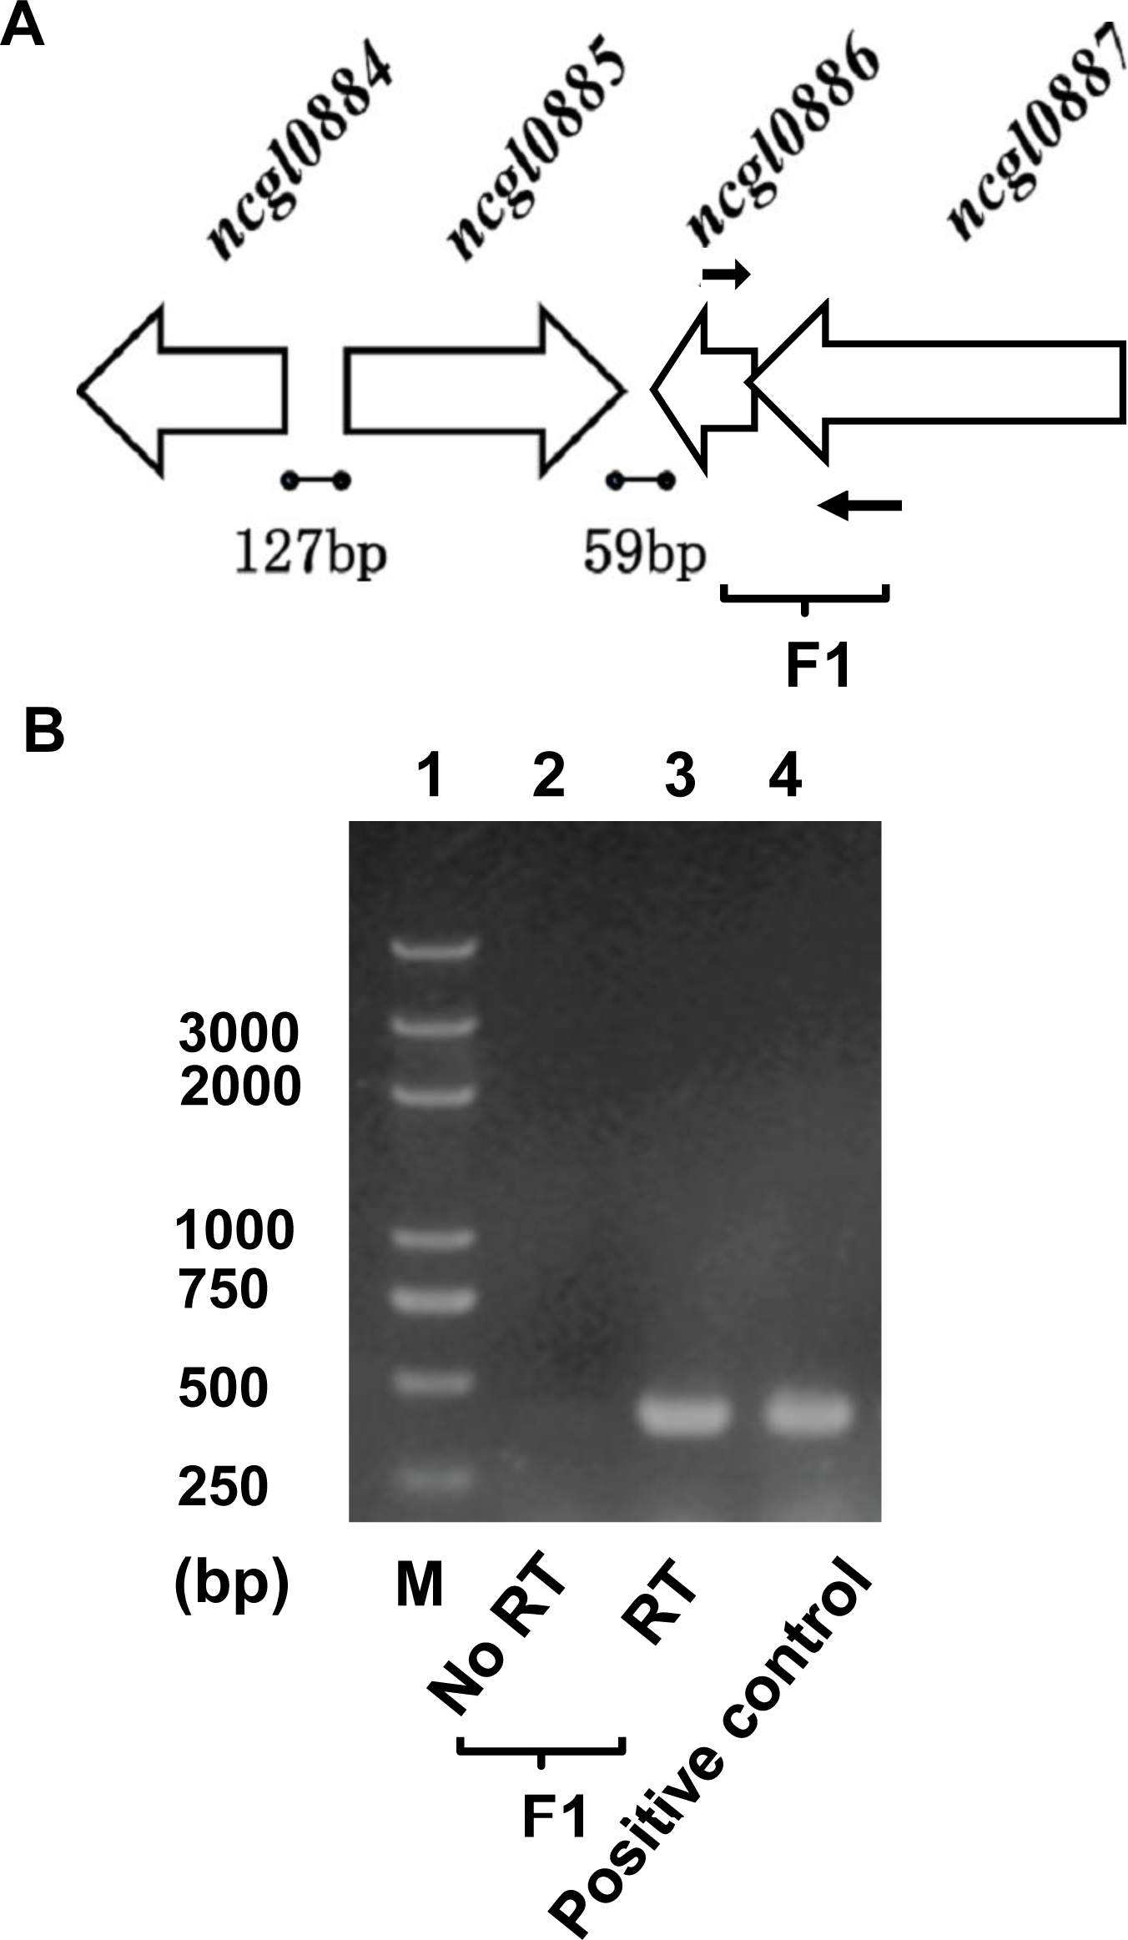
Figure S3 Assays for the ncgl0887-atsR co-transcription by reverse transcription PCR. (A) The operon structure of ncgl0887-atsR primer where designed for assays and indicated by blank arrows. (B) Reverse transcription PCR assays for ncgl0887-atsR co-transcription. Lane 1, DNA marker; Lane 2, negative control PCR reactions omitted the initial reverse transcription step (No-RT). lane 4, positive control using genomic DNA as template. PCR procedure was as follows: reactions were denatured 95 °C for 50 s, annealed at 58 °C for 40 s, extended at 72 °C for 30 s, and repeated 30 cycles.
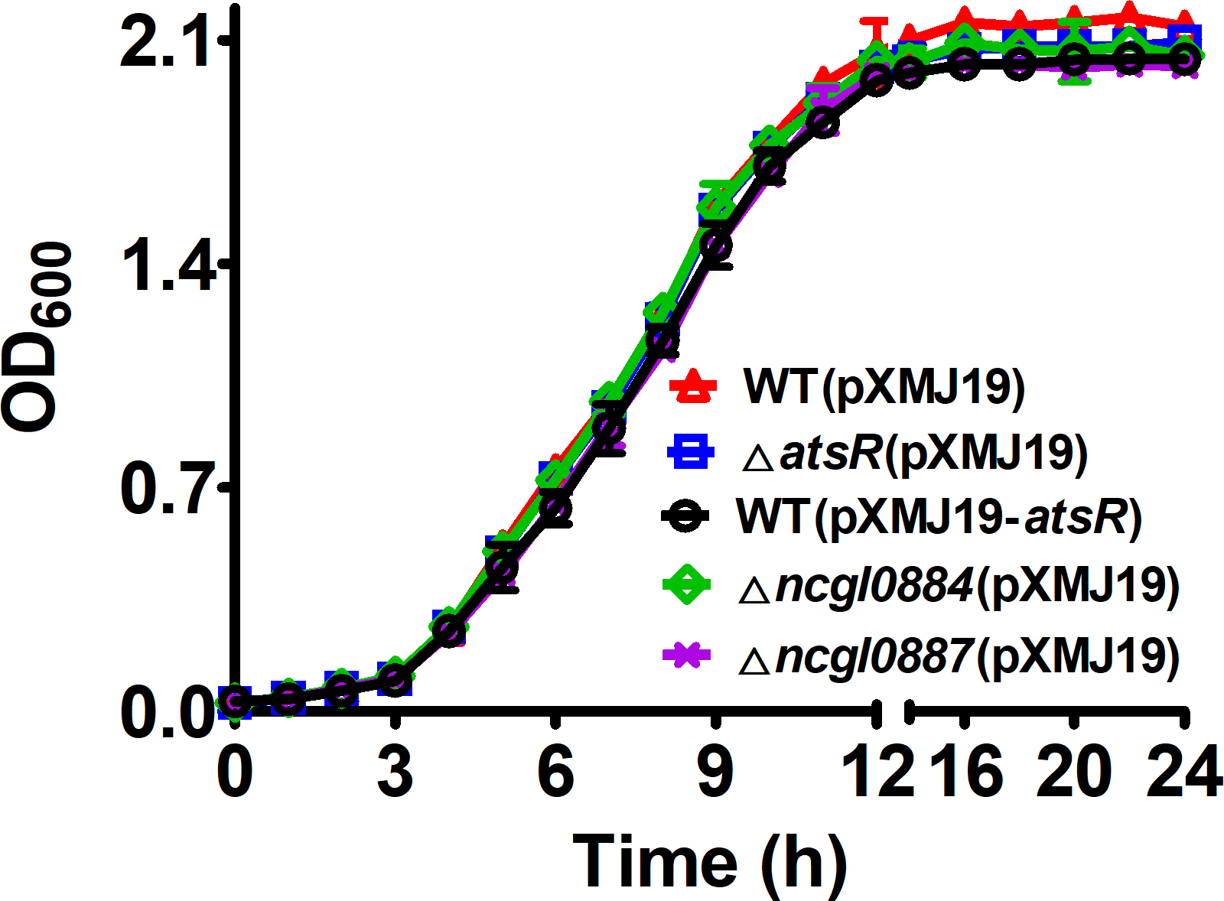

Figure S4 Growth curves of the WT(pXMJ19) strain (the C. glutamicum RES167 parental strain transformed with the empty plasmid pXMJ19), the ΔatsR(pXMJ19) mutant (the atsR deletion mutant expressing pXMJ19), the WT(pXMJ19-atsR) strain (C. glutamicum RES167 parental strain expressing the wide-type (WT) atsR gene in the shuttle vector pXMJ19), Δncgl0884(pXMJ19) mutant (the ncgl0884 deletion mutant expressing pXMJ19), and Δncgl0887(pXMJ19) mutant (the ncgl0884 deletion mutant expressing pXMJ19) under normal conditions. The growth of the indicated strains in LB media was monitored by measuring OD₆₀₀ at indicated time points.

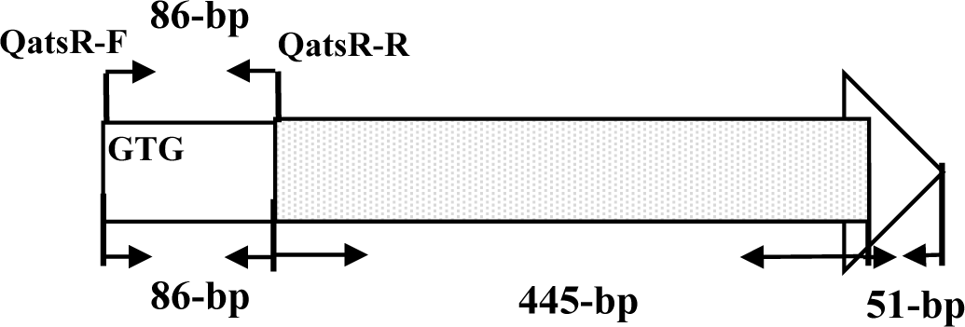
Figure S5 86-bp atsR transcript (from the translational start codon (GTG) of atsR gene to 86th nucleotide) was amplified from the remaining atsR ORF (open reading frame) in ΔatsR mutant with primers QatsR-F and QatsR-R. atsR ORF was marked by open arrows and the deleted region was in gray.
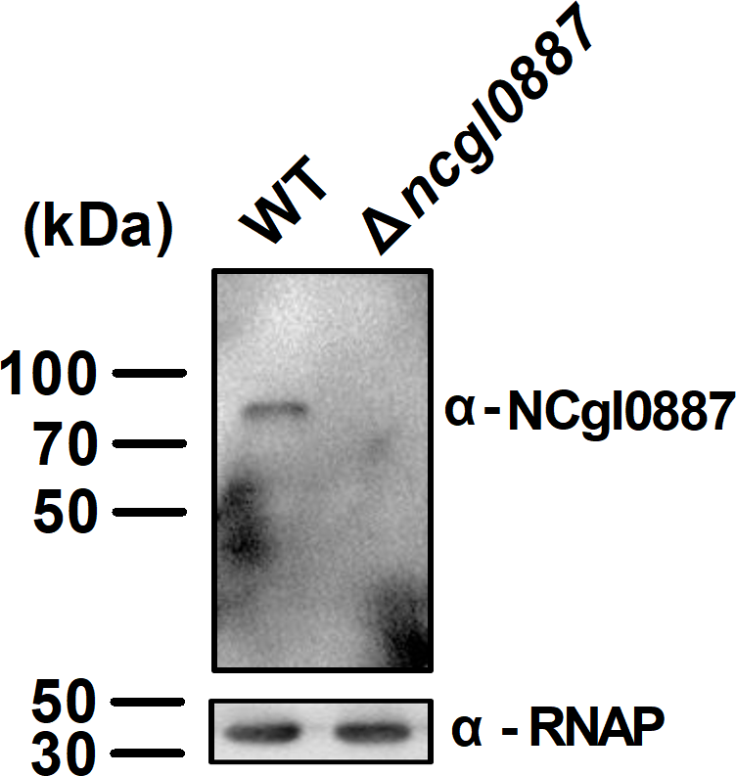
Figure S6 The NCgl0887 was examined in C. glutamicum. Anti-NCgl0887 antibody detected a single protein with a mobility consistent with the predicted size that was absent from Δncgl0887 mutants. Antibody to RNAP was used as a loading control.
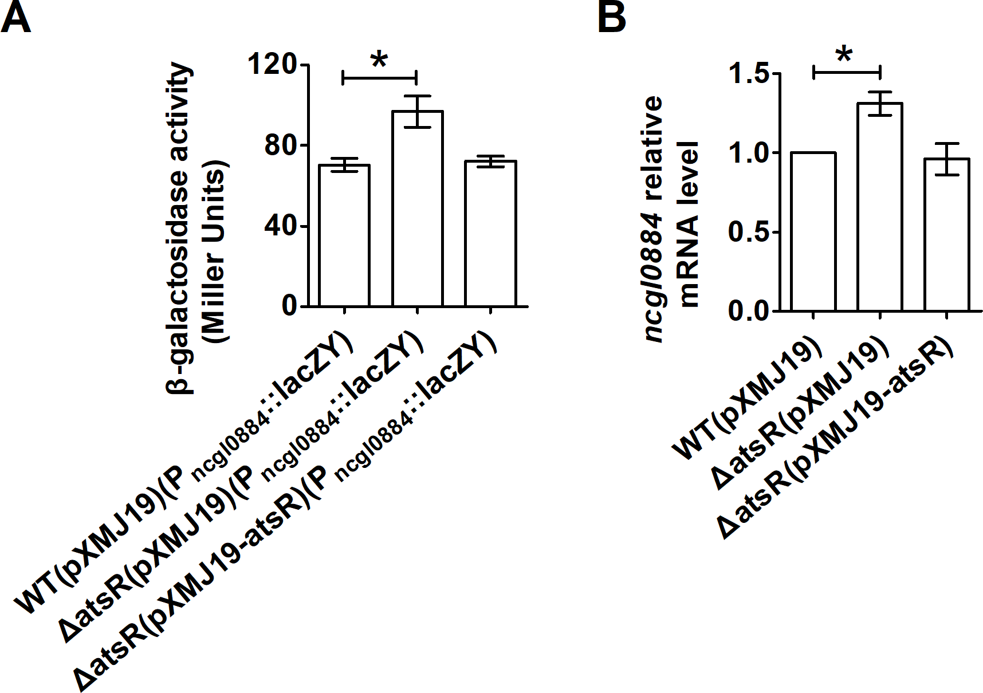
Figure S7 Negative regulation of ncgl0884 expression by AtsR. (A) β-galactosidase activity analysis of the ncgl0884 promoter was performed using the transcriptional P_{ncgl0884}::lacZY chromosomal fusion reporter expressed in WT(pXMJ19), ΔatsR(pXMJ19) mutant, and complementary ΔatsR(pXMJ19-atsR) strains. (B) qRT-PCR assay was performed to analyze the ncgl0884 expression in WT(pXMJ19), ΔatsR(pXMJ19), and complementary ΔatsR(pXMJ19-atsR) strains. The mRNA levels were presented relative to the value obtained from WT(pXMJ19) strains. Relative transcript levels of WT(pXMJ19) strains were set at a value of 1.0. Data show the averages of three independent experiments, and error bars indicated the SDs from three independent experiments. *: P≤0.05.

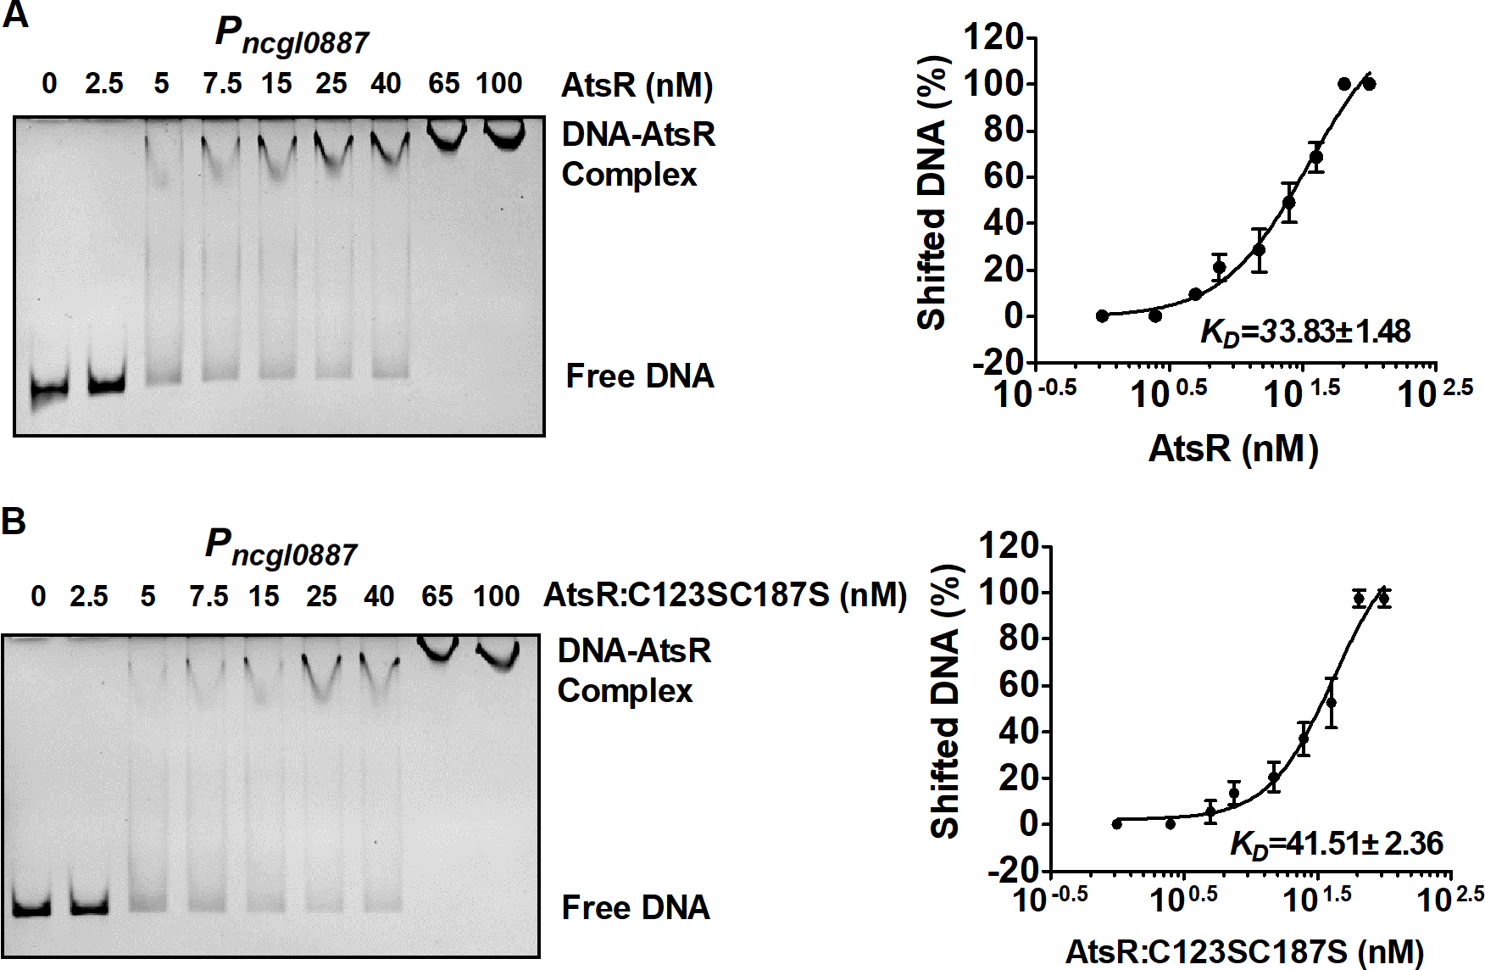
Figure S8 Determination of the apparent K_{D} values of AtsR and AtsR:C123SC187S for P_{ncgl0887}. P_{ncgl0887} was incubated with increasing AtsR (A) or AtsR:C123SC187S (B) concentrations, resolved on a 8% native PAGE, and stained with GelRedTM. At least three independent gels were performed for each binding site. The bands were quantified using ImageQuant software (GE Healthcare), and the percentage of shifted DNA was calculated from three independent gels. These values were plotted against the AtsR or AtsR:C123SC187S concentration in log₁₀ scale, and a sigmoidal fit was performed. The turning point of the curve was defined as the apparent K_{D} value.

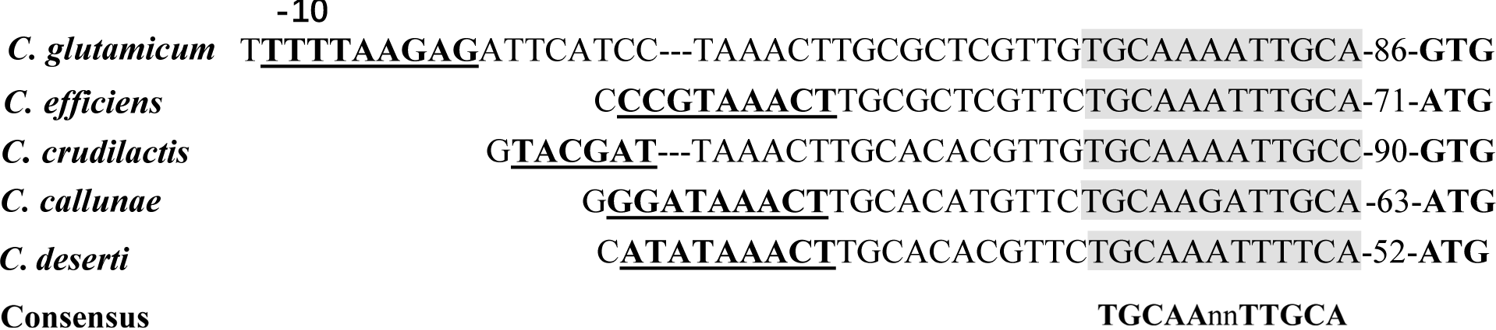

Figure S9 Sequence of the promoter region of C. glutamicum ncgl0887-atsR operon aligned to putative promoter regions from other Corynebacterium species. Indicated were the start of the ncgl0887 coding region (start codons black bold), putative -10 (underlined and black bold), and the AtsR binding site (shaded in gray) for the C. glutamicum ncgl0887-atsR operon. As shown by the alignment, also the other species possessed putative AtsR binding sites in the ncgl0887 upstream region. The binding site represented a perfect inverted repeat in five Corynebacterium species with the consensus sequence 5΄-TGCAA-N₂-TTGCA-3΄.

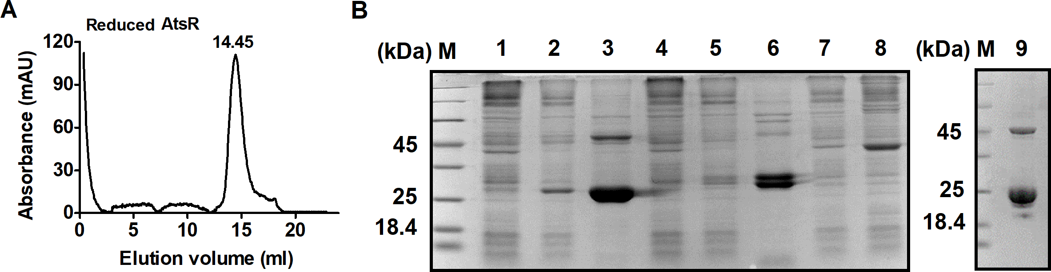

Figure S10 Purification of AtsR. (A) Elution of reduced AtsR (20 μM AtsR was incubated with 50 mM DTT) from size exclusion column. (B) Coomassie-stained SDS-PAGE of His₆-AtsR, His₆-PUP1, His₆-SUMO-AtsR, and AtsR. M, broad-range protein marker; lane 1, crude extract of BL21(pET28a-atsR) strain without IPTG induction; lane 2, crude extract of BL21(pET28a-atsR) strain with induction; lane 3, purified His₆-AtsR protein; lane 4, crude extract of BL21(pET28a-pup1) strain without IPTG induction; lane 5, crude extract of BL21(pET28a-pup1) strain with induction; lane 6, purified His₆-PUP1 protein; lane 7, crude extract of BL21(pET28a-SUMO-atsR) strain without IPTG induction; lane 8, crude extract of BL21(pET28a-pET28a-SUMO-atsR) strain with induction; lane 9, purified AtsR protein.

