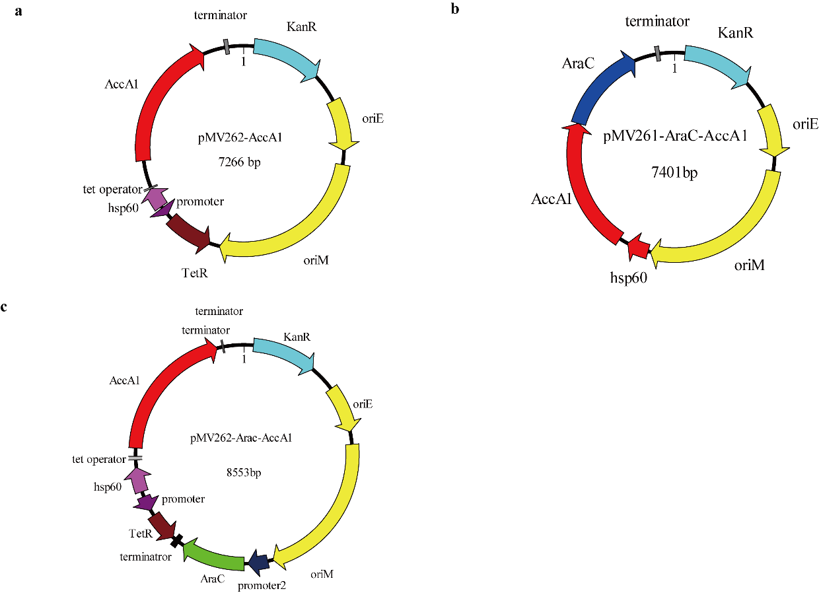
Supplementary Figure S1. Plasmid profiles of recombinant strains (a) pMV262-AccA1. (b) pMV261-AraC-AccA1. (c) pMV262-AraC-AccA1.

