Additional file 1
Lipid production from lignocellulosic biomass using an engineered and adapted Yarrowia lipolytica strain
Katarzyna Drzymała-Kapinos, Aleksandra M. Mirończuk1, Adam Dobrowolski1*
¹Department of Biotechnology and Food Microbiology, Wrocław University of Environmental and Life Sciences, Wrocław, Poland

*Corresponding Author – Email: adam.dobrowolski@upwr.edu.pl Address: University of Environmental and Life Sciences, Department of Biotechnology and Food Microbiology, 37 Chełmońskiego Street 51-630 Wrocław, Poland

Figure S1. Schematic for xylose utilization pathway and new Y. lipolytica strains preparation.
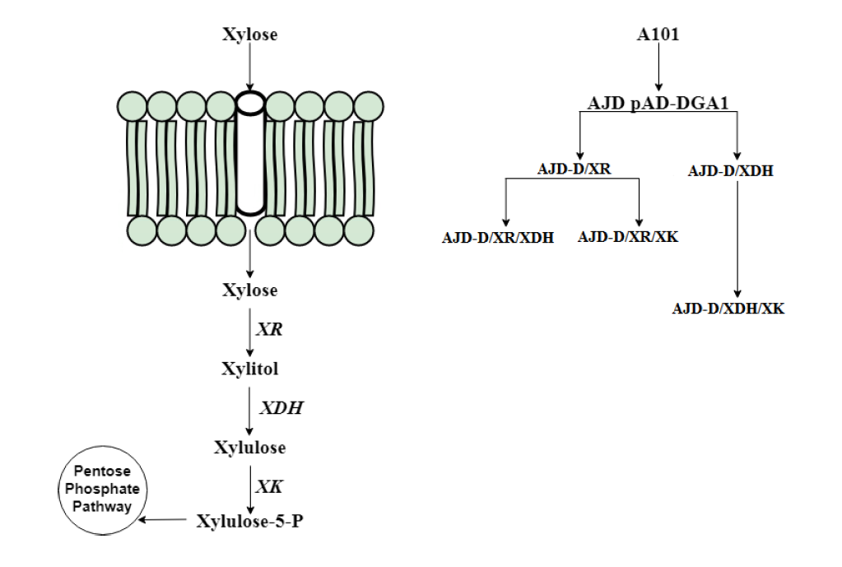

Table S1. Strains and plasmids used in presented study
Strain | Genotype or plasmid | Source
E. coli
DH5α | F− endA1 glnV44 thi-1 recA1 relA1 gyrA96 deoR nupG  Φ80dlacZΔM15 Δ(lacZYA-argF)U169, hsdR17(rK-mK+), λ− | Hanahan D. DNA cloning: a practical approach. In: Glover DM, editor.  McLean: IRL Press; 1985.
DH5α | pAD-XR, YALI0D07634g | This study
DH5α | pAD-XDH, YALI0E12463g | This study
DH5α | pAD-XYL3, YALI0F10923g | This study
Y. lipolytica
A101 | Wild type | Wojtatowicz et al., 1991
AJD | MATA, A101: ura3-302 | Mironczuk et al., 2015
AJD-D | MATA, A101: ura3-302 overexpression YALI0E32769g | This study
AJD-D/XR/XDH | MATA, A101: ura3-302 overexpression YALI0E32769g , YALI0D07634g and YALI0E12463g | This study
AJD-D/XR/3 | MATA, A101: ura3-302 overexpression YALI0E32769g , YALI0D07634g and YALI0F10923g | This study
AJD-D/XHD/3 | MATA, A101: ura3-302 overexpression YALI0E32769g , YALI0E12463g and YALI0F10923g | This study
AJD-D/XYL/ALE | MATA, A101: ura3-302 overexpression YALI0E32769g , YALI0E12463g and YALI0F10923g, with a short lag phase | This study

Table S2. List of primers
Gene | Plasmid | Sequence
Primers used for constructing plasmids
YALI0D07634g | XR_Asc1_F | ACGGGCGCGCCATGTCCTTCAAGCTCGCCTCCGGAAAG
 | XR_Nhe1_R | AGCGCTAGCTCCGTGTTTCCACGCTTAGG
YALI0E12463g | XDH_Asc1_F | ACGGGCGCGCCATGTCTTCTAACCCGTCATTTG
 | XDH_Pml1_R | CACGTGCCGGTTGTAGATTCACTAAG
YALI0F10923g | XK_Asc1_F | ATGGGCGCGCCATGTATCTCGGACTGGATCTTTCG
 | XK_Nhe1_R | ACGGCTAGCGCCATGCTGGTTTAGTTTAC
Primers used for RT-PCR
YALI0D07634g | q_XR_F | GATTCGGCCTGTGGAAGGTC
 | q_XR_R | TTGATGGCTCGTCGGATACC
YALI0E12463g | q_XDH_F | GCCATTGGATCTCGTCTTTG
 | q_XDH_R | CCTCCATGCAGATAGTAGTG
YALI0F10923g | q_XK_F | CGGACTGGATCTTTCGACTC
 | q_XK_R | CCACTGTAGAGCTGTGAAAG
YALI0E32769g | q_DGA1_F | TCGCGGGAATCCGATATGCC
 | q_DGA1_R | GTGGAATTGCGCAGCATAGC
actin | q_ACT_F | GAGTCACCGGTATCGTTC
 | q_ACT_R | GCGGAGTTGGTGAAAGAG

*Corresponding author: Adam Dobrowolski, University of Environmental and Life Sciences, Department of Biotechnology and Food Microbiology, 37 Chełmońskiego Street 51-630 Wrocław, Poland, Tel: 71 3207791, e-mail: adam.dobrowolski@upwr.edu.pl

