Additional file 1

Mining and Characterization of the PKS−NRPS Hybrid for Epicoccamide A: a Mannosylated Tetramate Derivative from Epicoccum sp. CPCC 400996

Tao Zhang^{a*}, Guowei Cai^{a,b}, Xiaoting Rong^{a,c}, Jingwen Xuª, Bingya Jiangª, Hao Wangª, Xinxin Liª, Lu Wangª, Ran Zhangª, Wenni He^{a*}, Liyan Yu^{a*}

ª Institute of Medicinal Biotechnology, Chinese Academy of Medical Sciences & Peking Union Medical College, Beijing 100050, China
^{b} Medical research center, Binzhou medical university hospital, Binzhou, Shandong province, China, 256603
^{c} College of Biotechnology, Jiangsu University of Science and Technology, Zhenjiang, Jiangsu, China, 212003

Corresponding Authors
Tao Zhang - Institute of Medicinal Biotechnology, Chinese Academy of Medical Sciences & Peking Union Medical College, Beijing 100050, China; Email: evergo218@163.com
Wenni He - Institute of Medicinal Biotechnology, Chinese Academy of Medical Sciences & Peking Union Medical College, Beijing 100050, China; Email: wnner0047@126.com
Liyan Yu - Institute of Medicinal Biotechnology, Chinese Academy of Medical Sciences & Peking Union Medical College, Beijing 100050, China; Email: yly@cpcc.ac.cn.

CONTENTS
Contents | Page
Table S1. NMR Data for epicoccamide A (1) | S3
Table S2. Comparison of the signature residues for amino acid selection by adenylation (A) domains of fungal PKS-NRPS (NRPS) | S4-5
Figure S1. The ¹H NMR spectrum of compound 1 | S6
Figure S2. The ¹³C NMR spectrum of compound 1 | S7
Figure S3. The ¹H-¹H COSY spectrum of compound 1 (in DMSO) | S8
Figure S4. The HSQC spectrum of compound 1 (in DMSO) | S9
Figure S5. The HMBC spectrum of compound 1 (in DMSO) | S10
Figure S6. HRESIMS spectrum of compound 1 | S11
Figure S7. ESI MS/MS (-) spectrum of compound 1 | S12

Table S1. NMR Data for epicoccamide A (1).
Position | δ_{C} | δ_{H} (J in Hz) | ¹H-¹H COSY | HMBC
1 | 172.3
2 | 100.2
3 | 189.8
4 | 62.2 | 3.87, br. s | H-5
5 | 14.4 | 1.23, d (6.3) | H-4 | C-3, C-4
6 | 26.0 | 2.88, s |  | C-1, C-4
7 | 194.5
8 | 35.2 | 3.50, br. s | H-9, H-23
9 | 33.0 | 1.41, m , 1.58, m | H-8, H-10 | C-10, C-11
10 | 26.6 | 1.20~1.29  overlapped
11-19 | 28.8-29.2 | 1.20~1.29  overlapped
20 | 25.6 | 1.20~1.29  overlapped
21 | 29.2 | 1.50, m | H-22 | C-19, C-20, C-22
22 | 68.4 | 3.39, m, 3.74, m | H-21 | C-20, C-21, C-1'
23 | 16.9 | 1.08, d (6.7) | H-8 | C-7, C-8, C-9
1' | 100.2 | 4.33, br. d | H-2' | C-2', C-5', C-22
2' | 70.6 | 3.60, m | H-1', H-3' | C-1', C-3', C-4'
3' | 73.7 | 3.23, m | H-2' | C-4'
4' | 67.2 | 3.29, m | H-5' | C-3', C-5', C-6'
5' | 77.5 | 3.00, m | H-4', H-6' | C-1', C-3', C-4', C-6'
6' | 61.4 | 3.45, m, 3.67, m | H-5' | C-4', C-5'

Table S2. Comparison of the signature residues for amino acid selection by adenylation (A) domains of selected fungal PKS-NRPS (NRPS).
Protein (module) | Pos1a  (235) | Pos2  (236) | Pos3  (239) | Pos4  (278) | Pos5  (299) | Pos6  (301) | Pos7  (322) | Pos8  (330) | Pos9  (331) | Pos10  (517) | substrate
GrsA | D | A | W | T | I | A | A | I | C | K | L-Phe
CcsA | D | M | S | E | S | W | C | F | C | K | L-Phe
PsoA | D | A | Y | T | S | W | A | I | C | K | L-Phe
EqiS | D | F | E | S | H | W | N | I | A | K | D-Ser
Pks3 | D | L | L | M | T | W | W | I | V | K | D-Ser
ATEG_00325 | D | A | S | L | Q | W | A | I | M | K | L-Leu
MycA | D | L | W | G | T | W | C | V | G | K | L-Leu
ApdA | D | M | V | I | Y | W | C | A | A | K | L-Tyr
TenS | D | M | V | I | T | W | C | A | A | K | L-Tyr
CpaS (A. flavus) | D | M | A | L | T | W | S | A | C | K | L-Trp
CpaS (A. oryzae) | D | M | A | L | A | W | S | A | C | K | L-Trp
UcsA | D | V | W | F | S | W | I | I | P | K | 3-methylproline
BuaA | D | V | Q | H | K | W | V | V | I | K | 4-methylproline
HTS1.2(NRPS) | D | A | G | G | C | A | M | V | A | K | D-Ala
CssA(NRPS) | D | L | L | F | G | I | A | V | L | K | L-Ala
HTS1.3(NRPS) | D | L | L | F | G | I | S | V | L | K | L-Ala
EasA4 | D | L | L | V | V | A | G | I | L | K | L-Ala
EasA5 | D | I | A | I | L | V | A | I | L | K | L-Ala
EpiA | D | L | G | I | F | G | V | V | W | K | L-Ala
Note: The 10 signature residues were based on the bacteria A domain as established previously [1]. Sequence numbering is according to A domain of EpiA as predicted by antiSMASH 6.0 [2] (corresponds to amino acid 2951 – 3354 of the full length EpiA) and were based on homology modelling with bacterial A domain as performed previously by Stachelhaus et al [3]. The signature residue table above is an expansion the table in this previous study [4].

■ REFERENCES
- Stachelhaus T, Mootz HD, Marahiel MA. The specificity-conferring code of adenylation domains in nonribosomal peptide synthetases. Chem Biol. 1999; 6(8):493-505.
- Blin K, Shaw S, Kloosterman AM, Charlop-Powers Z, van Wezel GP, Medema MH, Weber T. AntiSMASH 6.0: improving cluster detection and comparison capabilities. Nucleic Acids Res. 2021; 49:W29-W35.
- Chiang YM, Szewczyk E, Nayak T, Davidson AD, Sanchez JF, Lo HC, Ho WY, Simityan H, Kuo E, Praseuth A, Watanabe K, Oakley BR, Wang CCC. Molecular genetic mining of the Aspergillus secondary metabolome: discovery of the emericellamide biosynthetic pathway. Chem Biol. 2008; 15:527-532.
- Li H, Gilchrist CLM, Lacey HJ, Crombie A, Vuong D, Pitt JI, Lacey E, Chooi YH, Piggott AM. Discovery and heterologous biosynthesis of the burnettramic acids: rare PKS-NRPS-derived bolaamphiphilic pyrrolizidinediones from an Australian fungus, Aspergillus burnettii. Org Lett. 2019; 21:1287-1291.

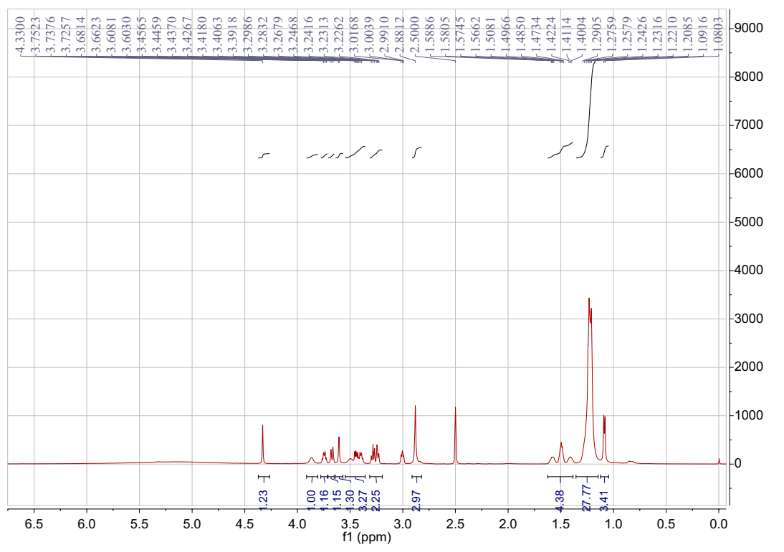
Figure S1. The ¹H NMR specturm of compound 1（in DMSO, 600MHz）
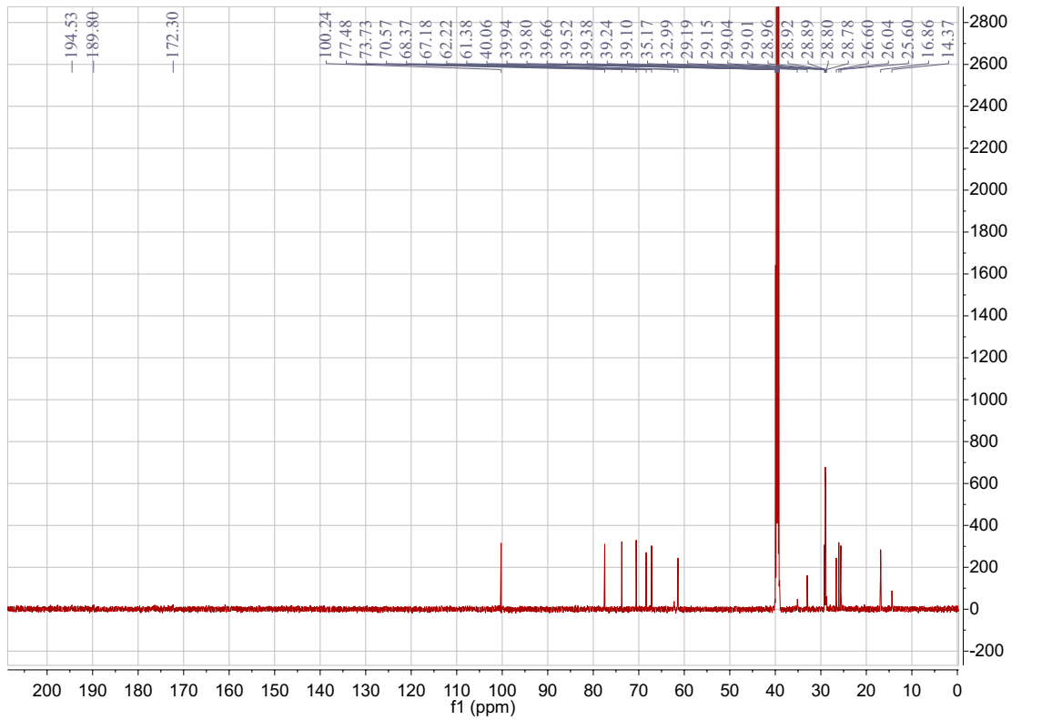
Figure S2. The ¹³C NMR spectrum of compound 1 (in DMSO, 151MHz)
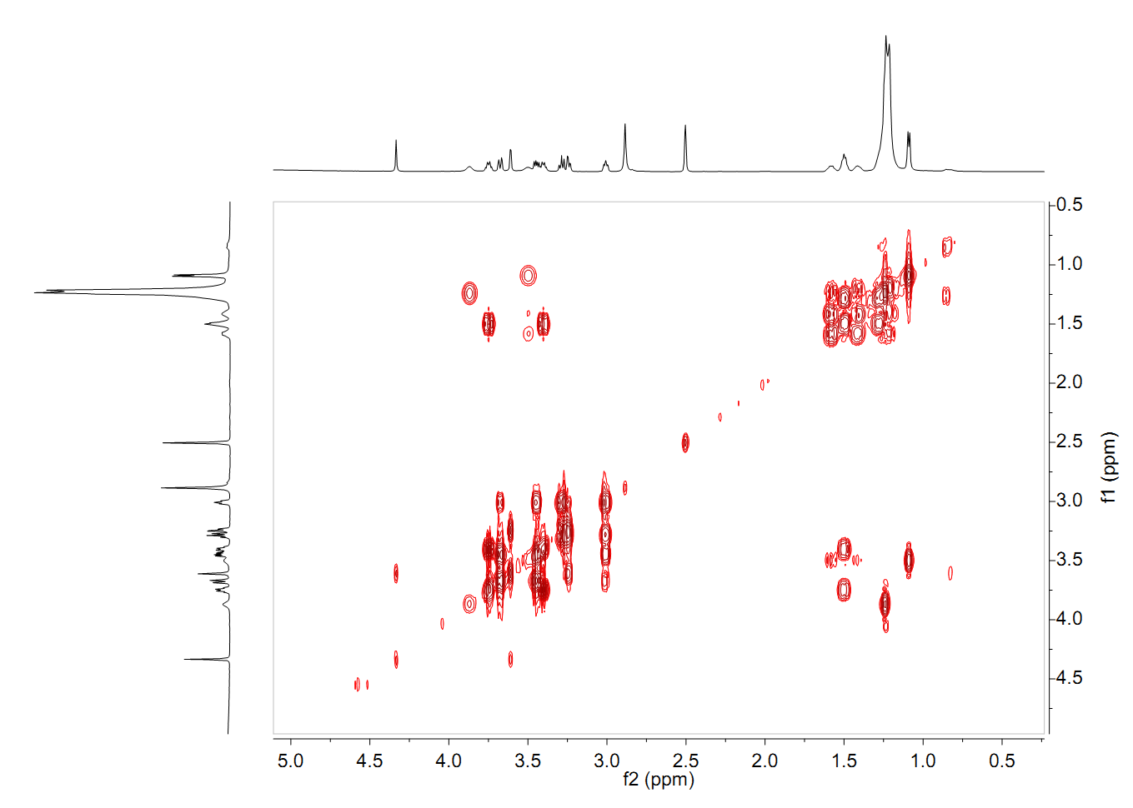
Figure S3. The ¹H-¹H COSY spectrum of compound 1 (in DMSO)
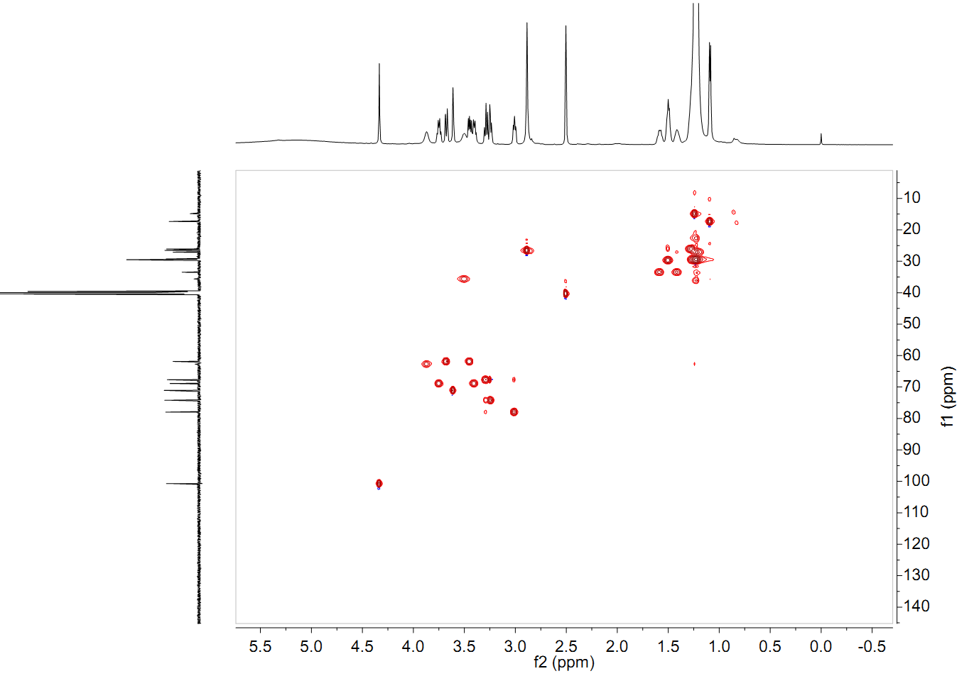
Figure S4. The HSQC spectrum of compound 1 (in DMSO)
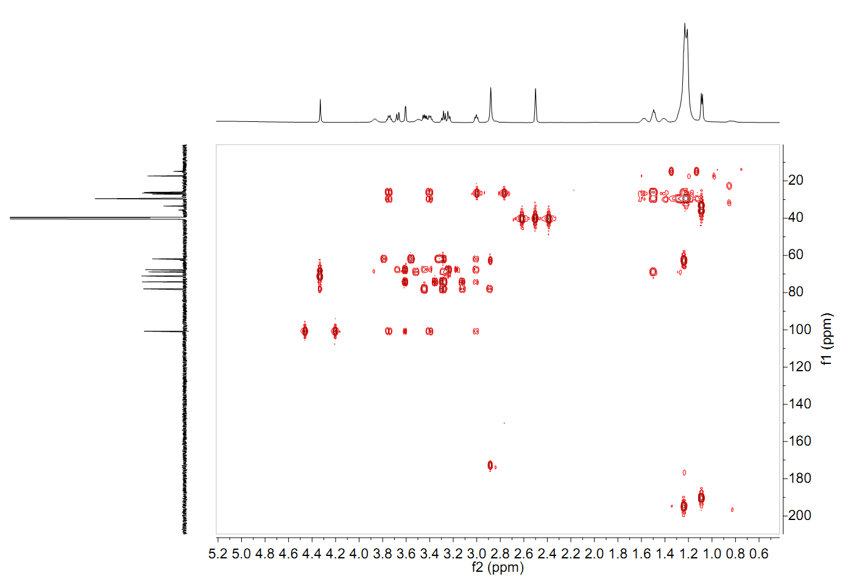
Figure S5. The HMBC spectrum of compound 1 (in DMSO)
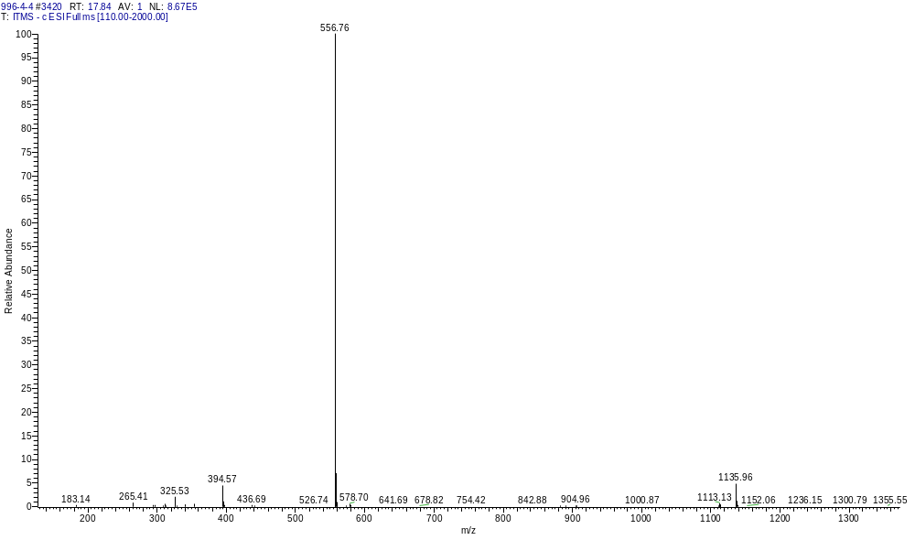
Figure S6. HRESIMS spectrum of compound 1

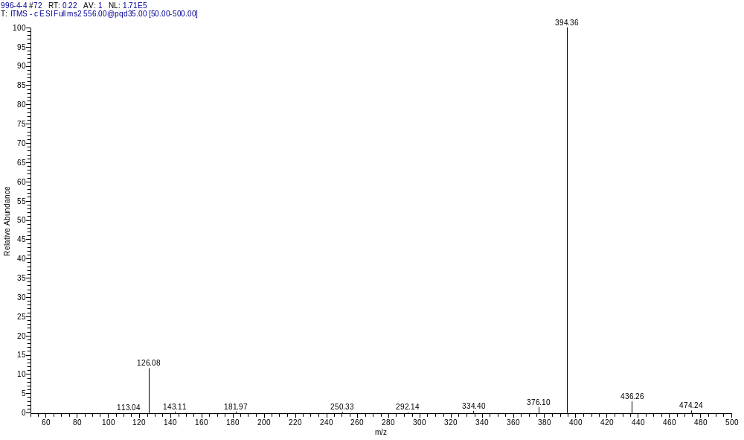
Figure S7. ESI MS/MS (-) spectrum of compound 1

