High-yield α-humulene production in Yarrowia lipolytica from waste cooking oil based on transcriptome analysis and metabolic engineering

Qi Guoª, Qian-Qian Peng^{b}, Ying-Ying Chen^{b}, Ping Song^{b}, Xiao-Jun Jiª, He Huang^{a,b,c*}, Tian-Qiong Shi^{b*}
ª College of Biotechnology and Pharmaceutical Engineering, Nanjing Tech University, No. 30 South Puzhu Road, Nanjing 211816, People’s Republic of China
^{b} School of Food Science and Pharmaceutical Engineering, Nanjing Normal University, 2 Xuelin Road, Qixia District, Nanjing 210046, People’s Republic of China
^{c} College of Pharmaceutical Sciences, Nanjing Tech University, No. 30 South Puzhu Road, Nanjing 211816, People’s Republic of China

*Corresponding Author: College of Biotechnology and Pharmaceutical Engineering, Nanjing Tech University (Tian-Qiong Shi, tqshi@njnu.edu.cn; He Huang, huangh@njnu.edu.cn)

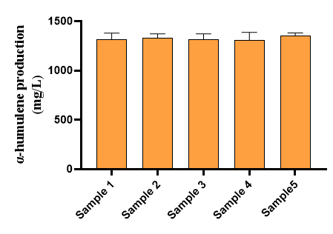
Fig. S1. Influence of WCO from different canteens on α-humulene production.

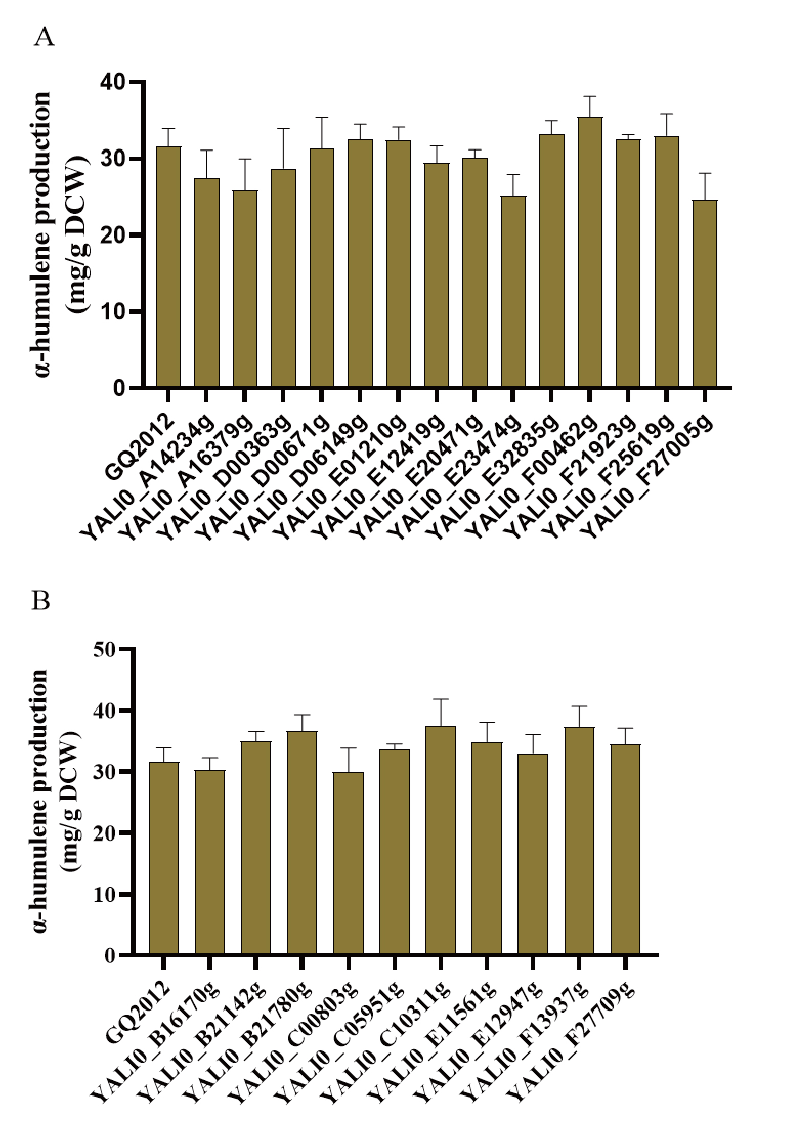
Fig. S2. Influence of differential genes regulation on α-humulene production (DCW). (A) Overexpression of genes with significantly up-regulated transcript levels. (B) down-regulation of gene with significantly down-regulated transcript levels. The data represent the means ± standard deviations (n = 3).

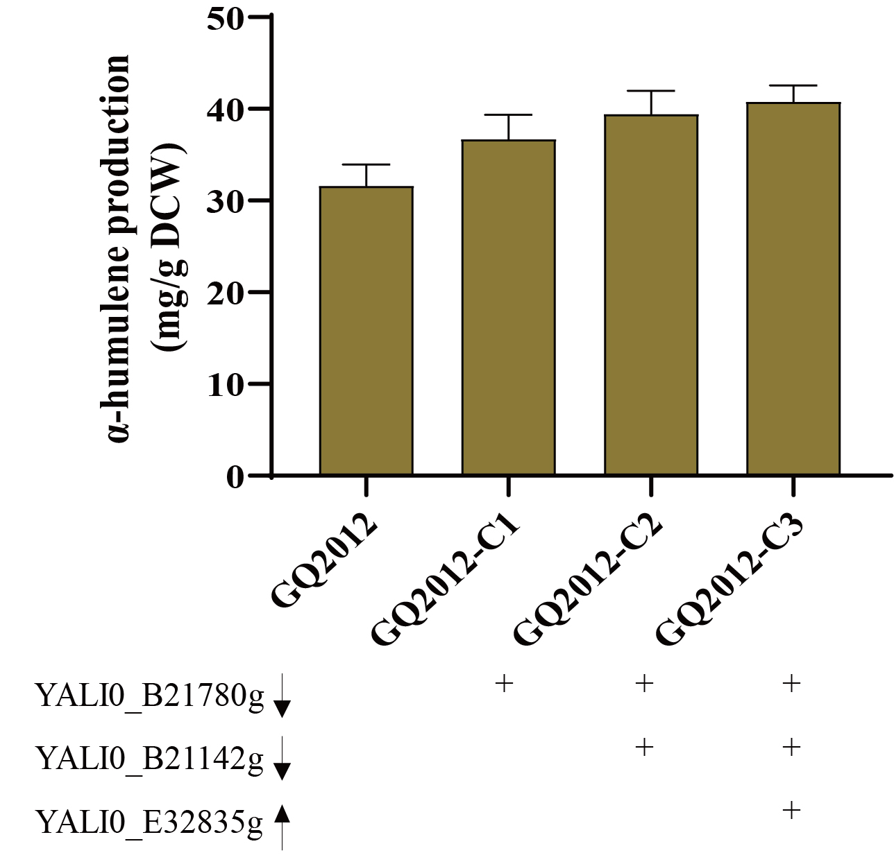
Fig. S3. Rational metabolic engineering to improve α-humulene production (DCW). YALI0_B21780g and YALI0_B21142g were down-regulated. YALI0_E32835g was overexpressed. The data represent the means ± standard deviations (n = 3).

