Supplementary Information for
Engineering of a newly isolated Bacillus tequilensis BL01 for poly-γ-glutamic acid production from citric acid
Dexin Wang^{1,2}†, Xiaoping Fu^{1,2}†, Dasen Zhou³, Jiaqi Gao^{1,2,4}, Wenqin Bai^{1,2*}

¹ CAS Key Laboratory of Systems Microbial Biotechnology, Tianjin Institute of Industrial Biotechnology, Chinese Academy of Sciences, Tianjin, 300308, China
² National Center of Technology Innovation for Synthetic Biology, Tianjin, 300308, China
³ College of Biotechnology, Tianjin University of Science and Technology, Tianjin, 300457, China
⁴ University of Chinese Academy of Sciences, 19A Yuquan Road, Shijingshan District, Beijing, 100049, China

*Correspondence to: WB (baiwq@tib.cas.cn)
†These authors contributed equally to this work

Additional file
Figure legends
Fig. S1 Neighbor-joining tree based on the 16S rDNA gene sequence showing relationships between BL01 and Bacillus species. Bootstrap values greater than 50 are indicated at the branch nodes. Bar, 0.005 substitutions per nucleotide position. T, representative type strain. GenBank accession numbers of 16S rDNA appear in brackets.
Fig. S2 The γ-PGA titer normalized to the biomass of the individual cultures. (a) Effect of carbon sources; (b) Effect of nitrogen sources; (c) Effect of temperature. Values represent the mean ± SD, n=3.
Fig. S3 Effect of disruption of pgdS and ggt genes in the B. tequilensis BL01 strain. (a) Change curves of lactic acid with fermentation time, (b) Change curves of acetic acid with fermentation time, (c) Growth curves of 2,3-BD with fermentation time. Values represent the mean ± SD, n=3.
Fig. S4 Effect of disruption of sucA and alsS genes in the B. tequilensis BL01 strain. (a) Change curves of acetic acid with fermentation time, (b) Change curves of lactic acid with fermentation time. Values represent the mean ± SD, n=3.
Fig. S5 The glutamic acid curve of B. tequilensis BL01 and mutant strains. Values represent the mean ± SD, n=3.
Fig. S6 The growth curve of B. tequilensis BL01 and engineered strains in the medium without citric acid. Values represent the mean ± SD, n=3.
Fig. S7 Time curves of fed-batch fermentation of γ-PGA in a 5 L fermenter by BL01 and BL01ΔpgdSΔggtΔsucAΔgudB:P43-citZ-pyk strain, (a) 2,3-BD growth curves, (b) acetic acid growth curves. Data are given as the mean ± SD, n=3. Aeration rate: 10 mL/min; agitation rate: 400 rpm (0–6 h), 500 rpm (6–12 h), 600 rpm (12–24 h), 700 rpm (24–48 h); the pH was controlled at pH 6.5±0.2. 20g of sodium citrate dissolved in 50 mL sterile water was fed into the fermenter at 24h, and 150 mL of feed medium containing 700 g/L of sucrose was fed at 30 and 36 h, individually.
Fig. S8 The molecular weight of γ-PGA produced by (a) B. tequilensis BL01 and (b) B. tequilensis BL01ΔpgdSΔggtΔsucAΔgudB:P43-citZ-pyk strain.

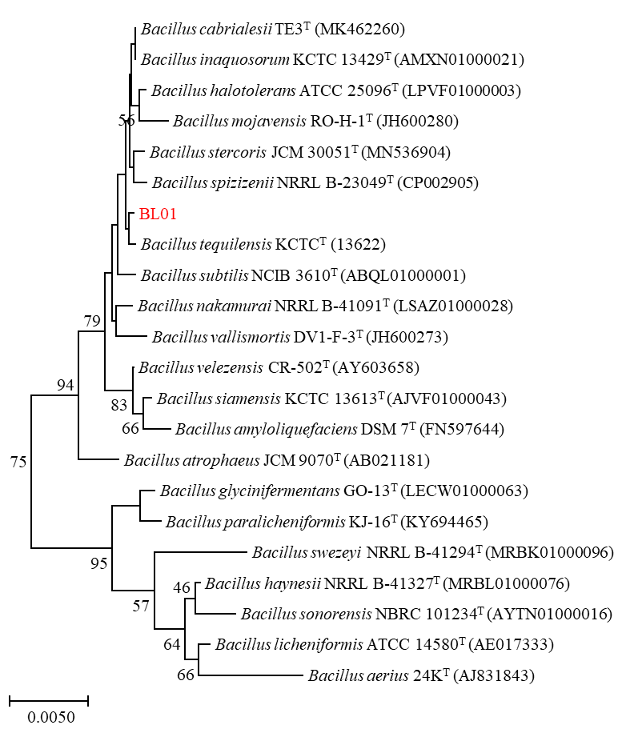
Fig. S1 Neighbor-joining tree based on the 16S rDNA gene sequence showing relationships between BL01 and Bacillus species. Bootstrap values greater than 50 are indicated at the branch nodes. Bar, 0.005 substitutions per nucleotide position. T, representative type strain. GenBank accession numbers of 16S rDNA appear in brackets.
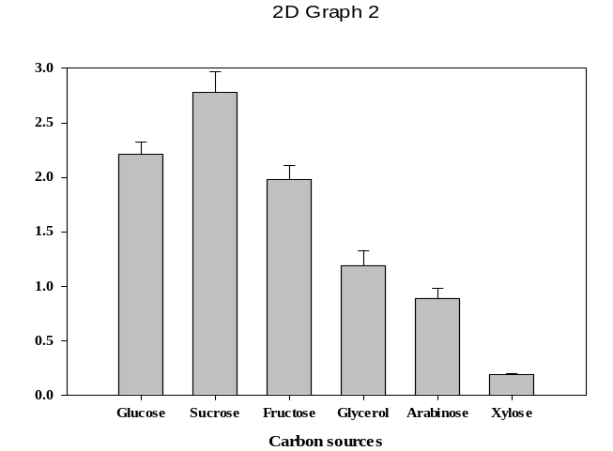
a
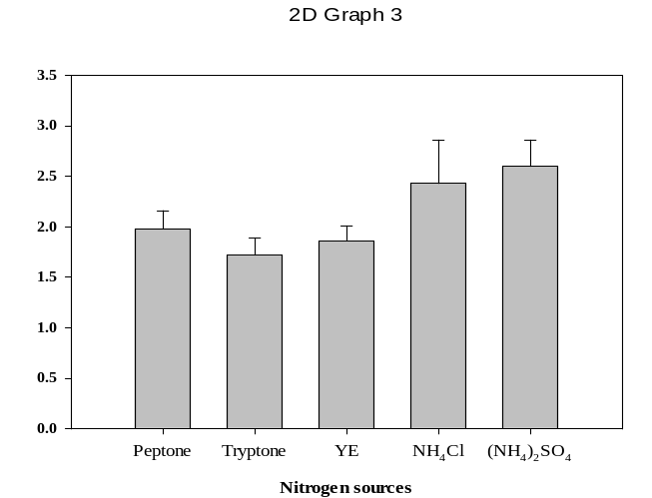
b
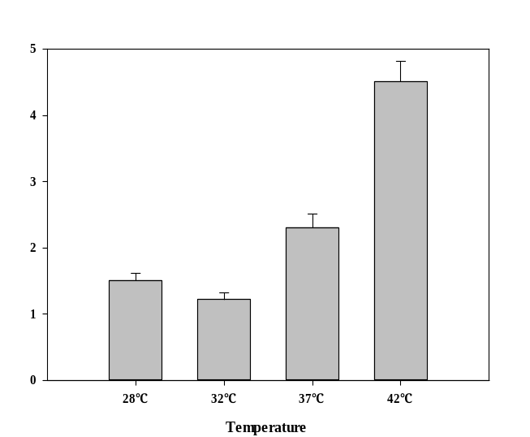
c
Fig. S2 The γ-PGA titer normalized to the biomass of the individual cultures. (a) Effect of carbon sources; (b) Effect of nitrogen sources; (c) Effect of temperature. Values represent the mean ± SD, n=3.
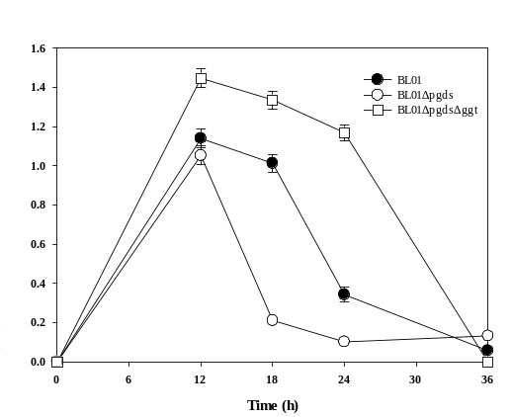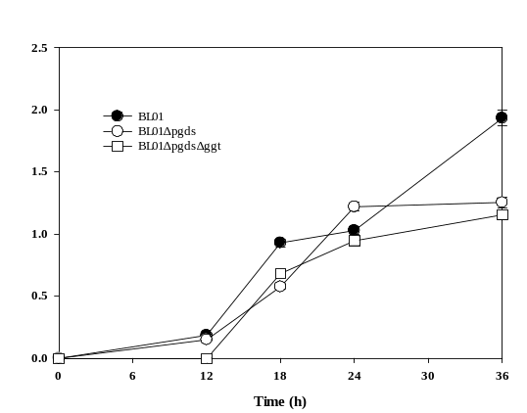
b
a
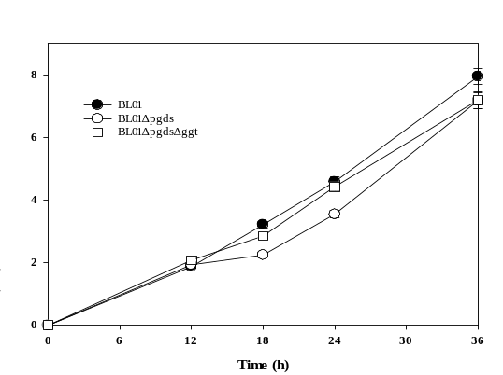
c
Fig. S3 Effect of disruption of pgdS and ggt genes in the B. tequilensis BL01 strain. (a) Change curves of lactic acid with fermentation time, (b) Change curves of acetic acid with fermentation time, (c) Growth curves of 2,3-BD with fermentation time. Values represent the mean ± SD, n=3.

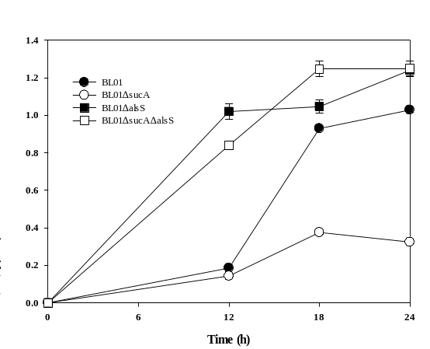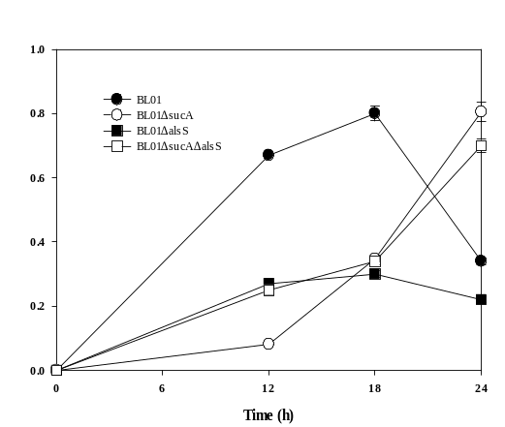
b
a
Fig. S4 Effect of disruption of sucA and alsS genes in the B. tequilensis BL01 strain. (a) Change curves of acetic acid with fermentation time, (b) Change curves of lactic acid with fermentation time. Values represent the mean ± SD, n=3.

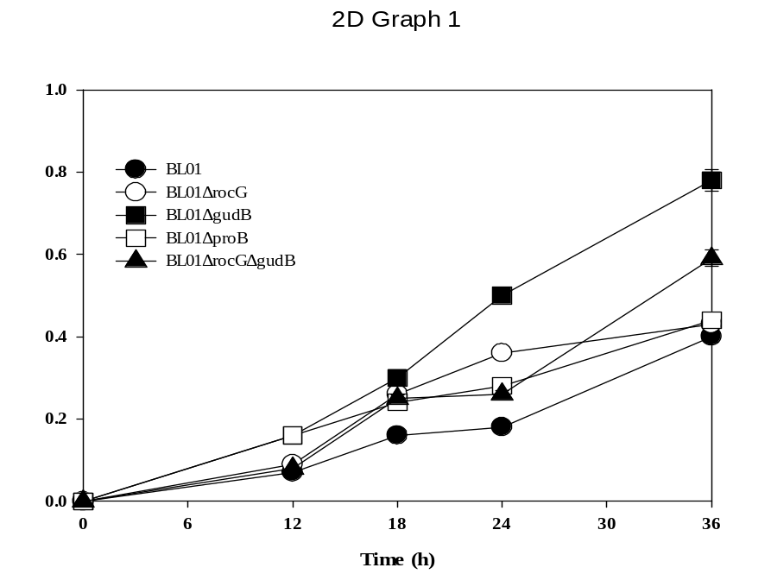
Fig. S5 The glutamic acid curve of B. tequilensis BL01 and mutant strains. Values represent the mean ± SD, n=3.

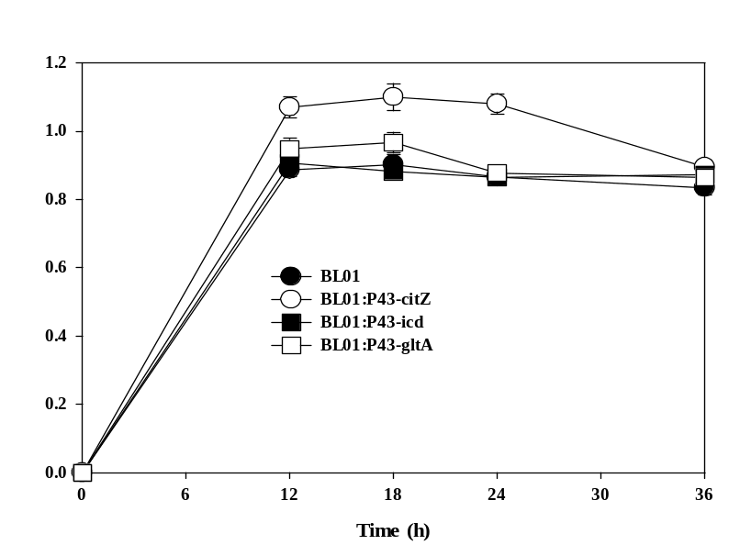
Fig. S6 The growth curve of B. tequilensis BL01 and engineered strains in the medium without citric acid. Values represent the mean ± SD, n=3.

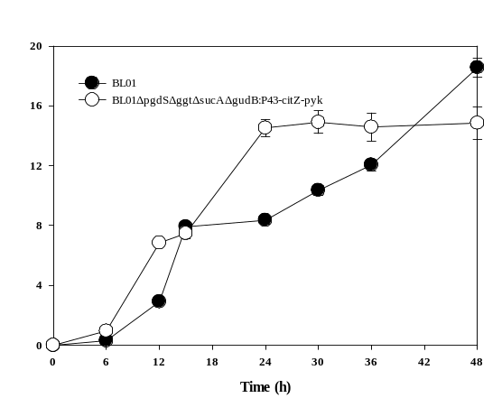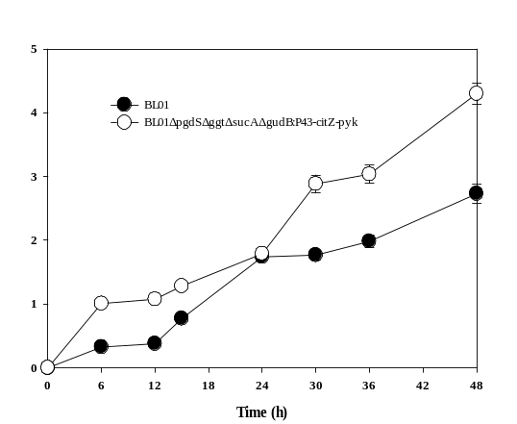
b
a
Fig. S7 Time curves of fed-batch fermentation of γ-PGA in a 5 L fermenter by BL01 and BL01ΔpgdSΔggtΔsucAΔgudB:P43-citZ-pyk strain, (a) 2,3-BD growth curves, (b) acetic acid growth curves. Data are given as the mean ± SD, n=3. Aeration rate: 10 mL/min; agitation rate: 400 rpm (0–6 h), 500 rpm (6–12 h), 600 rpm (12–24 h), 700 rpm (24–48 h); the pH was controlled at pH 6.5±0.2. 20g of sodium citrate dissolved in 50 mL sterile water was fed into the fermenter at 24h, and 150 mL of feed medium containing 700 g/L of sucrose was fed at 30 and 36 h, individually.

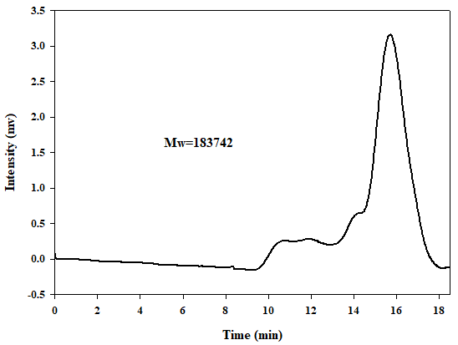
a
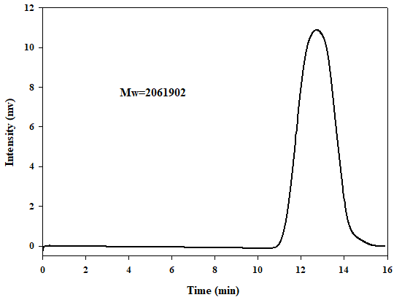
b
Fig. S8 The molecular weight of γ-PGA produced by (a) B. tequilensis BL01 and (b) B. tequilensis BL01ΔpgdSΔggtΔsucAΔgudB:P43-citZ-pyk strain.

Table S1 Strains and plasmids used in this study
Strain/plasmid | Genotype/description | Reference
strains
E. coli DH5α |  | Laboratory stock
B. tequilensis BL01 | Isolated from soybean | This study
B. tequilensis BL01ΔpgdS | B. tequilensis BL01 derivate, deletion of pgdS | This study
B. tequilensis BL01Δggt | B. tequilensis BL01 derivate, deletion of ggt | This study
B. tequilensis BL01ΔpgdS Δggt | B. tequilensis BL01 derivate, deletion of pgdS and ggt | This study
B. tequilensis BL01ΔalsS | B. tequilensis BL01 derivate, deletion of alsS | This study
B. tequilensis BL01ΔsucA | B. tequilensis BL01 derivate, deletion of sucA | This study
B. tequilensis BL01ΔgudB | B. tequilensis BL01 derivate, deletion of gudB | This study
B. tequilensis BL01ΔrocG | B. tequilensis BL01 derivate, deletion of rocG | This study
B. tequilensis BL01ΔproB | B. tequilensis BL01 derivate, deletion of proB | This study
B. tequilensis BL01ΔgudB ΔrocG | B. tequilensis BL01 derivate, deletion of gudB and rocG | This study
B. tequilensis BL01ΔpgdS ΔsucA | B. tequilensis BL01 derivate, deletion of pgdS and sucA | This study
B. tequilensis BL01ΔpgdS ΔggtΔgudB | B. tequilensis BL01 derivate, deletion of pgdS, ggt, and gudB | This study
B. tequilensis BL01ΔpgdS ΔggtΔsucA | B. tequilensis BL01 derivate, deletion of pgdS, ggt, and sucA | This study
B. tequilensis BL01ΔpgdS ΔggtΔsucAΔgudB | B. tequilensis BL01 derivate, deletion of pgdS, ggt, sucA and gudB | This study
B. tequilensis BL01:P43-citZ | B. tequilensis BL01 derivate, carrying P43-citZ | This study
B. tequilensis BL01:P43-icd | B. tequilensis BL01 derivate, carrying P43-icd | This study
B. tequilensis BL01:P43-gltA | B. tequilensis BL01 derivate, carrying P43-gltA | This study
B. tequilensis BL01:P43-pdhABCD | B. tequilensis BL01 derivate, carrying P43-pdhABCD | This study
B. tequilensis BL01:P43-pycA | B. tequilensis BL01 derivate, carrying P43-pycA | This study
B. tequilensis BL01:P43-pyk | B. tequilensis BL01 derivate, carrying P43-pyk | This study
B. tequilensis BL01:P43-pgsBCAE | B. tequilensis BL01 derivate, carrying P43-pgsBCAE | This study
B. tequilensis BL01:P43-citZ-icd-gltA | B. tequilensis BL01 derivate, carrying P43-citZ-icd-gltA | This study
B. tequilensis BL01:P43-citZ-pyk | B. tequilensis BL01 derivate, carrying P43-citZ-pyk | This study
B. tequilensis BL01ΔpgdS ΔggtΔsucAΔgudB:P43-pdhABCD | B. tequilensis BL01ΔpgdSΔggtΔsucAΔgudB derivate, carrying P43-pdhABCD | This study
B. tequilensis BL01ΔpgdS ΔggtΔsucAΔgudB:P43-pgsBCAE | B. tequilensis BL01ΔpgdSΔggtΔsucAΔgudB derivate, carrying P43-pgsBCAE | This study
B. tequilensis BL01ΔpgdS ΔggtΔsucAΔgudB:P43-citZ-pyk | B. tequilensis BL01ΔpgdSΔggtΔsucAΔgudB derivate, carrying P43-citZ-pyk | This study
Plasmids
pBAC-cas9 | E. coli-B. subtilis shuttle vector, Amp^{r} (E. coli), Cm^{r} (B. subtilis), containing fusion proteins of Cas9 | [53]
pBAC-cas9-N20-pgdS-up-down | pBAC-cas9 derivate, containing pgdS targeting 20 bp gRNA and 2 kb donor DNA | This study
pBAC-cas9-N20-ggt-up-down | pBAC-cas9 derivate, containing ggt targeting 20 bp gRNA and 2 kb donor DNA | This study
pBAC-cas9-N20-alsS-up-down | pBAC-cas9 derivate, containing alsS targeting 20 bp gRNA and 2 kb donor DNA | This study
pBAC-cas9-N20-sucA-up-down | pBAC-cas9 derivate, containing sucA targeting 20 bp gRNA and 2 kb donor DNA | This study
pBAC-cas9-N20-gudB-up-down | pBAC-cas9 derivate, containing gudB targeting 20 bp gRNA and 2 kb donor DNA | This study
pBAC-cas9-N20-rocG-up-down | pBAC-cas9 derivate, containing rocG targeting 20 bp gRNA and 2 kb donor DNA | This study
pBAC-cas9-N20-proB-up-down | pBAC-cas9 derivate, containing proB targeting 20 bp gRNA and 2 kb donor DNA | This study
pP43NMK | Amp^{r}, Km^{r}, E. coli-B. subtilis shuttle vector, P43-MCS | [54]
P43-gltA | pP43NMK derivate, containing the gene gltA | This study
P43-icd | pP43NMK derivate, containing the gene icd | This study
P43-citZ | pP43NMK derivate, containing the gene citZ | This study
P43-pdhABCD | pP43NMK derivate, containing the gene pdhABCD | This study
P43-pycA | pP43NMK derivate, containing the gene pycA | This study
P43-pyk | pP43NMK derivate, containing the gene pyk | This study
P43-pgsBCAE | pP43NMK derivate, containing the gene pgsBCAE | This study
P43-citZ-pyk | pP43NMK derivate, containing the gene citZ and pyk | This study
P43-citZ-icd-gltA | pP43NMK derivate, containing the gene citZ, icd and gltA | This study

Table S2 Primers used in this study
Primer | Sequence (5’-3’)
pgdS-N20-F | ATGTAAAGAGGGTTTCGATCCATC
pgdS-N20-R | AAACGATGGATCGAAACCCTCTTT
pgdS-up-F | AATCTGGCCTTATTGGCCAAAGATACGCTTGGAGAATTTGC
pgdS-up-R | CTTTATGTTCTTTTATTATCTCCTCCTCTTTTTGC
pgdS-down-F | GATAATAAAAGAACATAAAGCCTGGTGATGTTG
pgdS-down-R | GAGATGGCCAACGAGGCCCCTCATATCGAATCGGTTTTTGAC
ggt-N20-F | ATGTACTaCTCCTCCTCCAAGCTC
ggt-N20-R | AAACGAGCTTGGAGGAGGAGtAGT
ggt-up-F | AATCTGGCCTTATTGGCCGAAATCTGACGCTCCCAATTTTC
ggt-up-R | CTGTAAAGTGTAATTAATTGCTTCATCGAACGGG
ggt-down-F | CAATTAATTACACTTTACAGTTGCTGATCGATG
ggt-down-R | GAGATGGCCAACGAGGCCTCGTGACAGGGTCAAAAGATTAC
alsS-N20-F | ATGTGTTTCTGTCTCTGGTGACGG
alsS-N20-R | AAACCCGTCACCAGAGACAGAAAC
alsS-up-F | AATCTGGCCTTATTGGCCATCGTTTAAAACGGACACATCAAT
alsS-up-R | AACAGAACGGTTTCTCCCGATTTCACCAATGAAG
alsS-down-F | TCGGGAGAAACCGTTCTGTTCATTTACGTTCTTT
alsS-down-R | GAGATGGCCAACGAGGCCCCTGAAATGGTTTCAATAGCTCAC
sucA-N20-F | ATGTGCTCTTTGAAGTCATGCACA
sucA-N20-R | AAACTGTGCATGACTTCAAAGAGC
sucA-up-F | AATCTGGCCTTATTGGCCTCACTGTCATGAAGCACAAGGTTT
sucA-up-R | CTGATTCAAATTCAAGACGCTGAAACAAAATCAGC
sucA-down-F | GCGTCTTGAATTTGAATCAGATCGGCTGTAACAC
sucA-down-R | GAGATGGCCAACGAGGCCTTCGACAAAATGGACGAAACAAAAC
gudB-N20-F | ATGTAAACGTATCCCGCCTTTCGT
gudB-N20-R | AAACACGAAAGGCGGGATACGTTT
gudB-up-F | AATCTGGCCTTATTGGCCGCGGCATATCTGATCAGCAACG
gudB-up-R | TGCCAAATAGTTGAGTTAACCTCCTAGAATCTTCTG
gudB-down-F | GTTAACTCAACTATTTGGCAAAATTTATGCATGAT
gudB-down-R | GAGATGGCCAACGAGGCCGCGTTTTCGTCACTTTATGCAC
proB-N20-F | ATGTACCTCGGGTGCCGTAGCGGC
proB-N20-R | AAACGCCGCTACGGCACCCGAGGT
proB-up-F | AATCTGGCCTTATTGGCCCCTCTGTAGCGGATAAATTCGAC
proB-up-R | TTTTTGCTCTTTATTCTCCTCCGCGGCTCTTCTA
proB-down-F | AGGAGAATAAAGAGCAAAAACTTGCGGACATT
proB-down-R | GAGATGGCCAACGAGGCCACGTCTAAACCATCATTTAACGTAA
rocG-N20-F | ATGTAAGCATCGCGTTTCCGCGGA
rocG-N20-R | AAACTCCGCGGAAACGCGATGCTT
rocG-up-F | AATCTGGCCTTATTGGCCAGCGGTAGAATTTCAATTTCCTG
rocG-up-R | GCTTCTCAAAAATAAAGCCCGGAGAATCGAATTC
rocG-down-F | GGGCTTTATTTTTGAGAAGCCTCCGCAAAATC
rocG-down-R | GAGATGGCCAACGAGGCCACCTGTAAATGAGACAAACCGTG
citZ(P43)-F | GAATGTACACATGACAGCGACACGCGGTCT
citZ(P43)-R | GCTTTCATCATTAGGCTCTTTCTTCAATCGGAACG
P43(citZ)-back-F | AAGAGCCTAATGATGAAAGCTTGGCGTAATCAT
P43(citZ)-back-R | TCGCTGTCATGTGTACATTCCTCTCTTACCTATAATG
icd(P43)-F | CGGGATCCATGGCACAAGGTGAAAAAATTACAG
icd(P43)-R | TCCCCGCGGTTAGTCCATGTTTTTGATCAGTTCTTC
P43(icd)-F | GGTCTCACCGCGGTGAAAGCTTGGCGTAATCATG
P43(icd)-R | GGTCTCGGATCCGATTTCCTCCTCTATAATGGTACCGCTATCAC
gltA(P43)-F | GAATGTACACATGACGTACAATCAAATGCCAAAAG
gltA(P43)-R | GCTTTCATCATTACTGTACTACCGCTTGTTTTTGT
P43(gltA)-back-F | AGTACAGTAATGATGAAAGCTTGGCGTAATCAT
P43(gltA)-back-R | TGTACGTCATGTGTACATTCCTCTCTTACCTATAATG
pgsBCAE(P43)-F | GAATGTACACATGTGGTTACTCATTATAGCCTGT
pgsBCAE(P43)-R | CAAGCTTTCATTATTTATTGGCGCTTACCGGTTC
P43(pgsBCAE)-F | CAATAAATAATGAAAGCTTGGCGTAATCATGGTC
P43(pgsBCAE)-R | GTAACCACATGTGTACATTCCTCTCTTACCTATAATG
pdhABCD(P43)-F | GAATGTACACATGGCTGCAAAAACGAAAAAAG
pdhABCD(P43)-R | GCTTTCATCATTATTTTACGATGTGAATCGGACTTC
P43(pdhABCD)-F | CGTAAAATAATGATGAAAGCTTGGCGTAATCAT
P43(pdhABCD)-R | TTGCAGCCATGTGTACATTCCTCTCTTACCTATAATG
pycA(P43)-F | GAATGTACACTTGTCTCAGCAATCGATACAAAAAG
pycA(P43)-R | GCTTTCATCATTATGCTTTTTCAATTTCGAGAAGC
P43(pycA)-back-F | AAAAGCATAATGATGAAAGCTTGGCGTAATCAT
P43(pycA)-back-R | GCTGAGACAAGTGTACATTCCTCTCTTACCTATAATG
pyk(P43)-F | GAATGTACACATGAGAAAAACTAAAATTGTTTGTACCATC
pyk(P43)-R | GCTTTCATCATTAAAGAACGCTCGCACGGC
P43(pyk)-back-F | CGTTCTTTAATGATGAAAGCTTGGCGTAATCAT
P43(pyk)-back-R | TTTTTCTCATGTGTACATTCCTCTCTTACCTATAATG
citZ(P43-pyk)-F | GCCGTGCGAGCGTTCTTTAAGTAAGAGAGGAATGTACACATGACAGCGACACGCGGTCT
pyk(P43-citZ)-R | TTAAAGAACGCTCGCACGGC
icd-F | GTAAGAGAGGAATACTAGTATGGCACAAGGTGAAAAAATTACAG
CitZ-R | TACTAGTATTCCTCTCTTACTTAGGCTCTTTCTTCAATCGGAAC
gltA-F | TCAAAAACATGGACTAAGTAAGAGAGGAATGTACACATGACGTACAATCAAATGCCAA
icd-R | TACTTAGTCCATGTTTTTGATCAGTTCTTC
gltA-R | ATCATCTAGATTACTGTACTACCGCTTGTTTTTGT
P43(citZ-icd-gltA) -F | AGTACAGTAATCTAGATGATGAAAGCTTGGCGTAATC

Table S3 γ-PGA production by the isolated strains
Strains | 24 h |  | γ-PGA/Biomass  (g/g) | species
Strains | Biomass (g/L) | γ-PGA (g/L) | γ-PGA/Biomass  (g/g) | species
BL01 | 4.5 ± 0.2 | 8.6 ± 0.3 | 1.91 ± 0.16 | B. tequilensis
F29 | 4.7 ± 0.3 | 8.3± 0.3 | 1.76 ± 0.19 | B. halotolerans
L29 | 5.1 ± 0.3 | 7.9 ± 0.3 | 1.55 ± 0.16 | B. zanthoxyli
L45 | 4.8 ± 0.2 | 7.4 ± 0.3 | 1.54 ± 0.13 | B. licheniformis
W1 | 6.1 ± 0.3 | 5.1 ± 0.2 | 0.84 ± 0.07 | B. subtilis
Note: The biomass, γ-PGA titer and γ-PGA titer/Biomass were measured at 24 h. Values represent the mean ± SD, n=3.

