Additional file 4

Bidirectional hybrid erythritol-inducible promoter for synthetic biology in Yarrowia lipolytica

Lea Vidal¹*, Esteban Lebrun^{1,2}*, Young-Kyoung Park¹, Guillaume Mottet² and Jean-Marc Nicaud^{1ǂ}

Author affiliations
¹Université Paris-Saclay, INRAE, AgroParisTech, Micalis Institute, 78350 Jouy-en-Josas, France
²Large Molecules Research, Sanofi, 94400 Vitry-Sur-Seine, France
*These authors contributed equally to this work.

ǂCorresponding author
Université Paris-Saclay, INRAE, AgroParisTech, Micalis Institute, UMR1319, Team BIMLip: Integrative Biology of Microbial Lipid Metabolism, domaine de Vilvert, 78350 Jouy-en-Josas, France
Tel: +33 1 74 07 18 20
Email: jean-marc.nicaud@inrae.fr

Keywords: Bidirectional promoter, Inducible, Erythritol, Hybrid promoter, co-expression, Yarrowia lipolytica, Synthetic biology

Additional Table S1
Additional Table S1 List of primers used in this study
The bases corresponding to the BsaI recognition site are underlined; the overhang bases generated after digestion are in bold; nnn corresponds to the overlap of at least 20 nucleotides with the sequence to be amplified. F: forward primer; R: reverse primer.
Primer | Sequence (5’-3’) | Utilization
forwardpEYK450-F | GGTCTCTAAGTTTTGTGCAAGTGTGTGTGTGTGTGTGTG | Amplification for biobrick construction
forwardpEYK450-R | GGTCTCTTAGAAGTAGATGTGTAAGTGTGTAGAAGTGTCG | Amplification for biobrick construction
reversepEYK450-F | GGTCTCTAAGTAGTAGATGTGTAAGTGTGTAGAAGTGTCGTG | Amplification for biobrick construction
reversepEYK450-R | GGTCTCTTAGATTTGTGCAAGTGTGTGTGTGTGTGTGTG | Amplification for biobrick construction
reverseRedStarII-F | GGTCTCTACGGTGTCTTAGAGGAACGCATATACAGTAATCATAG | Amplification for biobrick construction
reverseRedStarII-R | GGTCTCTACTTATGAGTGCTTCTTCTGAAGATGTCATCACTG | Amplification for biobrick construction
YFP-F | GGTCTCTTCTAATGGTGAGCAAGGGCGAGGAGCTGTTC | Amplification for biobrick construction
YFP-R | GGTCTCTACTCTGTCTTAGAGGAACGCATATACAGTAATC | Amplification for biobrick construction
G1-GGA-with-BDP-F | GGTCTCTCTGTnnn | Amplification for biobrick construction
G1-GGA-with-BDP-R | GGTCTCTACTTnnn | Amplification for biobrick construction
G2-GGA-with-BDP-F | GGTCTCTTCTAnnn | Amplification for biobrick construction
G2-GGA-with-BDP-R | GGTCTCTATCCnnn | Amplification for biobrick construction
P1-forwardpEYK450-F | GGTCTCTACGGTTTGTGCAAGTGTGTGTGTGTGTGTG | Amplification for biobrick construction
P1-forwardpEYK450-R | GGTCTCTCATTAGTAGATGTGTAAGTGTGTAGAAGTGTCG | Amplification for biobrick construction
P1-reversepEYK450-F | GGTCTCTACGGAGTAGATGTGTAAGTGTGTAGAAGTGTCG | Amplification for biobrick construction
P1-reversepEYK450-R | GGTCTCTCATTTTTGTGCAAGTGTGTGTGTGTGTGTG | Amplification for biobrick construction
pEYK450-internal-F | GTGTGAGTGTGTAGTTGTGTGATGAGATCTTGGTGCCACCCCAAGGTATATATATATAAC | Removal of internal BsaI site
pEYK450-internal-R | GTTATATATATATACCTTGGGGTGGCACCAAGATCTCATCACACAACTACACACTCACAC | Removal of internal BsaI site
pEYK-boxA-F | GCATCTACTTTTCTCTATACTGTACGTTTCAATCTGGG | Fusion PCR
pEYK-boxA-R | CCCAGATTGAAACGTACAGTATAGAGAAAAGTAGATGC | Fusion PCR
ZetaUP-internal-F | TATCTTCTGACGCATTGACCAC | Verification of Golden Gate assembly
URA3-internal-F | CATCCAGAGAAGCACACAGG | Verification of Golden Gate assembly
RedStarII-internal-F | AAGACGGTGGCGTTGTTACT | Verification of Golden Gate assembly
RedStarII-internal-R | GACTTGCTTCTTGGCCTTGT | Verification of Golden Gate assembly
YFP-internal-F | ACGTAAACGGCCACAAGTTC | Verification of Golden Gate assembly
YFP-internal-R | AAGTCGTGCTGCTTCATGTG | Verification of Golden Gate assembly
ZetaDOWN-internal-R | GGTAACGCCGATTCTCTCTG | Verification of Golden Gate assembly

Additional Figure S1
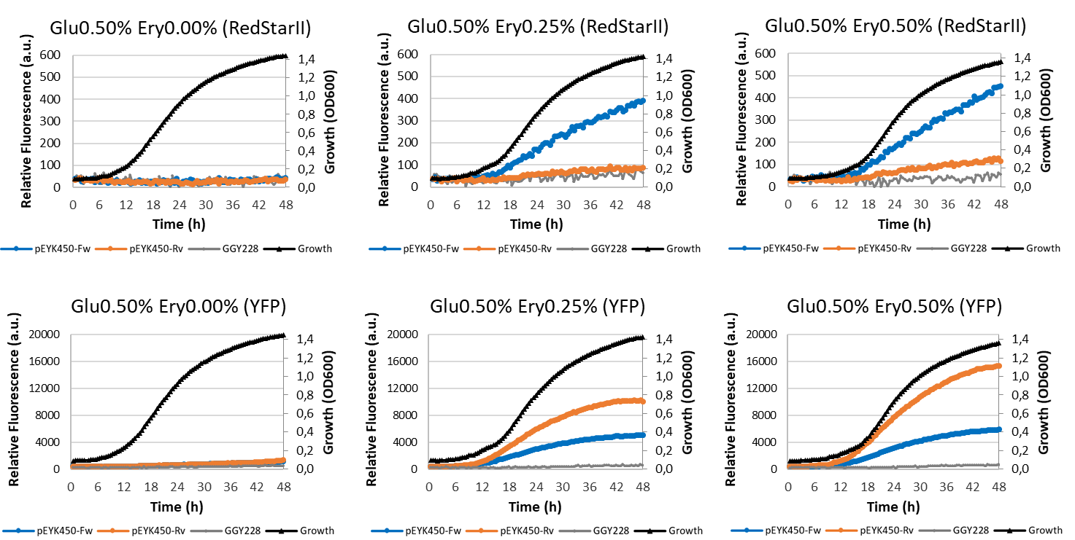

Additional Fig. S1 Patterns of erythritol-induced fluorescence. Mean RedStarII (above) and YFP (below) fluorescence over time depending on the inducer level. The blue (pEYK450-Fw) and orange (pEYK450-Rv) curves represent the mean fluorescence measured for 8 transformants. The gray curves represent the mean fluorescence of the control strain (GGY228), which does not contain a fluorescent reporter gene. The gain was 100 for both RedStarII and YFP. Yeast were grown in minimum media containing 5 g/L of glucose (Glu0.50%) as the carbon source and 0.0, 2.5 and 5.0 g/L of erythritol (Ery0.00%, Ery0.25% and Ery0.50%, respectively) as the inducer. The growth curves are shown in black.

Additional Figure S2
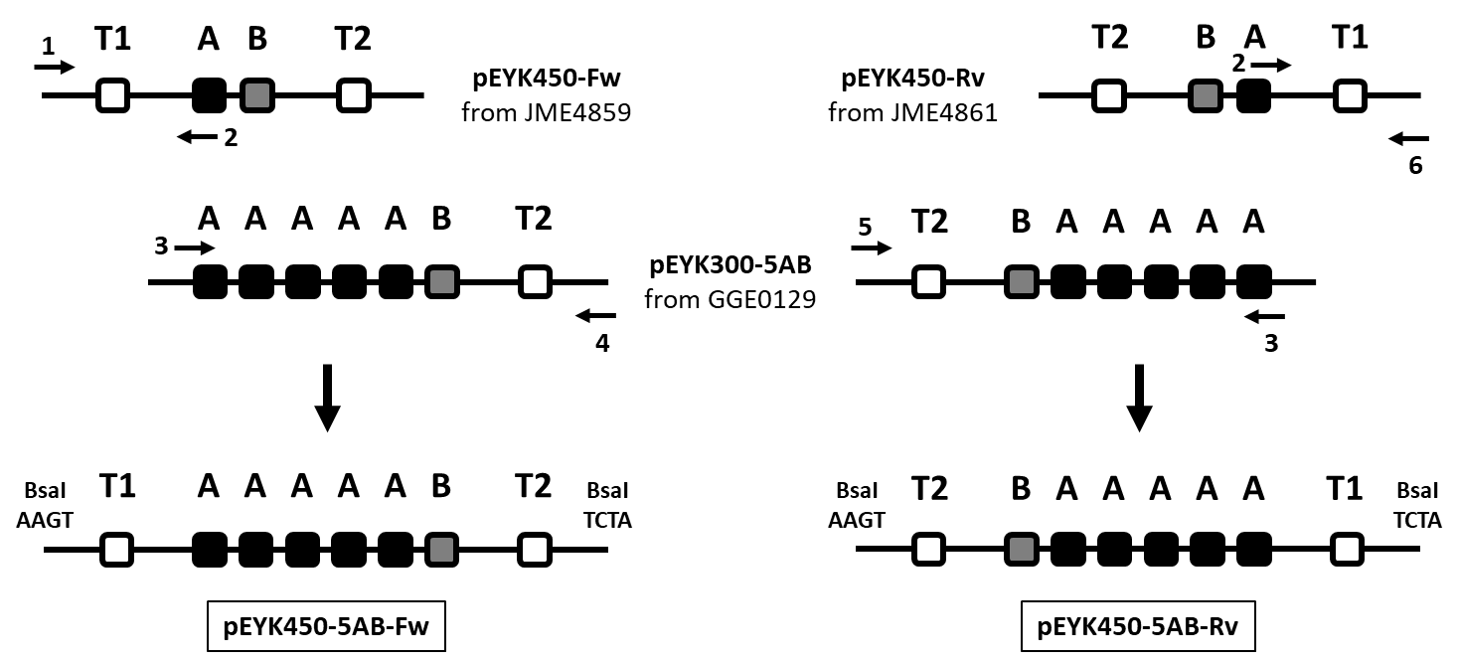
Additional Fig. S2 Construction of the hybrid promoters pEYK450-5AB-Fw and pEYK450-5AB-Rv. The upstream T1 A block and the downstream 5A-B-T2 block were amplified and fused to generate the T1-5AB-T2 fragment, which carried the BsaI sites with their AAGT and TCTA compatible overhangs. In this way, we created two versions of the hybrid promoter pEYK450-5AB: one with forward-oriented transcription (Fw) and one with reverse-oriented transcription (Rv). The following primers were used—1: forwardpEYK450-F, 2: pEYK-boxA-R, 3: pEYK-boxA-F, 4: forwardpEYK450-R, 5: reversepEYK450-F, and 6: reversepEYK450-R (Additional Table S1). The template plasmids employed during PCR are indicated in Table 1.

Additional Figure S3
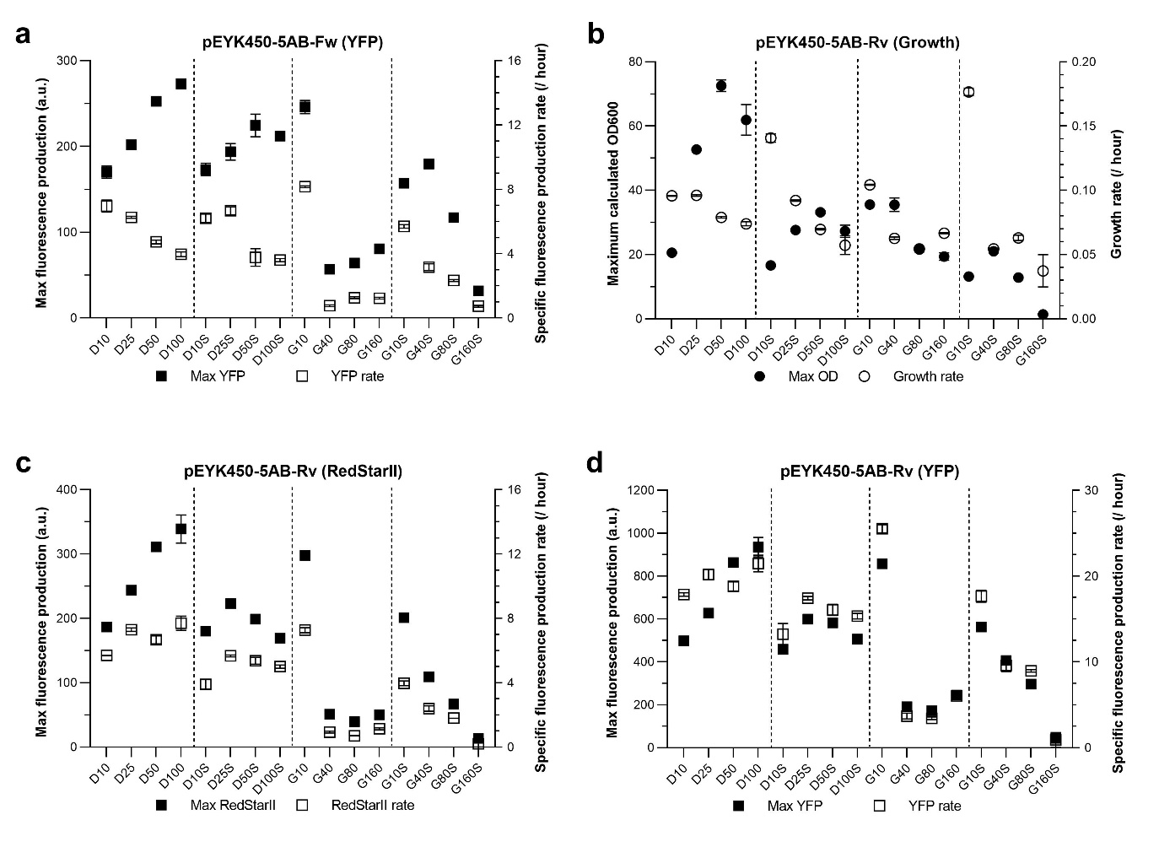
Additional Fig. S3 Patterns of fluorescence for strains grown under microbioreactor conditions. Strains JMY8833 (pEYK450-5AB-Fw) and JMY8834 (pEYK450-5AB-Rv) were cultivated for 72 h in YNB medium supplemented with 5 g/L of erythritol and with 10, 25, 50, or 100 g/L of glucose (treatments D10, D25, D50, and D100, respectively) or 10, 40, 80 or 160 g/L of glycerol (treatments G10, G40, G80, and G160, respectively). High osmotic pressure was generated by adding 250 g/L of sorbitol to the media (treatments D10S, D25S, D50S, D100S, G10S, G40S, G80S, and G160S). a Maximum fluorescence (black squares) and specific fluorescence production rate (white squares) for YFP displayed by JMY8833 (pEYK450-5AB-Fw) across all treatments. b Maximum cell density (black circles) and mean growth rate (white circles) for JMY8834 (pEYK450-5AB-Rv) across all treatments. c Maximum fluorescence (black squares) and specific fluorescence production rate (white squares) for RedStarII displayed by JMY8834 (pEYK450-5AB-Rv) across all treatments. d Maximum fluorescence (black squares) and specific fluorescence production rate (white squares) for YFP displayed by JMY8834 (pEYK450-5AB-Rv) across all treatments. Values were standardized based on cell density and growth rate. The standard error of the mean (SEM) is indicated. For each condition, cultures were performed in triplicate.

Additional Figure S4
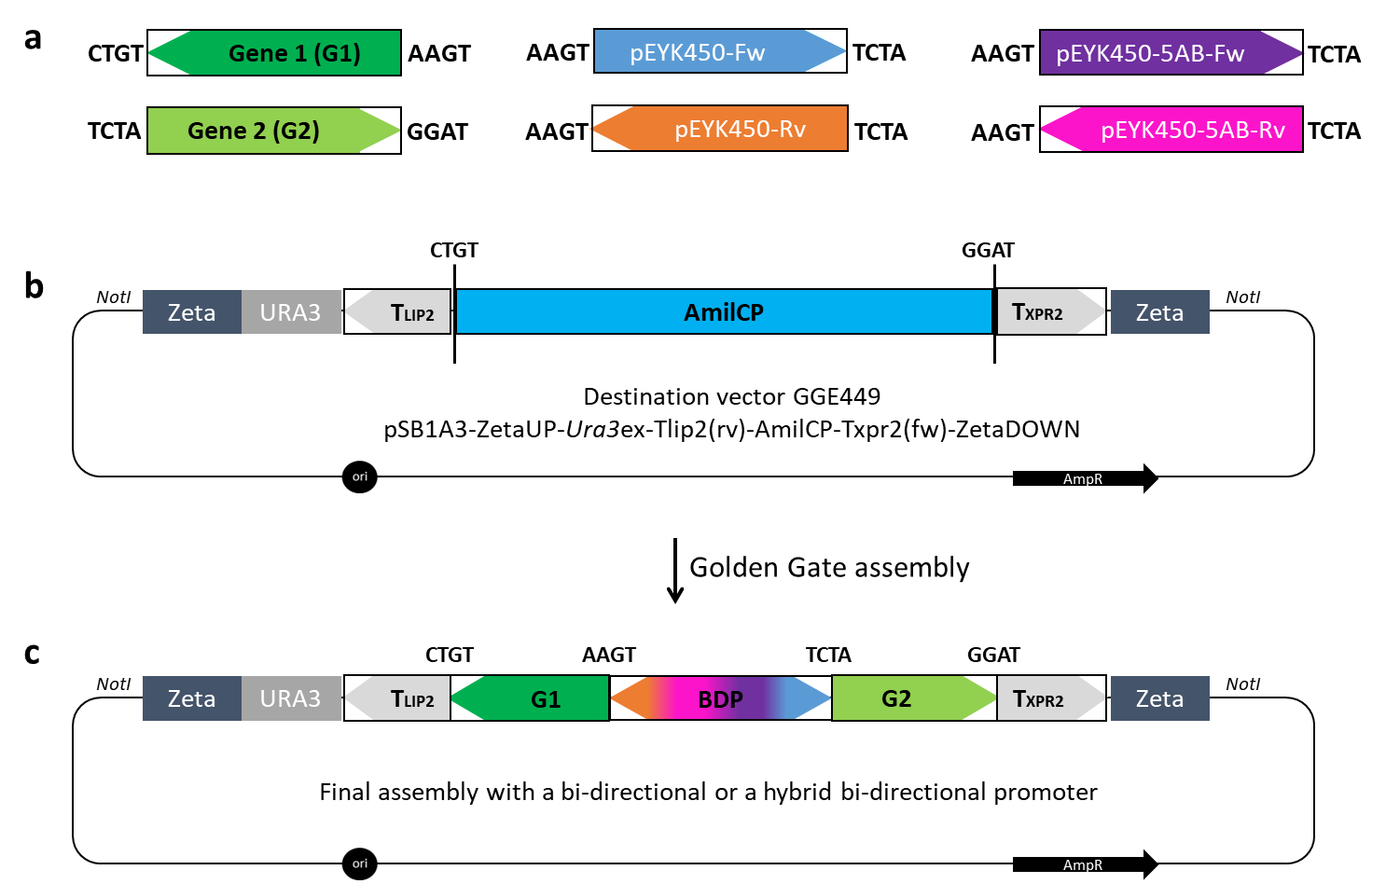
Additional Fig. S4 Schematic representation of the Golden Gate assembly strategy proposed for exploiting BDP and HBDP. a The four available BDP-bearing biobricks and the two biobricks to be constructed that will carry a gene of interest. The letters to either side of the biobricks represent the four-nucleotide overhangs generated by the BsaI restriction sites. To be compatible with this GGA strategy, the first gene (G1) should be oriented in reverse transcription orientation (3’-5’) and designed with the upstream overhang CTGT and the downstream overhang AAGT; the second gene (G2) should be oriented in forward transcription orientation (5’-3’) and designed with the upstream overhang TCTA and the downstream overhang GGAT. b The destination vector GGE449 designed to be used with a BDP or an HBDP. It contains the specific integration sites ZetaUP and ZetaDOWN, the URA3 marker, the T_{LIP2} and T_{XPR2} terminators, and the gene coding for the blue chromophore AmilCP. c Schematic representation of the final vector obtained after GGA. The biobrick containing AmilCP, surrounded by the GGA digestion/ligation sites, has been replaced by the constructed cassette, which contains two genes of interest that are co-expressed by one of the BDP or HBDP. The expression cassette can be released by NotI digestion to promote yeast transformation.

Additional Figure S5
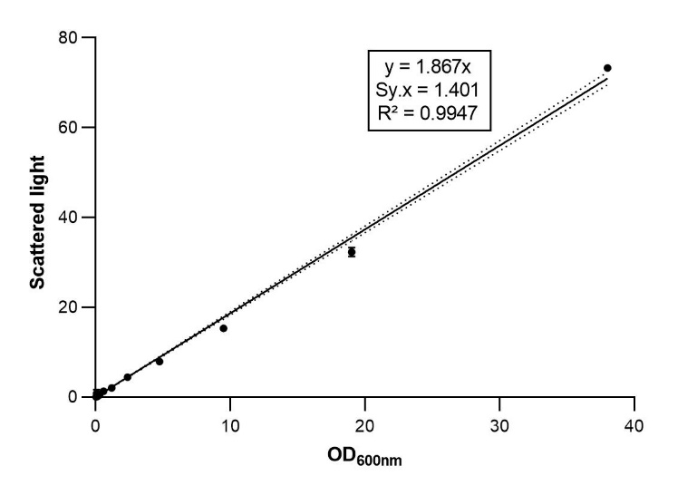
Additional Fig. S5 Calibration curve for estimating Y. lipolytica biomass from scattered light and OD_{600nm} values. Using serial dilutions of an overnight culture (200 µL per plate well), we measured OD_{600nm} using an Ultrospec 10 Cell Density Meter and scattered light using a BioLector I microbioreactor. The SEM is indicated.

