Supporting information
Improving the production of the micafungin precursor FR901379 in an industrial production strain
Ping Men^{1,2,3,4}, Yu Zhou^{1,2,3,5}, Li Xie^{1,2,3,6}, Xuan Zhang^{1,2,3}, Wei Zhang^{1,2,3,4}, Xuenian Huang^{12,3}*, Xuefeng Lu^{1,2,3,4,7}*
¹ Shandong Provincial Key Laboratory of Synthetic Biology, Qingdao Institute of Bioenergy and Bioprocess Technology, Chinese Academy of Sciences, Qingdao 266101, China.
² Shandong Energy Institute, Qingdao 266101, China.
³ Qingdao New Energy Shandong Laboratory, Qingdao 266101, China.
⁴ University of Chinese Academy of Sciences, Beijing 100049, China.
⁵ Institute for Smart Materials & Engineering, University of Jinan, Jinan 250022, China.
⁶ State Key Laboratory of Food Science and Technology, Nanchang University, Nanchang 330096, China.
⁷ Marine biology and Biotechnology Laboratory, Qingdao National Laboratory for Marine Science and Technology, Qingdao 266237, China.
* Correspondence to: huangxn@qibebt.ac.cn, lvxf@qibebt.ac.cn

Table S1 Plasmids used in this study
Table S2 Primers used in this study
Table S3 The expression profiles of C. empetri MEFC09 and mutant strains
Fig. S1 Plasmid maps and cassettes of mcfF (A, G), mcfH (B, G), mcfP (C), mcfS (D), and mcfJ (E), and CEfks2 (F).
Fig. S2 Titers of FR901379 were quantified in the mutant strains MEFC09-P and MEFC09-S
Fig. S3 Functional identification of gene mcfJ.
Fig. S4 The concentration of D-sorbitol of batch fermentation (A) and fed-batch fermentation (B) in a 5 L bioreactor.

Table S1 Plasmids used in this study
Plasmids | Characteristics | Reference
pXH2-1 | Amp^{r}, harboring cassettes of hph, PgpdAt, and TtrpC | [1]
pPM-4 | Amp^{r}, harboring cassette of neo | [2]
PU-ZX | Amp^{r}, harboring fragments of PgpdAt and Tpgk | Our lab
pPM-mcfF | Amp^{r}, harboring cassette of mcfF | This study
pPM-mcfH | Amp^{r}, harboring cassette of mcfH | This study
pPM-mcfP | Amp^{r}, harboring cassette of mcfP | This study
pPM-mcfS | Amp^{r}, harboring cassette of mcfS | This study
PU-mcfJ | Amp^{r}, harboring cassette of mcfJ | This study
1. Huang X, Lu X, Li JJ: Cloning, characterization and application of a glyceraldehyde-3-phosphate dehydrogenase promoter from Aspergillus terreus. J Ind Microbiol Biotechnol 2014, 41:585-592.
2. Men P, Wang M, Li J, Geng C, Huang X, Lu X: Establishing an efficient genetic manipulation system for sulfated echinocandin producing fungus Coleophoma empetri. Front Microbiol 2021, 12:734780.

Table S2 Primers used in this study
Primers | Sequence (5'-3') | Notes
mcfF-FP | caactcatcaatcatcacaacatgctttcagacacgacggc | Amplifying the cassette of mcfF
mcfF-RP | gatttcagtaacgttaagtggctattccgtccgccttctta | Amplifying the cassette of mcfF
mcfH-FP | caactcatcaatcatcacaacatggttccatcaatgatctc | Amplifying the cassette of mcfH
mcfH-RP | gatttcagtaacgttaagtggtcacagggctactttcgatc | Amplifying the cassette of mcfH
mcfP-F | atttcagtaacgttaagtggatgataaatcttgcaagtc | Amplifying the cassette of mcfP
mcfP-R | gatttcagtaacgttaagtggctaccgatgaccttcaaggac | Amplifying the cassette of mcfP
mcfS-F | aactcatcaatcatcacaacatggctttagaccgccagaatgc | Amplifying the cassette of mcfS
mcfS-R | atttcagtaacgttaagtggctacttcctagctagccaaac | Amplifying the cassette of mcfS
UCEfks1-F | accaaagctgcacctctcat | Amplifying the upstream of CEfks1
UCEfks1-R | ctttacgcttgcgatcccgaaacgagatctgagaagatggc | Amplifying the upstream of CEfks1
DCEfks1-F | ctgggttcgcaaagataattgtgccgagtacagatggaaaac | Amplifying the downstream of CEfks1
DCEfks1-R | gagtccaaatggaaacaccc | Amplifying the downstream of CEfks1
UCEfks1-CS-F | tctcttgatcattggcaaccgg | Amplifying the cassette of CEfks1-hph
DCEfks1-CS-R | tttggctgaaccttgcaaagc | Amplifying the cassette of CEfks1-hph
UCEfks2-F | gcaaggagaggagaacacca | Amplifying the upstream of CEfks2
UCEfks2-R | ctttacgcttgcgatcccgaattgaaagtcgctgaaaaggtc | Amplifying the upstream of CEfks2
DCEfks2-F | ctgggttcgcaaagataattgccgataagcctgaggatgagg | Amplifying the downstream of CEfks2
DCEfks2-R | gagaaaagaactgatgacgg | Amplifying the downstream of CEfks2
UCEfks2-CS-F | agtcacgaaggcggacgaaa | Amplifying the cassette of CEfks2-hph
DCEfks2-CS-R | cgccaaggcagctgtggatct | Amplifying the cassette of CEfks2-hph
CEfks2-F | caacaactcatcaatcatcacaatggctcaacctcacgatgcc | Amplifying the cassette of CEfks2
CEfks2-R | cgtttcacaaaattcttcatttatttattatcggagctttgtaggagtt | Amplifying the cassette of CEfks2
mcfJ-F1 | aactcatcaatcatcacatctagaatgcctatgcctatgtctacc | Amplifying the cassette of mcfJ
mcfJ-F2 | atgcacttttctcatagtccggg | Amplifying the cassette of mcfJ
mcfJ-R | caaaattcttcatttatttatcaggtcgtcctgcacagct | Amplifying the cassette of mcfJ
PgpdAt-F | aggtacttccattcttactag | Amplifying the cassette of PgpdAt-mcfF/mcfH/mcfP/mcfS/ CEfks2-hph
hph-R | caattatctttgcgaacccagg
Ppgk-F | aggtacacttgtttagaggtaataaataaatgaagaattttgtga | Amplifying the cassette of neo
Tpgk-R | attgcagcgcacaagtcagtc | Amplifying the cassette of neo
E-mcfK-F | cgatgttgacgaccaattcag | RT-PCR for mcfK
E-mcfK-F | tcccgaaaggtgctttcgtt | RT-PCR for mcfK
E-mcfI-F | cgtcgccaaaatggtgtcaa | RT-PCR for mcfI
E-mcfI-R | acagcgacaactttgtcctc | RT-PCR for mcfI
E-mcfN-F | gtctgttgtaagtcgttgcaga | RT-PCR for mcfN
E-mcfN-R | ttacgaagtgtgcccacagt | RT-PCR for mcfN
E-mcfE-F | atcgttgggttgatgagagtg | RT-PCR for mcfE
E-mcfE-R | aagggttccaaagtctgagt | RT-PCR for mcfE
E-mcfB-F | cctgatcaaaatgctctgcg | RT-PCR for mcfB
E-mcfB-R | cgccactggcagtacgtata | RT-PCR for mcfB
E-mcfO-F | ccagctcatagaaactcccg | RT-PCR for mcfO
E-mcfO-R | gggtcgtctttcgtgatcga | RT-PCR for mcfO
E-mcfC-F | tccctggtgcattcttcttct | RT-PCR for mcfC
E-mcfC-R | agcaagcaggttagctttgt | RT-PCR for mcfC
E-mcfD-F | tttaaatggcggggttccaa | RT-PCR for mcfD
E-mcfD-R | ggcgtccttaccaacagtatc | RT-PCR for mcfD
E-mcfF-F | gcaccaagtaaaccagcatt | RT-PCR for mcfF
E-mcfF-R | agcagtccaatgtccatacc | RT-PCR for mcfF
E-mcfH-F | ttggtaatgcagcagcatgt | RT-PCR for mcfH
E-mcfH-H | ccaatacgtcatctaaagcgg | RT-PCR for mcfH
E-mcfM-F | attccctgcaaaaggacaacc | RT-PCR for mcfM
E-mcfM-R | cgtcgtcgatggctcgaaata | RT-PCR for mcfM
E-mcfG-F | ctcctagctgtacgaacagaac | RT-PCR for mcfG
E-mcfG-R | cctcggactcggtaatgaaat | RT-PCR for mcfG
E-mcfL-F | ttgttaggtcgaagtacagcg | RT-PCR for mcfL
E-mcfL-R | ctcaggtcgaagctcatcac | RT-PCR for mcfL
E-mcfA-F | ttcgaacctcggagaatcgag | RT-PCR for mcfA
E-mcfA-R | gctggtcacttccagactaca | RT-PCR for mcfA
E-mcfP-F | gagctacatgttaatgacccag | RT-PCR for mcfP
E-mcfP-R | aatgtaaacatcgcggccaca | RT-PCR for mcfP
E-mcfS-F | ttcgctccagaactcatcgc | RT-PCR for mcfS
E-mcfS-R | ggaccccatccctcctttac | RT-PCR for mcfS
E-actin-F | acgagggtttctctcttcct | RT-PCR for actin gene
E-actin-R | gctcgttaccaatagtgatgacc | RT-PCR for actin gene

Table S3 The expression profiles of C. empetri MEFC09 and mutant strains
Genes | FPKM
Genes | MEFC09 | MEFC09-∆mcfJ | MEFC09-J
mcfA | 85.39 | 0.41 | 268.77
mcfL | 224.54 | 0.7 | 582.17
mcfG | 4434.28 | 5.99 | 5729.93
mcfM | 609.44 | 0.82 | 843.64
mcfH | 888.49 | 0.59 | 2130.84
mcfF | 414.66 | 0.27 | 1048.9
mcfD | 305.46 | 0.38 | 599.15
mcfC | 364.09 | 0.12 | 874.34
mcfO | 333.45 | 0.08 | 887.41
mcfB | 339.26 | 2.85 | 972.66
mcfE | 2201.39 | 1.64 | 3369.79
mcfN | 1331.64 | 1.47 | 1932.45
mcfI | 712.84 | 0.59 | 2754.18
mcfK | 2979.64 | 1.95 | 10349.3
mcfJ | 67.71 | 151.3 | 603.63
mcfP | 194.73 | 2.05 | 530.02
mcfS | 717.05 | 1.07 | 3492.54
actin | 1162.82 | 1089.76 | 1252.14
FPKM: Fragments per kilobase of exon per million mapped fragments.

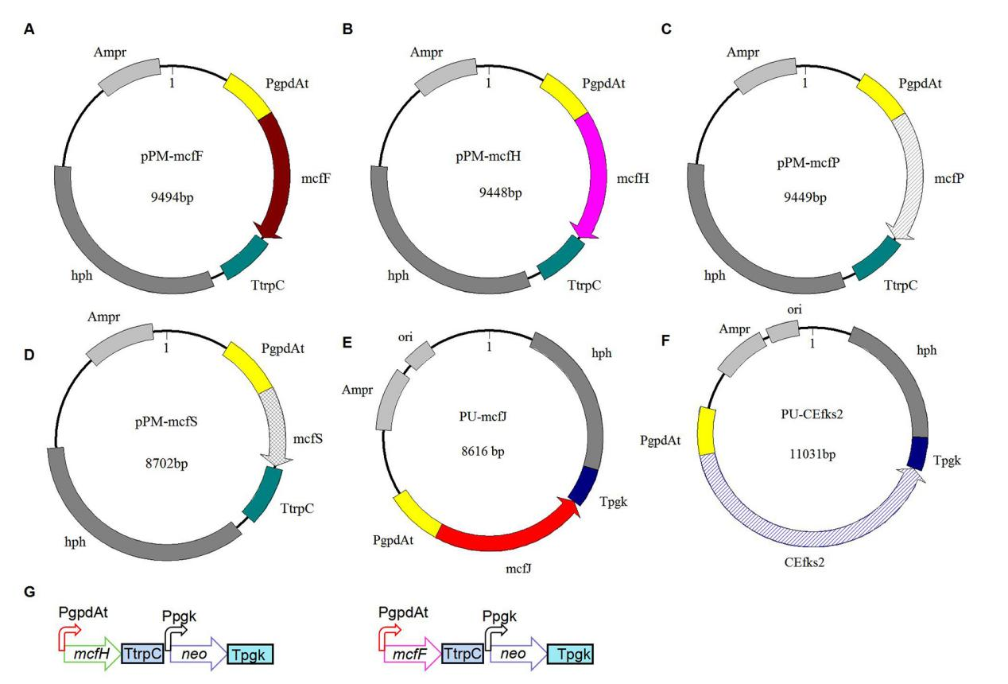
Fig. S1 Plasmid maps and cassettes of mcfF (A, G), mcfH (B, G), mcfP (C), mcfS (D), and mcfJ (E), and CEfks2 (F).
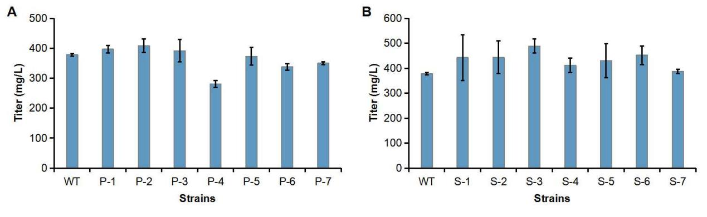
Fig. S2 Titers of FR901379 were quantified in the mutant strains MEFC09-P (A) and MEFC09-S (B); P: mutant strains MEFC09-P; S: mutant strains MEFC09-S; WT: C.empetri MEFC09.

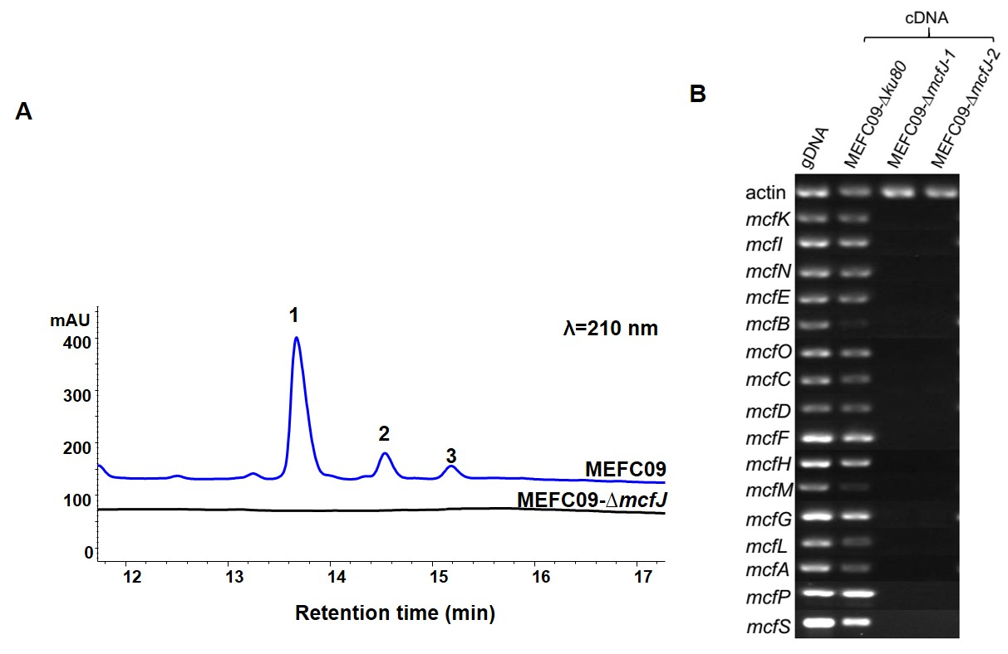
Fig. S3 Functional identification of gene mcfJ. (A) HPLC profiles of extracts from mcfJ deletion mutant. (B) Comparison of the transcription levels of the genes responsible for the FR901379 biosynthesis, with the actin coding gene as a control.

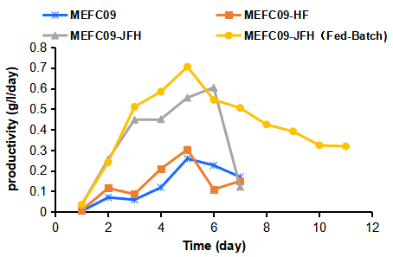
Fig. S4 The FR901379 productivity of strains MEFC09, MEFC09-HF, MEFC09-JFH in the batch fermentation and MEFC09-JFH in fed-batch fermentation.

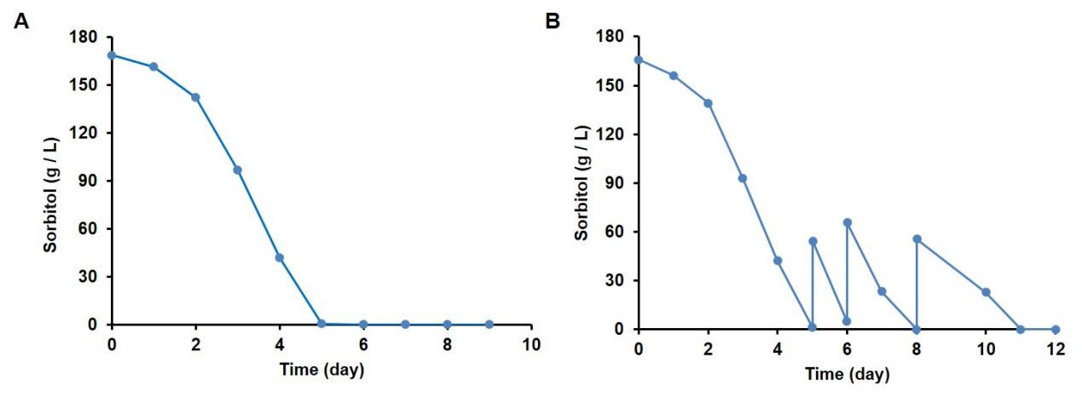
Fig. S5 The D-sorbitol concentration in batch fermentation (A) and fed-batch fermentation (B) using a 5 L bioreactor.

