Table S1. The sequences of the utilized primers.
Gene | Sequence
Beta actin | Forward 5'-GTCAGGTCATCACTATCGGCAAT-3'  Reverse 5'- AGAGGTCTTTACGGATGTCAACGT-3'
IL-1β | Forward 5'-CACCTCTCAAGCAGAGCACAG-3'  Reverse 5'-GGGTTCCATGGTGAAGTCAAC-3'
IL-6 | Forward 5'-GCCCTTCAGGAACAGCTATGA-3'  Reverse 5'-TGTCAACAACATCAGTCCCAAGA-3'

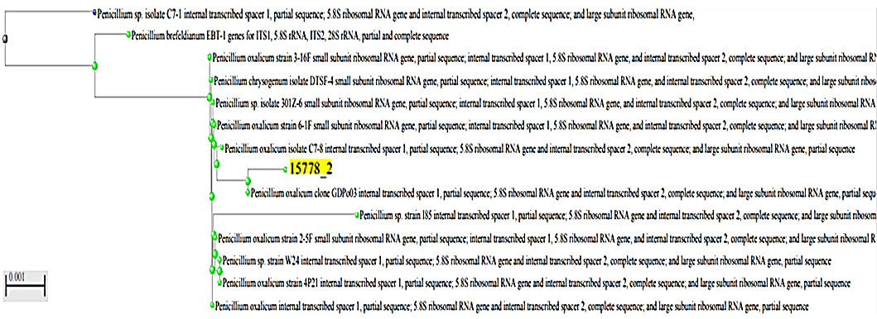
Figure S1. Phylogenetic tree of P. brefeldianum endophytic fungus (with yellow highlight) based on 18S rRNA sequencing.

Figure S2. The total ion chromatograms (TIC) of P. brefeldianum extract Negative ion mode.

Figure S3. The total ion chromatograms (TIC) of P. brefeldianum extract Positive ion mode.

