Additional file
A novel strategy for L-arginine production in engineered Escherichia coli
Mengzhen Nie^{1,2}, Jingyu Wang², Kechun Zhang^{2 *}
¹ Zhejiang University, Hangzhou, Zhejiang 310027, China
² Center of Synthetic Biology and Integrated Bioengineering, School of Engineering, Westlake University, Hangzhou, Zhejiang 310030, China

Table S1 Comparison of L-arginine production in strains N8, N9 and N11.
strains | subtrates | overexpression genes | OD₆₀₀ | L-arginine  (g/L) | Acetate  (g/L) | L-arginine  yield (mol/mol)ª
N8 | glucose+  L-ornithine | argIGH | 13±1 | 6.7±0.2 | 2.5±0.5 | 0.69
N9 | glucose+  L-ornithine | argIGH,  carAB | 13.3±0.4 | 7.6±0.1 | 2.3±0.4 | 0.76
N11 | glucose+  N-acetylglutamate | argCBH  argDGI | 18.2±1.1 | 1.1±0.4 | 2.7±0.4 | 0.92
ª L-arginine yield: L-arginine production (mol)/consumed substrate (mol). (For strains N8 and N9, the substrate represents L-ornithine; for strain N11, the substrate represents N-acetylglutamate.)
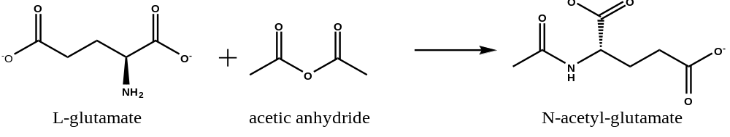
Fig. S1 N-acetylglutamate was synthesized by chemical acetylation of L-glutamate with acetic anhydride. The sodium L-glutamate (l g, 8 mmol), water (8 mL), and acetic anhydride (1.2 mL) were taken in a beaker (50 mL) and sonicated for 10 mins at ambient temperature. At the end of the reaction, the N-acetylglutamate concentration of samples was analyzed using HPLC. The water and acetic acid were removed completely and collected at 50℃ on a rotary vacuum evaporator.
Fig. S2 HPLC signal shows N-acetylglutamate accumulation.

