Additional file 1

Use of the mCherry Fluorescent Protein to Optimize the Expression of Class I Lanthipeptides in Escherichia coli
Winschau F. van Zyl^{1, 4*}, Anton D. van Staden^{1,3}, Leon MT. Dicks¹ and Marla Trindade²
¹ Department of Microbiology, Stellenbosch University, Cape Town, South Africa
² Institute for Microbial Biotechnology and Metagenomics, University of the Western Cape, Cape Town, South Africa
³ Division of Clinical Pharmacology, Department of Medicine, Faculty of Medicine and Health Sciences, Stellenbosch University, Cape Town, South Africa
⁴ Department of Microbiology and Biochemistry, University of the Free State, Bloemfontein, South Africa
* Corresponding Author: Winschau F. Van Zyl (vanzylwf1@ufs.ac.za)

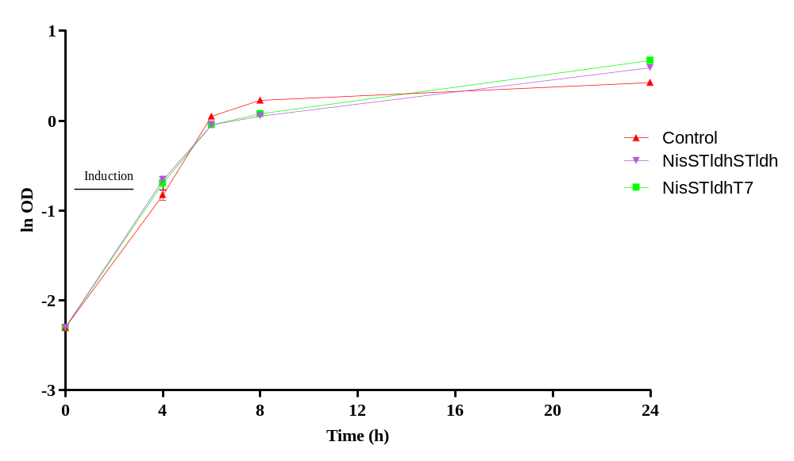
Fig. S1 Growth curves of E. coli BL21 strains NisSTldhSTldh and NisSTldhT7 expressing mCherry-PreNisA. Each vector with the respective promoter combinations were co-transformed with pACYCNisCi. The negative non-fluorescent control expression strain (Control) was transformed with empty pRSF-Duet 1 and pACYCNisCi. STldhSTldh = STldh promoter used for expression of mCherry-NisA and NisB; STldhT7 = STldh used for expression of mCherry-NisA and T7 promoter for NisB.

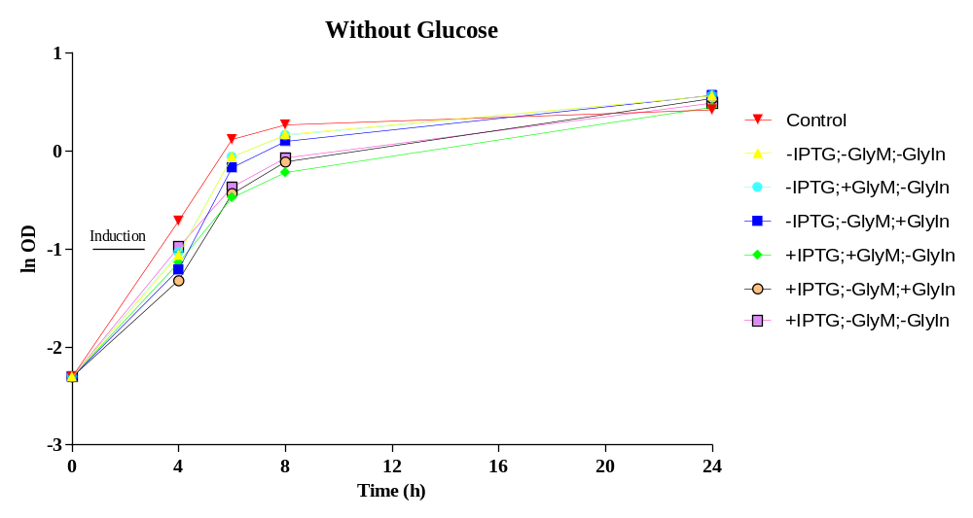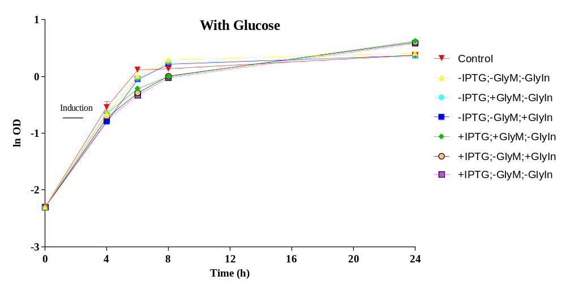
S2. B
S2. A
Fig. S2 Growth profiles of strain NisSTldhT7 expressing mCherry-PreNisA under various culturing and induction conditions. Cultures were grown in terrific broth supplemented without (A) and with (B) glucose (1% v/v) for 24 h. Control cultures were transformed with empty pRSF Duet-1 (without mCherry) and pACYC Duet-1 plasmids, while recombinant E. coli BL21 were transformed with pRSTldhCherryPrenisinNisB and pACYC-NisC plasmids. Culturing and induction conditions included: (-IPTG; -GlyM; -GlyIn) no induction; (-IPTG; +GlyM; -GlyIn) no IPTG induction with glycerol (0.5% v/v) added to pre-growth media; (-IPTG; -GlyM; +GlyIn) no IPTG induction but induced with glycerol (0.5% v/v); (+IPTG; +GlyM; -GlyIn) induced with 0.15 mM IPTG and glycerol added to pre-growth media; (+IPTG; -GlyM; +GlyIn) induced with 0.15 mM IPTG and glycerol; (+IPTG; -GlyM; -GlyIn) induced with 0.15 mM IPTG. IPTG = Thio-B-D-galactopyranoside; GlyM = glycerol presence in pre-growth media; GlyIn = glycerol used as inducer agent; + = added and - = not added.

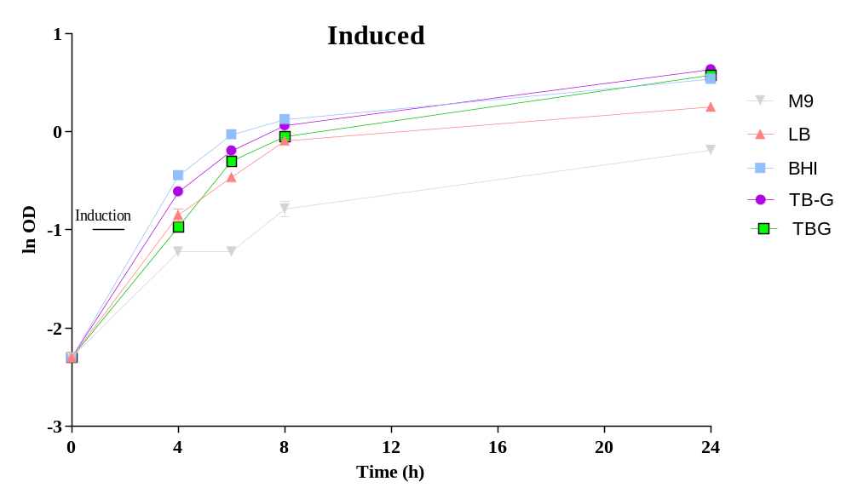
S3. B
S3. A

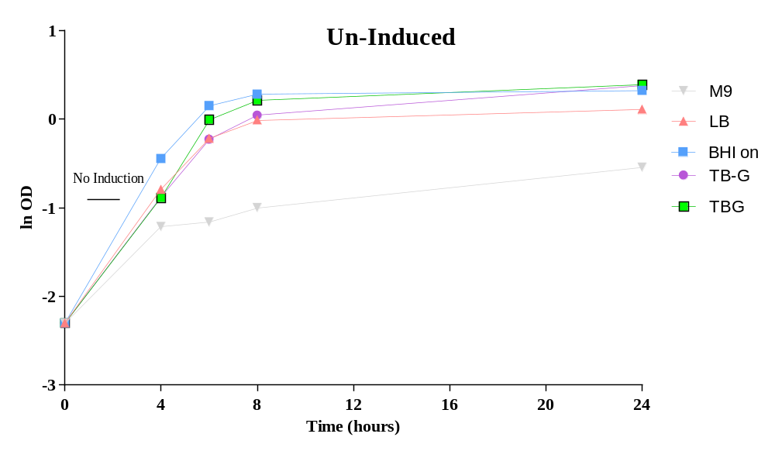
Fig. S3 Growth profiles of strain NisSTldhT7 expressing mCherry-PreNisA in M9 minimal media, LB, BHI, TBG (TB containing 0.5% glycerol), TB-G (TB without 0.5% glycerol), (A) induced with 0.15 mM IPTG and 0.5% glycerol (v/v) and (B) un-induced.

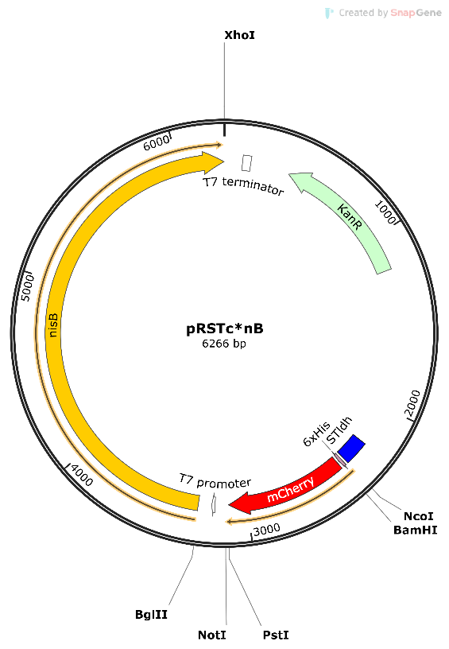
S4. A
S4. B
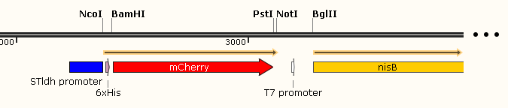
Fig. S4 (A) pRSTc*nB backbone plasmid map. (B). Close up view of gene fragments. Relevant plasmid elements, promoters, genes and restriction sites are shown. Lanthipeptide genes are inserted at PstI/NotI restriction enzyme sites.

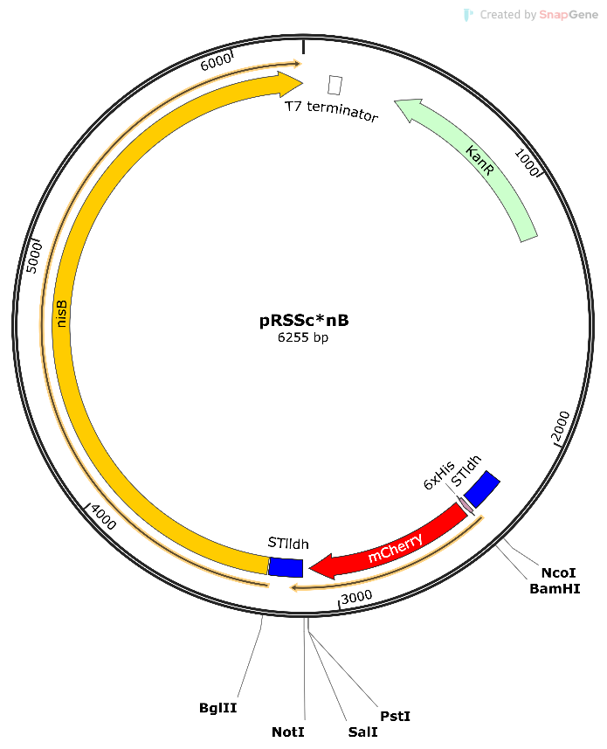
S5. A
S5. B

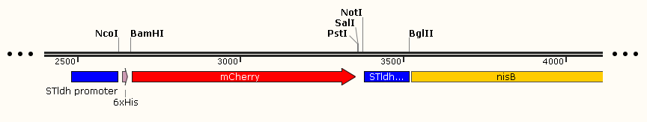
Fig. S5 (A) pRSSc*nB backbone plasmid map. (B). Close up view of gene fragments. Relevant plasmid elements, promoters, genes and restriction sites are shown. Lanthipeptide genes are inserted at PstI/NotI restriction enzyme sites. The T7 promoter in MCS2 was replaced with a second STldh promoter using NotI/BglII restriction enzyme sites.

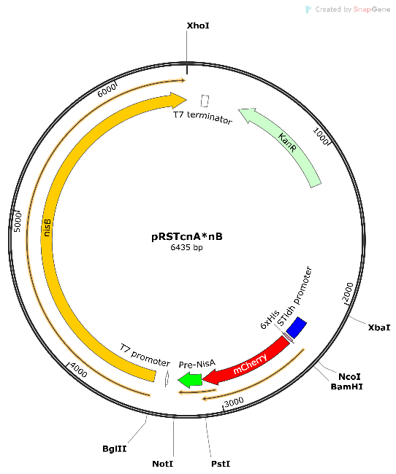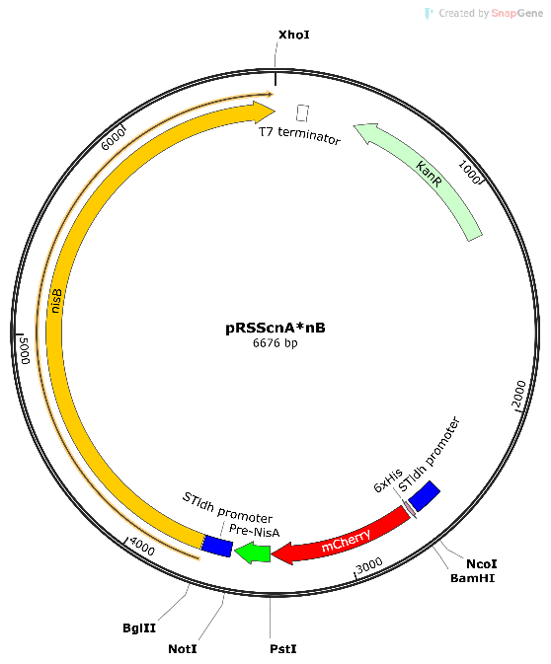
S6. B
S6. A

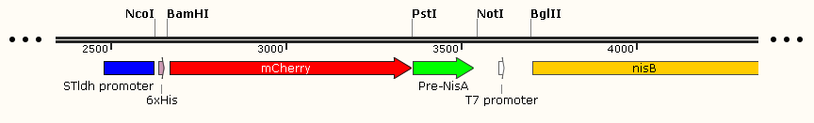
S6. C
S6. D
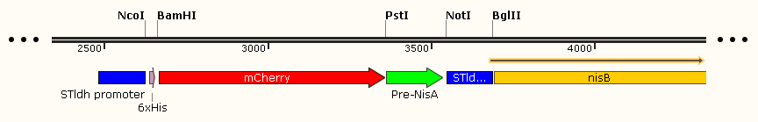
Fig. S6 (A) pRSTcnA*nB and (B) pRSScnA*nB mCherry-nisA heterologous expression plasmids. (C and D). Linearized views of gene fragments shown in A and B, respectively. Relevant plasmid elements, promoters, genes and restriction sites are shown.

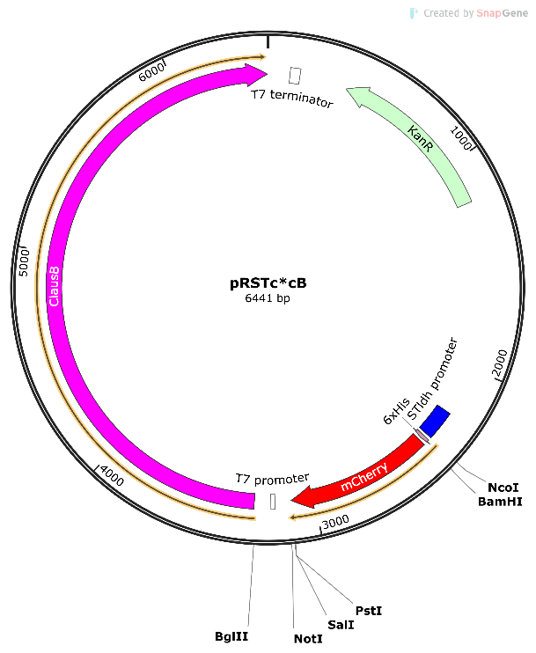
S7. A
S7. B
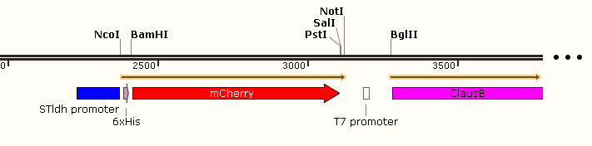
Fig. S7 (A) pRSTc*cB backbone plasmid map. (B). Close up view of gene fragments. Relevant plasmid elements, promoters, genes and restriction sites are shown. Lanthipeptide genes are inserted at PstI/NotI restriction enzyme sites.

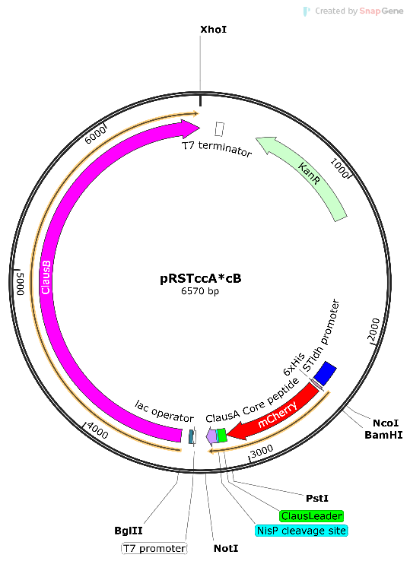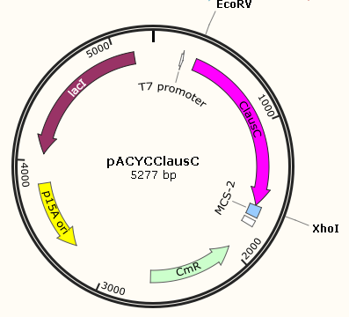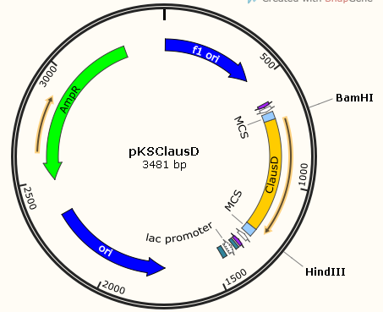
S8. D
S8. C
S8. B
S8. A

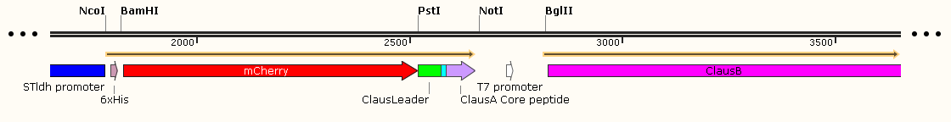
NisP cleavage site
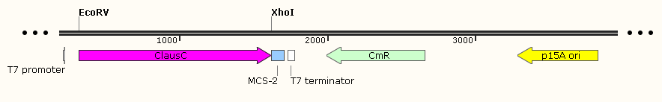
S8. E
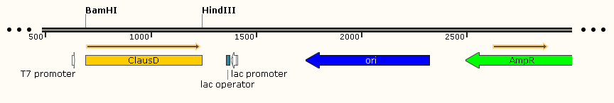
S8. F
Fig. S8 (A) pRSTccA*cB mCherry-ClausA heterologous expression plasmid, (B) pClausCi clausC cyclase expression plasmid and (C) pClausDi clausD expression plasmid. (D, E and F). Close up and linearized views of gene fragments shown in A, B and C, respectively. Relevant plasmid elements, promoters, genes and restriction sites are shown.

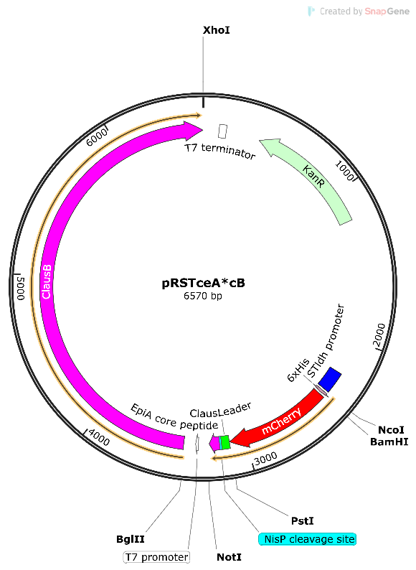
S9. B
S9. A

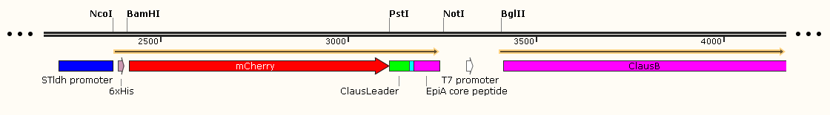
NisP cleavage site
Fig. S9 (A) pRSTceA*cB backbone plasmid map. (B). Close up view of gene fragments. Relevant plasmid elements, promoters, genes and restriction sites are shown. Lanthipeptide genes are inserted at PstI/NotI restriction enzyme sites.

1 2
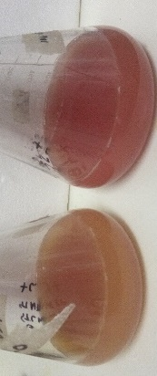
Fig. S10 Differentiation of mCherry-PreNisA production based on color produced by host cells in spent expression media carrying the promoter arrangement described for strains (1) NisSTldhSTldh and (2) NisSTldhT7, respectively, after 20 h incubation.

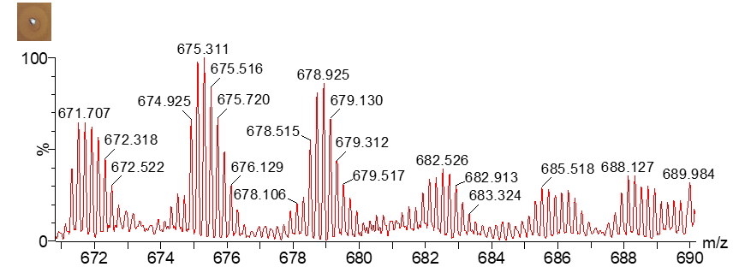
Fig. S11 Mass spectrum of hNisP cleaved mCherry-PreNisA produced in E. coli. Activity zones are representative of cleaved and extracted samples before ESI-MS analysis.

Off On
M9 
LB  
BHI 
TBG  
TB-G  
Fig. S12 Visual representation of colour differentiation of cell pellets produced when cultures are kept uninduced (off) and when induced (on).

Table S1 Bacterial strains and plasmids used in this study
Strain or plasmid | Description | Reference or source
Strain
E. coli
DH5α | Host strain used for general subcloning | (1)
BL21 (DE3) | Expression host strain | Lab culture collection
Lactococcus lactis QU2 | Nisin A producer | Gift from Prof. K. Sonomoto
Enterococcus mundtii ST4SA | Source strain of STldh promoter | Culture collection, Department of Microbiology, Stellenbosch University
Bacillus clausii AD1 | Clausin producer | (2)
Lactobacillus sakei 20017  Plasmid | Lanthipeptide sensitive organisms | Culture collection, Department of Microbiology, Stellenbosch University
pRSFDuet-1 | High copy number expression vector carrying the IPTG inducible T7 promoter in MCS1 and MCS2; Cloning site for N-terminal 6x His tag fusion in MCS1; T7 transcriptional terminator; Kan^{R} | Novagen
pACYCDuet-1 | Low copy number expression vector carrying the IPTG inducible T7 promoter in MCS1 and MCS2; Cloning site for N-terminal 6x His tag fusion in MCS1; Cm^{R} | Novagen
pNZSTldhMCS1-2 | Source vector carrying the constitutive E. mundtii ST4SA lactate dehydrogenase gene STldh promoter and two multiple cloning sites (MCS); Cm^{R} | Unpublished study
pRSTldhMCS1-2 | pRSFDuet-1 vector carrying the STldh constitutive promoter upstream of MCS 1; Cloning site for N-terminal 6x His tag fusion in MCS1; T7 promoter in MCS 2; Kan^{R} | This study
pRSFGFP | GFP source vector; pRSFDuet-1 vector carrying GFP with an N-terminal 6x His Tag and C-terminal WELQut site in MCS1; Kan^{R} | (3)
pNZSTldhCherry | mCherry source vector carrying mCherry under control of the constitutive E. mundtii ST4SA lactate dehydrogenase gene STldh promoter; Cm^{R} | Unpublished study
pRSTldhGFP | pRSTldhMCS1-2 vector carrying mCherry with a C-terminal WELQut site in MCS1; Kan^{R} | This study
pRSTldhCherry | pRSTldhMCS1-2 vector carrying mCherry with a C-terminal WELQut site in MCS1; Kan^{R} | This study
pRSTc*nB | pRSTldhCherry vector carrying nisB NisinA dehydratase in MCS2; Kan^{R} | This study
pRSTcnA*nB | pRSTc*nB vector carrying Pre-NisA (original ASPR hNisP cleavage site for removal of Nisin leader) fused to mCherry; Kan^{R} | This study
pRSSc*nB | pRSTc*nB vector carrying the constitutive E. mundtii ST4SA lactate dehydrogenase gene STldh promoter in MCS’s 1 and MCS2; Kan^{R} | This study
pRSScnA*nB | pRSSc*nB carrying Pre-NisA (original ASPR hNisP cleavage site for removal of Nisin leader) fused to mCherry; Kan^{R} | This study
pRSTc*cB | pRSTldhCherry vector carrying the clausB Clausin dehydratase in MCS2; Kan^{R} | This study
pRSTccA*cB | pRSTc*cB vector carrying the clausin leader-Clausin core peptide fused to mCherry (ASPR, hNisP cleavage site); Kan^{R} | This study
pRSTceA*cB | pRSTc*cB vector carrying the clausin leader-EpiA core peptide fused to mCherry (ASPR, hNisP cleavage site); Kan^{R} | This study
pACYCNisCi | pACYCDuet-1 vector carrying the nisC NisinA cyclase for co-expression of NisC in MCS2; Cm^{R} | (3)
pClausCi | pACYCDuet-1 vector carrying | This study
 | clausC for Clausin cyclase for co-expression of ClausC in MCS2; Cm^{R}
pBluescriptKS | High-copy number PCR cloning vector carrying the IPTG inducible T7 promoter and a MCS; Amp^{R} | This study
pClausDi | pBluescriptKS plasmid carrying clausD for Clausin amino-vinyl cysteine formation in the MCS; Amp^{R} | This study
pRSF-hNisPi | pRSFDuet-1 vector carrying truncated NisP with a C-terminal 8x His tag; Kan^{R} | (3)
Cm^{R}, chloramphenicol resistance; Kan^{R}, kanamycin resistance; Amp^{R}, ampicillin resistance; IPTG, Thio-B-D galactopyranoside; MCS, multiple cloning site; STldh, constitutive lactate dehydrogenase gene promoter.
Table S2. Oligonucleotides utilized in this study
Target | Primer | Sequence 5’ to 3’ | Restriction sites | Product size (bp)
nisB dehydratase | nisB1 | CAGCCGAGATCTGATGATAAAAAGTTCATTTAAAGCTCAACCG | BglII | 2982
 | nisB2 | CTAGCTCGAGTCATTTCATGTATTCTTCCGAAACAAACAACC | XhoI
STldh promoter | STldh1 | GCTTGGATCCATGGTAAGCCGATACGTACC | NotI | 156
 | STldh2 | AGTCAAGCTTCTACCCAATCAGTACGTTAATT | BglII
clausB dehydratase | clausB1 | GCGCAGATCTGATGGCGATGAGAAAAAGC | BglII | 3156
 | ClausB2 | GCGCCTCGAGTCATACGTTTAATGGTTG | XhoI
clausC dehydratase | ClausC1 | GCGCGATATCgATGATTGCCCATTTGA | EcoRV | 1299
 | ClausC2 | GCGCCTCGAGCTAACTGATTAAAAACGC | XhoI
clausD | clausD1 | GCGCCCATGGGATGCCCTCCTATTTAG | NcoI | 510
 | clausD2 | GCGCAAGCTTCTAGCTTTTTTCTTTTAC
nisA | nisA1 | CTAGATGGATCCGATGAGTACAAAAGATTTTAACTTGG | BamHI | 174
 | nisA2 | CTAGAAGCTTTTATTTGCTTACGTGAATACTACAATG | HindIII
epiA | epiAFor | CATGCTGCAGGATGGAAGCAGTAAAA | PstI | 159
 | EpiANotIRev | CATGGCGGCCGCTTAACAACAATAACTGTTAA | NotI
ClausA core with 5’ hNisP sequence overlap | ClausNisPLanOL | GCATCACCACGCTTCACAAGCGTCAGTTT | - | 89
epiA core with 5’ hNisP sequence overlap | EpiANisPOL | GCATCACCACGCATTGCTAGTAAATTTATATGTA | - | 94
clausA leader fusion to clausA/epiA core peptides | ClausLFor | CTCACTGCAGGATGGAAAAAGCTTTTGA | PstI | 76
 | ClausLNisPRevOL | GCGTGGTGATGCATCCTTCGCTTTCGTGT | -
 | ClausANotIRev | ATAATTTAGCGGCCGCTTAGCAGCAGAAGCTATTAAAGC | NotI | 135

References
- Ausubel FM, Brent R, Kingston RE, Moore DD, Seidman JG, Smith JA, Struhl K. Current protocols in molecular biology. New York: Wiley. 1994.
- Van Staden AD, Heunis T, Smith C, Deane S, Dicks LMT. Efficacy of lantibiotic treatment of Staphylococcus aureus-induced skin infections, monitored by in vivo bioluminescent imaging. Antmicrob Agents Chemother.2016;60(7):3948-55.
- Van Staden AD, Faure LM, Vermeulen RR, Dicks LMT, Smith C. Functional expression of GFP-fused class I lanthipeptides in Escherichia coli. ACS Synth Biol. 2019;8:2220–7.

