Supplementary Material

A strategy to promote the convenient storage and direct use of polyhydroxybutyrate-degrading Bacillus sp. JY14 by lyophilization with protective reagents

Su Hyun Kimª, Nara Shinª, Suk Jin Ohª, Jeong Hyeon Hwangª, Hyun Jin Kimª,Shashi Kant Bhatia^{a,b}, JeongheeYun^{c}, Yung-Hun Yang^{a,b*}

ªDepartment of Biological Engineering, College of Engineering, Konkuk University, Seoul, Republic of Korea
^{b}Institute for Ubiquitous Information Technology and Application, Konkuk University, Seoul, Republic of Korea
^{c}Department of Forest Products and Biotechnology, Kookmin University, Seoul 02707, Republic of Korea

*Corresponding author
Prof. Yung-Hun Yang
Department of Biological Engineering, College of Engineering
Konkuk University, Seoul 05029, Republic of Korea.
E-mail address:seokor@konkuk.ac.kr
Phone number:(+82) 10-9079-9846
Figure S1. Confirmation of degradation activity by clear zone test. The PHB degradation activity of the strain was assessed after lyophilization with protective reagents by clear-zone test. Compared with control, larger and more transparent clear zones were observed when sugars were added.
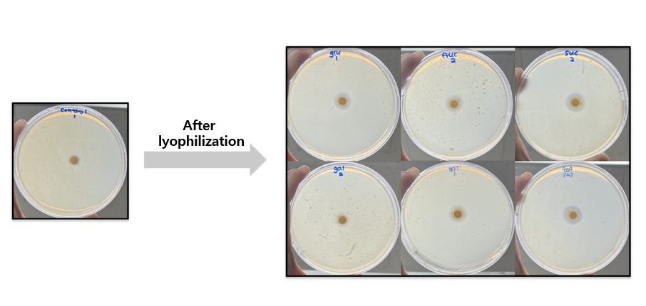

Figure S2. A calibration curve obtained from the GC-MS analysis based on the weight of PHB film. This was used to quantify the amount of the residual PHB film.
