Supporting Information
Robotic workflows for automated long-term adaptive laboratory evolution: Improving ethanol utilization by Corynebacterium glutamicum
Lars Halle^{1,2}, Niels Hollmann¹, Niklas Tenhaef¹, Lea Mbengi¹, Christiane Glitz¹, Wolfgang Wiechert^{1,2}, Tino Polen^{1,2}, Meike Baumgart¹, Michael Bott^{1,2}, Stephan Noack^{1,2,#}

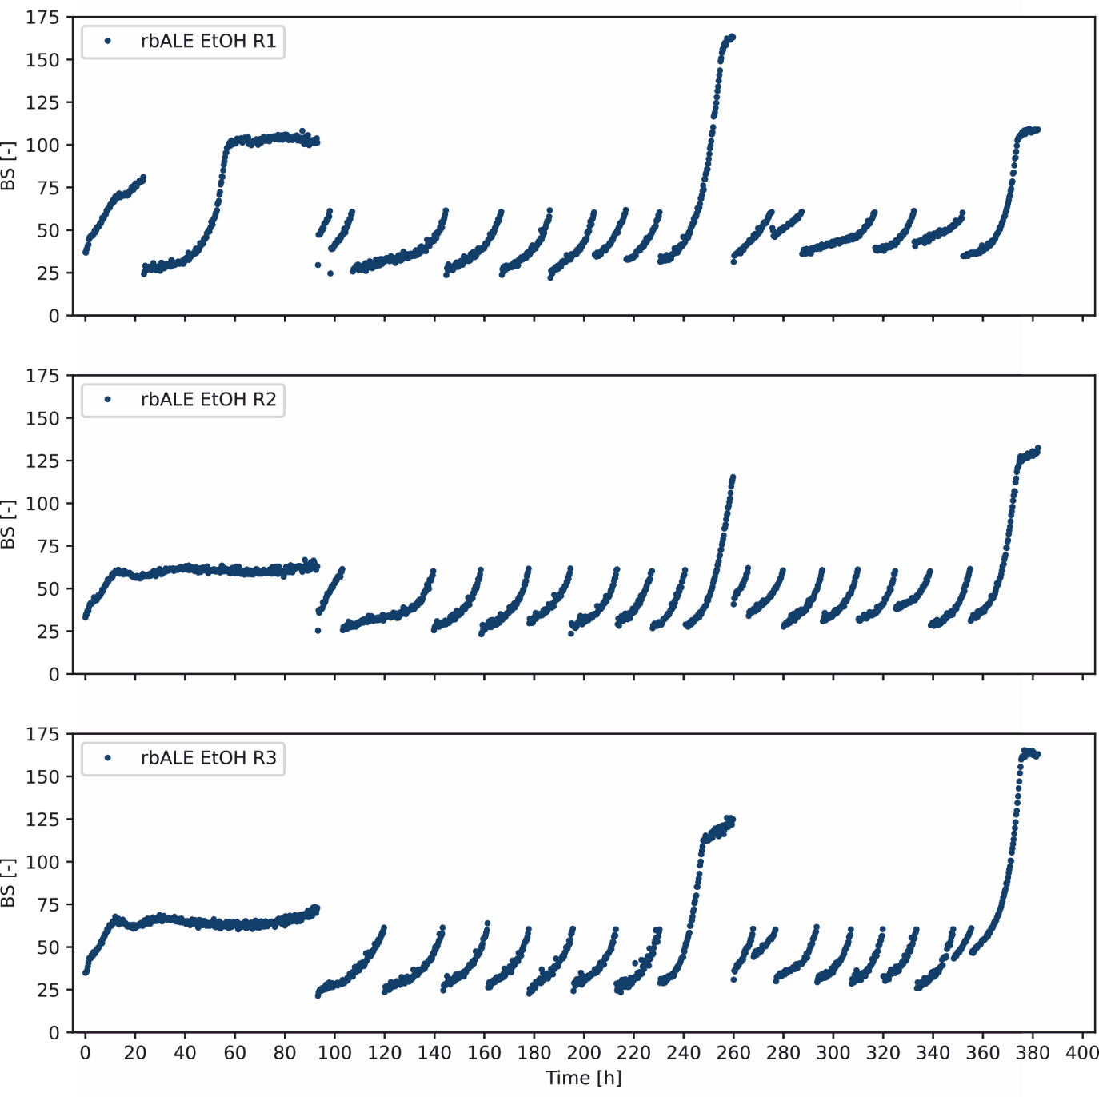
Figure S1: Long-term rbALE experiment to improve ethanol utilization of C. glutamicum WT. A total of three replicate runs in one FlowerPlate were performed. C. glutamicum WT was cultivated for a total number of 16 to 18 repetitive batches in one FlowerPlate and defined CGXII medium with 428 mM ethanol as sole carbon and energy source. The resulting online BS measurements against cultivation time are shown.
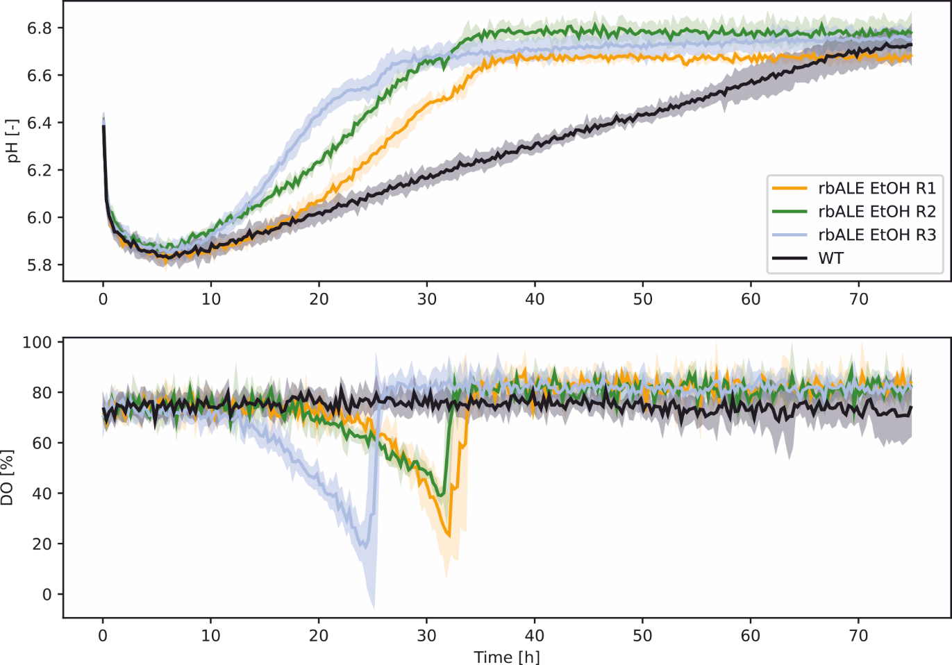
Figure S2: Additional online data (pH and dissolved oxygen (DO)) for the phenotyping experiments of the three evolved mutant strains in comparison to C. glutamicum WT (cf. Figure 3C).

Table S1: Single nucleotide variants (SNV) of rbALE EtOH R3 compared to the WT identified by genome sequencing appearing with a frequency of at least 75%.
Position and mutation on DNA level | Frequency (%) | Locus tag, gene name, annotation | Mutation and interpretationª
829516_SNV_T_A | 99.32 | cg0896, putative membrane protein | cg0896 Y967*, no promoter affected
923955_SNV_G_T | 99.3 | cg0987, conserved hypothetical protein | cg0987 A12D, no promoter affected
381944_SNV_T_G | 100 | P_{cg0435}, udgA1, UDP-glucose 6-dehydrogenase | Mutation between RBS and TLS, 4 bp upstream of ATG, presumably no effect
512738_SNV_G_A | 100 | P_{cg0576}, rpoB, DNA-directed RNA polymerase β subunit | Mutation between TSS and TLS, 175 bp upstream of TLS, regulation not known.
1096559_SNV_A_G | 100 | cg1189, hypothetical protein | cg1189 I38V, no promoter affected
1813816_SNV_G_C | 100 | cg1935, gntR2, gluconate responsive repressor 2, involved in gluconate metabolism and the pentose phosphate pathway. | GntR2 V13L , no promoter affected
1993795_SNV_T_C | 100 | NCgl1815, hypothetical protein, CGP4 | NCgl1815 R109R, silent mutation, no promoter affected
1993797_SNV_G_T | 100 | NCgl1815, hypothetical protein, CGP4 | NCgl1815 R109R, silent mutation, no promoter affected
1993809_SNV_A_G | 100 | NCgl1815, hypothetical protein, CGP4 | NCgl1815 L105L, silent mutation, no promoter affected
1993912_SNV_C_T | 100 | NCgl1815, hypothetical protein, CGP4 | NCgl1815 P70P, silent mutation, no promoter affected
2368804_SNV_A_C | 100 | cg2452, galK, putative galactokinase | cg2452 Q338P, no promoter affected
2981767_SNV_G_A | 75.61 | P_{cg3096}, ald, acetaldehyde dehydrogenase | Located in the GlxR binding site upstream of cg3096, presumably effect on transcription of ald.
ª RBS, Ribosome binding site; TLS, Translational start site; TSS, Transcriptional start site
Table S2. Differentially synthesized proteins of C. glutamicum WT_EtOH-Evo in comparison to the control strain C. glutamicum WT with ethanol as sole carbon and energy source. Proteins with statistically significant changes (p-value < 0.01, Log2(Fold-Change) > 1 for upregulated proteins and Log2(Fold-Change) < -1 for down-regulated proteins) as intersection of the four sampled conditions during exponential growth (EVO(t₁), WT(t₁)) and stationary phase (EVO(t₂), WT(t₂)) are shown (cf. Figure 5).
Identified protein | Gene | Locus | FC | p-value
Putative protein of nitroreductase-family |  | cg0404 | 0.15 | 6.39e-05
Uncharacterized ACR, double-stranded β-helix domain |  | cg3277 | 0.151 | 1.55e-06
Predicted nucleoside-diphosphate-sugar epimerase |  | cg3375 | 0.168 | 5.82e-05
Pyruvate:quinone oxidoreductase | pqo (poxB) | cg2891 | 0.172 | 6.53e-07
Conserved hypothetical protein |  | cg1131 | 0.181 | 0.0002
Iron-regulated ABC transporter ATPase subunit | sufC | cg1762 | 0.185 | 3.69e-06
O-Acetylhomoserine (Thiol)-Lyase | metY | cg0755 | 0.191 | 3.18e-10
Uracil phosphoribosyltransferase | upp | cg0786 | 0.197 | 2.07e-07
Electron transfer flavoprotein, α subunit | fixB | cg1387 | 0.2 | 2.18e-08
Putative secreted protein |  | cg4005 | 0.209 | 2.47e-05
Riboflavin synthase subunit β | ribH | cg1797 | 0.213 | 3.65e-05
Fe-S cluster assembly protein | sufB | cg1764 | 0.224 | 0.00128
Cu²⁺/cation-transporting ATPase transmembrane protein | copB | cg3281 | 0.226 | 4.81e-06
6-phosphogluconolactonase | pgi (devB) | cg1780 | 0.228 | 1.6e-07
Citrate uptake transporter | tctC | cg3127 | 0.232 | 0.0161
Putative membrane-bound protease modulator | ppmA | cg3138 | 0.257 | 5.51e-09
Putative alkanal monooxygenase α chain, FMN-linked |  | cg2538 | 0.265 | 1.62e-06
Electron transfer flavoprotein, β subunit | fixA | cg1386 | 0.29 | 3.46e-08
Putative homoserine O-acetyltransferase |  | cg0961 | 0.295 | 0.00119
Cysteinyl-tRNA synthetase | cysS2 | cg1709 | 0.3 | 5.34e-08
Peptide methionine sulfoxide reductase | msrA | cg3236 | 0.306 | 8.49e-05
30S ribosomal protein S10 | rpsJ | cg0593 | 0.314 | 8.78e-05
High affinity ABC-type methionine transporter | metQ | cg0737 | 0.317 | 2.1e-07
Bifunctional 3,4-dihydroxy-2-butanone 4-phosphate synthase/ GTP cyclohydrolase II protein | ribA | cg1798 | 0.333 | 7.86e-11
2-methycitrate dehydratase | prpD2 | cg0759 | 0.334 | 0.000257
Homoserine kinase | thrB | cg1338 | 0.336 | 0.00277
Putative protein, CsbD-family, probably involved in stress response | cybD | cg0282 | 0.352 | 9.33e-08
Putative coenzyme F420-dependent N5,N10-methylene tetrahydromethanopterin reductase or related flavin-depende |  | cg2329 | 0.357 | 1.16e-05
Thioredoxin reductase | trxB | cg3422 | 0.362 | 1.35e-11
Putative Fe-S cluster assembly protein |  | cg1759 | 0.363 | 0.0157
Putative lysine decarboxylase-family protein |  | cg1261 | 0.364 | 7.8e-08
Pyruvate carboxylase | pyc | cg0791 | 0.365 | 0.00976
Putative NADPH quinone reductase or Zn-dependent oxidoreductase |  | cg3405 | 0.374 | 0.0357
Fe-S cluster assembly membrane protein | sufD | cg1763 | 0.391 | 0.00857
Cysteine desulfhydrase | sufU | cg1760 | 0.404 | 0.0161
N-acetylglucosaminyl transferase | murG | cg2369 | 0.429 | 6.36e-07
30S ribosomal protein S19 | rpsS | cg0599 | 0.433 | 2.51e-07
ATP-dependent helicase PCRA | pcrA | cg0976 | 0.444 | 6.82e-06
30S ribosomal protein S17 | rpsQ | cg0604 | 0.456 | 1.22e-06
Oxaloacetate decarboxylase | odx | cg1458 | 0.457 | 0.0047
Cytochrome aa3 oxidase, subunit 1 | ctaD | cg2780 | 2.116 | 0.000383
Conserved hypothetical protein |  | cg0935 | 2.136 | 2.38e-05
Hypothetical protein |  | cg0452 | 2.379 | 0.00031
Phosphate acetyltransferase | pta | cg3048 | 2.637 | 1.79e-09
Thiosulfate sulfurtransferase | thtR | cg0803 | 2.886 | 1.47e-07
Cysteine desulfurase-like protein involved in Fe-S cluster assembly | nadS | cg1214 | 2.965 | 1.1e-05
Putative metallo-β-lactamase superfamily protein |  | cg0349 | 3.641 | 1.34e-06
Conserved hypothetical protein |  | cg2464 | 3.788 | 4.09e-07
Aldehyde dehydrogenase | ald | cg3096 | 4.082 | 3.71e-10
Putative signal-transduction protein containing cAMP-binding and CBS domain |  | cg1456 | 4.18 | 4.92e-09
4-hydroxy-3-methylbut-2-enyl diphosphate reductase | IpsH (lytB) | cg1164 | 4.316 | 8.57e-08
Conserved hypothetical protein |  | cg2363 | 4.316 | 1.44e-06
Putative secreted protein |  | cg2949 | 5.16 | 2.34e-09
Trehalose uptake system, ABC-type, bacterial extracellular solute-binding protein | tusE | cg0834 | 5.429 | 0.00051
Quinolinate synthetase | nadA | cg1216 | 9.182 | 1.63e-11
δ-aminolevulinate dehydratase | hemB | cg0512 | 9.736 | 4.19e-06
Conserved hypothetical protein |  | cg1045 | 14.999 | 1.21e-10
Putative NADPH-dependent FMN reductase |  | cg3223 | 20.12 | 7.7e-08
Phosphoenolpyruvate carboxykinase | pck | cg3169 | 26.869 | 1.94e-07

Table S3: Oligonucleotides used in this study.
Oligonucleotide | Sequence (5’ → 3’) and propertiesª
Construction of plasmid pK19mobsacB-P01-ald and PCR-analysis of the resulting mutants
PLZM056 | CAGCTATGACCATGATTACGCCATCCACACCGAAAAAATCCAACG
PLZM057 | TTGTAAAACGACGGCCAGTGAATTTCATTGGGTCTCCTTTGGGCCAC
M13-fw | CGCCAGGGTTTTCCCAGTCAC
M13-rv | AGCGGATAACAATTTCACACAGGA
P01-ald-Test-fw | CGGGCCAGAACCGCTAGACG
P01-ald-Test-rv | GCCACCAATGTAGTTCTCGTAGCGC
ª Overlaps for Gibson assembly are written in bold letters.

