Supplementary Information

Heterologous overproduction of oviedomycin by refactoring biosynthetic gene cluster and metabolic engineering of host strain Streptomyces coelicolor

Boncheol Gu¹, Duck Gyun Kim¹, Do-Kyung Kim¹, Minji Kim², Hyun Uk Kim², Min-Kyu Oh¹

¹Department of Chemical & Biological Engineering, Korea University, Seoul 02841, Republic of Korea
²Department of Chemical and Biomolecular Engineering (BK21 four), Korea Advanced Institute of Science and Technology (KAIST), Daejeon, 34141, Republic of Korea

Table. S1 Strains and plasmids in this study.
Strains | Genotype or Description | References
Escherichia coli
TOP10 | A derivative of E. coli K12 strain. F_ mcrA Δ(mrr-hsdRMS-mcrBC) φ80lacZΔM15 ΔlacX74 endA1 galE15 galK16 rpsL (StrR) nupG recA1 araD139 Δ(ara-leu)7697 | Invitrogen
ET12567(pUZ8002) | A methylation-deficient strain for conjugation-based gene transfer; carrying pUZ8002 plasmid | (1)
Streptomyces coelicolor M1152 | A derivative Streptomyce coelicolor A3(2) strain. ∆act ∆red ∆cpk ∆cda rpoB (C1298T) | (2)
SCMO | M1152 harboring pCBAO | This study
SCMO1 | M1152 harboring pCBAO1 | This study
SCMO1F | M1152 harboring pCBAO1F | This study
SCMO2 | M1152 harboring pCBAO2 | This study
Plasmids
pCAP-BAC | Low copy maintenance of large constructs in E. coli | (3)
pSET152-kasO*p | An integrated expression plasmid of Streptomyces with kasO*p | (4)
pCBA | Integrated phage φC31 integrase, apramycin^{R,} tra, from pSET152 and ori2, repE. sopA, sopB, sopC from pCAP-BAC | This study
pCBAO | Cloned ovm BGC into pCBA | This study
pCBAO1 | Refactoring ovm01 followed by ermE*p | This study
pCBAO1F | Refactoring ovm01 with ermE*p and ovmF with kasO*p | This study
pCBAO1F-1 | Insert a MTFHD with kasO*p into pCBAO1F | This study
pCBAO1F-2 | Insert a PSERT with kasO*p into pCBAO1F | This study
pCBAO1F-3 | Insert a ACCOAC with kasO*p into pCBAO1F | This study
pCBAO2 | Refactoring ovm01 with ermE*p, ovmF and ovm02 with kasO*p | This study
pCBAO2-1 | Insert a MTFHD with kasO*p into pCBAO2 | This study
pCBAO2-2 | Insert a PSERT with kasO*p into pCBAO2 | This study
pCBAO2-3 | Insert a ACCOAC with kasO*p into pCBAO2 | This study
pCBAO2-4 | Insert MTFHD and PSERT with kasO*p into pCBAO2 | This study
pCBAO2-5 | Insert MTFHD and ACCOAC with kasO*p into pCBAO2 | This study
pCBAO2-6 | Insert PSERT and ACCOAC with kasO*p into pCBAO2 | This study
pCBAO2-7 | Insert MTFHD, PSERT and ACCOAC with kasO*p into pCBAO2 | This study

Table. S2 Primers used in this study.
Name | 5’ to 3’ sequence
pSET152_F | GAAGATCCTTTGATCTTTTCTACGGGG
pSET152_R | CAGGCTTCCCGGGTGTCT
ovm_BGC_F | AGTGCCACCTGGGTCCTTTTCATCACGTGCTATAAAAATAATTATAATTTCGACATGACGTGCCCTCAG
ovm_BGC_R | CTGGTGCTTCCTCTCACTATAGGGCGAATTGGAGCTCCACCGCGGTGGCTCATGGGTACCCTCCGGTTG
MTHFD_F | ATATATCATATGACCGCCCAGATTCTCGATGG
MTHFD_R | ATATATGGATCCTCAGCCGGCACTGCGCTC
ACCOAC_F | ATATATCATATGACCGTTTTGGATGAGGCGC
ACCOAC_R | ATATATGCGGCCGCTCACTGCGGCGGGTTGCC
PSERT_F | ATATATCATATGAAGCCCGCGGACGGT
PSERT_R | ATATATGGATCCTCACAGCTTCTCGATGACGTGGTC
sgRNA
ovm01 | ACGCAACAGGAAAGGAGGCG
ovmF | GAAACGCTCCCGGTGCCGGA
ovm02 | CGAAGCACGGCGGAACCATG
Rescue DNA
ermE*p_ovm01_F | CGGGACGTACGCAACAGGAAtcgatcttgacggctggcgagaggtgcggggaggatctgaccgacgcggtccacacgtggcaccgcgatgctgttgtgggca
ermE*p_ovm01_R | TCGACGAGGGCAGCGTCCATatggggacctcctggggtgcgttggaccgctggatcctaccaaccggcacgattgtgcccacaacagcatcgcgg
kasO*p_ovmF_F | CGGTACCGGAAACGCTCCCGtgttcacattcgaacggtctctgctttgacaacatgctgtgcggtgttgtaaagtcgtggccagg
kasO*p_ovmF_R | ACAGGTCCACGCGCCGGCCGTCCGGCACATGCGCActcccccagtcctgcacgctgtcgtattctcctggccacgactttacaac
kasO*p_ovm02_F | AGGACTACGCCGAAGCACGGCGGAACCATGCGGACTGAtgttcacattcgaacggtctctgctttgacaacatgctgtgcggtgttgtaaagtcgtgg
kasO*p_ovm02_R | GCCCGCGCCGACGACGAGGACGTCAGTCCGCATATGCGCActcccccagtcctgcacgctgtcgtattctcctggccacgactttacaac
RT-qPCR
ovm01_F | CGTCAACCTGGGCTGGAAGC
ovm01_R | GCATCTCGCTGCCGCTGA
ovmC_F | TGAAGCACAGCACGTTGATC
ovmC_R | CGGTACTTGAACAGCTGACG
ovmP_F | AAGAACTTCTGGAGCCTGCT
ovmP_R | TGTTCCTCCGGATCGAAGTC
ovmK_F | CATCGAGGAGGGGCTGATC
ovmK_R | CAGGTCCAGGTCGTAGCC
ovmS_F | GTCGACGACCTCAAGCGC
ovmS_R | GAGGAAGTCGGCGCTGTC
ovmT_F | GACACGAACCTCAACAGCG
ovmT_R | GAGGCGATGTTGATGATCCG
ovmA_F | GGAAGATCGCCTACAAGCAG
ovmA_R | CGTGATGTTGTCGGTGTTGA
ovm02_F | CCTCAACCTCGGTCTCCAG
ovm02_R | CTCGGAGTGGTACGTGTCC
ovm03_F | CGGAAACTGAGCAACCTGAC
ovm03_R | TGATCAGCACGTACGGGTAG
ovmF_F | CTCACCTCACCTCACCTCAC
ovmF_R | CTCCGGTTGCCTTGCCAA
In primer sequences, italic, bold, and small characters represent enzyme sites, homologous region to genomic DNA, and promoter region, repectively.)

Table. S3 Overexpression targets obtained from GEM analysis.
Targets | Name | Locus ID
ACCOAC | Acetyl-CoA carboxylase | (SCO2445 or (SCO5535 and SCO5536)) and (SCO2777 or SCO4921 or SCO6271)
ACLS | Acetolactate synthase | (SCO5512 or SCO2769 or SCO6584) and SCO5513
ADK1 | Adenylate kinase | SCO4723
ADSK | Adenylyl-sulfate kinase | SCO6099
ADSL1r | Adenylsuccinate lyase | SCO1254
ADSL2r | Adenylosuccinate lyase | SCO1254
ADSS | Adenylosuccinate synthase | SCO3629
AHSERL2 | O acetylhomoserine thiol lyase | SCO1294 or SCO4958
AICART | Phosphoribosylaminoimidazolecarboxamide formyltransferase | SCO4814
AIRCr | Phosphoribosylaminoimidazole carboxylase | SCO3059 and SCO3060
ASP1DC | Aspartate 1-decarboxylase | SCO0978 or SCO3416
ASPTA | Aspartate transaminase | SCO4645 or SCO3658
BPNT | 3',5'-bisphosphate nucleotidase | SCO5161
CYSTS | Cystathionine beta synthase | SCO3077
CYTK1 | Cytidylate kinase (CMP) | SCO1760
DHAD1 | Dihydroxy-acid dehydratase (2,3-dihydroxy-3-methylbutanoate) | SCO1176 or SCO1888 or SCO3345
DPCOAK | Dephospho-CoA kinase | SCO1996
DPR | 2-dehydropantoate 2-reductase | SCO0462 or SCO6562
FBA3 | Sedoheptulose 1,7-bisphosphate D-glyceraldehyde-3-phosphate-lyase | SCO3649 or SCO5852
G6PDH1b | beta-D-glucose-6-phosphate:NAD+ 1-oxidoreductase | SCO1937 or SCO6661
G6PDH2r | Glucose 6-phosphate dehydrogenase | SCO1937 or SCO6661
G6PI | Glucose 6 phosphate isomerase | SCO1942 or SCO6659
GAPD | Glyceraldehyde-3-phosphate dehydrogenase | SCO1947 or SCO7040 or SCO7511
GARFT | Phosphoribosylglycinamide formyltransferase | SCO4813
GHMT2r | Glycine hydroxymethyltransferase, reversible | SCO4837 or SCO5470 or SCO5364
GLNS | Glutamine synthetase | SCO1613 or SCO2198 or SCO2210 or SCO2241 or SCO6962
GLUPRT | Glutamine phosphoribosyldiphosphate amidotransferase | SCO4086
GLYCL | Glycine Cleavage System | SCO5471 and SCO1378 and SCO5472 and (SCO0884 or SCO2180 or SCO4919)
H2Ot | H2O transport via diffusion | s0001
IMPC | IMP cyclohydrolase | SCO4814
KARA1i | acetohydroxy acid isomeroreductase | SCO5514 or SCO7154
METB1 | Metb1 (rev) | SCO1294 or SCO4958
MOHMT | 3-methyl-2-oxobutanoate hydroxymethyltransferase | SCO2256
MTHFC | Methenyltetrahydrofolate cyclohydrolase | SCO4824
MTHFD | Methylenetetrahydrofolate dehydrogenase (NADP) | SCO4824
NDPK1 | Nucleoside-diphosphate kinase (ATP:GDP) | SCO2612
NDPK3 | Nucleoside-diphosphate kinase (ATP:CDP) | SCO2612
NH4t | Ammonia reversible transport | SCO5583 or s0001
PANTS | Pantothenate synthase | SCO3383
PAPSR | Phosphoadenylyl-sulfate reductase (thioredoxin) | SCO6100 and (SCO0885 or SCO3889 or SCO5419 or SCO5438)
PFK_3 | Phosphofructokinase (s7p) | SCO5426 or SCO2119 or SCO1214
PGCD | Phosphoglycerate dehydrogenase | SCO3478 or SCO5515
PGIA | Glucose-6-phosphate isomerase (g6p-A) | SCO1942 or SCO6659
PGK | Phosphoglycerate kinase | SCO1946
PIt2r | Phosphate reversible transport via symport | SCO4138 or SCO1845
PNTK | Pantothenate kinase | SCO3380 or SCO4738
PPA_1 | Pyrophosphate energized proton pump | SCO3409 or SCO3547
PPCDC | Phosphopantothenoylcysteine decarboxylase | SCO1477
PRAGSr | Phosphoribosylglycinamide synthase | SCO4068
PRAIS | Phosphoribosylaminoimidazole synthase | SCO4087
PRASCSi | Phosphoribosylaminoimidazolesuccinocarboxamide synthase | SCO4071
PRFGS | Phosphoribosylformylglycinamidine synthase | SCO4077 and SCO4078 and SCO4079
PRPPS | Phosphoribosylpyrophosphate synthetase | SCO0782 or SCO3123
PSERT | Phosphoserine transaminase | SCO4366
PSP_L | Phosphoserine phosphatase (L-serine) | SCO1808 or SCO3691
PTPATi | Pantetheine-phosphate adenylyltransferase | SCO5568
RPE | Ribulose 5-phosphate 3-epimerase | SCO1464
RPI | Ribose-5-phosphate isomerase | SCO0579 or SCO1224 or SCO2627
SADT | Sulfate adenylyltransferase | SCO6097 and SCO6098
SO4t2 | Sulfate transport in via proton symport | SCO3276
TALAb | sedoheptulose-7-phosphate:D-glyceraldehyde-3-phosphate glyceronetransferase | SCO1936 or SCO6662
TKT1 | Transketolase | SCO1935 or SCO6497 or SCO6663
TPI | Triose-phosphate isomerase | SCO0578 or SCO1945
TRDR | Thioredoxin reductase (NADPH) | (SCO3890 or SCO6834 or SCO7298) and (SCO0885 or SCO3889 or SCO5419 or SCO5438)

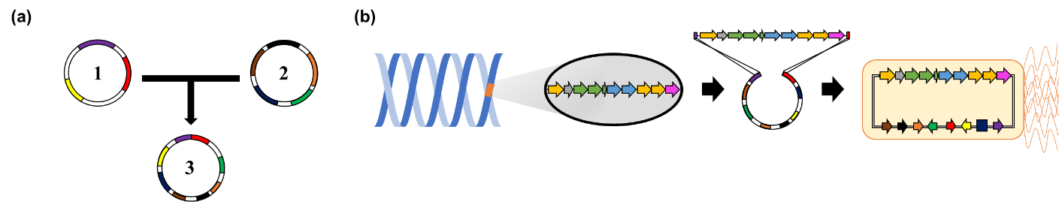
Fig. S1 (a) To capture a BGC, we combined two plasmids; pSET152 (1) and pCAP-BAC (2) to make a pCAP-BAC-Apr (pCBA) (3), Purple : phage φC31 integrase, Red : AparamycinR, Yellow : tra from pSET152, Navy : ori2 , Brown : repE, Black : sopA, Orange : sopB, Green : sopC from pCAP-BAC. (b) gDNA was extracted from Streptomyces antibioticus NRRL 3238, and then ovm BGC was synthesized by PCR method. Ovm BGC PCR product, included homology region (50 bp) of pCBA, was ligated into linear pCBA. Ovm BGC captured plasmid (pCBAO) was transformed into E. coli ET12567(pUZ8002).

Fig. S2 RT-qPCR analysis on the fold change of SCMO and refactoring strains SCMO1. Relative expression was normalized by housekeeping gene, hrdB. These data represented the averages of three independent experiments ± standard deviations.

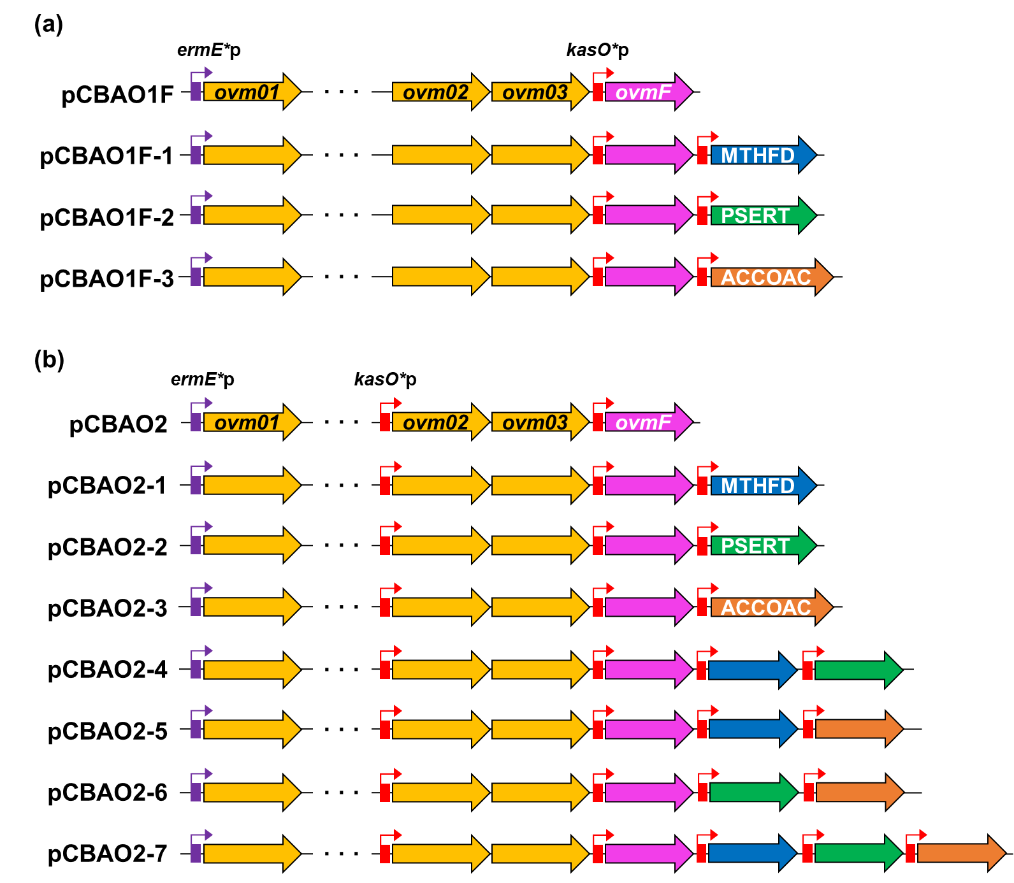
Fig. S3 Plasmid construction for overexpressing three candidate genes from GEM into pCBAO1F (a) and pCBAO2 (b)

Reference
1. Macneil DJ, Gewain KM, Ruby CL, Dezeny G, Gibbons PH, Macneil T. Analysis of Streptomyces avermitilis genes required for avermectin biosynthesis utilizing a novel integration vector. Gene 1992,111:61-68. https://doi.org/10.1016/0378-1119(92)90603-m.
2. Gomez‐Escribano JP, Bibb MJ. Engineering Streptomyces coelicolor for heterologous expression of secondary metabolite gene clusters. Microbial biotechnology 2011, 4:207-215. https://doi.org/10.1111/j.1751-7915.2010.00219.x.
3. Bauman KD, Li J, Murata K, Mantovani SM, Dahesh S, Nizet V, Luhavaya H, Moore BS. Refactoring the Cryptic Streptophenazine Biosynthetic Gene Cluster Unites Phenazine, Polyketide, and Nonribosomal Peptide Biochemistry. Cell Chem Bio 2019, 26:724-736.e7. https://doi.org/10.1016/j.chembiol.2019.02.004.
4. Cho MK, Lee BT, Kim HU, Oh MK. Systems metabolic engineering of Streptomyces venezuelae for the enhanced production of pikromycin. Biotechnology and Bioengineering 2022. https://doi.org/10.1002/bit.28114.

